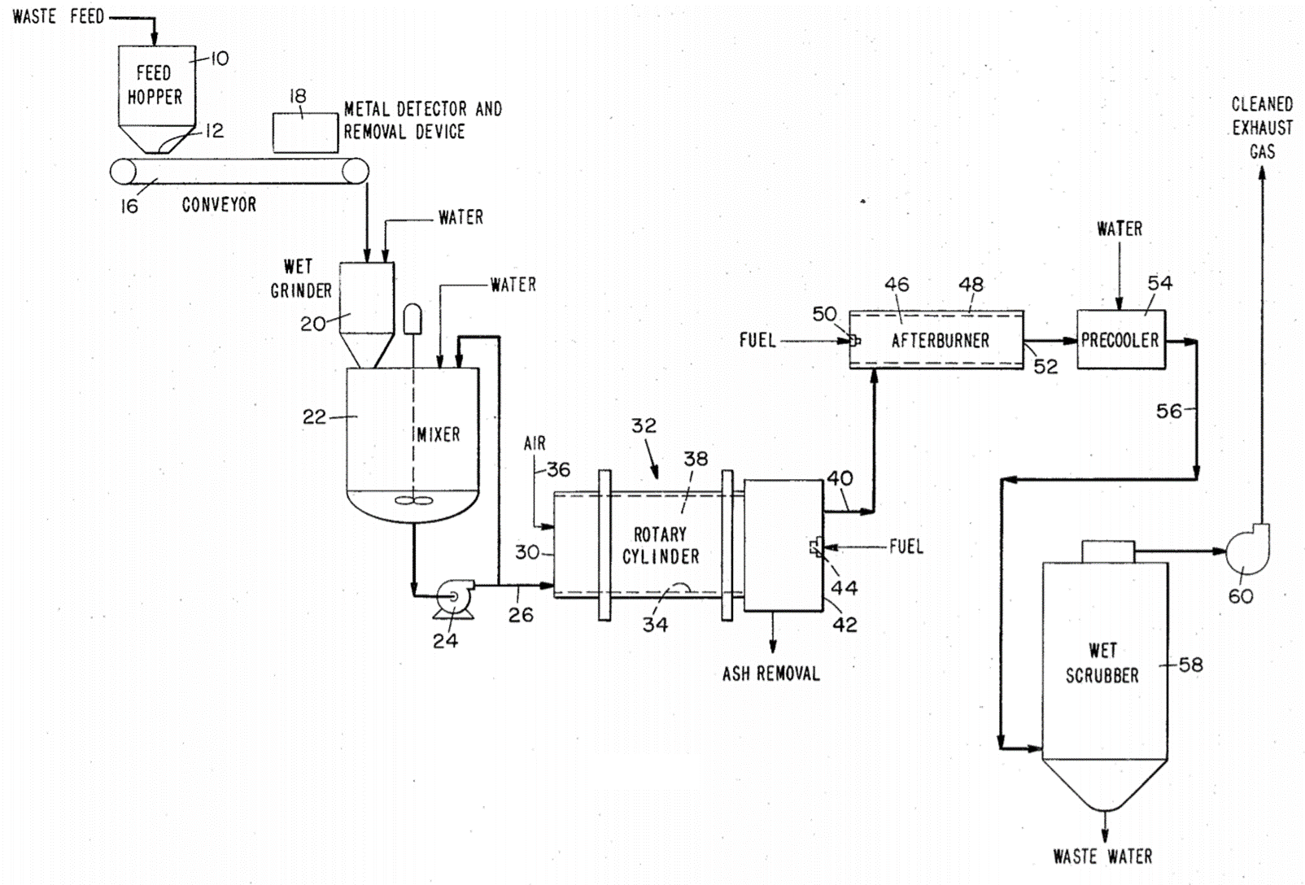
FUEL
FUEL
AIR
WET GRINDER
ASH REMOVAL
CLEANED EXHAUST GAS
WASTER WATER
WET SCRUBBER
PRECOOLER
AFTERBURNER
ROTARY CYLINDER
MIXER
WATER
WATER
WATER
CONVEYOR
FEED HOPPER
WASTE FEED

FUEL
FUEL
AIR
WET GRINDER
ASH REMOVAL
CLEANED EXHAUST GAS
WASTE WATER
WET SCRUBBER
PRECOOLER
AFTERBURNER
ROTARY CYLINDER
MIXER
WATER
WATER
WATER
CONVEYOR
FEED HOPPER
WASTE FEED

FUEL
FUEL
AIR
WET GRINDER
ASH REMOVAL
CLEANED EXHAUST GAS
WASTER WATER
WET SCRUBBER
PRECOOLER
AFTERBURNER
ROTARY CYLINDER
MIXER
WATER
WATER
WATER
CONVEYOR
FEED HOPPER
WASTE FEED
WASTE FEED
CLEANED EXHAUST GAS
WASTE WATER
PRECOOLER
AFTERBURNER
ROTARY CYLINDER
WATER
WATER
CONVEYOR
FEED HOPPER

AIR
FUEL
FUEL
ASH REMOVAL
WET GRINDER
MIXER
WET SCRUBBER
WATER

