Meeting Preview: September 9th, 2025
Amy Kim
Project Overview
In this project, I aim to be the first to measure the individual-level effect of winning the H-1B lottery on labor market outcomes by linking administrative data on H-1B lottery results to individual-level outcomes in LinkedIn. The empirical challenge lies in the linkage: I have very limited information on individuals in the H-1B lottery data (firm, year of birth, gender, country of nationality). Past work has been impeded by the idea that if an individual loses the H-1B lottery, they likely don’t end up working at the firm listed on the lottery application and are therefore not linkable via firm. My contribution is to show that for the subset of applicants that graduated with a STEM degree in the U.S., the three-year OPT program permits working at a firm and continuously applying for the H-1B lottery until three years has expired. This allows me to link on firm for OPT-eligible individuals.

Summary of Progress so far
Over the summer, my goal was to try to finish linking (however imperfect) to try to get some initial results and decide on the direction of the project. Linking proved much more difficult than initially expected and my final linked sample as of now exhibits two primary problems:
- Selection – I impute individuals’ nationality from information on their LinkedIn page (name, education, position history) and am therefore systematically less likely to match individuals with less information on their LinkedIn pages. In various cuts of the data I limit the sample to smaller companies, exclude India and China, etc., making it less clear that my results will be externally valid.
- Noise – Even in my most selected sample (excluding India and China, only focused on small companies) each application is currently matched to about six potential LinkedIn users. I have additional information about lottery winners that allows me to ‘check’ match quality for winners and it seems that I am finding the true applicant most of the time, it’s just being diluted by false matches.

With these caveats in mind, my empirical specification for H-1B application $j$ with company $c$ in year $t$ is as follows:
$$y_{jct}=β_{0}+β_{1}{win}_{j}+β_{2}{ADE}_{j}+ε_{jct}$$
where${win}_{j}$ represents the outcome of lottery application $j$ for an individual at company $c$ in lottery year $t$, ${ADE}_{j}$ is an indicator for advanced degree status, which increases lottery odds, and $y_{jct}$ is the outcome of interest. In additional specifications I include company by lottery year fixed effects. Table 1 shows estimates of $β_{1}$ for various outcomes constructed by taking a weighted average across all potential LinkedIn user matches. In columns (1) and (2) the outcome variable is an indicator for still working at company $c$ one year after the lottery, in columns (3) and (4) the outcome variable is an indicator for still working in the US one year after the lottery, and in columns (5) and (6) the outcome variable is an indicator for being in school one year after the lottery. The estimates largely suggest that losing the lottery does push people out of the company and out of the US, but the magnitudes of the estimates are quite small. The fundamental problem is that it is difficult to distinguish whether my estimate of $β_{1}$ is small because the true population coefficient is small (either due to the multiple tries at the lottery or because firms find other ways to retain their employees) or due to measurement error.

Based on this ‘trial run’ and the empirical issues that have emerged, my advisors and I have decided that it would be better for this to not be my job market paper. Nonetheless we think it’s an important and big enough question for my work to be a meaningful contribution to the field, so they’ve advised that I try to write up a draft quickly enough that I have time to pivot to an alternate JMP idea. I’m primarily looking for feedback on what the most compelling packaging/’story’ for this paper is, that doesn’t require too much additional data work beyond what I’ve already done.

Table 1: Application-level regressions of various labor market outcomes one year after the H-1B lottery on an indicator for winning the H-1B lottery. All regressions include a control for Advanced Degree Exemption (ADE) status, which increases lottery odds.
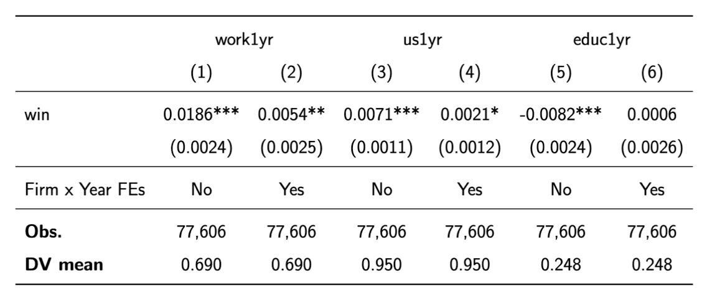

Table 2: Application-level regressions of various labor market outcomes two years after the H-1B lottery on an indicator for winning the H-1B lottery. All regressions include a control for Advanced Degree Exemption (ADE) status, which increases lottery odds.
