Supplementary Materials For “The Effects of Prohibiting Marriage Bars:

The Case of U.S. Teachers”

Amy Kim and Carolyn Tsao∗ November 10, 2025

∗Department of Economics, Princeton University, kimamy@princeton.edu and ctsao@princeton.edu

Additional Figures

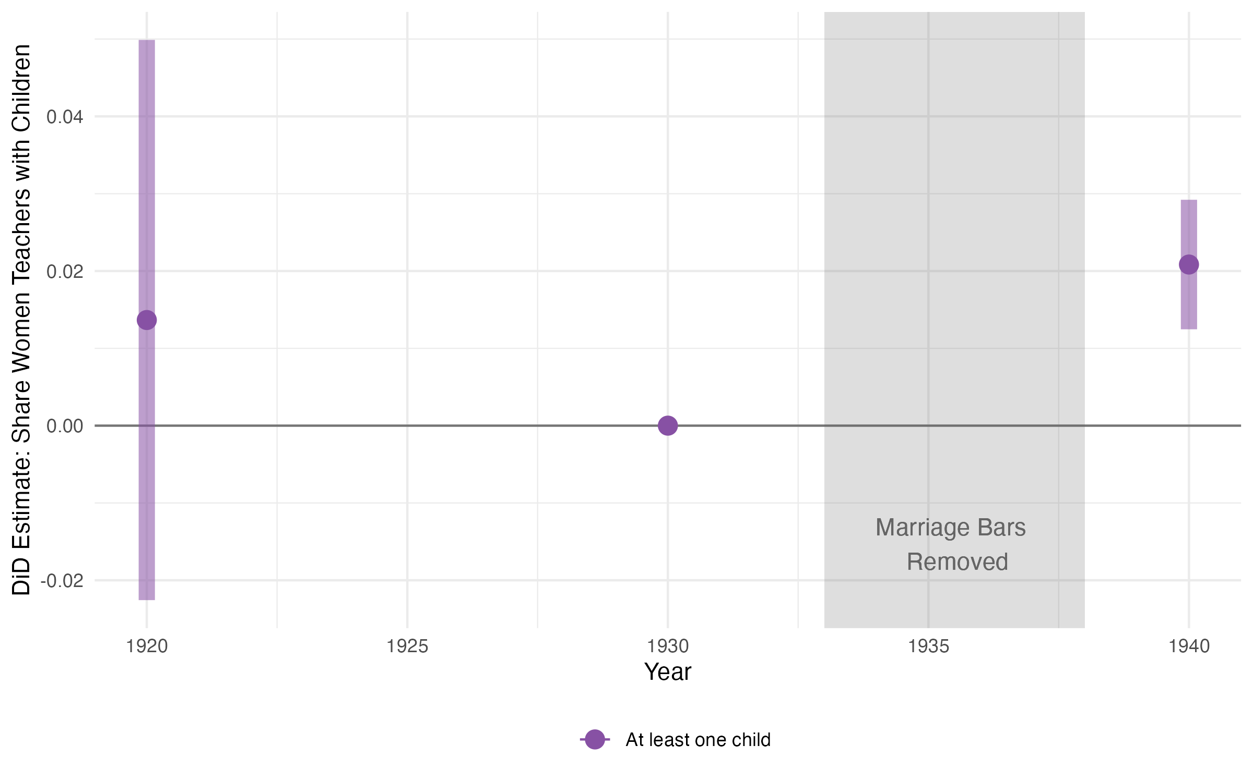
Figure A1: Results on fertility: Estimated effects of the introduction of employment pro-tections for married women in teaching on the county shares of white women teachers with children.

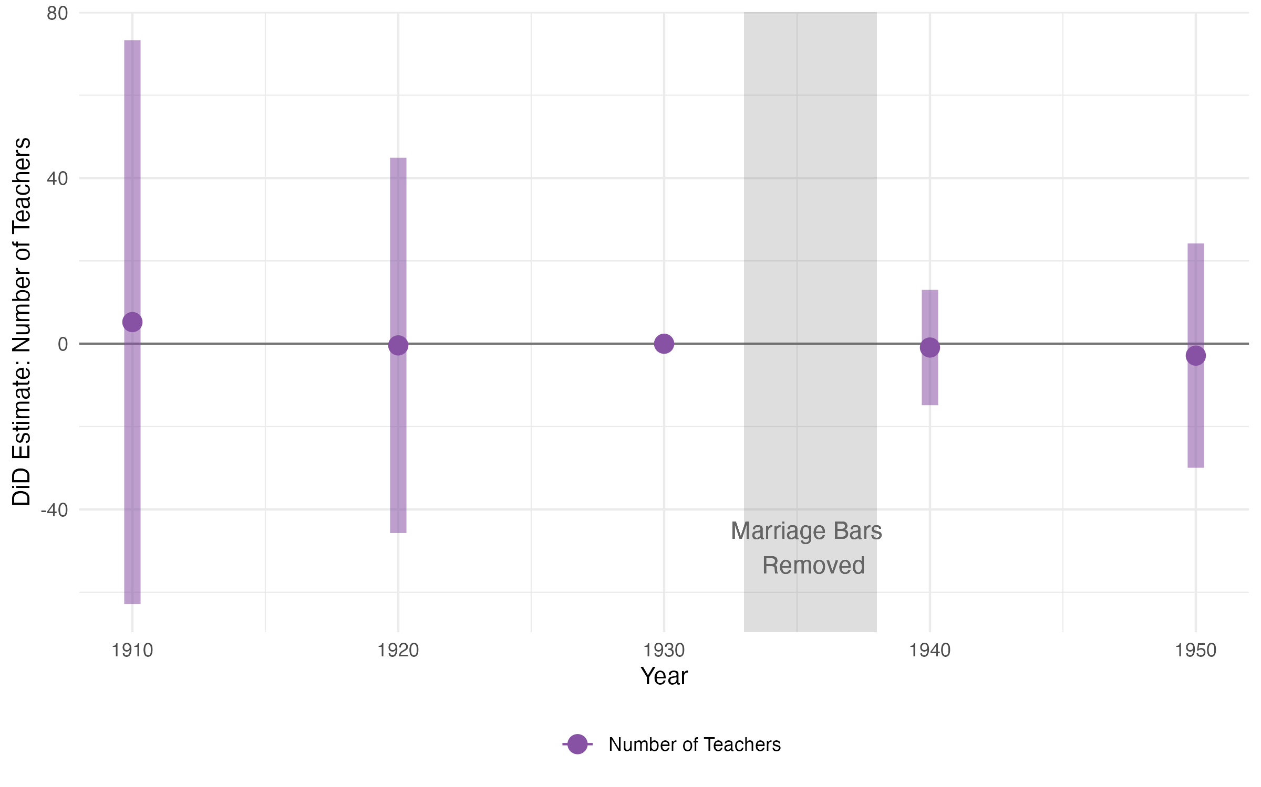
Figure A2: Estimated effects of the introduction of employment protections for married women on the total number of white teachers per county.

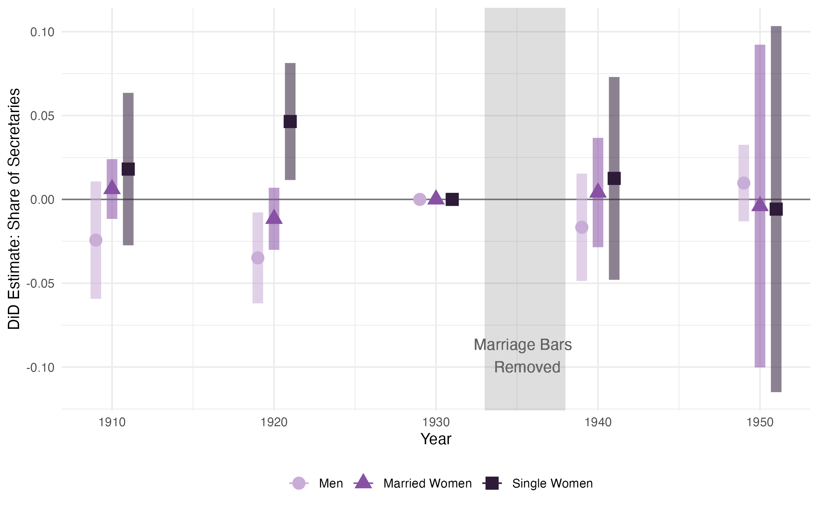
Figure A3: Placebo test: Estimated effects of the introduction of employment protections for married women in teaching on the county shares of secretaries who are men, unmarried women, and single women.

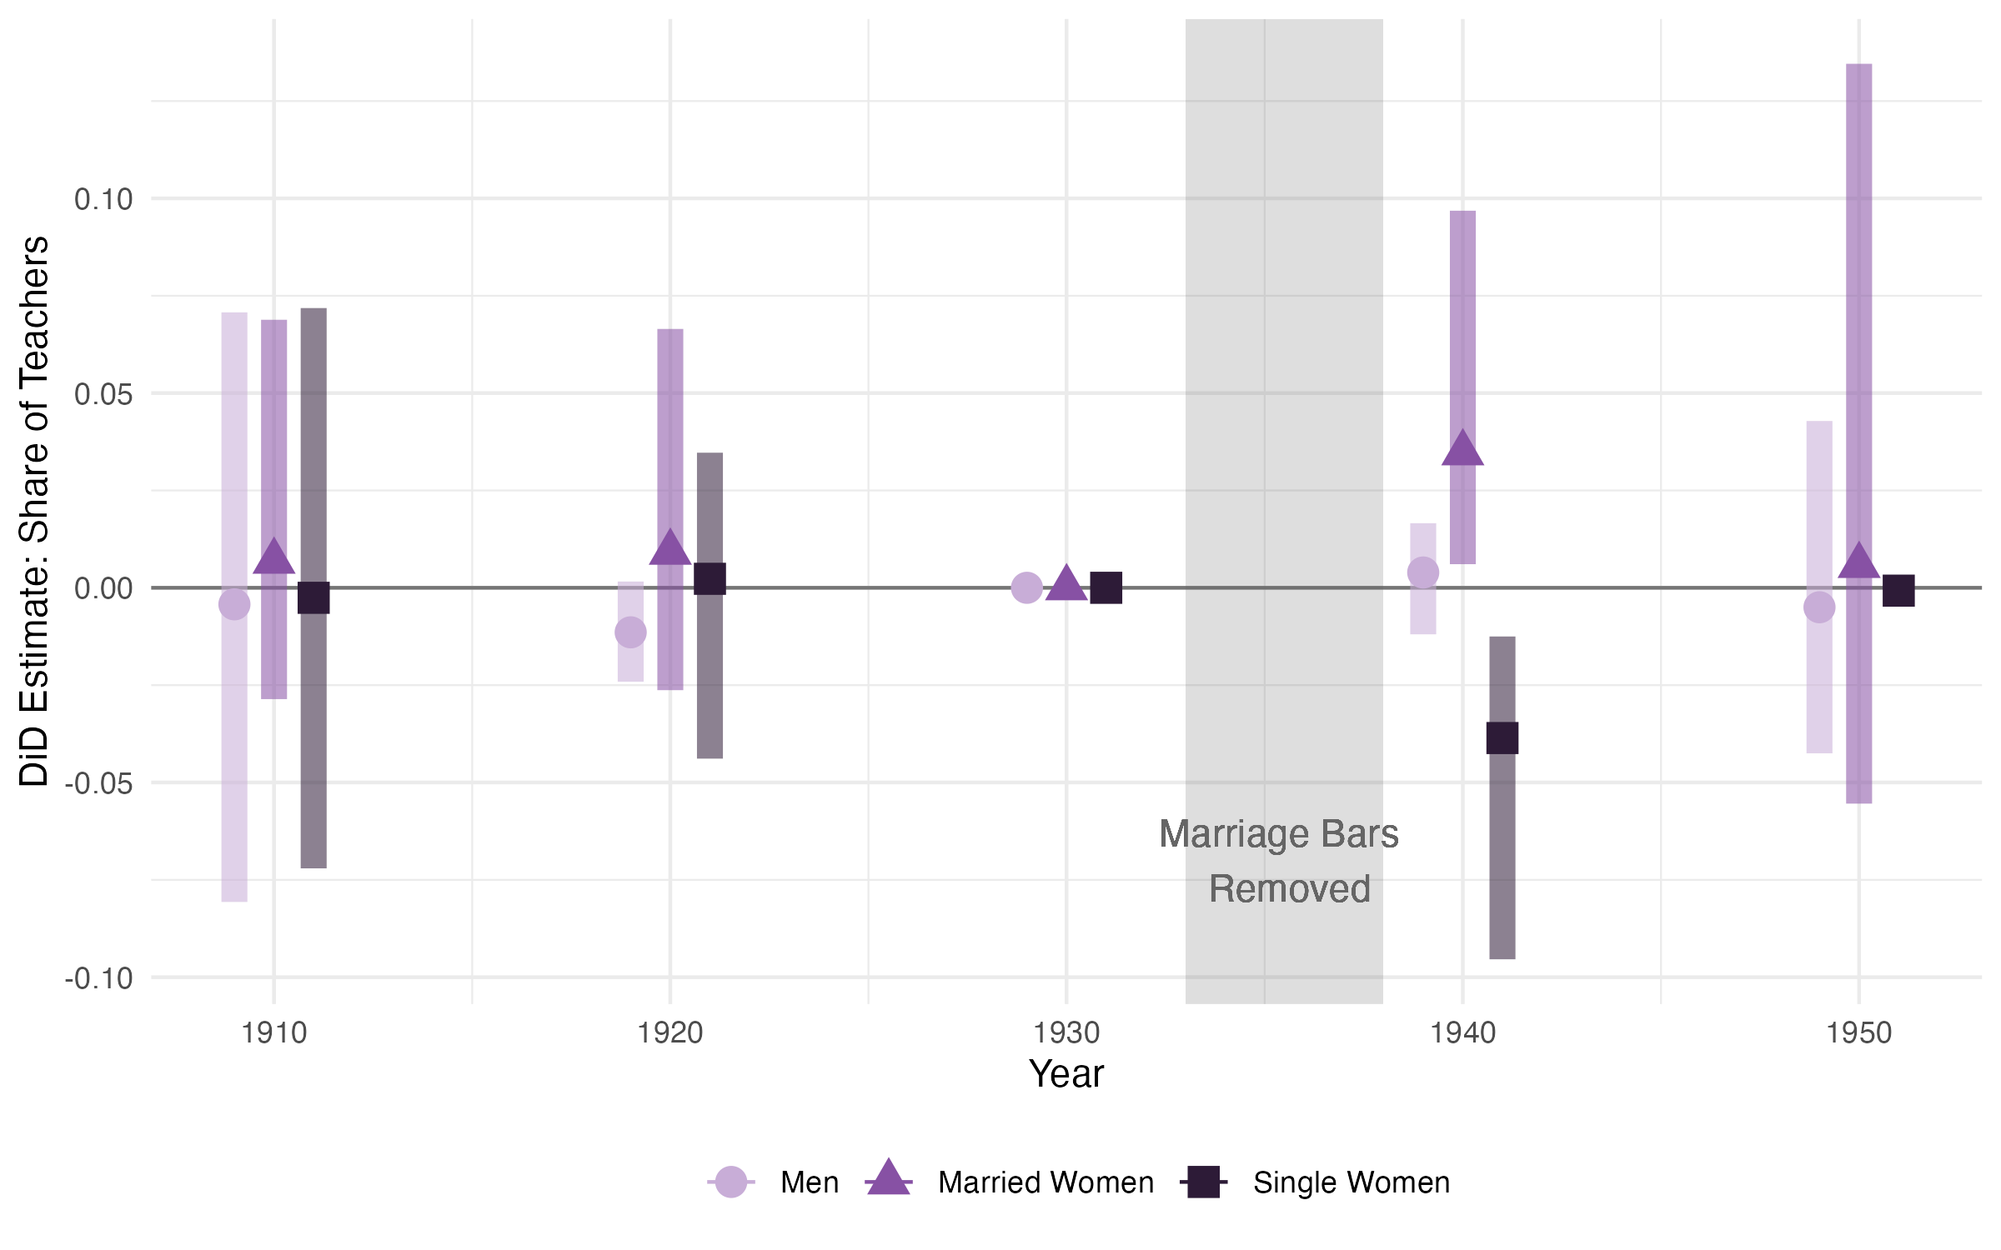
Figure A4: Main results, with state-level clustering of standard errors using wild cluster bootstrapping (Fischer & Roodman (2021)): Estimated effects of the introduction of em-ployment protections for married women in teaching on the county shares of teachers who are men, unmarried women, and single women.

Additional Tables

Table B1: Census linkage rates by year and group.

Treated
 |  | States | States | Women | Women | Women | Women | Women  Teachers | Women  Teachers
 |  | (1) | (2) | (3) | (4) | (5) | (6) | (7) | (8)
 | 1910-1920 Linked Sample
 | % 1910 Individuals Linked to 1920 | 60.9% | 56.3% | 61.0% | 30.6% | 53.9% | 62.8% | 47.9% | 59.8%
 | Number of 1910 Individuals (Thous.) | 4,500.8 | 6,988.0 | 39,530.1 | 5,018.5 | 27,002.2 | 17,689.2 | 415.4 | 24.6
 | 1920-1930 Linked Sample
 | % 1920 Individuals Linked to 1930 | 62.2% | 57.4% | 62.0% | 32.1% | 53.9% | 65.8% | 47.8% | 66.4%
 | Number of 1920 Individuals (Thous.) | 4,978.4 | 7,798.1 | 46,387.0 | 5,276.4 | 30,334.6 | 21,490.5 | 538.3 | 58.3
 | 1930-1940 Linked Sample
 | % 1930 Individuals Linked to 1940 | 62.8% | 59.4% | 62.5% | 35.3% | 53.0% | 68.5% | 45.6% | 71.4%
 | Number of 1930 Individuals (Thous.) | 5,784.9 | 8,510.2 | 54,423.5 | 6,035.6 | 34,453.1 | 26,242.3 | 679.0 | 150.5

Control

White

Black

Unmarried

Married
Unmarried
Married

4

Notes: Linkage rates are computed as the share of a given population in the base year (e.g. 1910) that are successfully linked to the following census (e.g. 1920). Groups (e.g. marital status) are based on base year characteristics. Treated states are NC and KY. We use Census Tree linkages from 1910-1920, 1920-1930, and 1930-1940 (Price et al. 2023a,b,c).

Table B2: Summary statistics on retail sales per capita during the Great Depression, by treated status
5

 |  | 1929 Retail Sales per cap (1967 USD)  (1) | 1929-33 RS per cap growth (%)  (2) | 1933-39 RS per cap growth (%)  (3) | 1939 RS per cap (1967 USD)  (4)
 | Treated Counties
 | Kentucky | 441.8 | -41.2 | 41.5 | 443.0
 | North Carolina | 406.9 | -35.8 | 41.6 | 431.1
 | Treated Average | 422.7 | -38.4 | 41.5 | 436.4
Neighboring Southern Control Counties
 | South Carolina | 339.7 | -23.5 | 45.6 | 423.9
 | Tennessee | 485.2 | -43.4 | 47.5 | 505.3
 | Virginia | 488.8 | -28.0 | 43.3 | 569.3
 | West Virginia | 510.0 | -36.7 | 37.8 | 515.3
 | Control Average | 461.5 | -34.0 | 43.8 | 509.1

Notes: Data source: Fishback et al. (2005).

Table B3: Heterogeneity in estimated effects of prohibitions on the share of teachers that are married women.
6

Dependent Variable: Pr(Married Woman — Teacher)

1940
Model: | (1) | (2) | (3) | (4) | (5) | (6) | (7) | (8) | (9)
Variables  Treated ×1940 (γ^{DD} ) | 0.0350∗∗∗ | 0.0347∗∗∗ | 0.0240∗∗∗ | 0.0313∗∗∗ | 0.0375∗∗∗ | 0.0388∗∗∗ | 0.0346∗∗∗ | 0.0405∗∗∗ | 0.0397∗∗∗
Treated ×1940 × Nonwhite | (0.0073) | (0.0066) | (0.0079) | (0.0064) | (0.0075) | (0.0072)  -0.0332∗∗ | (0.0072) | (0.0077)  -0.0426∗∗ | (0.0068)
 |  |  |  |  |  | (0.0129) |  | (0.0171)
Treated ×1940 × Urban |  |  |  |  |  |  | -0.0023 | -0.0107
 |  |  |  |  |  |  | (0.0112) | (0.0121)
Treated ×1940 × Nonwhite × Urban |  |  |  |  |  |  |  | 0.0306
Treated ×1940 × (Age − 30) |  |  |  |  |  |  |  | (0.0232) | -0.0025∗∗∗
 |  |  |  |  |  |  |  |  | (0.0005)
Inverse Weighted by County | No | Yes | Yes | Yes | Yes | Yes | Yes | Yes | Yes
Observations | 437,111 | 437,111 | 322,511 | 221,846 | 343,350 | 437,111 | 437,111 | 437,111 | 437,111
Adjusted R² | 0.09100 | 0.10761 | 0.09672 | 0.03215 | 0.10726 | 0.12169 | 0.10846 | 0.12249 | 0.12136

Notes: Estimation of Equation (2) for the cross-sectional sample of all teachers in our balanced sample of counties in treated (KY, NC) and neighbor-ing Southern control states (VA, SC, TN, WV). The outcome variable for all regressions is an indicator for whether an individual is a married woman in t. Column (1) includes all teachers with no weights or controls. Column (2) includes inverse weighting of each observation by the number of teachers in a county and year, thus replicating the county-level regression in Table 2, Column (1). All remaining columns use county-year inverse population weights for comparability with our main county-level results. Column (3) restricts the sample to the set of counties with at least ten Black teachers in 1930 and 1940 (see Section 3.3 for more details). Column (4) includes county-level controls for the share of workers in manufacturing, the share of workers in agriculture, unemployment rate, and log population. Note that the sample size is smaller because full-count Census data on employment status was only available in 1930 and 1940. Column (5) excludes counties in the Tennessee Valley Authority (see Section 4.3 for further discussion). Columns (6) and (7) include indicators for whether a teacher is non-white (Nonwhite) and whether a teacher lives in an urban area (Urban) respec-tively as additional interaction terms. Column (8) includes Nonwhite, Urban, and the interaction between the two as additional interaction terms. Column (9) includes an individual’s age relative to 30 (the mean age for teachers in treated counties in 1930) as an additional interaction term. All regressions include county and year fixed effects and use 1910-1950 full-count cross-sectional decennial Census data unless otherwise stated (Ruggles et al. 2024). Standard errors are clustered at the county level.

Table B4: Estimated effects of the prohibitions on women’s propensity to get married and to teach, work outside of teaching, and exit the labor force.
7

Dependent Variable: Pr(Married in t) Pr(Married Teacher in t) Pr(Married Non-Teacher in LF in t) Pr(Married Not in LF in t)
(1) |  |  | (2) | (3) | (4)
Sample 4: Women who were married and working as non-teachers in t − 10
 | Treated × 1940 (γ^{DD} ) | -0.0016 | 0.0002 | 0.0189 | -0.0207
 |  | (0.0049) | (0.0006) | (0.0148) | (0.0165)
 | Dep. Var. 1930 Treated Mean | 0.8779 | 0.0032 | 0.2078 | 0.6669
 | Observations | 248,533 | 248,533 | 248,533 | 248,533
 | Adjusted R² | 0.03724 | 0.00187 | 0.10338 | 0.09394
Sample 5: Women who were unmarried and working as non-teachers in t − 10
 | Treated × 1940 (γ^{DD} ) | 0.0044 | 0.0003 | 0.0145∗∗ | -0.0104
 |  | (0.0043) | (0.0005) | (0.0072) | (0.0078)
 | Dep. Var. 1930 Treated Mean | 0.5132 | 0.0021 | 0.0824 | 0.4287
 | Observations | 320,304 | 320,304 | 320,304 | 320,304
 | Adjusted R² | 0.17755 | 0.00154 | 0.04312 | 0.15284

1940

1940

Notes: Sample 4 contains linked women who were aged 18-50, white, married and in the labor force but not working as teachers in 1920 and 1930. Sample 5 contains linked women who were aged 8-40, white, unmarried and in the labor force but not working as teachers in 1920 and 1930. See notes of Table 3 for further details on sample construction and estimation.

Table B5: Estimated effects of marriage bar prohibitions on fertility, occupational scores, LFP, and mobility for women who were unmarried and teaching in t − 10
8

Dependent Variable: Has child in t Occupational Score in t In Labor Force in t Moves state in t

Model: | (1) |  | (2) | (3) |  | (4) | (5) |  | (6) | (7)
Treated × 1940 | -0.0251∗∗ |  | 0.8418∗∗ | -0.0814 |  | 0.0266∗∗ | -0.0033 |  | 0.0391∗∗∗ | 0.0589∗∗∗
Treated × 1940 × Married in t | (0.0118) |  | (0.3655) | (0.2838)  1.526∗∗∗ |  | (0.0128) | (0.0100)  0.0442∗∗∗ |  | (0.0095) | (0.0119)  -0.0429∗∗∗
 |  |  |  | (0.4302) |  |  | (0.0151) |  |  | (0.0131)
Dep. Var. 1930 Treated Mean | 0.4819 |  | 10.39 | 10.39 |  | 0.4091 | 0.4091 |  | 0.1421 | 0.1421
County fixed effects | Yes |  | Yes | Yes |  | Yes | Yes
Age fixed effects | Yes |  | Yes | Yes |  | Yes | Yes
Observations | 59,542 |  | 59,542 | 59,542 |  | 59,542 | 59,542
Adjusted R² | 0.10860 |  | 0.13437 | 0.46280 |  | 0.11917 | 0.47197 |  | 0.02193 | 0.04099

Notes: All columns show results from estimating Equation (2) for women in linked Sample 1, defined in the notes of Table 3. The outcome in Column (1) is an indicator for whether the woman has child in year t. The outcome in Column (2) is the woman’s occupational score in year t. We include women who are unemployed, for whom their occupational score is 0. The outcome in Column (4) is an indicator for whether the woman is in the labor force in t. The outcome in Column (6) is an indicator for whether the woman lives in a different state in year t compared to year t − 10. Columns (3), (5), and (7) add to the previous column an interaction term for whether the woman is married in year t. Standard errors are clustered at the county level. All specifications include year, county and age fixed effects.

Table B6: Heterogeneity in estimated effects of the prohibitions on the propensity of women not in the labor force in t − 10 to work as a non-teacher in t.
9

Dependent Variable: Pr(Married Non-Teacher in LF in t)

Model: | (1) | (2) | (3) | (4) | (5) | (6)
Sample 2: Women who were married and not in the labor force in t − 10
Treated × 1940 | 0.0064∗ | 0.0028 | 0.0071∗∗ | 0.0077∗∗ | 0.0048 |  | 0.0059
 | (0.0035) | (0.0028) | (0.0033) | (0.0032) | (0.0039) |  | (0.0062)
Observations | 3,125,563 | 3,125,563 | 3,110,334 | 2,279,708 | 2,332,161 |  | 914,032
Adjusted R² | 0.01862 | 0.01560 | 0.01875 | 0.02253 | 0.02014 |  | 0.02101
Sample 3: Women who were unmarried and not in the labor force in t − 10
Treated × 1940 | 0.0044∗∗ | 0.0020 | 0.0045∗∗ | 0.0051∗∗∗ | 0.0041∗ |  | 0.0005
 | (0.0021) | (0.0017) | (0.0021) | (0.0019) | (0.0024) |  | (0.0034)
Observations | 2,217,852 | 2,217,852 | 2,209,789 | 1,511,858 | 1,688,568 |  | 646,957
Adjusted R² | 0.02051 | 0.01699 | 0.02064 | 0.02383 | 0.02206 |  | 0.02018
0.02022 | 0.01997

Notes: Each column shows estimates from Equation (1) on samples defined in the notes of Table 3. Column (1) shows the unweighted estimates, replicating the main result in Table 3, Column (3). Column (2) includes inverse weighting of each observation by the number of observations in a county and year, imitating a county-level regression. Column (3) includes controls for industry share and population. Column (4) adds controls for county-level unemployment; note that the sample is smaller because the variable on employment status is not available in the 1920 Census. Column
(5) excludes counties that were affected by the Tennessee Valley Authority (TVA). Column (6) includes only border counties, defined in Supplemental Appendix C. Standard errors are clustered at the county level. All specifications include year, county and age fixed effects.

10

Table B7: Estimated effects of the prohibitions on women’s propensity to remain unmarried and to teach, work outside of teaching, and exit the labor force.

Dependent Variable: Pr(Unmarried in t) Pr(Unmarried Teacher in t) Pr(Unmarried Non-Teacher in LF in t) Pr(Unmarried Not in LF in t)
(1) |  |  | (2) | (3) | (4)
Sample 3: Women who were unmarried and not in the labor force in t − 10
 | Treated × 1940 (γ^{DD} ) | 0.0003 | 0.0014 | −0.0058 | 0.0047
 |  | (0.0036) | (0.0009) | (0.0036) | (0.0039)
 | Dep. Var. 1930 Mean | 0.5224 | 0.0323 | 0.1918 | 0.2982
 | Observations | 2,217,852 | 2,217,852 | 2,217,852 | 2,217,852
 | Adjusted R² | 0.15575 | 0.01056 | 0.06495 | 0.14088
Sample 5: Women who were unmarried and working as non-teachers in t − 10
 | Treated × 1940 (γ^{DD} ) | -0.0044 | 0.0014 | -0.0047 | -0.0011
 |  | (0.0043) | (0.0009) | (0.0064) | (0.0061)
 | Dep. Var. 1930 Mean | 0.4868 | 0.0096 | 0.3498 | 0.1274
 | Observations | 320,304 | 320,304 | 320,304 | 320,304
 | Adjusted R² | 0.17755 | 0.00284 | 0.12281 | 0.07548

1940

1940

Notes: See notes for Tables 3 and Supplemental Appendix B6.

Table B8: Estimated effects of prohibitions on the labor force participation of women.
11

Dependent Variable: Pr(In Labor Force)

1940
Model: | (1) | (2) | (3) | (4) | (5) | (6) | (7) | (8)
Variables  Treated ×1940 (γ^{DD} ) | 0.0062 | 0.0091∗∗ | 0.0001 | 0.0042 | 0.0019 | 0.0083∗ | 0.0057 | 0.0095
 | (0.0046) | (0.0039) | (0.0087) | (0.0045) | (0.0057) | (0.0049) | (0.0054) | (0.0069)
Treated ×1940 × Married |  |  | 0.0072
 |  |  | (0.0108)
Treated ×1940 × Nonwhite |  |  |  | -0.0023
 |  |  |  | (0.0132)
Treated ×1940 × Urban |  |  |  |  | 0.0141
 |  |  |  |  | (0.0118)
Inverse Weighted by County | No | Yes | No | No | No | No | No | No
Observations | 21,423,773 | 21,423,773 | 21,423,773 | 21,423,773 | 21,423,773 | 16,739,277 | 16,533,201 | 5,859,581
Adjusted R² | 0.07115 | 0.06639 | 0.16767 | 0.10433 | 0.08549 | 0.07904 | 0.07183 | 0.07169

Notes: Estimation of Equation (2) for the cross-sectional sample of all women in our balanced sample of counties in treated (KY, NC) and neighboring Southern control states (VA, SC, TN, WV). The outcome variable for all regressions is an indicator for whether an in-dividual is in the labor force. Column (1) includes all women with no weights or controls. Column (2) includes inverse weighting of each observation by the number of women in a county and year, effectively imitating a county-level regression. All remaining columns do not use weights. Columns (3), (4) and (5) include indicators for whether a woman is married (Married), whether a woman is non-white (Nonwhite), and whether a woman lives in an urban area (Urban) respectively as additional interaction terms. Column (6) includes county-level controls for the share of workers in manufacturing, the share of workers in agriculture, unemployment rate, and log popu-lation. Note that the sample size is smaller because full-count Census data on employment status was only available in 1930 and 1940. Column (7) excludes counties in the Tennessee Valley Authority (see Section 4.3 for further discussion). Column (8) includes only border counties, defined in Supplemental Appendix C. All regressions include county, year, and age fixed effects and use 1910-1950 full-count cross-sectional decennial Census data unless otherwise stated (Ruggles et al. 2024). Standard errors are clustered at the county level.

State-Level Synthetic Difference-in-Differences
As discussed in Section 4, our preferred specification involves analysis at the county level as there is reason to believe that counties with different initial norms and policies surrounding married women teachers may have responded heterogeneously to the uniform ‘treatment’ of the state-level marriage bar prohibitions. That said, given that the treatment of interest was implemented at the state level, in this section we conduct an alternate state-level analysis to confirm that our results are not driven by our choice of the unit of analysis.

Empirical Strategy
At the state level, we have only two treated units—Kentucky and North Carolina—which motivates our decision to use a synthetic difference-in-differences empirical strategy. We follow Arkhangelsky et al. (2021) in our implementation of synthetic difference-in-differences by finding both unit weights ωˆ^{sdid} that balance pre-treatment trends in our outcome variables for treated and control units as well as time weights λˆsdid that balance trends in control unit outcomes in the pre-treatment and post-treatment periods.¹ We then use the computed weights to solve the following problem:
γˆ^{sdid}, αˆ, βˆ = arg min n XN X(y_{st} −α^{sdid} −β^{sdid} −γ^{sdid} ×Treat_{s} ×Y ear_{t=1940})²ωˆ^{sdid}λˆsdido,
T

γ,α,β

i=1

t=1
t s 1940
i t
(1)

which boils down to estimating a weighted two-way fixed effects regression to obtain an estimate of our coefficient of interest γ^{sdid} , the effect of the prohibition of marriage bars on state-level outcome y_{st} in treated relative to control states. We define our state-level outcomes analogously to the county-level outcomes described in Section 4.2.
1940

Estimation and Results
We begin by computing the unit and time weights. State weights ωˆ^{sdid} as computed for our main outcome variable (the share of women in state s who are married women) are shown
¹Because it is unclear which units are treated in 1950, all estimation in this section uses only data from 1910-1940.

in Panel (a) of Figure D1. Computed time weights for all analyses are 1 for 1930 and 0 for other pre-period years, simplifying our setup to a two-period setting.
First, we use the synthetic DiD setup to estimate the state-level effect of the marriage bar prohibitions on the composition of the teacher workforce. Figure D2 plots estimates of γ^{sdid} for the share of teachers who were married women (triangles), men (circles), and unmarried women (squares) respectively. The first two groups of estimates juxtapose the results our preferred specification (at the county level with county-level clustered standard errors) with the state-level synthetic DiD estimates. Standard errors are computed using a permutation approach (‘placebo’ option in R). The point estimates are very similar between the county and state-level analyses, and our primary finding that the share of married women teachers increased in treated relative to control states remains significant at the 95% confidence level despite widened confidence intervals.
1940
An additional benefit of using the synthetic DiD approach is that it also allows us to perform analysis with only one treated unit. As such, we estimate the effects of the prohibitions on married women teachers in North Carolina and Kentucky separately. Panels
(b) and (c) of Figure D2 map control unit weights for NC and KY individually, and we see that much of the control unit weighting in the joint analysis is driven by North Carolina. Nevertheless, the third and fourth groups of estimates in Figure D2 show that, while noisier, the point estimates for the effects of the marriage bar prohibitions on NC and KY are remarkably similar to the overall effects, suggesting that results are not being driven by one state alone.
Finally, we replicate our results on mechanisms using the state-level synthetic DiD and linked data aggregated to the state level. Table D1 replicates Table 3 from the body of the paper, presenting synthetic DiD estimates and standard errors computed using the placebo method. Note that this not an individual level regression and therefore not directly comparable to Table 3 since it is weighted to match pre-trends rather than by population. Results are qualitatively similar to our preferred estimates. We therefore conclude that our main results are not sensitive to the chosen unit of analysis.

Figure D1: Maps of treated (pink) and control (green) states shaded by unit weights com-puted in our synthetic difference-in-differences empirical strategy (computed to match pre-trends between control and treatment states for outcome variable share teachers married women). Panel (a) uses both Kentucky and North Carolina as treated units, panel (b) uses only North Carolina as a treated unit, and panel (c) uses only Kentucky as a treated unit.
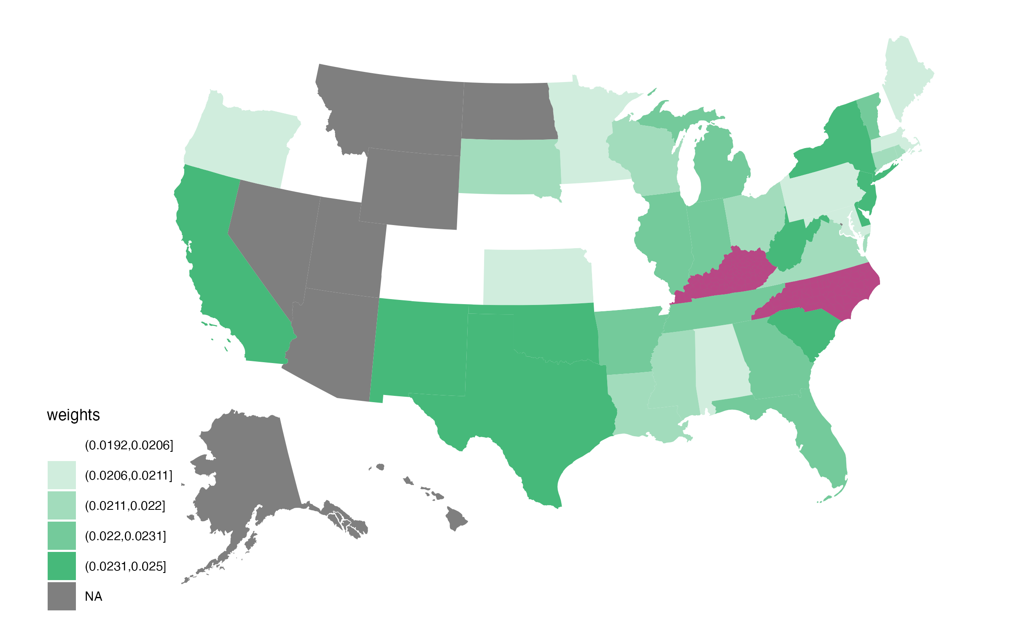
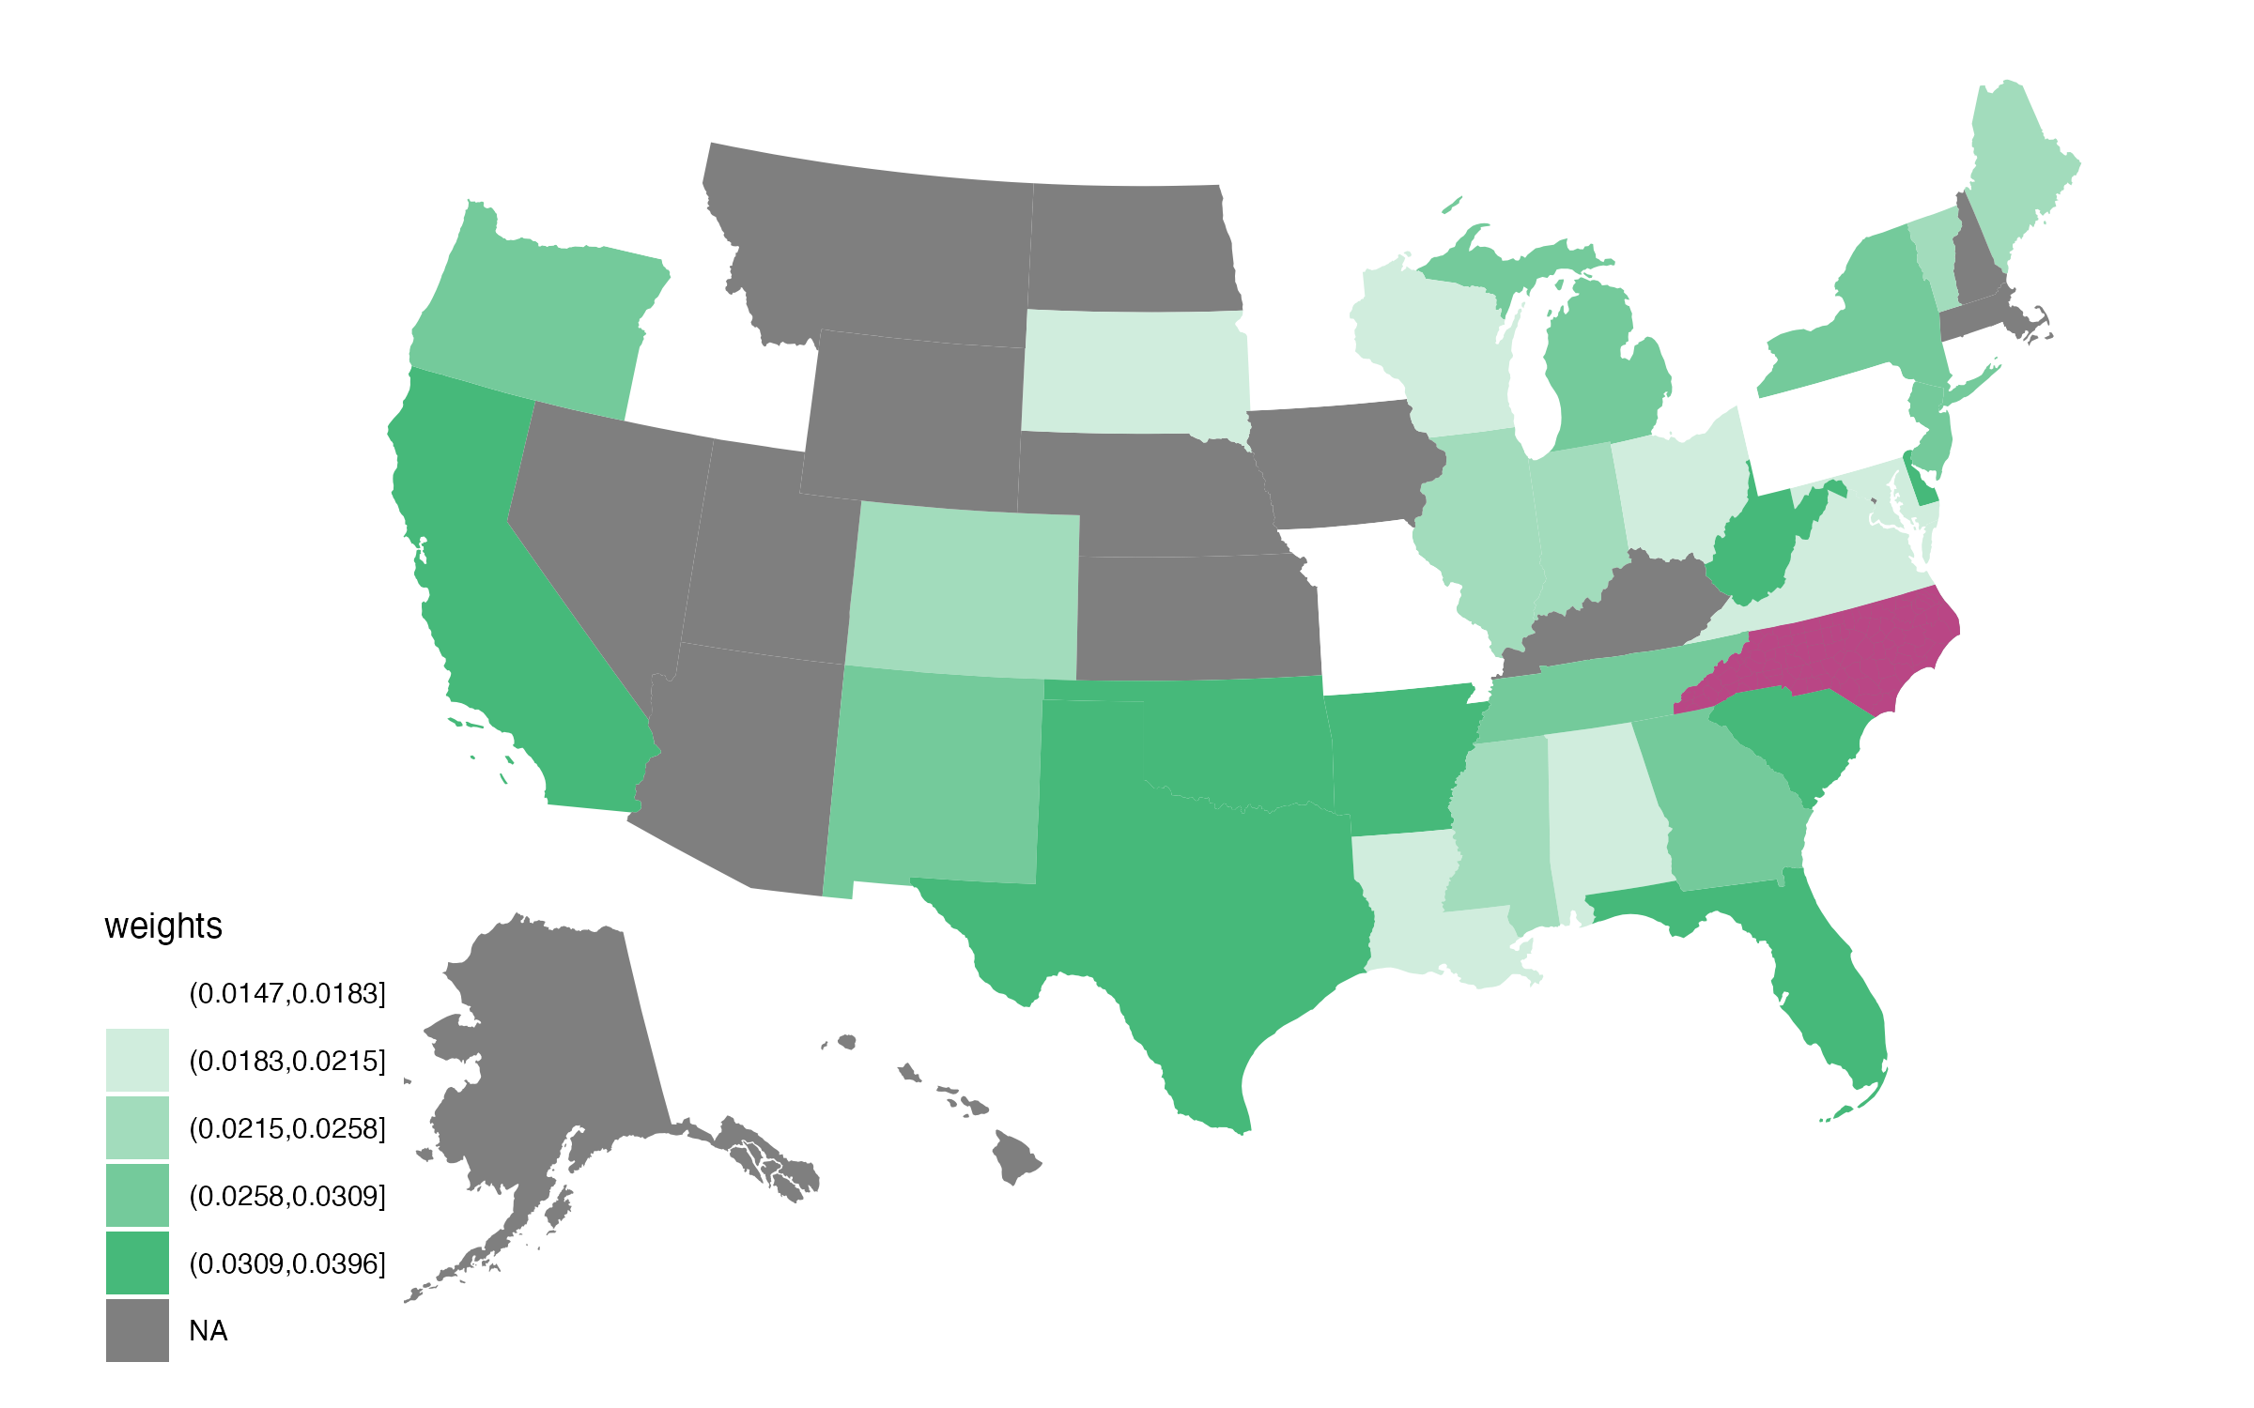
(a) Control Unit Weights: North Carolina (b) Control Unit Weights: North Carolina

and Kentucky
Only
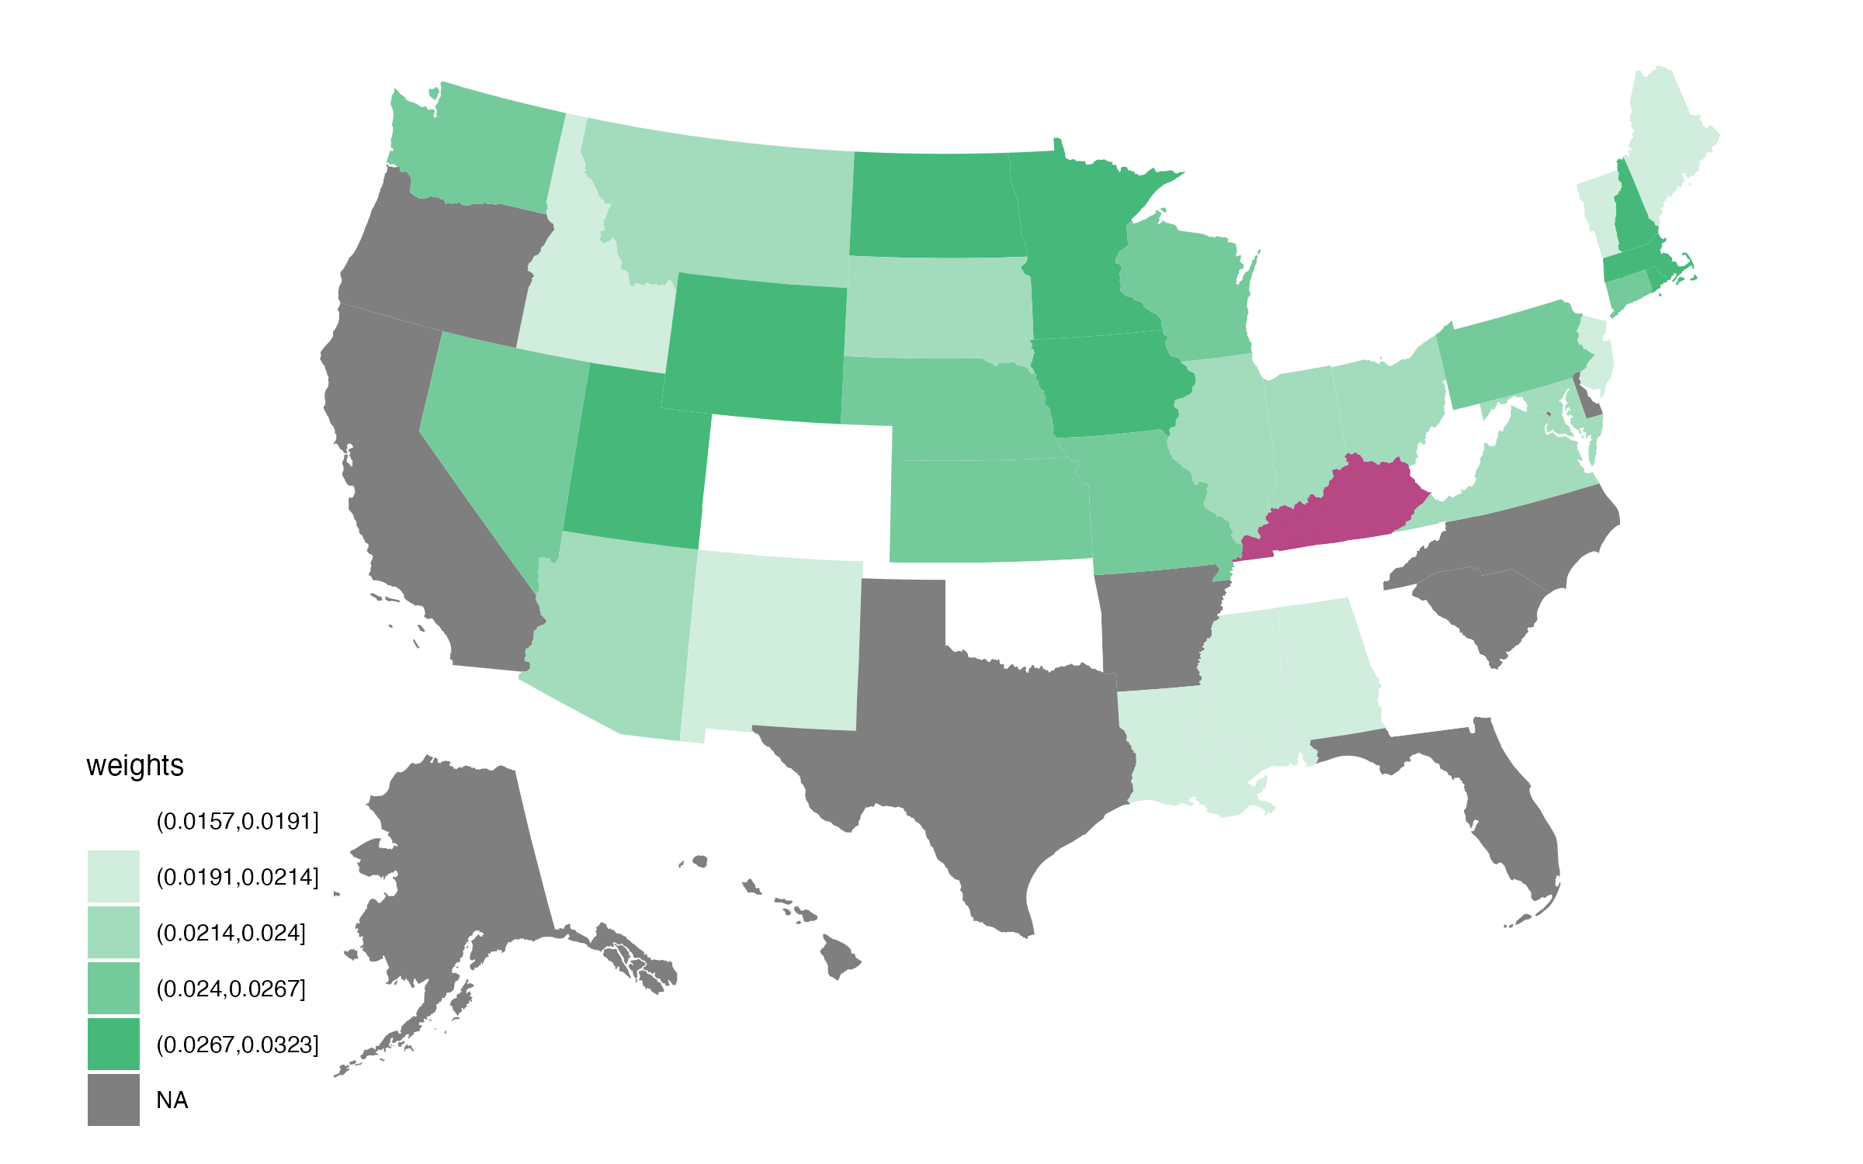
(c) Control Unit Weights: Kentucky Only

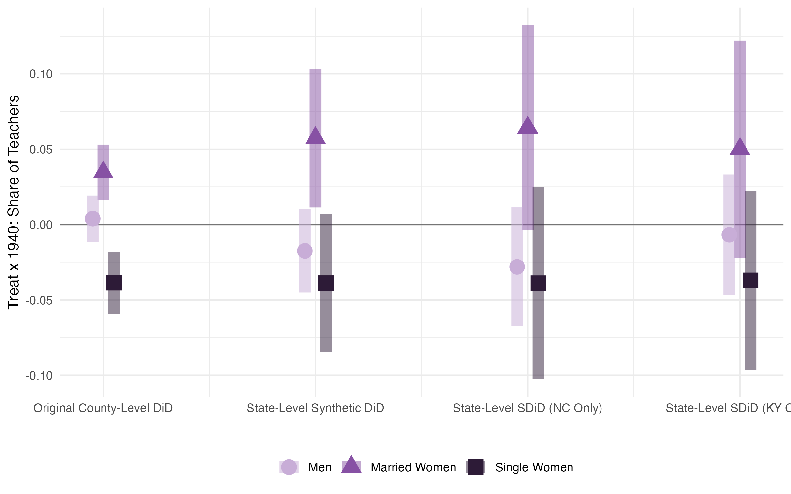
Figure D2: Estimates of the effect of the prohibition of marriage bars in teaching on the gender composition of teachers. The first column uses the standard difference-in-differences setup from our main specification at the county level, with standard errors clustered at the county level. The other columns use state-level synthetic difference-in-differences, with standard errors computed using a ‘placebo’ method. The second column includes both KY and NC as treated units, while the third and fourth only include NC and KY respectively. 95% confidence intervals are shown.

Table D1: State-Level Synthetic DiD: Estimated effects of the prohibitions on women’s propensity to get married and either teach, work outside of teaching, and exit the labor force.

Dependent Variable: Pr(Married in t)

Pr(Married Teacher in t)
Pr(Married
Non-Teacher in LF in
t)

Pr(Married Not in LF in t)

(1) (2) (3) (4)

Sample 1: Women who were unmarried and teaching in t − 10

1940
 | Treated × 1940 (γ^{DD} ) | −0.033  (0.035) | 0.036∗∗∗  (0.013) | −0.003  (0.006) |  | −0.082∗∗  (0.038)
 | Dep. Var. 1930 Mean | 0.5857 | 0.0452 | 0.0350 |  | 0.5056
Sample 2: Women who were married and not in the labor force in t − 10
 | Treated × 1940 (γ^{DD} ) | −0.003 | 0.0007 | 0.009 |  | −0.013
 |  | (0.002) | (0.0005) | (0.009) |  | (0.009)
 | Dep. Var. 1930 Mean | 0.9328 | 0.0018 | 0.0549 |  | 0.8761
Sample 3: Women who were unmarried and not in the labor force in t − 10
 | Treated × 1940 (γ^{DD} ) | −0.024 | 0.002∗∗ | 0.011∗∗∗ |  | −0.038∗
 |  | (0.017) | (0.0008) | (0.004) |  | (0.021)
 | Dep. Var. 1930 Mean | 0.5072 | 0.0044 | 0.0437 |  | 0.4590

1940

1940

Notes: Estimation follows Equation (1). Construction of these state-level linked samples follows the construction of individual-level linked sam-ples, but aggregated to the state level and weighted according to the procedure outlined above. Sample 1 contains linked women who were under 40, unmarried, and teaching in 1910, 1920, and 1930, Sample 2 contains linked women who were aged 18-50, married, and not in the labor force in 1910, 1920, and 1930, and Sample 3 contains linked women who were aged 8-40, unmarried, and not in the labor force in 1910, 1920, and 1930. All regressions use the 1910-1920, 1920-1930, and 1930-1940 linked full-count Census samples. Standard errors are computed using a ‘placebo’ method. See Section 3 for details and full citations for data.

Linkage Rates
This appendix describes the linkage rates between consecutive censuses and discusses poten-tial concerns about the bias that the linking process may introduce to the results.

Linkage rates. Supplemental Table B1 shows linkage rates for various populations across censuses. While linkage rates are largely similar over time and between treated and control states, there are two differences of note. First, linkage rates are higher in all years for married women versus unmarried women (65.8% versus 53.9% in 1920) and for white women versus Black women (62.0% versus 32.1% in 1920). These differences are known in the literature, in part due to the Census Tree links coming from a free genealogical website (Buckles et al. (2023)), and persist over time. As a result, women who get married or move between decennial Censuses are less likely to appear in our linked samples, which may attenuate our estimated effects of the prohibitions on unmarried women teachers towards zero.
Second, linkage rates increase over time for married women but remain stable for un-married women. One potential explanation for these trends could be that reports on the FamilySearch website are more frequent in more recent years, driven by descendants of mar-ried women. However, given that linkage rates rise similarly in both treated and control states, we are not concerned that the differential trends bias our results.

Bias due to linkage loss. Linkage loss could introduce bias to our results if linkage rates differed by women’s treatment status, marital status, or employment status. We find similar linkage rates between treated and control states, so the first case is not a concern. However, the second and third cases may both be at play. On one hand, because single women who get married between censuses are less likely to be linked, single women who get married are underrepresented in our linked samples. As a result, using the linked data, our estimated effects of the prohibitions on the likelihood that a woman in t − 10 is married in t are attenuated towards zero. On the other hand, single women who stop working because they got married between censuses are also underrepresented in our linked samples. As a result, using the linked data, our estimated effects of the prohibitions on the likelihood that a woman in t − 10 is working in t are upward biased.

It is difficult to bound these biases, as doing so would require estimating the number of single women who get married whom we are unable to link, which is inherently unobserved. However, what we can say is that our main estimate of interest in our linked analyses—that is, the effect of the prohibitions on the likelihood that women in t − 10 become married women teachers in t—is ambiguously biased due to linkage loss, given it is subject to two sources of bias that go in opposite directions and could even negate each other.

References
Arkhangelsky, D., Athey, S., Hirshberg, D. A., Imbens, G. W. & Wager, S. (2021), ‘Synthetic difference-in-differences’, American Economic Review 111(12), 4088–4118.
URL: https://www.aeaweb.org/articles?id=10.1257/aer.20190159

Buckles, K., Haws, A., Price, J. & Wilbert, H. (2023), Breakthroughs in historical record linking using genealogy data: The census tree project, Working Paper 31671, National Bureau of Economic Research.
Fischer, A. & Roodman, D. (2021), ‘fwildclusterboot: Fast wild cluster bootstrap inference for linear regression models (version 0.14.3)’.
URL: https://cran.r-project.org/package=fwildclusterboot

Fishback, P. V., Horrace, W. C. & Kantor, S. (2005), ‘Did new deal grant programs stimulate local economies? a study of federal grants and retail sales during the great depression’, The Journal of Economic History 65(1), 36–71.
Price, J., Buckles, K., Haws, A. & Wilbert, H. (2023a), The census tree, 1910-1920, Technical report, Ann Arbor, MI: Inter-university Consortium for Political and Social Research [distributor].
Price, J., Buckles, K., Haws, A. & Wilbert, H. (2023b), The census tree, 1920-1930, Technical report, Ann Arbor, MI: Inter-university Consortium for Political and Social Research [distributor].
Price, J., Buckles, K., Haws, A. & Wilbert, H. (2023c), The census tree, 1930-1940, Technical report, Ann Arbor, MI: Inter-university Consortium for Political and Social Research [distributor].
Ruggles, S., Nelson, M. A., Sobek, M., Fitch, C. A., Goeken, R., Hacker, J. D., Roberts,
E. & Warren, J. R. (2024), IPUMS Ancestry Full Count Data: Version 4.0, Dataset, Minneapolis, MN: IPUMS.

