**Amy McVicar**

**659 Data Administration Concepts and Database Management**

**Fall 2019 - Thursday 9 PM EDT**

**Project Deliverable**

**Dog Project**

Contents

Part 1: Design 2

Summary 2

Business Case 2

Stakeholders 2

High-Level Rules 3

Expectations 3

Source Data Samples 3

Entity Relationship Diagram 4

Data Dictionary 4

Part 2: Implementation 10

Logical Model 10

SQL DDL 11

SQL DML 19

Answers to Data Questions 20

GUI Prototype 22

Reflection 25

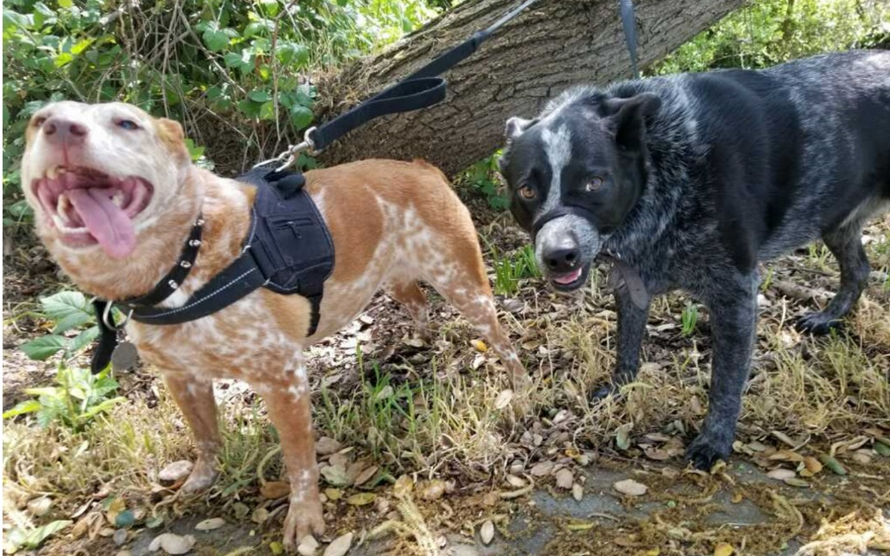

# **Part 1: Design**

## **Summary**

The following document describes a database created to support any organization focused on helping canines in need. Organizations do not need to be nonprofit and can start with a for-profit model to assist getting off the ground with fewer requirements. Organizations may also help and interact with other organizations in a multitude of ways. This document outlines a database designed to assist with a variety of scenarios an organization supporting canine rescue and assistance may find itself.

## **Business Case**

There are many types of organizations that strive to assist canines in need. They can range from profit to non-profit, to those that directly support or those that support other organizations indirectly. They all need data management and guidance. This document will outline a database for any scenario and will be offered for free.

The data and database should answer five data questions to ensure successful adoption by and support for an organization.

1. **What dogs are in the database, and what are their statuses?**
2. **How much money was taken in a period?**
3. **How much money was spent in a period?**
4. **What are the details and sources of money?**
5. **What are the details and sources of the costs?**

## **Stakeholders**

The high-level stakeholders are people, organizations, and (most importantly) canines.

* + - Canines
    - People
      * 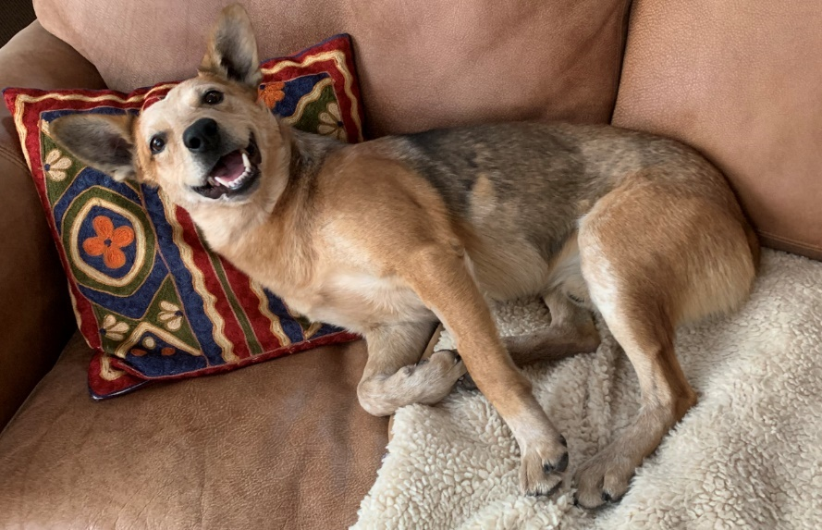Donors
      * Sponsors
      * Customers
      * Vendors
      * Partners
      * Employees
      * Volunteers
      * Adopters
    - Organizations
      * Rescues
      * Shelters
      * Vendors
      * Partners

## **High-Level Rules**

**People & Organizations**

* A contact or an organization can own a dog.
* Contacts and organizations can be associated with multiple dogs.

**Dogs**

* Dogs are not one-time clients but can have multiple status changes.
* A dog can be owned by contact or by an organization.
* A dog can be directly associated with costs or income (in the case it is sponsored, for example).

**Money**

* Costs can be associated with one dog, but if associated with more than one dog, it will not be assigned to dogs.
* Income can be a donation that would have nothing due, a sponsorship which would only have estimated due within cancellation policy and contractually obligated amounts owing.

**Events**

* Events may have registrants or may be non-registered events.
* Events may be online, offline or other fund-raising efforts

**Products**

* The product table is a simple inventory tool. A future phase may add functionality.

## **Expectations**

The result will be a data model that can assist data capture, management, and web support for any organization that needs to start collecting data and helping dogs regardless of the business model.

## **Source Data Samples**

|  |  |  |  |  |  |  |  |
| --- | --- | --- | --- | --- | --- | --- | --- |
| **Current Name** | **Original Name** | **Breed** | **Color** | **Sex** | **Age Estimated** | **Birthdate** | **Status** |
| Dixie | Unknown | StumpyX | Orange | Female | Y | Jun-13 | Adopted |
| Cody | Cody | StumpyX | Merle | Male | Y | Nov-14 | Adopted |
| Fennec | Unknown | ACD Mis | Beige | Male | Y | Jan-19 | Foster |

|  |  |  |  |  |
| --- | --- | --- | --- | --- |
| **First Name** | **Last Name** | **Email** | **Phone** | **Type** |
| Gary | Schoonover | [doofusdogs@nodomain.xyz](mailto:doofusdogs@nodomain.xyz) | 415-497-6382 | Volunteer |

|  |  |  |  |  |  |
| --- | --- | --- | --- | --- | --- |
| **Product** | **Size** | **Description** | **Color** | **Cost** | **List Price** |
| Dog Jacket | 30-40 lbs | Jacket for 30-40 lbs Dog | Multi | 10 | 15 |
| Canvas Shopping Bag | Medium | Canvas Shopping Bag | Cream | 5 | 30 |

## **Entity Relationship Diagram**

## **Data Dictionary**

| **Entity** | **Attribute** | **Type** | **Properties** |
| --- | --- | --- | --- |
| Organizations | Org_ID | int identity | PK |
| Organizations | Org_Name | varchar(100) | Required, Unique |
| Organizations | Org_Address_1 | varchar(100) |  |
| Organizations | Org_Address_2 | varchar(100) |  |
| Organizations | Org_City | varchar(100) |  |
| Organizations | Org_State | varchar(100) | State or Provence |
| Organizations | Org_Postal | varchar(50) |  |
| Organizations | Org_Country_ID | int | Required, FK |
| Organizations | Org_Phone | varchar(50) |  |
| Organizations | Org_URL | varchar(100) |  |
| Organizations | Contact_Org_Status_ID | char(20) | Required, Active or Inactive (Unknown is Active) |
| Organizations | Org_Type_ID | int | FK |
| Organization_Type | Org_Type_ID | int identity | PK |
| Organization_Type | Org_Type_Value | char(20) | Required, Unique Values: Vendor Rescue Shelter Profit Partner |
| Countries | Country_ID | int identity | PK |
| Countries | Country_ISO_Code | char(2) | 2 char iso country code standard |
| Countries | Country_Name | char(200) | country name (iso code standard) |
| Contacts | Contact_ID | int identity | PK |
| Contacts | First_Name | varchar(50) |  |
| Contacts | Middle_Name | varchar(50) |  |
| Contacts | Last_Name | varchar(50) |  |
| Contacts | Contact_Org_ID | int | Required, FK, defines if contact is personal or linked to an organization |
| Contacts | Phone | varchar(50) |  |
| Contacts | Email | varchar(100) | Required, Unique |
| Contacts | Email_Opt_In | char(1) | Y, N, Null |
| Contacts | Address_1 | varchar(100) |  |
| Contacts | Address_2 | varchar(100) |  |
| Contacts | City | varchar(100) |  |
| Contacts | State | varchar(100) |  |
| Contacts | Postal | varchar(50) |  |
| Contacts | Country_ID | int | Required, FK |
| Contacts | Contact_Org_Status_ID | int | Required, Default '1' for Active |
| Contacts | Org_ID | int | FK |
| Contact_Organization | Contact_Org_ID | int identity | PK |
| Contact_Organization | Contact_Org_Value | char(50) | Values:  Organization Personal |
| Contact_Sub_Type_Values | Contact_Sub_Type_Value_ID | int identity | PK |
| Contact_Sub_Type_Values | Contact_Sub_Type_Value | char(50) | Values:  Organization - Partner Organization - Vendor Personal - Donor Personal - Employee Personal - Volunteer Personal - Foster Personal - Adopter Personal - Other |
| Contact_Sub_Type | Contact_Sub_Type_ID | int identity | PK |
| Contact_Sub_Type | Contact_ID | int | FK |
| Contact_Sub_Type | Contact_Sub_Type_Value_ID | int | FK |
| Contact_Sub_Type | Contact_Type_Date | datetime | Date entered. Default to current, |
| Contact_Org_Status | Contact_Org_Status_ID | int identity | PK |
| Contact_Org_Status | Contact_Org_Status_Value | char(50) | Values: Active Inactive - Deceased Inactive - Out of Business Inactive - Other Inactive - Bad Contact Data |
| Canines | Canine_ID | int identity | PK |
| Canines | Current_Name | varchar(50) | Current Name |
| Canines | Original_Name | varchar(50) | If known previous name |
| Canines | Age_Estimated | char(1) | Y/N |
| Canines | Birthdate | date | YYYY-MM-DD |
| Canines | Breed | varchar(50) | Text Field, usually the best guess |
| Canines | Description | varchar(255) |  |
| Canines | Canine_Location_Type_ID | int | Required, FK |
| Canines | Canine_Status_ID | in | Required, FK |
| Canines | Contact_Org_ID | int | Required, FK |
| Canines | Owner_Org_ID | int | FK |
| Canines | Owner_Contact_ID | int | FK |
| Canines | Owner_Org_Identifier | char(100) | If Owner Organization has ID# for dog |
| Canines | Create_Date | DateTime | Required, Default to current |
| Canine_Location_Type | Canine_Location_Type_ID | int identity | PK |
| Canine_Location_Type | Canine_Location_Type_Value | char(20) | Values: Shelter Fostered Foster Hospice Home Rescue |
| Canine_Status | Canine_Status_ID | ind identity | PK |
| Canine_Status | Canine_Status_Value | char(20) | Values: Urgent Need Need Fostered Sponsored Adopted Lost Found Reunited Deceased |
| Income | Income_ID | int identity | PK |
| Income | Contact_Org_ID | varchar(50) | FK, Defines if the record is associated thru a contact record or directly to an organization |
| Income | Org_ID | varchar(50) | FK |
| Income | Contact_ID | varchar(50) | FK |
| Income | Amount_Due | decimal (10,2) |  |
| Income | Amount_Paid | decimal (10,2) | Required |
| Income | Due_Date | date |  |
| Income | Paid_Date | date |  |
| Income | Payment_Type_ID | int | FK |
| Income | Payment_Description | varchar(255) |  |
| Income | Event_ID | int | FK |
| Income | Canine_ID | int | FK |
| Payment_Type | Payment_Type_ID | int identity | PK |
| Payment_Type | Payment_Type_Value | char(20) | Values: Adoption Fee Sponsorship Donation Customer Credit Adjustment Other |
| Costs | Cost_ID | int identity | PK |
| Costs | Contact_Org_ID | int | FK |
| Costs | Org_ID | int | FK |
| Costs | Contact_ID | int | FK |
| Costs | Cost_Type_ID | int | FK |
| Costs | Cost_Description | varchar(255) |  |
| Costs | PO | varchar(50) |  |
| Costs | Amount_Due | decimal (10,2) | Required |
| Costs | Amount_Paid | decimal (10,2) |  |
| Costs | Due_Date | date | YYYY-MM-DD |
| Costs | Paid_Date | date | YYYY-MM-DD |
| Costs | Paid_By_Contact_ID | int | FK |
| Costs | Event_ID | int | FK |
| Costs | Canine_ID | int | FK |
| Cost_Type | Cost_Type_ID | int identity | PK |
| Cost_Type | Cost_Type_Value | char(50) | Values (vary by org): Payroll Supplies Veterinarian Taxes Services Other |
| Products | Products_ID | int identity | PK |
| Products | Product_Name | varchar(100) |  |
| Products | Product_Type_ID | int | FK |
| Products | Product_Description | varchar(255) |  |
| Products | Product_Cost | decimal (10,2) |  |
| Products | Sale_Price | decimal (10,2) |  |
| Products | Inventory_Quantity | int |  |
| Products | Product_Graphic_ID | int |  |
| Products | Product_Status | char(20) | Required: Active or Inactive (Default to Active) |
| Product_Type | Product_Type_ID | int identity |  |
| Product_Type | Product_Type_Value | char(100) | Unique, Required. Values vary by Org. Values: Collar Leash Food Mat Dog Bed Padding Dog Bed Cover Travel Water Bowl Hiking Water Dispenser |
| Events | Event_ID | int identity | PK |
| Events | Event_Name | varchar(100) | Required |
| Events | Location | varchar(50) | Required |
| Events | Event_Start_Date | datetime | Required |
| Events | Event_End_Date | datetime |  |
| Events | Event_Type_ID | int |  |
| Events | Description | varchar(255) |  |
| Event_Type | Event_Type_ID | int identity |  |
| Event_Type | Event_Type_Value | char(100) | Unique, Required. Values vary by Org. Values: Adoption Auction Awareness Donation Drive Sales Other |

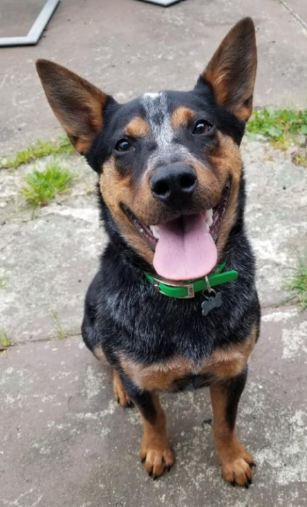

# **Part 2: Implementation**

## **Logical Model**

## SQL DDL

/*

SQL DDL Statements for Dog Project

Author: Amy McVicar

December 2019

IST659 Database Project

*/

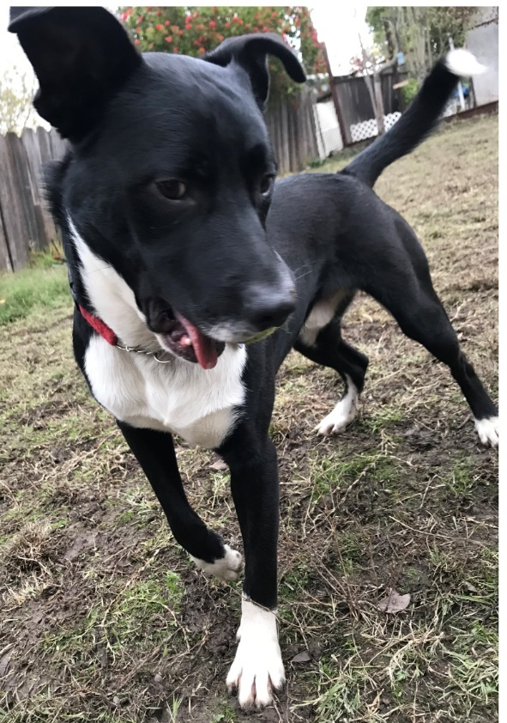

/*

Drop Tables

Create Tables

*/

DROP TABLE IF EXISTS Income;

DROP TABLE IF EXISTS Costs;

DROP TABLE IF EXISTS Canines;

DROP TABLE IF EXISTS Contacts;

DROP TABLE IF EXISTS Organizations;

DROP TABLE IF EXISTS Fun_Events;

DROP TABLE IF EXISTS Products;

DROP TABLE IF EXISTS Contact_Organization;

DROP TABLE IF EXISTS Organization_Type;

DROP TABLE IF EXISTS Event_Type;

DROP TABLE IF EXISTS Countries;

DROP TABLE IF EXISTS Contact_Sub_Type_Value;

DROP TABLE IF EXISTS Contact_Sub_Type;

DROP TABLE IF EXISTS Contact_Org_Status;

DROP TABLE IF EXISTS Canine_Location_Type;

DROP TABLE IF EXISTS Canine_Status;

DROP TABLE IF EXISTS Cost_Type;

DROP TABLE IF EXISTS Payment_Type;

DROP TABLE IF EXISTS Product_Type;

---------------------------------------------

---------------------------------------------

-- Create Table Organization_Type

CREATE TABLE Organization_Type (

-- Columns for the Organization_Type table

Org_Type_ID int identity,

Org_Type_Value char(20) not null,

-- Constraints on the Organization_Type Table

CONSTRAINT PK_Organization_Type PRIMARY KEY (Org_Type_ID),

CONSTRAINT U1_Organization_Type UNIQUE (Org_Type_Value)

)

-- End Creating the Organization_Type table

---------------------------------------------

-- Create Table Event_Type

CREATE TABLE Event_Type (

-- Columns for the Event_Type table

Event_Type_ID int identity,

Event_Type_Value char(100) NOT NULL,

-- Constraints on the Event_Type Table

CONSTRAINT PK_Event_Type PRIMARY KEY (Event_Type_ID),

CONSTRAINT U1_Event_Type UNIQUE (Event_Type_Value)

)

-- End Creating the Event_Type table

---------------------------------------------

-- Create Table Countries

CREATE TABLE Countries (

-- Columns for the Countries table

Country_ID int identity,

Country_ISO_Code char(2) not null,

Country_Name char(200) not null,

-- Constraints on the Countries Table

CONSTRAINT PK_Countries PRIMARY KEY (Country_ID),

CONSTRAINT U1_Countries UNIQUE (Country_ISO_Code),

CONSTRAINT U2_Countries UNIQUE (Country_Name)

)

-- End Creating the Countries table

---------------------------------------------

-- Create Table Contact_Sub_Type_Value

CREATE TABLE Contact_Sub_Type_Value (

-- Columns for the Contact_Sub_Type_Value table

Contact_Sub_Type_Value_ID int identity,

Contact_Sub_Type_Value char(50),

-- Constraints on the Contact_Sub_Type_Valuee Table

CONSTRAINT PK_Contact_Sub_Type_Value PRIMARY KEY (Contact_Sub_Type_Value_ID),

CONSTRAINT U1_Contact_Sub_Type_Value UNIQUE (Contact_Sub_Type_Value)

)

-- End Creating the Contact_Sub_Type_Value table

---------------------------------------------

-- Create Table Contact_Sub_Type

CREATE TABLE Contact_Sub_Type (

-- Columns for Contact_Sub_Type table

Contact_Sub_Type_ID int identity,

Contact_ID int NOT NULL,

Contact_Sub_Typ_Value_ID int NOT NULL,

Contact_Type_Date datetime DEFAULT CURRENT_TIMESTAMP,

-- Constraints on the Contact_Sub_Type Table

CONSTRAINT PK_Contact_Sub_Type PRIMARY KEY (Contact_Sub_Type_ID),

)

-- End Creating the Contact_Sub_Type table

---------------------------------------------

-- Create Table Contact_Org_Status

CREATE TABLE Contact_Org_Status (

-- Columns for the Contact_Status table

Contact_Org_Status_ID int identity,

Contact_Org_Status_Value char(50) NOT NULL,

-- Constraints on the Organization_Type Table

CONSTRAINT PK_CContact_Org_Status PRIMARY KEY (Contact_Org_Status_ID),

CONSTRAINT U1_Contact_Org_Status UNIQUE (Contact_Org_Status_Value)

)

-- End Creating the Contact_Status table

---------------------------------------------

-- Create Table Canine_Location_Type

CREATE TABLE Canine_Location_Type (

-- Columns for the Canine_Location_Type table

Canine_Location_Type_ID int identity,

Canine_Location_Type_Value char(20) NOT NULL,

-- Constraints on the Canine_Location_Type Table

CONSTRAINT PK_Canine_Location_Type PRIMARY KEY (Canine_Location_Type_ID),

CONSTRAINT U1_Canine_Location_Type UNIQUE (Canine_Location_Type_Value)

)

-- End Creating the Canine_Location_Type table

---------------------------------------------

-- Create Table Canine_Status

CREATE TABLE Canine_Status (

-- Columns for the Canine_Status table

Canine_Status_ID int identity,

Canine_Status_Value char(20) NOT NULL,

-- Constraints on the Canine_Status Table

CONSTRAINT PK_Canine_Status PRIMARY KEY (Canine_Status_ID),

CONSTRAINT U1_Canine_Status UNIQUE (Canine_Status_Value)

)

-- End Creating the Canine_Status table

---------------------------------------------

-- Create Table Payment_Type

CREATE TABLE Payment_Type (

-- Columns for the Payment_Type table

Payment_Type_ID int identity,

Payment_Type_Value char(20) NOT NULL,

-- Constraints on the Payment_Type Table

CONSTRAINT PK_Payment_Type PRIMARY KEY (Payment_Type_ID),

CONSTRAINT U1_Payment_Type UNIQUE (Payment_Type_Value)

)

-- End Creating the Payment_Type table

---------------------------------------------

-- Create Table Cost_Type

CREATE TABLE Cost_Type (

-- Columns for the Cost_Type table

Cost_Type_ID int identity,

Cost_Type_Value char(20) NOT NULL,

-- Constraints on the Cost_Type Table

CONSTRAINT PK_Cost_Type PRIMARY KEY (Cost_Type_ID),

CONSTRAINT U1_Cost_Type UNIQUE (Cost_Type_Value)

)

-- End Creating the Cost_Type table

---------------------------------------------

-- Create Table Product_Type

CREATE TABLE Product_Type (

-- Columns for the Product_Type table

Product_Type_ID int identity,

Product_Type_Value char(100) NOT NULL,

-- Constraints on the Product_Type Table

CONSTRAINT PK_Product_Type PRIMARY KEY (Product_Type_ID),

CONSTRAINT U1_Product_Type UNIQUE (Product_Type_Value)

)

-- End Creating the Product_Type table

-- Create Table Contact_Organization

CREATE TABLE Contact_Organization (

-- Columns for the Contact_Organization table

Contact_Org_ID int identity,

Contact_Org_Value char(50) not null,

-- Constraints on the Contact_Organization Table

CONSTRAINT PK_Contact_Organization PRIMARY KEY (Contact_Org_ID),

CONSTRAINT U1_Contact_Organization UNIQUE (Contact_Org_Value)

)

-- End Creating the Contact_Organization table

---------------------------------------------

-- Create Fun_Events Table

CREATE TABLE Fun_Events (

-- Columns for the Fun_Events table

Event_ID int identity,

Event_Name varchar(100) NOT NULL,

Location varchar(50) NOT NULL,

Event_Start_Date date NOT NUll,

Event_End_Date date,

Event_Type_ID int,

Description varchar(255),

-- Constraints on the Fun_Events Table

CONSTRAINT PK_Fun_Events PRIMARY KEY (Event_ID),

CONSTRAINT F1_Fun_Events FOREIGN KEY (Event_Type_ID) REFERENCES Event_Type(Event_Type_ID)

)

-- End Creating the Fun_Events table

---------------------------------------------

-- Create Products Table

CREATE TABLE Products (

-- Columns for the Products table

Product_ID int identity,

Product_Name varchar(100),

Product_Type int,

Product_Description varchar(255),

Product_Cost decimal(10,2),

Sale_Price decimal(10,2),

Inventory_Quantity int,

Product_Graphic_ID int,

Product_Status char(20) DEFAULT 'Active',

-- Constraints on the Products Table

CONSTRAINT PK_Products PRIMARY KEY (Product_ID)

)

-- End Creating the Products table

-- Create Table Organizations

CREATE TABLE Organizations (

-- Columns for the User table

Org_ID int identity,

Org_Name varchar(100) not null,

Org_Address_1 varchar(100),

Org_Address_2 varchar(100),

Org_City varchar(100),

Org_State varchar(100),

Org_Postal varchar(50),

Org_Country_ID int,

Org_Phone varchar(50),

Org_URL varchar(100),

Contact_Org_Status_ID int DEFAULT 1,

Org_Type_ID int,

-- Constraints on the Organizations Table

CONSTRAINT PK_Organizations PRIMARY KEY (Org_ID),

CONSTRAINT U1_Organizations UNIQUE (Org_Name),

CONSTRAINT FK1_Organizations FOREIGN KEY (Org_Type_ID) REFERENCES Organization_Type(Org_Type_ID),

CONSTRAINT FK2_Organizations FOREIGN KEY (Contact_Org_Status_ID) REFERENCES Contact_Org_Status(Contact_Org_Status_ID)

)

-- End Creating the Organizations table

--------------------------------------------

---------------------------------------------

-- Create Table Contacts

CREATE TABLE Contacts (

-- Columns for the Contacts table

Contact_ID int identity,

First_Name varchar(50),

Middle_Name varchar(50),

Last_Name varchar(50),

Contact_Org_ID int,

Phone varchar(50),

Email varchar(100) not null,

Email_Opt_In char(1),

Address_1 varchar(100),

Address_2 varchar(100),

City varchar(100),

Postal varchar(50),

[State] varchar(100),

Country_ID int,

Contact_Org_Status_ID int DEFAULT 1,

Org_ID int,

-- Constraints on the Contacts Table

CONSTRAINT PK_Contacts PRIMARY KEY (Contact_ID),

CONSTRAINT U1_Contacts UNIQUE (Email),

CONSTRAINT FK1_Contacts FOREIGN KEY (Contact_Org_ID) REFERENCES Contact_Organization(Contact_Org_ID),

CONSTRAINT FK2_Contacts FOREIGN KEY (Country_ID) REFERENCES Countries(Country_ID),

CONSTRAINT FK3_Contacts FOREIGN KEY (Org_ID) REFERENCES Organizations(Org_ID),

CONSTRAINT FK4_Contacts FOREIGN KEY (Contact_Org_Status_ID) REFERENCES Contact_Org_Status(Contact_Org_Status_ID)

)

-- End Creating the Contacts table

---------------------------------------------

-- Create Table Canines

CREATE TABLE Canines (

-- Columns for the Canines table

Canine_ID int identity,

Current_Name varchar(50) NOT NULL,

Original_Name varchar(50),

Age_Estimated char(1),

Birthdate date,

Breed varchar(50),

Description varchar(255),

Canine_Location_Type_ID int NOT NULL,

Canine_Status_ID int NOT NULL,

Contact_Org_ID int NOT NULL,

Owner_Org_ID int,

Owner_Contact_ID int,

Owner_Organization_Identifier char(100),

Create_Date datetime,

-- Constraints on the Canines Table

CONSTRAINT PK_Canines PRIMARY KEY (Canine_ID),

CONSTRAINT F1_Canines FOREIGN KEY (Canine_Location_Type_ID) REFERENCES Canine_Location_Type(Canine_Location_Type_ID),

CONSTRAINT F2_Canines FOREIGN KEY (Canine_Status_ID) REFERENCES Canine_Status(Canine_Status_ID),

CONSTRAINT F3_Canines FOREIGN KEY (Contact_Org_ID) REFERENCES Contact_Organization(Contact_Org_ID),

CONSTRAINT F4_Canines FOREIGN KEY (Owner_Org_ID) REFERENCES Organizations(Org_ID),

CONSTRAINT F5_Canines FOREIGN KEY (Owner_Contact_ID) REFERENCES Contacts(Contact_ID)

)

-- End Creating the Canines table

---------------------------------------------

---------------------------------------------

-- Create Table Income

CREATE TABLE Income (

-- Columns for the Income table

Income_ID int identity,

Contact_Org_ID int,

Org_ID int,

Contact_ID int,

Amount_Due decimal(10,2),

Amount_Paid decimal(10,2) NOT NULL,

Due_Date date,

Paid_Date date NOT NULL,

Payment_Type_ID int,

Payment_Description varchar(255),

Event_ID int,

Canine_ID int,

-- Constraints on the Income table

CONSTRAINT PK_Income PRIMARY KEY (Income_ID),

CONSTRAINT F1_Income FOREIGN KEY (Contact_Org_ID) REFERENCES Contact_Organization(Contact_Org_ID),

CONSTRAINT F2_Income FOREIGN KEY (Org_ID) REFERENCES Organizations(Org_ID),

CONSTRAINT F3_Income FOREIGN KEY (Contact_ID) REFERENCES Contacts(Contact_ID),

CONSTRAINT F4_Income FOREIGN KEY (Payment_Type_ID) REFERENCES Payment_Type(Payment_Type_ID),

CONSTRAINT F5_Income FOREIGN KEY (Event_ID) REFERENCES Fun_Events(Event_ID),

CONSTRAINT F6_Income FOREIGN KEY (Canine_ID) REFERENCES Canines(Canine_ID)

)

-- End Creating the Income table

---------------------------------------------

-- Create Table Costs

CREATE TABLE Costs (

-- Columns for the Costs table

Cost_ID int identity,

Contact_Org_ID int,

Org_ID int,

Contact_ID int,

Cost_Type_ID int,

Cost_Description varchar(255),

PO varchar(50),

Amount_Due decimal(10,2) NOT NULL,

Due_Date date NOT NULL,

Paid_Date date,

Paid_By_Contact_ID int,

Event_ID int,

Canine_ID int

-- Constraints on the Costs Table

CONSTRAINT PK_Costs PRIMARY KEY (Cost_ID),

CONSTRAINT F1_Costs FOREIGN KEY (Contact_Org_ID) REFERENCES Contact_Organization(Contact_Org_ID),

CONSTRAINT F2_Costs FOREIGN KEY (Org_ID) REFERENCES Organizations(Org_ID),

CONSTRAINT F3_Costs FOREIGN KEY (Contact_ID) REFERENCES Contacts(Contact_ID),

CONSTRAINT F4_Costs FOREIGN KEY (Cost_Type_ID) REFERENCES Cost_Type(Cost_Type_ID),

CONSTRAINT F5_Costs FOREIGN KEY (Paid_By_Contact_ID) REFERENCES Contacts(Contact_ID),

CONSTRAINT F6_Costs FOREIGN KEY (Event_ID) REFERENCES [Fun_Events](Event_ID),

CONSTRAINT F7_Costs FOREIGN KEY (Canine_ID) REFERENCES Canines(Canine_ID)

)

-- End Creating the Costs table

## SQL DML

/*

SQL DML Statements for Dog Project

Author: Amy McVicar

December 2019

IST659 Database Project

*/

/*

Load Sample Data into each of tables

Begin with the 'Type' and 'Value' tables created to manage data quality

*/

----TYPE TABLES----

-- Insert Into Organization_Type

INSERT INTO Organization_Type([Org_Type_Value]) VALUES('Vendor');

INSERT INTO Organization_Type([Org_Type_Value]) VALUES('Rescue');

INSERT INTO Organization_Type([Org_Type_Value]) VALUES('Shelter');

INSERT INTO Organization_Type([Org_Type_Value]) VALUES('Profit');

INSERT INTO Organization_Type([Org_Type_Value]) VALUES('Partner');

-- Insert Into Event_Type

INSERT INTO Event_Type([Event_Type_Value]) VALUES('Adoption');

INSERT INTO Event_Type([Event_Type_Value]) VALUES('Auction');

INSERT INTO Event_Type([Event_Type_Value]) VALUES('Awareness');

INSERT INTO Event_Type([Event_Type_Value]) VALUES('Donation Drive');

INSERT INTO Event_Type([Event_Type_Value]) VALUES('Sales');

INSERT INTO Event_Type([Event_Type_Value]) VALUES('Other');

-- Insert Into Countries

-- ISO Standard 2 ISO Country Code & Country Name imported from Excel

-- Insert Into Contact_Sub_Type_Value

INSERT INTO Contact_Sub_Type_Value([Contact_Sub_Type_Value]) VALUES('Organization - Partner');

INSERT INTO Contact_Sub_Type_Value([Contact_Sub_Type_Value]) VALUES('Organization - Vendor');

INSERT INTO Contact_Sub_Type_Value([Contact_Sub_Type_Value]) VALUES('Personal - Donor');

INSERT INTO Contact_Sub_Type_Value([Contact_Sub_Type_Value]) VALUES('Personal - Employee');

INSERT INTO Contact_Sub_Type_Value([Contact_Sub_Type_Value]) VALUES('Personal - Volunteer');

INSERT INTO Contact_Sub_Type_Value([Contact_Sub_Type_Value]) VALUES('Personal - Foster');

INSERT INTO Contact_Sub_Type_Value([Contact_Sub_Type_Value]) VALUES('Personal - Adopter');

INSERT INTO Contact_Sub_Type_Value([Contact_Sub_Type_Value]) VALUES('Personal - Other');

-- Insert Into Contact_Sub_Type

-- Insert Into Contact_Org_Status

INSERT INTO Contact_Org_Status([Contact_Org_Status_Value]) VALUES('Active');

INSERT INTO Contact_Org_Status([Contact_Org_Status_Value]) VALUES('Inactive - Deceased');

INSERT INTO Contact_Org_Status([Contact_Org_Status_Value]) VALUES('Inactive - Out of Business');

INSERT INTO Contact_Org_Status([Contact_Org_Status_Value]) VALUES('Inactive - Other');

INSERT INTO Contact_Org_Status([Contact_Org_Status_Value]) VALUES('Inactive - Bad Contact Data');

-- Insert Into Canine_Location_Type

INSERT INTO Canine_Location_Type([Canine_Location_Type_Value]) VALUES('Shelter');

INSERT INTO Canine_Location_Type([Canine_Location_Type_Value]) VALUES('Foster');

INSERT INTO Canine_Location_Type([Canine_Location_Type_Value]) VALUES('Foster Hospice');

INSERT INTO Canine_Location_Type([Canine_Location_Type_Value]) VALUES('Home');

INSERT INTO Canine_Location_Type([Canine_Location_Type_Value]) VALUES('Recue');

-- Insert Into Canine_Status

INSERT INTO Canine_Status([Canine_Status_Value]) VALUES('Urgent Need');

INSERT INTO Canine_Status([Canine_Status_Value]) VALUES('Need');

INSERT INTO Canine_Status([Canine_Status_Value]) VALUES('Fostered');

INSERT INTO Canine_Status([Canine_Status_Value]) VALUES('Sponsored');

INSERT INTO Canine_Status([Canine_Status_Value]) VALUES('Adopted');

INSERT INTO Canine_Status([Canine_Status_Value]) VALUES('Lost');

INSERT INTO Canine_Status([Canine_Status_Value]) VALUES('Found');

INSERT INTO Canine_Status([Canine_Status_Value]) VALUES('Reunited');

INSERT INTO Canine_Status([Canine_Status_Value]) VALUES('Deceased');

-- Insert Into Cost_Type

INSERT INTO Cost_Type([Cost_Type_Value]) VALUES('Payroll');

INSERT INTO Cost_Type([Cost_Type_Value]) VALUES('Supplies');

INSERT INTO Cost_Type([Cost_Type_Value]) VALUES('Taxes');

INSERT INTO Cost_Type([Cost_Type_Value]) VALUES('Veterinarian');

INSERT INTO Cost_Type([Cost_Type_Value]) VALUES('Services');

INSERT INTO Cost_Type([Cost_Type_Value]) VALUES('Other');

-- Insert Into Payment_Type

INSERT INTO Payment_Type([Payment_Type_Value]) VALUES('Adoption Fee');

INSERT INTO Payment_Type([Payment_Type_Value]) VALUES('Sponsorship');

INSERT INTO Payment_Type([Payment_Type_Value]) VALUES('Donation');

INSERT INTO Payment_Type([Payment_Type_Value]) VALUES('Customer');

INSERT INTO Payment_Type([Payment_Type_Value]) VALUES('Credit Adjustment');

INSERT INTO Payment_Type([Payment_Type_Value]) VALUES('Other');

-- Insert Into Product_Type

INSERT INTO Product_Type([Product_Type_Value]) VALUES('Collar');

INSERT INTO Product_Type([Product_Type_Value]) VALUES('Leash');

INSERT INTO Product_Type([Product_Type_Value]) VALUES('Food Mat');

INSERT INTO Product_Type([Product_Type_Value]) VALUES('Dog Bed Padding');

INSERT INTO Product_Type([Product_Type_Value]) VALUES('Dog Bed Cover');

INSERT INTO Product_Type([Product_Type_Value]) VALUES('Travel Water Bowl');

INSERT INTO Product_Type([Product_Type_Value]) VALUES('Hiking Water Dispenser');

--Insert into Contact_Organization

INSERT INTO Contact_Organization([Contact_Org_Value]) VALUES('Contact');

INSERT INTO Contact_Organization([Contact_Org_Value]) VALUES('Organization');

## Answers to Data Questions

The organization using the database in this example is Dog’s Home.

1. **What dogs are in the database, and what are their statuses?**

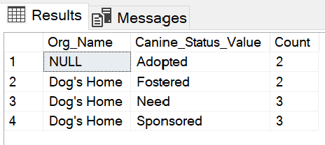

*Analysis – It looks like a Dog’s Home has two previous clients who have been adopted, and eight current clients that are fostered, are in need (not fostered or sponsored) or are sponsored.*

SELECT o.Org_Name, cs.Canine_Status_Value, COUNT(c.Canine_ID) as Count

FROM

Canines AS c

JOIN Canine_Status AS cs

ON c.Canine_Status_ID=cs.Canine_Status_ID

LEFT JOIN Organizations AS o

ON c.Owner_Org_ID = o.Org_ID

GROUP BY o.Org_Name, cs.Canine_Status_Value;

1. **How much money was taken in a period?**



SELECT SUM(i.Amount_Paid) as Payments

FROM Income AS i

WHERE Year(i.Paid_Date)=2019

;

1. **How much money was spent in a period?**

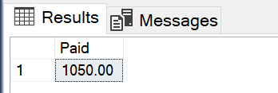

SELECT SUM(c.Amount_Due) as Paid

FROM Costs AS c

WHERE Year(c.Paid_Date)=2019

;

1. **What was the sources of the income?**

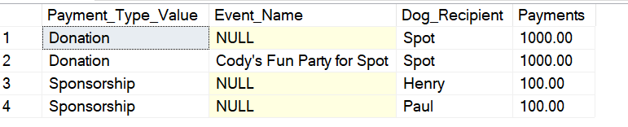

SELECT pt.Payment_Type_Value, fe.Event_Name, ca.Current_Name as Dog_Recipient, SUM(i.Amount_Paid) as Payments

FROM Income AS i

JOIN Payment_Type AS pt

ON i.Payment_Type_ID=pt.Payment_Type_ID

LEFT JOIN Fun_Events as fe

ON i.Event_ID = fe.Event_ID

LEFT JOIN Canines AS ca

ON ca.Canine_ID = i.Canine_ID

WHERE Year(i.Paid_Date)=2019

GROUP BY pt.Payment_Type_Value, fe.Event_Name, ca.Current_Name

;

1. **What were the details of the costs?**

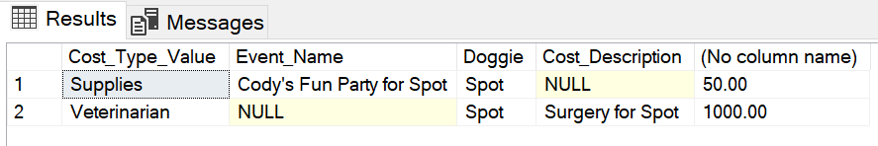

SELECT ct.Cost_Type_Value, fe.Event_Name, ca.Current_Name as Doggie, co.Cost_Description, SUM(co.Amount_Due)

FROM Costs AS co

JOIN Cost_Type AS ct

ON co.Cost_Type_ID=ct.Cost_Type_ID

LEFT JOIN Fun_Events AS fe

ON co.Event_ID = fe.Event_ID

LEFT JOIN Canines AS ca

ON co.Canine_ID = ca.Canine_ID

WHERE Year(co.Paid_Date)=2019

GROUP BY ct.Cost_Type_Value, fe.Event_Name, ca.Current_Name, co.Cost_Description;

## GUI Prototype

I created forms for entering data into the main objects:

* Contacts
* Organization
* Canines
* Events
* Costs
* Incomes

#### **Contacts**

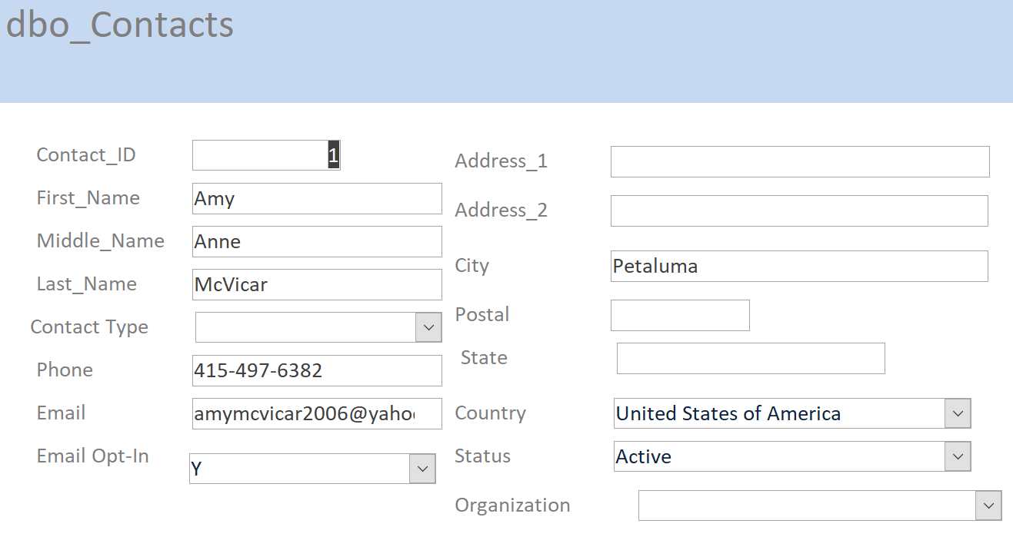

#### Organizations

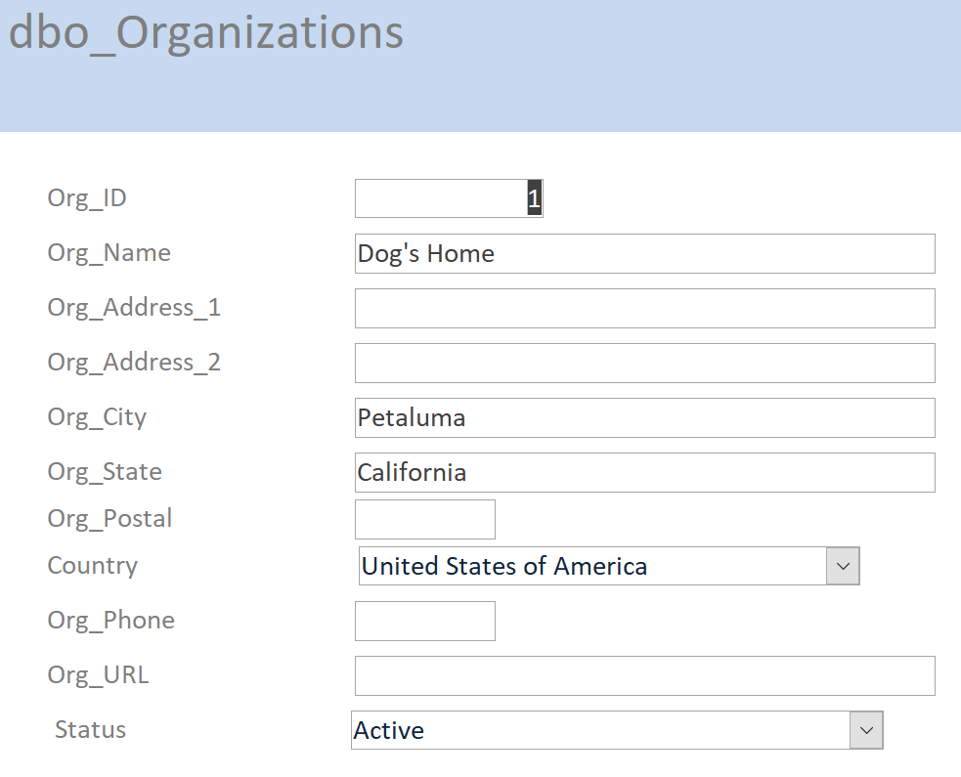

#### Canines

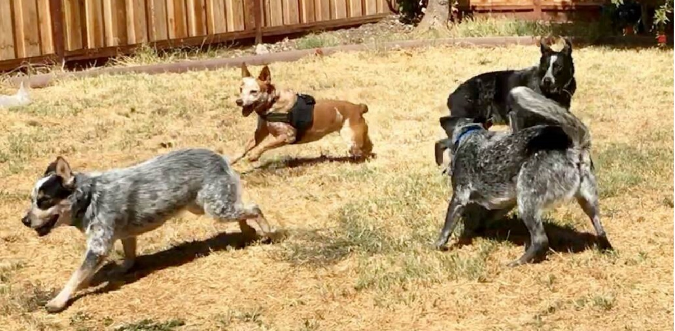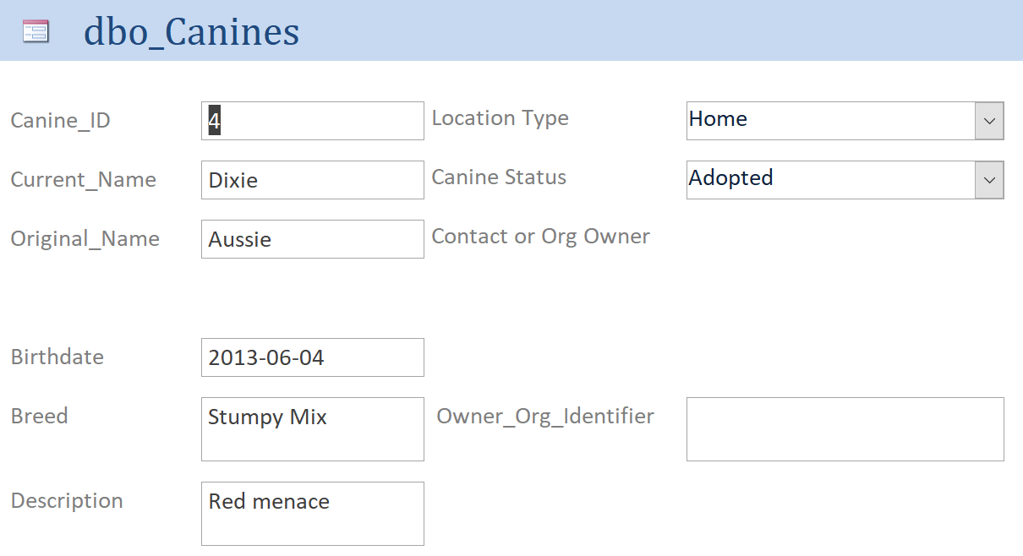

#### Costs

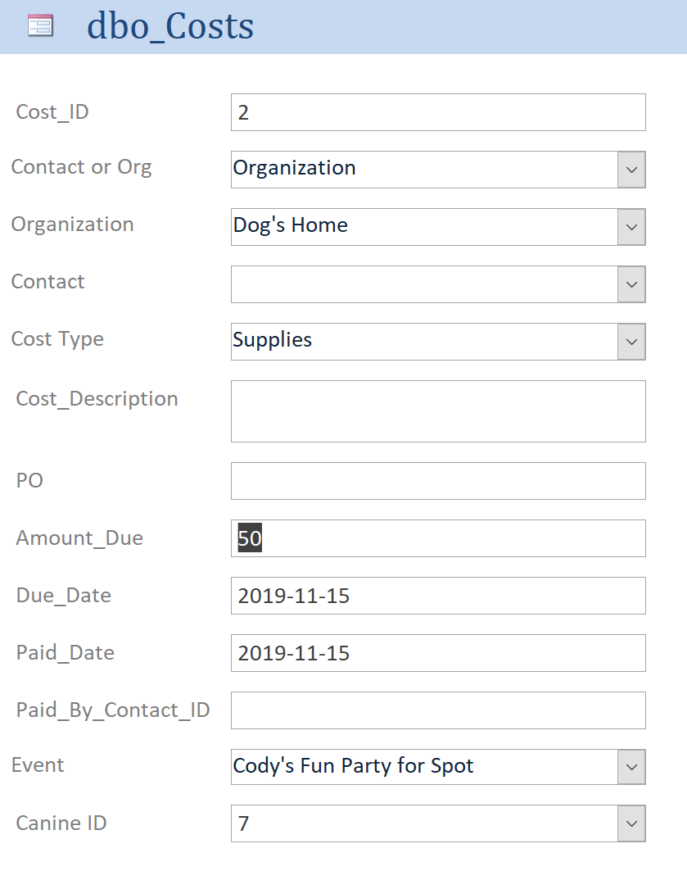

#### Income

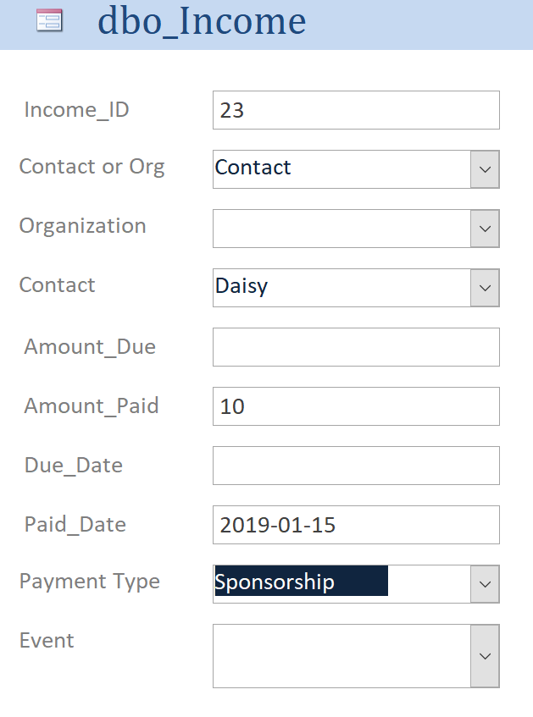

#### Fun Events

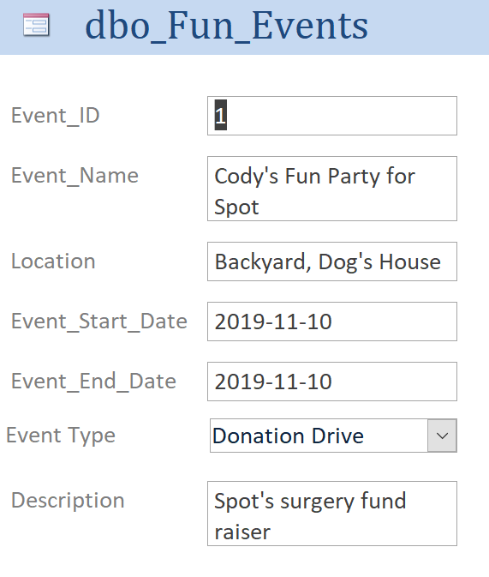

## Reflection

I always knew that good design was the critical aspect of database design and usability, but I learned I underestimated the time needed. I learned that moving ahead before your design is ready costs more time and ultimately flaws in the final implementation. Another big take away for me from this class is the iterative and staged approach to design. In my false start, I made two mistakes: I included too much detail in the first stages and plans and jumped to the next steps prematurely. I didn’t understand starting with conceptual models that weren’t what you would know would be the logical and normalized versions, but now I see what a helpful and important step this is and why you focus on keeping it high level. My implementation is not perfect, and I see many improvements to make. I have two significant, extremely valuable outcomes from this class. One is a better idea on how to design this database in the future and the other is a new respect and understanding the design process which I will improve any of my efforts in time and end product.

