Bank Marketing Data Analysis

Amy M Kalna

# Bank Marketing Data Analysis & Modeling

## 1.Introduction:

This project applies machine learning techniques that go beyond standard linear regression. I had the opportunity to use a publicly available dataset to solve the problem of my choice. I sifted through the datasets available on Kaggle and chose a finance/bank related dataset. I work at a bank so I was geared toward selecting a topic that’s relevant to the banking business.

The goal of the project is to answer the following question: What kind of behaviors do potential customers exhibit that result in them more likely to subscribe to a term deposit?

The business problem is to devise a target marketing strategy for the bank based on the behavioral data collected. The dataset is included in one of the submission files and can be downloaded from Kaggle (<https://www.kaggle.com/henriqueyamahata/bank-marketing>).

The Dataset: It contains 41,188 customer data on direct marketing campaigns (phone calls) of a Portuguese banking institution.

It has the following variables:

Client: age, job, marital, education, default status, housing, and loan

Campaign: last contact type, last contact month of year, last contact day of the week, and last contact duration

Others: number of contacts performed in current campaign, number of days that passed by after the client was last contacted, number of contacts performed before this campaign, outcome of previous campaign, and whether a client has subscribed a term deposit

Key Steps Performed:

I first used Data Classification to examine the set related with direct marketing campaigns of a Portuguese banking institution. The objective of the classification is to predict if the client will subscribe to a Term Deposit. Data Classification is the use of machine learning techniques to organize datasets into related sub-populations, not previous specified in the dataset. This can uncover hidden characteristics within data, and identify hidden categories that new data belongs within. The rest of the key steps that were performed used the data science techniques of Exploratory Data Analysis, Data Classification basis Random Forest and K-Nearest Neighbor.

## 2.Data Analysis:

### 2.1.Exploratory Analysis

**Loading the required packages:**

rm(list = ls())  
options(warn=-1)  
  
if(!require(readr)) install.packages("readr", repos = "")  
if(!require(tidyverse)) install.packages("tidyverse", repos = "")  
if(!require(GGally)) install.packages("GGally", repos = "")  
if(!require(glmnet)) install.packages("glmnet", repos = "")  
if(!require(Matrix)) install.packages("Matrix", repos = "")  
if(!require(DataExplorer)) install.packages("DataExplorer", repos = "")  
if(!require(corrplot)) install.packages("corrplot", repos = "")  
if(!require(caret)) install.packages("caret", repos = "")  
if(!require(randomForest)) install.packages("randomForest", repos = "")  
if(!require(class)) install.packages("class", repos = "")  
if(!require(gmodels)) install.packages("gmodels", repos = "")  
if(!require(dplyr)) install.packages("dplyr", repos = "")  
if(!require(psych)) install.packages("psych", repos = "")  
  
  
library(readr)  
library(tidyverse)  
library(GGally)  
library(glmnet)  
library(Matrix)  
library(ggplot2)  
library(DataExplorer)  
library(corrplot)  
library(caret)  
library(randomForest)  
library(class)  
library(gmodels)  
library(dplyr)  
library(psych)  
  
  
set.seed(1)

**Loading the dataset:**

#setwd("C:/Users/1012233/Downloads/20191103 - R Studio Kaggle project")  
#data.df <- read.csv("bank-additional-full.csv", header=TRUE, sep=";")  
  
data.df <- read.csv("https://raw.github.com/amymkalna/Kaggle-Bank-Marketing-Data/master/bank-additional-full.csv", header=TRUE, sep=";")

**Viewing the column names of the dataset:**

names(data.df)

## [1] "age" "job" "marital" "education"   
## [5] "default" "housing" "loan" "contact"   
## [9] "month" "day_of_week" "duration" "campaign"   
## [13] "pdays" "previous" "poutcome" "emp.var.rate"   
## [17] "cons.price.idx" "cons.conf.idx" "euribor3m" "nr.employed"   
## [21] "y"

**Column details of the dataset:**

str(data.df)

## 'data.frame': 41188 obs. of 21 variables:  
## $ age : int 56 57 37 40 56 45 59 41 24 25 ...  
## $ job : Factor w/ 12 levels "admin.","blue-collar",..: 4 8 8 1 8 8 1 2 10 8 ...  
## $ marital : Factor w/ 4 levels "divorced","married",..: 2 2 2 2 2 2 2 2 3 3 ...  
## $ education : Factor w/ 8 levels "basic.4y","basic.6y",..: 1 4 4 2 4 3 6 8 6 4 ...  
## $ default : Factor w/ 3 levels "no","unknown",..: 1 2 1 1 1 2 1 2 1 1 ...  
## $ housing : Factor w/ 3 levels "no","unknown",..: 1 1 3 1 1 1 1 1 3 3 ...  
## $ loan : Factor w/ 3 levels "no","unknown",..: 1 1 1 1 3 1 1 1 1 1 ...  
## $ contact : Factor w/ 2 levels "cellular","telephone": 2 2 2 2 2 2 2 2 2 2 ...  
## $ month : Factor w/ 10 levels "apr","aug","dec",..: 7 7 7 7 7 7 7 7 7 7 ...  
## $ day_of_week : Factor w/ 5 levels "fri","mon","thu",..: 2 2 2 2 2 2 2 2 2 2 ...  
## $ duration : int 261 149 226 151 307 198 139 217 380 50 ...  
## $ campaign : int 1 1 1 1 1 1 1 1 1 1 ...  
## $ pdays : int 999 999 999 999 999 999 999 999 999 999 ...  
## $ previous : int 0 0 0 0 0 0 0 0 0 0 ...  
## $ poutcome : Factor w/ 3 levels "failure","nonexistent",..: 2 2 2 2 2 2 2 2 2 2 ...  
## $ emp.var.rate : num 1.1 1.1 1.1 1.1 1.1 1.1 1.1 1.1 1.1 1.1 ...  
## $ cons.price.idx: num 94 94 94 94 94 ...  
## $ cons.conf.idx : num -36.4 -36.4 -36.4 -36.4 -36.4 -36.4 -36.4 -36.4 -36.4 -36.4 ...  
## $ euribor3m : num 4.86 4.86 4.86 4.86 4.86 ...  
## $ nr.employed : num 5191 5191 5191 5191 5191 ...  
## $ y : Factor w/ 2 levels "no","yes": 1 1 1 1 1 1 1 1 1 1 ...

**Summary analysis of the dataset:**

summary(data.df)

## age job marital   
## Min. :17.00 admin. :10422 divorced: 4612   
## 1st Qu.:32.00 blue-collar: 9254 married :24928   
## Median :38.00 technician : 6743 single :11568   
## Mean :40.02 services : 3969 unknown : 80   
## 3rd Qu.:47.00 management : 2924   
## Max. :98.00 retired : 1720   
## (Other) : 6156   
## education default housing   
## university.degree :12168 no :32588 no :18622   
## high.school : 9515 unknown: 8597 unknown: 990   
## basic.9y : 6045 yes : 3 yes :21576   
## professional.course: 5243   
## basic.4y : 4176   
## basic.6y : 2292   
## (Other) : 1749   
## loan contact month day_of_week  
## no :33950 cellular :26144 may :13769 fri:7827   
## unknown: 990 telephone:15044 jul : 7174 mon:8514   
## yes : 6248 aug : 6178 thu:8623   
## jun : 5318 tue:8090   
## nov : 4101 wed:8134   
## apr : 2632   
## (Other): 2016   
## duration campaign pdays previous   
## Min. : 0.0 Min. : 1.000 Min. : 0.0 Min. :0.000   
## 1st Qu.: 102.0 1st Qu.: 1.000 1st Qu.:999.0 1st Qu.:0.000   
## Median : 180.0 Median : 2.000 Median :999.0 Median :0.000   
## Mean : 258.3 Mean : 2.568 Mean :962.5 Mean :0.173   
## 3rd Qu.: 319.0 3rd Qu.: 3.000 3rd Qu.:999.0 3rd Qu.:0.000   
## Max. :4918.0 Max. :56.000 Max. :999.0 Max. :7.000   
##   
## poutcome emp.var.rate cons.price.idx cons.conf.idx   
## failure : 4252 Min. :-3.40000 Min. :92.20 Min. :-50.8   
## nonexistent:35563 1st Qu.:-1.80000 1st Qu.:93.08 1st Qu.:-42.7   
## success : 1373 Median : 1.10000 Median :93.75 Median :-41.8   
## Mean : 0.08189 Mean :93.58 Mean :-40.5   
## 3rd Qu.: 1.40000 3rd Qu.:93.99 3rd Qu.:-36.4   
## Max. : 1.40000 Max. :94.77 Max. :-26.9   
##   
## euribor3m nr.employed y   
## Min. :0.634 Min. :4964 no :36548   
## 1st Qu.:1.344 1st Qu.:5099 yes: 4640   
## Median :4.857 Median :5191   
## Mean :3.621 Mean :5167   
## 3rd Qu.:4.961 3rd Qu.:5228   
## Max. :5.045 Max. :5228   
##

### 2.2.Data Preparation

**We check if there are any missing values that exists:**

sum(is.na(data.df))

## [1] 0

There are no missing values in our dataset.

In the above exploratory analysis, we observed that there are many variables with class=int; hence, we convert them into numeric class

**Converting quantitative values to numeric class:**

data.df$age <- as.numeric(data.df$age)  
data.df$duration <- as.numeric(data.df$duration)  
data.df$campaign <- as.numeric(data.df$campaign)  
data.df$pdays <- as.numeric(data.df$pdays)  
data.df$previous <- as.numeric(data.df$previous)

**Ordering the levels of month:**

data.df$month<- factor(data.df$month, ordered = TRUE, levels = c("mar", "apr", "may", "jun", "jul", "aug", "sep", "oct", "nov", "dec"))

Since are target variable is a categorical variables with 2 possible values: yes, no; we transform it into a numerical denotation: 1,0 respectively.

**Transforming the target variable as Yes=1 and No=0:**

table(data.df$y)

##   
## no yes   
## 36548 4640

data.df <- data.df %>%  
 mutate(y = ifelse(y=="yes", 1, 0))  
  
data.df$y <- as.factor(data.df$y)  
table(data.df$y)

##   
## 0 1   
## 36548 4640

### 2.3.Descriptive Analysis

**Let us look at the histogram of the input variables:**

plot_histogram(data.df[,-21],ggtheme = theme_gray(base_size = 10, base_family = "serif"))

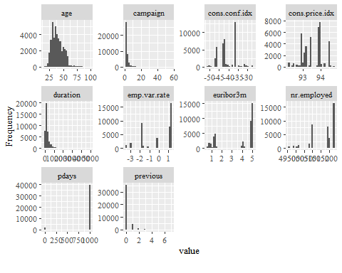

mytable <- table(data.df$marital, data.df$y)  
tab <- as.data.frame(prop.table(mytable, 2))  
colnames(tab) <- c("marital", "y", "perc")  
ggplot(data = tab, aes(x = marital, y = perc, fill = y)) +   
 geom_bar(stat = 'identity', position = 'dodge', alpha = 2/3) +   
 xlab("Marital")+ylab("Percent")

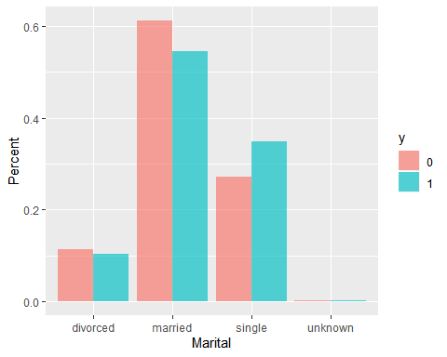

**With respect to Marital Status there is not an observed large difference in the proportion of people subscribed to term deposits and people without term deposits.**

mytable <- table(data.df$education, data.df$y)  
tab <- as.data.frame(prop.table(mytable, 2))  
colnames(tab) <- c("education", "y", "perc")  
ggplot(data = tab, aes(x = education, y = perc, fill = y)) +   
 geom_bar(stat = 'identity', position = 'dodge', alpha = 2/3) +  
theme(axis.text.x=element_text(angle=90,hjust=1)) +  
 xlab("Education")+ylab("Percent")

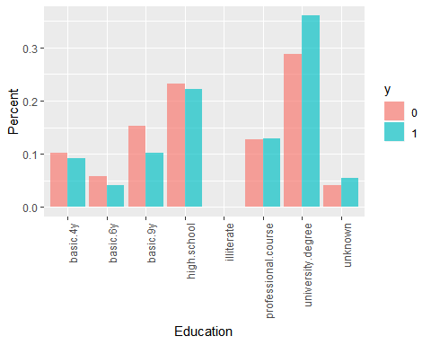

**We can see that customers who sign up for bank deposits, proportionally, have achieved a higher level of education, than those who didn’t sign up.**

mytable <- table(data.df$month, data.df$y)  
tab <- as.data.frame(prop.table(mytable, 2))  
colnames(tab) <- c("month", "y", "perc")  
ggplot(data = tab, aes(x = month, y = perc, fill = y)) +   
 geom_bar(stat = 'identity', position = 'dodge', alpha = 2/3) +  
 xlab("Month")+ylab("Percent")

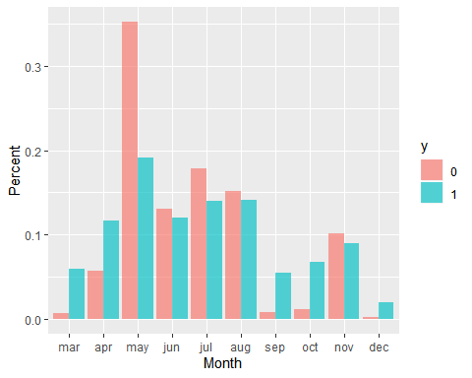

**The month of May is when the highest number of calls were placed for marketing deposit. And the following months of April, September, and October is the time when a higher proportion of people subscribed for term deposits.**

mytable <- table(data.df$job, data.df$y)  
tab <- as.data.frame(prop.table(mytable, 2))  
colnames(tab) <- c("job", "y", "perc")  
ggplot(data = tab, aes(x = job, y = perc, fill = y)) +   
 geom_bar(stat = 'identity', position = 'dodge', alpha = 2/3) +  
theme(axis.text.x=element_text(angle=90,hjust=1)) +  
 xlab("Job")+ylab("Percent")

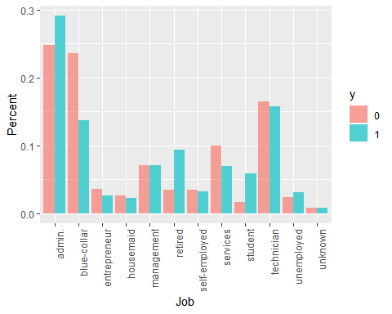

**We see there are higher proportions for customers signing up for the term deposits who have the jobs of admin, retired, and students.**

mytable <- table(data.df$default, data.df$y)  
tab <- as.data.frame(prop.table(mytable, 2))  
colnames(tab) <- c("default", "y", "perc")  
ggplot(data = tab, aes(x = default, y = perc, fill = y)) +   
 geom_bar(stat = 'identity', position = 'dodge', alpha = 2/3) +  
 xlab("Default")+ylab("Percent")

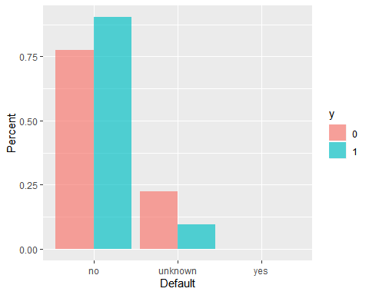

**The data shows that people who aren’t in default are a higher proportion of people who have subscribed for bank deposits.**

mytable <- table(data.df$housing, data.df$y)  
tab <- as.data.frame(prop.table(mytable, 2))  
colnames(tab) <- c("housing", "y", "perc")  
ggplot(data = tab, aes(x = housing, y = perc, fill = y)) +   
 geom_bar(stat = 'identity', position = 'dodge', alpha = 2/3) +  
 xlab("Housing")+ylab("Percent")

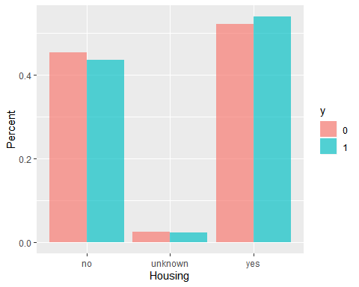

**We see that a higher proportion of people who have subscribed for bank deposit are home owners versus ones that don’t own their own houses.**

mytable <- table(data.df$loan, data.df$y)  
tab <- as.data.frame(prop.table(mytable, 2))  
colnames(tab) <- c("loan", "y", "perc")  
ggplot(data = tab, aes(x = loan, y = perc, fill = y)) +   
 geom_bar(stat = 'identity', position = 'dodge', alpha = 2/3) +  
 xlab("Loan")+ylab("Percent")

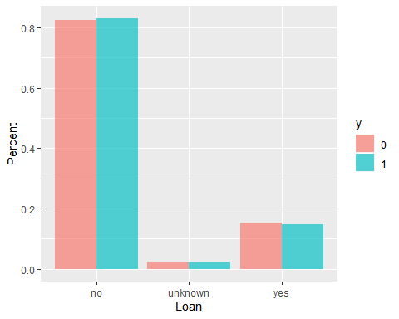

**We see the proportion of people who have subscribed and not subscribed to a term deposit is the same for categories of the Loan.**

mytable <- table(data.df$contact, data.df$y)  
tab <- as.data.frame(prop.table(mytable, 2))  
colnames(tab) <- c("contact", "y", "perc")  
ggplot(data = tab, aes(x = contact, y = perc, fill = y)) +   
 geom_bar(stat = 'identity', position = 'dodge', alpha = 2/3) +  
 xlab("Contact")+ylab("Percent")

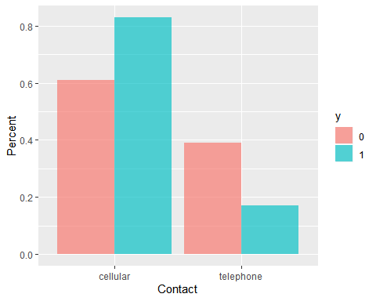

**Customers who have cell phones, and therefore a more direct way of communicating, signed up for term deposits more than those who only had a landline telephone.**

mytable <- table(data.df$day_of_week, data.df$y)  
tab <- as.data.frame(prop.table(mytable, 2))  
colnames(tab) <- c("day_of_week", "y", "perc")  
ggplot(data = tab, aes(x = day_of_week, y = perc, fill = y)) +   
 geom_bar(stat = 'identity', position = 'dodge', alpha = 2/3) +  
 xlab("Day_of_week")+ylab("Percent")

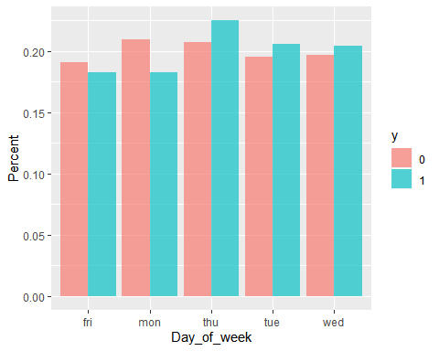

**Campaigns that were performed midweek, on Tuesdays, Wednesdays, and Thursdays had a slightly higher proportion of people who subscribed for bank deposit..**

mytable <- table(data.df$poutcome, data.df$y)  
tab <- as.data.frame(prop.table(mytable, 2))  
colnames(tab) <- c("poutcome", "y", "perc")  
ggplot(data = tab, aes(x = poutcome, y = perc, fill = y)) +   
 geom_bar(stat = 'identity', position = 'dodge', alpha = 2/3) +  
 xlab("Outcome of previous marketing campaign")+ylab("Percent")

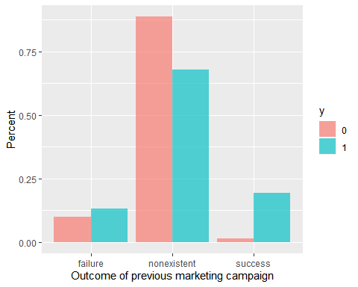

**Potential customers who successfully connected and responded in previous campaigns had a higher proportion of signing up for the term deposit.**

ggplot(data.df, aes(factor(y), duration)) + geom_boxplot(aes(fill = factor(y)))

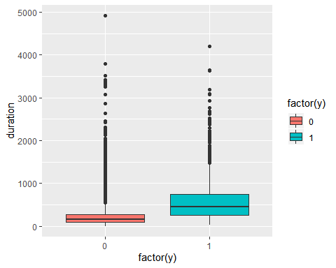

**The longer the phone conversation the greater the conversion rate is for the potential customer to sign up for the term deposit. There are higher median and quartile ranges.**

ggplot(data.df, aes(factor(y), age)) + geom_boxplot(aes(fill = factor(y)))

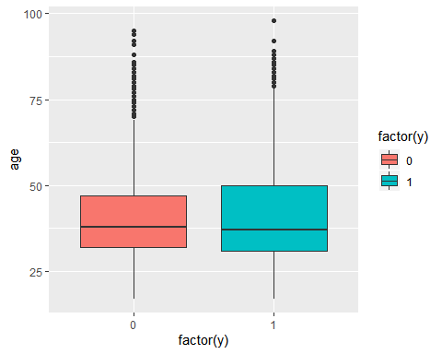

**The age range for successful conversion has a slightly lower median, but higher quartile ranges.**

df_cor <- select_if(data.df, is.numeric) %>% cor()  
corrplot(df_cor, method = "number")

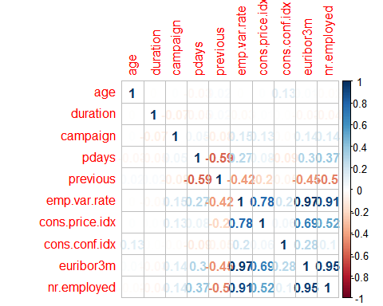

**We see our target variable has a high positive correlation with duration and if the customer was involved and connected in a previous campaign, while there’s negative correlation with Nr.employed (number of employees), pdays (number of days from last contact), Euribor3m (Euribor 3 month rate) and emp.var.rate (employee variation rate).**

## 3.Data Modeling and Results:

### 3.1.Data Preparation

**Missing values for duration were filtered out (last contact duration, in seconds (numeric)) because if duration=0 then y=“no” (no call was made). Thus, it doesn’t make sense to have 0 second duration. I also filtered out education illiterate, and default yes because they only have 1 observation each. We can’t predict these situations if they happen to be in the test data but not the train data.**

data.df <- data.df %>%  
 filter(duration != 0, education != "illiterate", default != "yes") %>%  
 mutate(y = ifelse(y==1, 1, 0))

**Split the data into training and test datasets:**

set.seed(123)  
trainIndex <- createDataPartition(data.df$y,  
 p = 0.8, # training contains 80% of data  
 list = FALSE)  
dfTrain <- data.df[ trainIndex,]  
dfTest <- data.df[-trainIndex,]

dim(dfTrain)

## [1] 32931 21

dim(dfTest)

## [1] 8232 21

**The code and output above show that the trainData dataset has 8929 rows and 17 columns and the testData dataset gas 2233 rows and 17 columns. The number of columns remains the same because the dataset was split vertically.**

### 3.2.Data Modeling using Random Forest:

First the data set was divided into training and testing data with 80%-20% split respectively. A seed value was set using set.seed() function to make sure that the randomly split data could be regenerated. A random forest model was built using training data using randomforest package. We use 10 predictors for each split and grow 200 trees fully without pruning. A subset of predictors is randomly chosen without replacement at each split which helps in reducing the variance of the model overall. This is a prime advantage of random forest as compared to traditional decision trees.

In the below summary we can see that this model has an Out-Of-Bag error rate of 8.7%. The model also outputs a confusion matrix. We can see that random forest is doing a fairly good job in predicting the response variable i.e. deposit(Yes/No) field.

set.seed(123)  
# random forest  
model_rf <- randomForest(as.factor(y)~.,  
 data = dfTrain,  
 ntree = 200,  
 mtry=10,  
 importance = TRUE)  
  
print(model_rf)

##   
## Call:  
## randomForest(formula = as.factor(y) ~ ., data = dfTrain, ntree = 200, mtry = 10, importance = TRUE)   
## Type of random forest: classification  
## Number of trees: 200  
## No. of variables tried at each split: 10  
##   
## OOB estimate of error rate: 8.72%  
## Confusion matrix:  
## 0 1 class.error  
## 0 27981 1244 0.0425663  
## 1 1626 2080 0.4387480

pred_rf_prob <- predict(model_rf,  
 newdata = dfTest)

head(pred_rf_prob)

**Model evaluation:**

# put "pred_rf_prob" in a data frame  
RF_outcome_test <- data.frame(dfTest$y)  
  
# merge "model_rf" and "RF_outcome_test"   
RF_comparison_df <- data.frame(pred_rf_prob, RF_outcome_test)  
  
# specify column names for "RF_comparison_df"  
names(RF_comparison_df) <- c("RF_Predicted_y", "RF_Observed_y")  
  
RF_comparison_df$RF_Predicted_y <- as.factor(RF_comparison_df$RF_Predicted_y)  
RF_comparison_df$RF_Observed_y <- as.factor(RF_comparison_df$RF_Observed_y)  
  
# inspect "RF_comparison_df"   
head(RF_comparison_df)

## RF_Predicted_y RF_Observed_y  
## 12 0 0  
## 23 0 0  
## 27 0 0  
## 36 0 0  
## 39 0 0  
## 44 0 0

str(RF_comparison_df)

confusionMatrix(RF_comparison_df$RF_Observed_y,RF_comparison_df$RF_Predicted_y)

## Confusion Matrix and Statistics  
##   
## Reference  
## Prediction 0 1  
## 0 7029 273  
## 1 415 515  
##   
## Accuracy : 0.9164   
## 95% CI : (0.9102, 0.9223)  
## No Information Rate : 0.9043   
## P-Value [Acc > NIR] : 7.338e-05   
##   
## Kappa : 0.5532   
##   
## Mcnemar's Test P-Value : 7.634e-08   
##   
## Sensitivity : 0.9443   
## Specificity : 0.6536   
## Pos Pred Value : 0.9626   
## Neg Pred Value : 0.5538   
## Prevalence : 0.9043   
## Detection Rate : 0.8539   
## Detection Prevalence : 0.8870   
## Balanced Accuracy : 0.7989   
##   
## 'Positive' Class : 0   
##

The RF test data consisted of 8232 observations. Out of which 7034 cases have been accurately predicted (TN->True Negatives) as negative class (0) which constitutes 85%. Also, 510 out of 8232 observations were accurately predicted (TP-> True Positives) as positive class (1) which constitutes 6%. Thus a total of 510 out of 8232 predictions where TP i.e, True Positive in nature.

There were 420 cases of False Positives (FP) meaning 544 cases out of 8232 were actually negative but got predicted as positive.

There were 268 cases of False Negatives (FN) meaning 199 cases our of 8232 were actually positive in nature but got predicted as negative.

Accuracy of the model is the correctly classified positive and negative cases divided by all ther cases.The total accuracy of the model is 91.64%, which means the model prediction is very accurate.

**Viewing the variable importance plot:**

varImpPlot(model_rf)

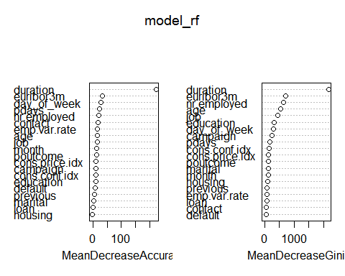

**By setting the importance argument on, we obtained the variable importance plot as above using varImpPlot() function and we can see that duration is highly significant in our data set.**

We plot a graph for the error rate (False Positive Rate, False Negative Rate and Out-Of-Bag Error) with the increasing number of trees.

plot(model_rf)  
legend("right", legend=c("OOB Error", "FPR", "FNR"),  
 col=c("black", "red", "green"), lty=1:3, cex=0.8)

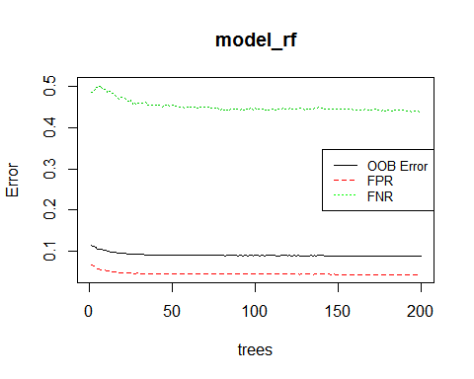

**In the above plot, we can see the change of error with increasing number of trees. The False Negative Rate is higher compared to other error rate and False Positive Rate is lowest. The error rate starts dropping for at ntree~ 20. This says that our model is predicting ‘Yes’ cases more accurately than ‘No’ cases which can also be confirmed by the confusion matrix above.**

## 3.2.Data Modeling using KNN

We will make a copy of our data set so that we can prepare it for our k-NN classification.

data_knn <- data.df  
  
str(data_knn)

## 'data.frame': 41163 obs. of 21 variables:  
## $ age : num 56 57 37 40 56 45 59 41 24 25 ...  
## $ job : Factor w/ 12 levels "admin.","blue-collar",..: 4 8 8 1 8 8 1 2 10 8 ...  
## $ marital : Factor w/ 4 levels "divorced","married",..: 2 2 2 2 2 2 2 2 3 3 ...  
## $ education : Factor w/ 8 levels "basic.4y","basic.6y",..: 1 4 4 2 4 3 6 8 6 4 ...  
## $ default : Factor w/ 3 levels "no","unknown",..: 1 2 1 1 1 2 1 2 1 1 ...  
## $ housing : Factor w/ 3 levels "no","unknown",..: 1 1 3 1 1 1 1 1 3 3 ...  
## $ loan : Factor w/ 3 levels "no","unknown",..: 1 1 1 1 3 1 1 1 1 1 ...  
## $ contact : Factor w/ 2 levels "cellular","telephone": 2 2 2 2 2 2 2 2 2 2 ...  
## $ month : Ord.factor w/ 10 levels "mar"<"apr"<"may"<..: 3 3 3 3 3 3 3 3 3 3 ...  
## $ day_of_week : Factor w/ 5 levels "fri","mon","thu",..: 2 2 2 2 2 2 2 2 2 2 ...  
## $ duration : num 261 149 226 151 307 198 139 217 380 50 ...  
## $ campaign : num 1 1 1 1 1 1 1 1 1 1 ...  
## $ pdays : num 999 999 999 999 999 999 999 999 999 999 ...  
## $ previous : num 0 0 0 0 0 0 0 0 0 0 ...  
## $ poutcome : Factor w/ 3 levels "failure","nonexistent",..: 2 2 2 2 2 2 2 2 2 2 ...  
## $ emp.var.rate : num 1.1 1.1 1.1 1.1 1.1 1.1 1.1 1.1 1.1 1.1 ...  
## $ cons.price.idx: num 94 94 94 94 94 ...  
## $ cons.conf.idx : num -36.4 -36.4 -36.4 -36.4 -36.4 -36.4 -36.4 -36.4 -36.4 -36.4 ...  
## $ euribor3m : num 4.86 4.86 4.86 4.86 4.86 ...  
## $ nr.employed : num 5191 5191 5191 5191 5191 ...  
## $ y : num 0 0 0 0 0 0 0 0 0 0 ...

Because k-NN algorithm involves determining distances between datapoints, we must use numeric variables only. This is applicable only to independent variables. The target variable for k-NN classification should remain a factor variable. First, we scale the data just in case our features are on different metrics. For example, if we had “duration” as a variable, it would be on a much larger scale than “age”, which could be problematic given the k-NN relies on distances. Note that we are using the ‘scale’ function here, which means we are scaling to a z-score metric.

We see that the variables “age”, “duration”, “campaign”, “pdays”, “previous”, “emp.var.rate”, “cons.price.idx”, “cons.conf.idx”, “euribor3m” and “nr.employed” are interger variables, which means they can be scaled.

data_knn[, c("age", "duration", "campaign", "pdays", "previous", "emp.var.rate", "cons.price.idx", "cons.conf.idx", "euribor3m","nr.employed")] <- scale(data_knn[, c("age", "duration", "campaign", "pdays", "previous", "emp.var.rate", "cons.price.idx", "cons.conf.idx", "euribor3m","nr.employed")])  
  
head(data_knn)

## age job marital education default housing loan  
## 1 1.533684728 housemaid married basic.4y no no no  
## 2 1.629657912 services married high.school unknown no no  
## 3 -0.289805768 services married high.school no yes no  
## 4 -0.001886216 admin. married basic.6y no no no  
## 5 1.533684728 services married high.school no no yes  
## 6 0.477979704 services married basic.9y unknown no no  
## contact month day_of_week duration campaign pdays previous  
## 1 telephone may mon 0.01036255 -0.5658418 0.1954061 -0.3494959  
## 2 telephone may mon -0.42162181 -0.5658418 0.1954061 -0.3494959  
## 3 telephone may mon -0.12463256 -0.5658418 0.1954061 -0.3494959  
## 4 telephone may mon -0.41390781 -0.5658418 0.1954061 -0.3494959  
## 5 telephone may mon 0.18778470 -0.5658418 0.1954061 -0.3494959  
## 6 telephone may mon -0.23262865 -0.5658418 0.1954061 -0.3494959  
## poutcome emp.var.rate cons.price.idx cons.conf.idx euribor3m  
## 1 nonexistent 0.6480509 0.7224735 0.8865513 0.7124339  
## 2 nonexistent 0.6480509 0.7224735 0.8865513 0.7124339  
## 3 nonexistent 0.6480509 0.7224735 0.8865513 0.7124339  
## 4 nonexistent 0.6480509 0.7224735 0.8865513 0.7124339  
## 5 nonexistent 0.6480509 0.7224735 0.8865513 0.7124339  
## 6 nonexistent 0.6480509 0.7224735 0.8865513 0.7124339  
## nr.employed y  
## 1 0.3317071 0  
## 2 0.3317071 0  
## 3 0.3317071 0  
## 4 0.3317071 0  
## 5 0.3317071 0  
## 6 0.3317071 0

str(data_knn)

## 'data.frame': 41163 obs. of 21 variables:  
## $ age : num 1.53368 1.62966 -0.28981 -0.00189 1.53368 ...  
## $ job : Factor w/ 12 levels "admin.","blue-collar",..: 4 8 8 1 8 8 1 2 10 8 ...  
## $ marital : Factor w/ 4 levels "divorced","married",..: 2 2 2 2 2 2 2 2 3 3 ...  
## $ education : Factor w/ 8 levels "basic.4y","basic.6y",..: 1 4 4 2 4 3 6 8 6 4 ...  
## $ default : Factor w/ 3 levels "no","unknown",..: 1 2 1 1 1 2 1 2 1 1 ...  
## $ housing : Factor w/ 3 levels "no","unknown",..: 1 1 3 1 1 1 1 1 3 3 ...  
## $ loan : Factor w/ 3 levels "no","unknown",..: 1 1 1 1 3 1 1 1 1 1 ...  
## $ contact : Factor w/ 2 levels "cellular","telephone": 2 2 2 2 2 2 2 2 2 2 ...  
## $ month : Ord.factor w/ 10 levels "mar"<"apr"<"may"<..: 3 3 3 3 3 3 3 3 3 3 ...  
## $ day_of_week : Factor w/ 5 levels "fri","mon","thu",..: 2 2 2 2 2 2 2 2 2 2 ...  
## $ duration : num 0.0104 -0.4216 -0.1246 -0.4139 0.1878 ...  
## $ campaign : num -0.566 -0.566 -0.566 -0.566 -0.566 ...  
## $ pdays : num 0.195 0.195 0.195 0.195 0.195 ...  
## $ previous : num -0.349 -0.349 -0.349 -0.349 -0.349 ...  
## $ poutcome : Factor w/ 3 levels "failure","nonexistent",..: 2 2 2 2 2 2 2 2 2 2 ...  
## $ emp.var.rate : num 0.648 0.648 0.648 0.648 0.648 ...  
## $ cons.price.idx: num 0.722 0.722 0.722 0.722 0.722 ...  
## $ cons.conf.idx : num 0.887 0.887 0.887 0.887 0.887 ...  
## $ euribor3m : num 0.712 0.712 0.712 0.712 0.712 ...  
## $ nr.employed : num 0.332 0.332 0.332 0.332 0.332 ...  
## $ y : num 0 0 0 0 0 0 0 0 0 0 ...

**We can see that the variables “job”, “marital”, “education”, “default”, “housing”, “loan”, “contact”, “month”, “day_of_week” and “poutcome” are factor variables that have two or more levels.**

** Then dummy code variables that have two levels, but are not numeric. **

data_knn$contact <- dummy.code(data_knn$contact)

**Next we dummy code variables that have three or more levels.**

job <- as.data.frame(dummy.code(data_knn$job))  
marital <- as.data.frame(dummy.code(data_knn$marital))  
education <- as.data.frame(dummy.code(data_knn$education))  
default <- as.data.frame(dummy.code(data_knn$default))  
housing <- as.data.frame(dummy.code(data_knn$housing))  
loan <- as.data.frame(dummy.code(data_knn$loan))  
month <- as.data.frame(dummy.code(data_knn$month))  
day_of_week <- as.data.frame(dummy.code(data_knn$day_of_week))  
poutcome <- as.data.frame(dummy.code(data_knn$poutcome))

**Rename “unknown” columns, so we don’t have duplicate columns later).**

job <- rename(job, unknown_job = unknown)  
marital <- rename(marital, unknown_marital = unknown)  
education <- rename(education , unknown_education = unknown)  
default <- rename(default , unknown_default = unknown)  
housing <- rename(housing , unknown_housing = unknown)  
loan <- rename(loan , unknown_loan = unknown)  
  
default <- rename(default , yes_default = yes)  
default <- rename(default , no_default = no)  
  
housing <- rename(housing , yes_housing = yes)  
housing <- rename(housing , no_housing = no)  
  
loan <- rename(loan , yes_loan = yes)  
loan <- rename(loan , no_loan = no)

**Combine new dummy variables with original data set.**

data_knn <- cbind(data_knn, job, marital, education, default, housing, loan, month, day_of_week,poutcome)

str(data_knn)

## 'data.frame': 41163 obs. of 72 variables:  
## $ age : num 1.53368 1.62966 -0.28981 -0.00189 1.53368 ...  
## $ job : Factor w/ 12 levels "admin.","blue-collar",..: 4 8 8 1 8 8 1 2 10 8 ...  
## $ marital : Factor w/ 4 levels "divorced","married",..: 2 2 2 2 2 2 2 2 3 3 ...  
## $ education : Factor w/ 8 levels "basic.4y","basic.6y",..: 1 4 4 2 4 3 6 8 6 4 ...  
## $ default : Factor w/ 3 levels "no","unknown",..: 1 2 1 1 1 2 1 2 1 1 ...  
## $ housing : Factor w/ 3 levels "no","unknown",..: 1 1 3 1 1 1 1 1 3 3 ...  
## $ loan : Factor w/ 3 levels "no","unknown",..: 1 1 1 1 3 1 1 1 1 1 ...  
## $ contact : num [1:41163, 1:2] 0 0 0 0 0 0 0 0 0 0 ...  
## ..- attr(*, "dimnames")=List of 2  
## .. ..$ : NULL  
## .. ..$ : chr "cellular" "telephone"  
## $ month : Ord.factor w/ 10 levels "mar"<"apr"<"may"<..: 3 3 3 3 3 3 3 3 3 3 ...  
## $ day_of_week : Factor w/ 5 levels "fri","mon","thu",..: 2 2 2 2 2 2 2 2 2 2 ...  
## $ duration : num 0.0104 -0.4216 -0.1246 -0.4139 0.1878 ...  
## $ campaign : num -0.566 -0.566 -0.566 -0.566 -0.566 ...  
## $ pdays : num 0.195 0.195 0.195 0.195 0.195 ...  
## $ previous : num -0.349 -0.349 -0.349 -0.349 -0.349 ...  
## $ poutcome : Factor w/ 3 levels "failure","nonexistent",..: 2 2 2 2 2 2 2 2 2 2 ...  
## $ emp.var.rate : num 0.648 0.648 0.648 0.648 0.648 ...  
## $ cons.price.idx : num 0.722 0.722 0.722 0.722 0.722 ...  
## $ cons.conf.idx : num 0.887 0.887 0.887 0.887 0.887 ...  
## $ euribor3m : num 0.712 0.712 0.712 0.712 0.712 ...  
## $ nr.employed : num 0.332 0.332 0.332 0.332 0.332 ...  
## $ y : num 0 0 0 0 0 0 0 0 0 0 ...  
## $ admin. : num 0 0 0 1 0 0 1 0 0 0 ...  
## $ blue-collar : num 0 0 0 0 0 0 0 1 0 0 ...  
## $ entrepreneur : num 0 0 0 0 0 0 0 0 0 0 ...  
## $ housemaid : num 1 0 0 0 0 0 0 0 0 0 ...  
## $ management : num 0 0 0 0 0 0 0 0 0 0 ...  
## $ retired : num 0 0 0 0 0 0 0 0 0 0 ...  
## $ self-employed : num 0 0 0 0 0 0 0 0 0 0 ...  
## $ services : num 0 1 1 0 1 1 0 0 0 1 ...  
## $ student : num 0 0 0 0 0 0 0 0 0 0 ...  
## $ technician : num 0 0 0 0 0 0 0 0 1 0 ...  
## $ unemployed : num 0 0 0 0 0 0 0 0 0 0 ...  
## $ unknown_job : num 0 0 0 0 0 0 0 0 0 0 ...  
## $ divorced : num 0 0 0 0 0 0 0 0 0 0 ...  
## $ married : num 1 1 1 1 1 1 1 1 0 0 ...  
## $ single : num 0 0 0 0 0 0 0 0 1 1 ...  
## $ unknown_marital : num 0 0 0 0 0 0 0 0 0 0 ...  
## $ basic.4y : num 1 0 0 0 0 0 0 0 0 0 ...  
## $ basic.6y : num 0 0 0 1 0 0 0 0 0 0 ...  
## $ basic.9y : num 0 0 0 0 0 1 0 0 0 0 ...  
## $ high.school : num 0 1 1 0 1 0 0 0 0 1 ...  
## $ illiterate : num 0 0 0 0 0 0 0 0 0 0 ...  
## $ professional.course: num 0 0 0 0 0 0 1 0 1 0 ...  
## $ university.degree : num 0 0 0 0 0 0 0 0 0 0 ...  
## $ unknown_education : num 0 0 0 0 0 0 0 1 0 0 ...  
## $ no_default : num 1 0 1 1 1 0 1 0 1 1 ...  
## $ unknown_default : num 0 1 0 0 0 1 0 1 0 0 ...  
## $ yes_default : num 0 0 0 0 0 0 0 0 0 0 ...  
## $ no_housing : num 1 1 0 1 1 1 1 1 0 0 ...  
## $ unknown_housing : num 0 0 0 0 0 0 0 0 0 0 ...  
## $ yes_housing : num 0 0 1 0 0 0 0 0 1 1 ...  
## $ no_loan : num 1 1 1 1 0 1 1 1 1 1 ...  
## $ unknown_loan : num 0 0 0 0 0 0 0 0 0 0 ...  
## $ yes_loan : num 0 0 0 0 1 0 0 0 0 0 ...  
## $ mar : num 0 0 0 0 0 0 0 0 0 0 ...  
## $ apr : num 0 0 0 0 0 0 0 0 0 0 ...  
## $ may : num 1 1 1 1 1 1 1 1 1 1 ...  
## $ jun : num 0 0 0 0 0 0 0 0 0 0 ...  
## $ jul : num 0 0 0 0 0 0 0 0 0 0 ...  
## $ aug : num 0 0 0 0 0 0 0 0 0 0 ...  
## $ sep : num 0 0 0 0 0 0 0 0 0 0 ...  
## $ oct : num 0 0 0 0 0 0 0 0 0 0 ...  
## $ nov : num 0 0 0 0 0 0 0 0 0 0 ...  
## $ dec : num 0 0 0 0 0 0 0 0 0 0 ...  
## $ fri : num 0 0 0 0 0 0 0 0 0 0 ...  
## $ mon : num 1 1 1 1 1 1 1 1 1 1 ...  
## $ thu : num 0 0 0 0 0 0 0 0 0 0 ...  
## $ tue : num 0 0 0 0 0 0 0 0 0 0 ...  
## $ wed : num 0 0 0 0 0 0 0 0 0 0 ...  
## $ failure : num 0 0 0 0 0 0 0 0 0 0 ...  
## $ nonexistent : num 1 1 1 1 1 1 1 1 1 1 ...  
## $ success : num 0 0 0 0 0 0 0 0 0 0 ...

**Remove original variables that had to be dummy coded.**

data_knn <- data_knn %>% select(-one_of(c("job", "marital", "education", "default", "housing", "loan", "month", "day_of_week", "poutcome")))  
  
head(data_knn)

## age contact.cellular contact.telephone duration campaign  
## 1 1.533684728 0 1 0.01036255 -0.5658418  
## 2 1.629657912 0 1 -0.42162181 -0.5658418  
## 3 -0.289805768 0 1 -0.12463256 -0.5658418  
## 4 -0.001886216 0 1 -0.41390781 -0.5658418  
## 5 1.533684728 0 1 0.18778470 -0.5658418  
## 6 0.477979704 0 1 -0.23262865 -0.5658418  
## pdays previous emp.var.rate cons.price.idx cons.conf.idx euribor3m  
## 1 0.1954061 -0.3494959 0.6480509 0.7224735 0.8865513 0.7124339  
## 2 0.1954061 -0.3494959 0.6480509 0.7224735 0.8865513 0.7124339  
## 3 0.1954061 -0.3494959 0.6480509 0.7224735 0.8865513 0.7124339  
## 4 0.1954061 -0.3494959 0.6480509 0.7224735 0.8865513 0.7124339  
## 5 0.1954061 -0.3494959 0.6480509 0.7224735 0.8865513 0.7124339  
## 6 0.1954061 -0.3494959 0.6480509 0.7224735 0.8865513 0.7124339  
## nr.employed y admin. blue-collar entrepreneur housemaid management  
## 1 0.3317071 0 0 0 0 1 0  
## 2 0.3317071 0 0 0 0 0 0  
## 3 0.3317071 0 0 0 0 0 0  
## 4 0.3317071 0 1 0 0 0 0  
## 5 0.3317071 0 0 0 0 0 0  
## 6 0.3317071 0 0 0 0 0 0  
## retired self-employed services student technician unemployed unknown_job  
## 1 0 0 0 0 0 0 0  
## 2 0 0 1 0 0 0 0  
## 3 0 0 1 0 0 0 0  
## 4 0 0 0 0 0 0 0  
## 5 0 0 1 0 0 0 0  
## 6 0 0 1 0 0 0 0  
## divorced married single unknown_marital basic.4y basic.6y basic.9y  
## 1 0 1 0 0 1 0 0  
## 2 0 1 0 0 0 0 0  
## 3 0 1 0 0 0 0 0  
## 4 0 1 0 0 0 1 0  
## 5 0 1 0 0 0 0 0  
## 6 0 1 0 0 0 0 1  
## high.school illiterate professional.course university.degree  
## 1 0 0 0 0  
## 2 1 0 0 0  
## 3 1 0 0 0  
## 4 0 0 0 0  
## 5 1 0 0 0  
## 6 0 0 0 0  
## unknown_education no_default unknown_default yes_default no_housing  
## 1 0 1 0 0 1  
## 2 0 0 1 0 1  
## 3 0 1 0 0 0  
## 4 0 1 0 0 1  
## 5 0 1 0 0 1  
## 6 0 0 1 0 1  
## unknown_housing yes_housing no_loan unknown_loan yes_loan mar apr may  
## 1 0 0 1 0 0 0 0 1  
## 2 0 0 1 0 0 0 0 1  
## 3 0 1 1 0 0 0 0 1  
## 4 0 0 1 0 0 0 0 1  
## 5 0 0 0 0 1 0 0 1  
## 6 0 0 1 0 0 0 0 1  
## jun jul aug sep oct nov dec fri mon thu tue wed failure nonexistent  
## 1 0 0 0 0 0 0 0 0 1 0 0 0 0 1  
## 2 0 0 0 0 0 0 0 0 1 0 0 0 0 1  
## 3 0 0 0 0 0 0 0 0 1 0 0 0 0 1  
## 4 0 0 0 0 0 0 0 0 1 0 0 0 0 1  
## 5 0 0 0 0 0 0 0 0 1 0 0 0 0 1  
## 6 0 0 0 0 0 0 0 0 1 0 0 0 0 1  
## success  
## 1 0  
## 2 0  
## 3 0  
## 4 0  
## 5 0  
## 6 0

We are now ready for k-NN classification. We split the data into training and test sets. We partition 80% of the data into the training set and the remaining 20% into the test set.

**Splitting the dataset into Test and Train:**

set.seed(1234) # set the seed to make the partition reproducible  
  
# 80% of the sample size  
sample_size <- floor(0.8 * nrow(data_knn))  
  
  
train_index <- sample(seq_len(nrow(data_knn)), size = sample_size)  
  
# put outcome in its own object  
knn_outcome <- data_knn %>% select(y)  
  
# remove original variable from the data set  
data_knn <- data_knn %>% select(-y)  
  
  
  
# creating test and training sets that contain all of the predictors  
knn_data_train <- data_knn[train_index, ]  
knn_data_test <- data_knn[-train_index, ]  
  
# Split outcome variable into training and test sets using the same partition as above.  
knn_outcome_train <- knn_outcome[train_index, ]  
knn_outcome_test <- knn_outcome[-train_index, ]

Using ‘class’ package, we run k-NN classification on our data. We have to decide on the number of neighbors (k).This is an iterative exercise as we need to keep changing the value of k to dtermine the optimum performance. In our case, we started with k=10 till k=20, and finally got an optimum performance at k=17.

model_knn <- knn(train = knn_data_train, test = knn_data_test, cl = knn_outcome_train, k=17)

**Model evaluation:**

# put "knn_outcome_test" in a data frame  
knn_outcome_test <- data.frame(knn_outcome_test)  
  
# merge "model_knn" and "knn_outcome_test"   
knn_comparison_df <- data.frame(model_knn, knn_outcome_test)  
  
# specify column names for "knn_comparison_df"  
names(knn_comparison_df) <- c("KNN_Predicted_y", "KNN_Observed_y")  
  
knn_comparison_df$KNN_Predicted_y <- as.factor(knn_comparison_df$KNN_Predicted_y)  
knn_comparison_df$KNN_Observed_y <- as.factor(knn_comparison_df$KNN_Observed_y)  
  
# inspect "knn_comparison_df"   
head(knn_comparison_df)

## KNN_Predicted_y KNN_Observed_y  
## 1 0 0  
## 2 0 0  
## 3 0 0  
## 4 0 0  
## 5 0 0  
## 6 0 0

Next, we compare our predicted values of deposit to our actual values. The confusion matrix gives an indication of how well our model predicted the actual values. The confusion matrix output also shows overall model statistics and statistics by class

confusionMatrix(knn_comparison_df$KNN_Observed_y,knn_comparison_df$KNN_Predicted_y)

## Confusion Matrix and Statistics  
##   
## Reference  
## Prediction 0 1  
## 0 7071 179  
## 1 586 397  
##   
## Accuracy : 0.9071   
## 95% CI : (0.9006, 0.9133)  
## No Information Rate : 0.93   
## P-Value [Acc > NIR] : 1   
##   
## Kappa : 0.4618   
##   
## Mcnemar's Test P-Value : <2e-16   
##   
## Sensitivity : 0.9235   
## Specificity : 0.6892   
## Pos Pred Value : 0.9753   
## Neg Pred Value : 0.4039   
## Prevalence : 0.9300   
## Detection Rate : 0.8589   
## Detection Prevalence : 0.8806   
## Balanced Accuracy : 0.8064   
##   
## 'Positive' Class : 0   
##

The K-nn test data consisted of 8238 observations. Out of which 7128 cases have been accurately predicted (TN->True Negatives) as negative class (0) which constitutes 87%. Also, 367 out of 8238 observations were accurately predicted (TP-> True Positives) as positive class (1) which constitutes 4%. Thus a total of 367 out of 8238 predictions where TP i.e, True Positive in nature.

There were 544 cases of False Positives (FP) meaning 544 cases out of 8238 were actually negative but got predicted as positive.

There were 199 cases of False Negatives (FN) meaning 199 cases were actually positive in nature but got predicted as negative.

Accuracy of the model is the correctly classified positive and negative cases divided by all ther cases.The total accuracy of the model is 91.13%, which means the model prediction is very accurate.

## 4.Conclusion:

### Model Comparison:

Both the algorithms namely Random Forest and K Nearest Neignbor are generaing high accuracy when trained with the bank marketing dataset.

The parameter comparision for both the model is:

Parameter Random Forest K-nn Model

-------------------- |----------------------|----------------|

Accuracy | 91.64% | 91.13% |

-------------------- |----------------------|----------------|

Sensitivity | 94.37% | 93.03% |

-------------------- |----------------------|----------------|

Specificity | 65.55% | 65.68% |

-------------------- |----------------------|----------------|

Pos Pred Value | 96.33% | 97.31% |

-------------------- |----------------------|----------------|

Neg Pred Value | 54.84% | 41.38% |

-------------------- |----------------------|----------------|

* The accuracy of both the algorithms is very similar, and random forest model has a slightly higher accuracy compared to K-nn model.
* The sensitivity and specificity of both the algorithms is also very close, and random forest model has a slightly higher sensitivity compared to K-nn model.
* The Positive Pred Value of random forest model is a little lower as compared to K-nn model.
* The Negative Pred Value of random forest model is nearly 10% higher as compared to K-nn model.

At an overall level, the performance of both the model is similar, however Random Forest model has a better prediction performance for Negative classes and hence, we can go forward with selecting Random Forest as a better model for our objective.

### Analysis Summary:

The key insights derived from the overall analysis are: - With respect to Marital Status, there is not an observed large difference in the proportion of people subscribed to term deposits and people without term deposits. - Customers who sign up for bank deposits, proportionally, have achieved a higher level of education, than those who didn’t sign up. - The months of April, September, and October is the time when a higher proportion of people subscribed for term deposits. - There are higher proportions for customers signing up for the term deposits who have the jobs of admin, retired, and students. - People who aren’t in default are a higher proportion of people who have subscribed for bank deposits. - Higher proportion of people who have subscribed for bank deposit are home owners versus ones that don’t own their own houses. - The proportion of people who have subscribed and not subscribed to a term deposit is the same for categories of the Loan. - Customers who have cell phones, and therefore a more direct way of communicating, signed up for term deposits more than those who only had a landline telephone. - Campaigns that were performed midweek, on Tuesdays, Wednesdays, and Thursdays had a slightly higher proportion of people who subscribed for bank deposit. - Potential customers who successfully connected and responded in previous campaigns had a higher proportion of signing up for the term deposit. - The longer the phone conversation the greater the conversion rate is for the potential customer to sign up for the term deposit. There are higher median and quartile ranges. - The age range for successful conversion has a slightly lower median, but higher quartile ranges. - Subscribing to term deposit has a high positive correlation with duration and if the customer was involved and connected in a previous campaign, while there’s negative correlation with Nr.employed (number of employees), pdays (number of days from last contact), Euribor3m (Euribor 3 month rate) and emp.var.rate (employee variation rate).

Using the above insights, the bank should devise a target marketing strategy that is customized towards potential customers with higher education, work in admin related job or are either students or retired, have an existing account with the bank, have registered using a mobile phone number, and have responded positively to campaigns in the past. Also, in order to improve the probability of success, the campaigns should be launched in months such as April, September and October. It is also advised that the bank representative should spend maximum time on the call with the potential customer which increases the probability of the customer to subscribe term deposit.

### Future Work:

Data analytics is usually used to analyze and work with big data such as the one we provided in the project here. It eases the cross-examination of the data and the methods of finding relationships within the data, so it becomes easier. There is a lot of things that we can do in future upon the existing model such as determining the right day of the week and time for each of the target audience or build custom models for individual clusters to further improve the prediction rate and reduce the error rate.