**4m**

when alpha=1, the GA becomes EM. When alpha<1, then GA converges slower than EM. When alpha>1, then GA can diverge.

Indeed, in the experiments, GA with alpha=0.05 converges slower than EM.

In both cases with mu=0.5 and mu=3.0, the relative estimation error by EM is small and comparable in both cases.

**Results:**

n_points: 100 , True mean:0.500, GA (final) estimate:0.510, EM (final) estimate:0.510

n_points: 100 , True mean:3.000, GA (final) estimate:3.085, EM (final) estimate:3.085

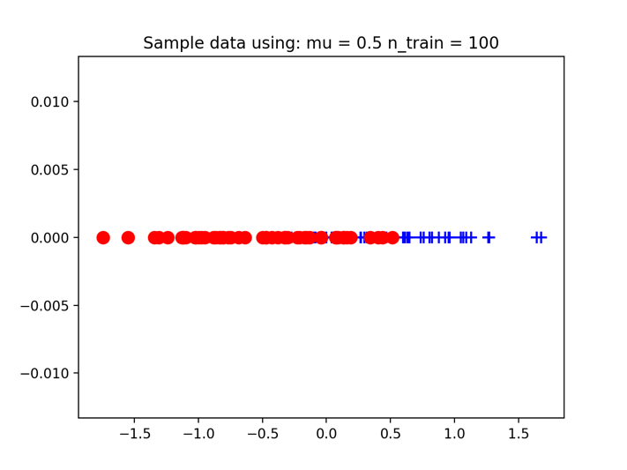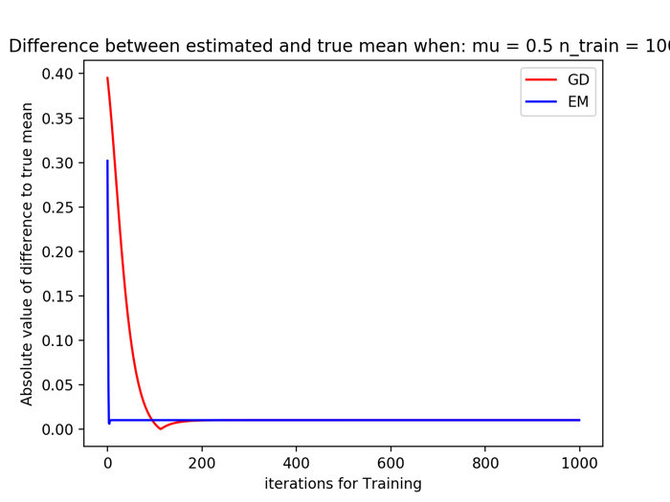

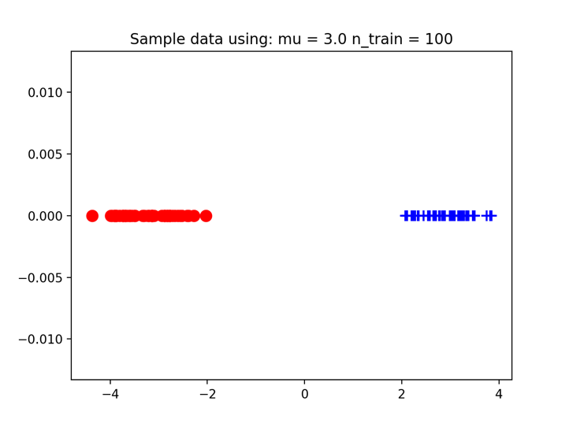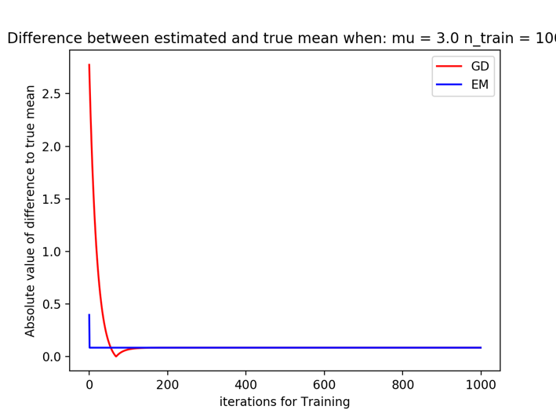

**4n**

When mu is large, clusters are well separated, kmeans work reasonably well, but when mu is small, clusters are not well separated, kmeans doesn’t work so well.

**Results:**

True mean:0.500, GA (final) estimate:0.510, EM (final) estimate:0.510, K-Means (final) estimate:0.591

True mean:3.000, GA (final) estimate:3.085, EM (final) estimate:3.085, K-Means (final) estimate:3.085

