**5a**

The initial guesses are not good since the clusters are close to each other and with elongated shape. EM is able to capture the clusters but “hard” version EM cannot.

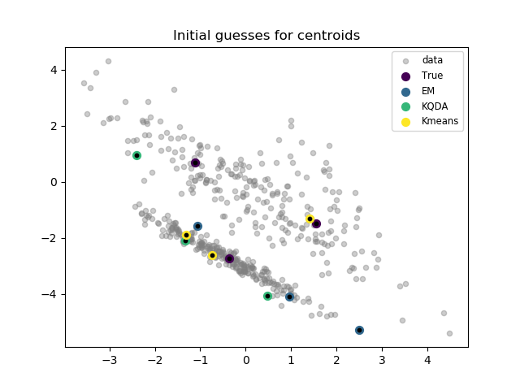

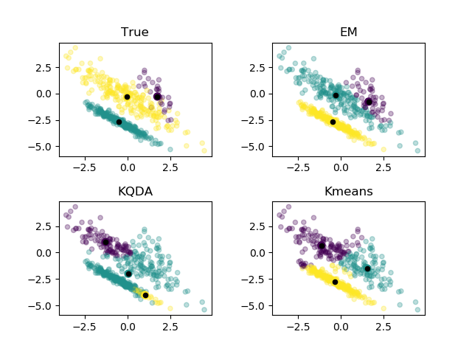

**5b**

when clusters are well separated, initial guessed are good, since when sampling, points from each cluster have similar chances of being drawn. So it is very likely when we draw 3 initial random points from all points, we are drawing one from each cluster.

In this case, all algorithm works pretty well.

