**3b**

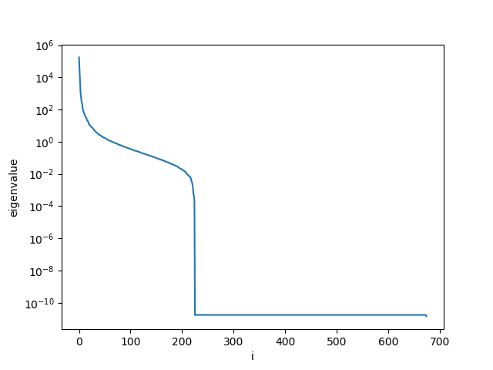

**3c**

Looks like a face if you look carefully. The features(eyes, nose, etc) on the face are the correlated parts between the mooney image and gray scale image.



**3d**

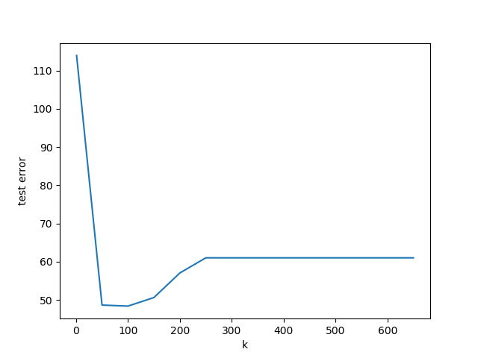

**3e**

We use k=100 since the test error is the smallest

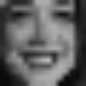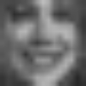

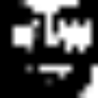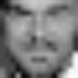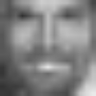

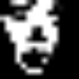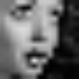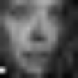

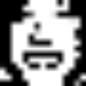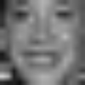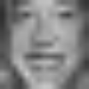

import os

import numpy as np

import cv2

import copy

import glob

import sys

from numpy.random import uniform

import pickle

from scipy.linalg import eig

from scipy.linalg import sqrtm

from numpy.linalg import inv

from numpy.linalg import svd

import numpy.linalg as LA

import matplotlib.pyplot as plt

import IPython

from sklearn.preprocessing import StandardScaler

def standardized(v):

return (v/255.0) * 2.0 - 1.0

def flatten_and_standardize(data):

result = []

for d in data:

d = d.flatten()

d = standardized(d)

result.append(d)

return result

class Mooney(object):

def __init__(self):

self.lmbda = 1e-5

def load_data(self):

self.x_train = pickle.load(open('x_train.p','rb'))

self.y_train = pickle.load(open('y_train.p','rb'))

self.x_test = pickle.load(open('x_test.p','rb'))

self.y_test = pickle.load(open('y_test.p','rb'))

def compute_covariance_matrices(self):

# USE STANDARD SCALAR TO DO MEAN SUBTRACTION

ss_x = StandardScaler(with_std = False)

ss_y = StandardScaler(with_std = False)

num_data = len(self.x_train)

x = self.x_train[0]

y = self.y_train[0]

x_f = x.flatten()

y_f = y.flatten()

x_f_dim = x_f.shape[0]

y_f_dim = y_f.shape[0]

self.x_dim = x_f_dim

self.y_dim = y_f_dim

self.C_xx = np.zeros([x_f_dim,x_f_dim])

self.C_yy = np.zeros([y_f_dim,y_f_dim])

self.C_xy = np.zeros([x_f_dim,y_f_dim])

x_data = []

y_data = []

for i in range(num_data):

x_image = self.x_train[i]

y_image = self.y_train[i]

# FLATTEN DATA

x_f = x_image.flatten()

y_f = y_image.flatten()

# STANDARDIZE DATA

x_f = standardized(x_f)

y_f = standardized(y_f)

x_data.append(x_f)

y_data.append(y_f)

# SUBTRACT MEAN

ss_x.fit(x_data)

x_data = ss_x.transform(x_data)

ss_y.fit(y_data)

y_data = ss_y.transform(y_data)

for i in range(num_data):

x_f = np.array([x_data[i]])

y_f = np.array([y_data[i]])

#####TO DO:

self.C_xx += x_f.T @ x_f

self.C_yy += y_f.T @ y_f

self.C_xy += x_f.T @ y_f

# DIVIDE BY THE NUMBER OF DATA POINTS

self.C_xx = 1.0/float(num_data)*self.C_xx

self.C_yy = 1.0/float(num_data)*self.C_yy

self.C_xy = 1.0/float(num_data)*self.C_xy

def compute_projected_data_matrix(self,X_proj):

Y = []

X = []

Y_test = []

X_test = []

# LOAD TRAINING DATA

for x in self.x_train:

x_f = np.array([x.flatten()])

# STANDARDIZE DATA

x_f = standardized(x_f)

# TODO: PROJECT DATA

X.append(x_f @ X_proj.T)

Y = flatten_and_standardize(self.y_train)

for x in self.x_test:

x_f = np.array([x.flatten()])

# STANDARDIZE DATA

x_f = standardized(x_f)

# TODO: PROJECT DATA

X_test.append(x_f @ X_proj.T)

Y_test = flatten_and_standardize(self.y_test)

# CONVERT TO MATRIX

self.X_ridge = np.vstack(X)

self.Y_ridge = np.vstack(Y)

self.X_test_ridge = np.vstack(X_test)

self.Y_test_ridge = np.vstack(Y_test)

def compute_data_matrix(self):

X = flatten_and_standardize(self.x_train)

Y = flatten_and_standardize(self.y_train)

X_test = flatten_and_standardize(self.x_test)

Y_test = flatten_and_standardize(self.y_test)

# CONVERT TO MATRIX

self.X_ridge = np.vstack(X)

self.Y_ridge = np.vstack(Y)

self.X_test_ridge = np.vstack(X_test)

self.Y_test_ridge = np.vstack(Y_test)

def solve_for_variance(self):

eigen_values = np.zeros((675,))

eigen_vectors = np.zeros((675, 675))

# TODO:

D1 = self.C_xx+self.lmbda*np.eye(675)

D1[np.diag_indices(675)] = 1/(D1.diagonal()**0.5)

D2 = self.C_yy+self.lmbda*np.eye(675)

D2[np.diag_indices(675)] = 1/(D2.diagonal()**0.5)

matrix = D1 @ self.C_xy @ D2

eigen_vectors, eigen_values, dummy = svd(matrix)

return eigen_values, eigen_vectors

def project_data(self, eig_val,eig_vec,proj=150):

# TODO: COMPUTE PROJECTION SINGULAR VECTORS

return eig_vec[:, 0:proj].T

def ridge_regression(self):

w_ridge = []

for i in range(self.y_dim):

# TODO: IMPLEMENT RIDGE REGRESSION

y = self.Y_ridge[:, i]

w = inv(self.X_ridge.T @ self.X_ridge + self.lmbda*np.eye(self.X_ridge.shape[1])) @ self.X_ridge.T @ y

w_ridge.append(w)

self.w_ridge = np.vstack(w_ridge)

def plot_image(self, vector):

vector = ((vector+1.0)/2.0)*255.0

vector = np.reshape(vector,(15,15,3))

p = vector.astype("uint8")

p = cv2.resize(p,(100,100))

count = 0

cv2.imwrite('a_face_'+str(count)+'.png',p)

def measure_error(self, X_ridge, Y_ridge):

prediction = np.matmul(self.w_ridge,X_ridge.T)

evaluation = Y_ridge.T - prediction

#print(evaluation)

dim,num_data = evaluation.shape

error = []

for i in range(num_data):

# COMPUTE L2 NORM for each vector then square

error.append(LA.norm(evaluation[:,i])**2)

# Return average error

return np.mean(error)

def draw_images(self):

for count, x in enumerate(self.X_test_ridge):

prediction = np.matmul(self.w_ridge,x)

prediction = ((prediction+1.0)/2.0)*255.0

prediction = np.reshape(prediction,(15,15,3))

p = prediction.astype("uint8")

p = cv2.resize(p,(100,100))

cv2.imwrite('face_'+str(count)+'.png',p)

for count, x in enumerate(self.x_test):

x = x.astype("uint8")

x = cv2.resize(x,(100,100))

cv2.imwrite('og_face_'+str(count)+'.png',x)

for count, x in enumerate(self.y_test):

x = x.astype("uint8")

x = cv2.resize(x,(100,100))

cv2.imwrite('gt_face_'+str(count)+'.png',x)

if __name__ == '__main__':

mooney = Mooney()

mooney.load_data()

mooney.compute_covariance_matrices()

eig_val, eig_vec = mooney.solve_for_variance()

plt.semilogy(np.arange(675), eig_val)

plt.xlabel('i')

plt.ylabel('eigenvalue')

plt.savefig('spectrum.png')

plt.show()

mooney.plot_image(eig_vec[:, 0])

proj = [1,50,100,150,200,250,300,350,400,450,500,650]

error_test = []

#for p in proj:

# X_proj = mooney.project_data(eig_val,eig_vec, proj=p)

# COMPUTE REGRESSION

# mooney.compute_projected_data_matrix(X_proj)

# mooney.ridge_regression()

# training_error = mooney.measure_error(mooney.X_ridge, mooney.Y_ridge)

# test_error = mooney.measure_error(mooney.X_test_ridge, mooney.Y_test_ridge)

## mooney.draw_images()

# error_test.append(test_error)

#plt.plot(proj,error_test)

#plt.xlabel('k')

#plt.ylabel('test error')

#plt.savefig('error.png')

#plt.show()

# COMPUTE REGRESSION NO PROJECT

X_proj = mooney.project_data(eig_val,eig_vec, proj=100)

mooney.compute_projected_data_matrix(X_proj)

mooney.ridge_regression()

mooney.draw_images()

#training_error = mooney.measure_error(mooney.X_ridge, mooney.Y_ridge)

#test_error = mooney.measure_error(mooney.X_test_ridge, mooney.Y_test_ridge)