**4b**

step_size = 0.1 is most efficient

step_size = 0.1 (in 1000 steps):

The real object location is

[[ 44.38632327 33.36743274]]

The estimated object location with zero initialization is

[[ 43.07188433 32.71217817]]

The estimated object location with random initialization is

[[ 43.07188433 32.71217817]]

step_size = 0.01 (in 1000 steps):

The real object location is

[[ 44.38632327 33.36743274]]

The estimated object location with zero initialization is

[[ 43.07188433 32.71217817]]

The estimated object location with random initialization is

[[ 43.07188433 32.71217817]]

step_size = 0.001(in 1000 steps):

The real object location is

[[ 44.38632327 33.36743274]]

The estimated object location with zero initialization is

[[ 42.57128857 32.04116473]]

The estimated object location with random initialization is

[[ 44.42031211 34.37381408]]

-----------------code-------------------------------------------------------------

from common import *

from math import sqrt

import numpy as np

from numpy.linalg import norm

########################################################################

######### Part b ###################################

########################################################################

########################################################################

######### Gradient Computing and MLE ###################################

########################################################################

def compute_gradient_of_likelihood(single_obj_loc, sensor_loc,

single_distance):

"""

Compute the gradient of the loglikelihood function for part a.

Input:

single_obj_loc: 1 * d numpy array.

Location of the single object.

sensor_loc: k * d numpy array.

Location of sensor.

single_distance: k dimensional numpy array. (k: number of sensors, d: dimensionality)

Observed distance of the object.

Output:

grad: d-dimensional numpy array.

"""

#Your code: implement the gradient of loglikelihood

#grad = np.zeros_like(single_obj_loc)

#print(single_obj_loc)

#print(np.diag(single_obj_loc[0, :]))

#print(np.ones_like(sensor_loc))

sensor_loc_diff = sensor_loc - np.ones_like(sensor_loc) @ np.diag(single_obj_loc[0, :])

#print(sensor_loc)

#print(sensor_loc_diff)

sensor_loc_diff_norm = norm(sensor_loc_diff, axis = 1)

#print('\n')

#print(sensor_loc_diff_norm.shape)

#print(single_distance.shape)

second_term = 1 - single_distance/sensor_loc_diff_norm

#print(second_term)

grad = -2*sensor_loc_diff.T @ second_term

#print(grad)

return grad

def find_mle_by_grad_descent_part_b(initial_obj_loc,

sensor_loc, single_distance, lr=0.001, num_iters = 10000):

"""

Compute the gradient of the loglikelihood function for part a.

Input:

initial_obj_loc: 1 * d numpy array.

Initialized Location of the single object.

sensor_loc: k * d numpy array. Location of sensor.

single_distance: k dimensional numpy array.

Observed distance of the object.

Output:

obj_loc: 1 * d numpy array. The mle for the location of the object.

"""

# Your code: do gradient descent

obj_loc = initial_obj_loc

for i in range(num_iters):

obj_loc = obj_loc - lr * compute_gradient_of_likelihood(obj_loc, sensor_loc,

single_distance)

return obj_loc

if __name__ == "__main__":

########################################################################

######### MAIN ########################################################

########################################################################

# Your code: set some appropriate learning rate here

lr = 0.001

np.random.seed(0)

sensor_loc = generate_sensors()

obj_loc, distance = generate_data(sensor_loc)

single_distance = distance[0]

print('The real object location is')

print(obj_loc)

# Initialized as [0,0]

initial_obj_loc = np.array([[0.,0.]])

estimated_obj_loc = find_mle_by_grad_descent_part_b(initial_obj_loc,

sensor_loc, single_distance, lr=lr, num_iters = 1000)

print('The estimated object location with zero initialization is')

print(estimated_obj_loc)

# Random initialization.

initial_obj_loc = np.random.randn(1,2)*100+100

#initial_obj_loc = np.array([[44.38, 33.36]])

estimated_obj_loc = find_mle_by_grad_descent_part_b(initial_obj_loc,

sensor_loc, single_distance, lr=lr, num_iters = 1000)

print('The estimated object location with random initialization is')

print(estimated_obj_loc)

**4c**

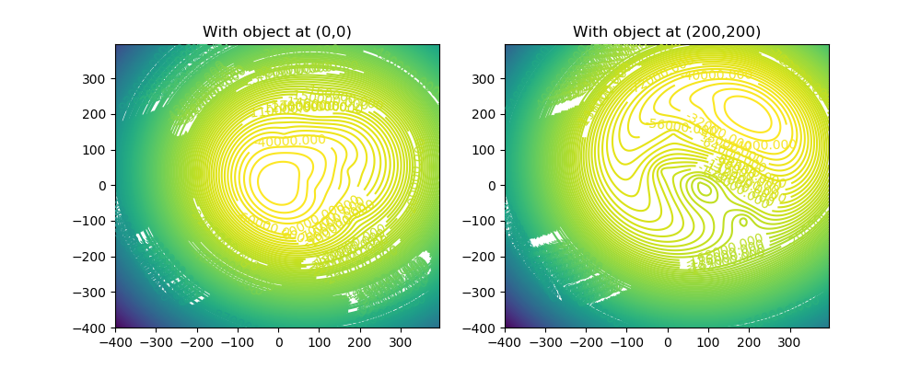

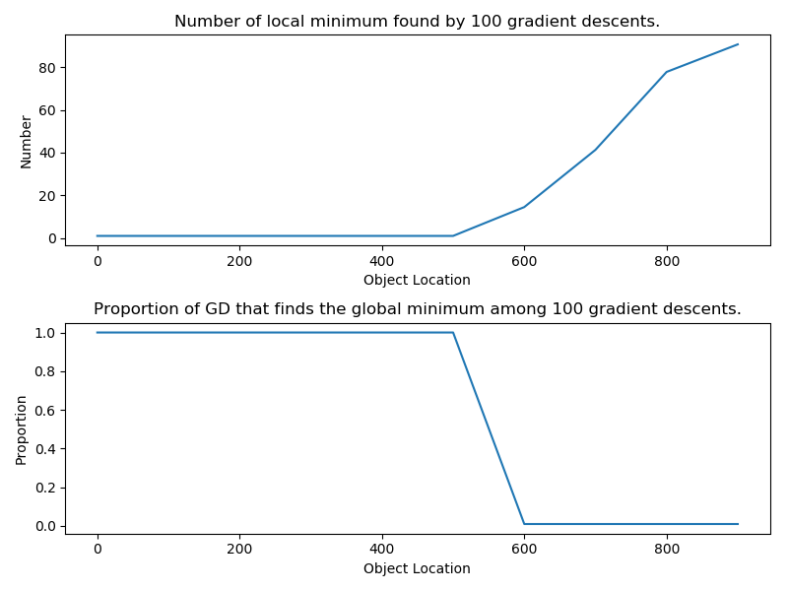

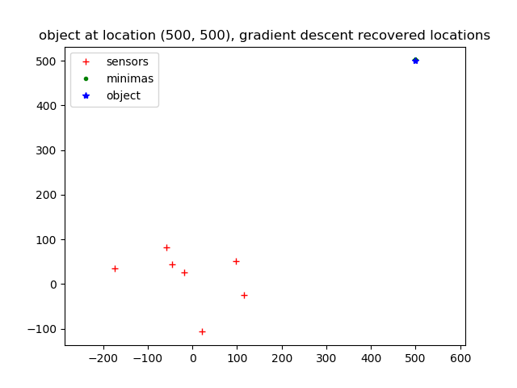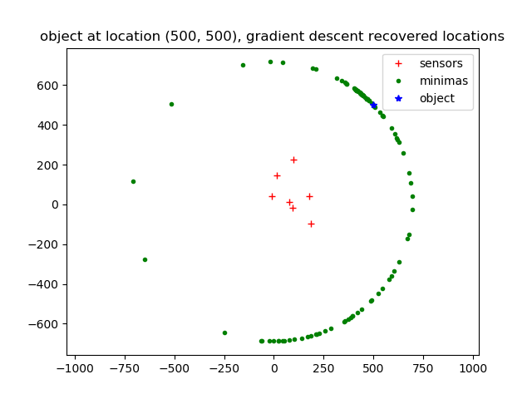

step_size = 0.1 step_size = 0.01

**4d**

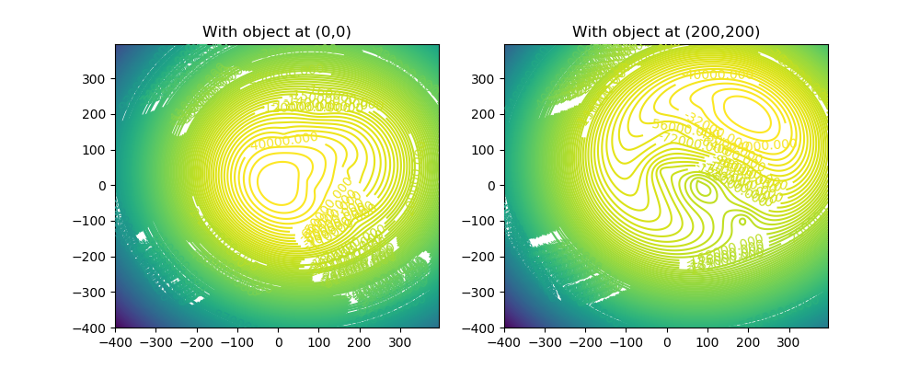

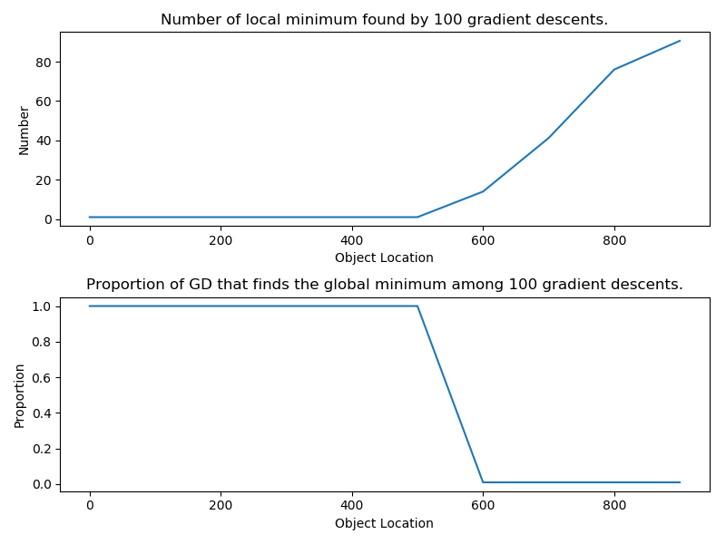

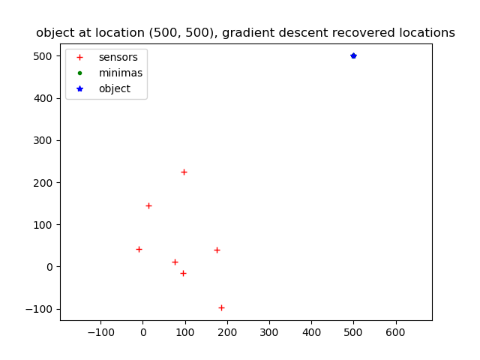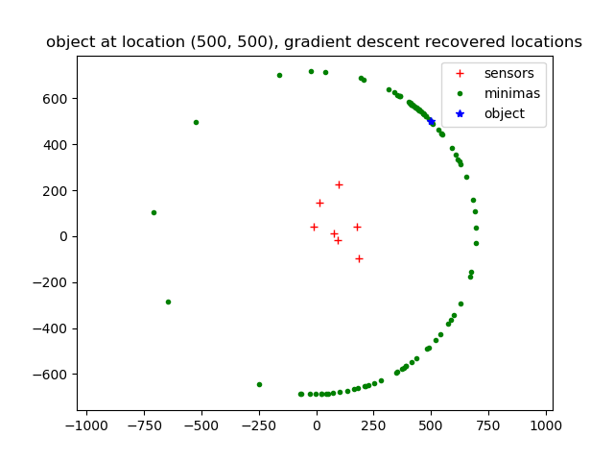

step_size = 0.1 step_size = 0.01

**4e**

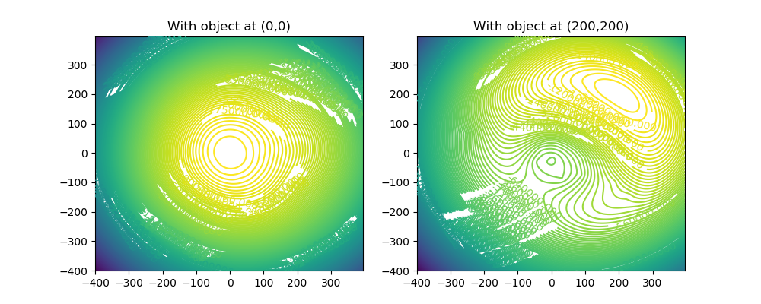

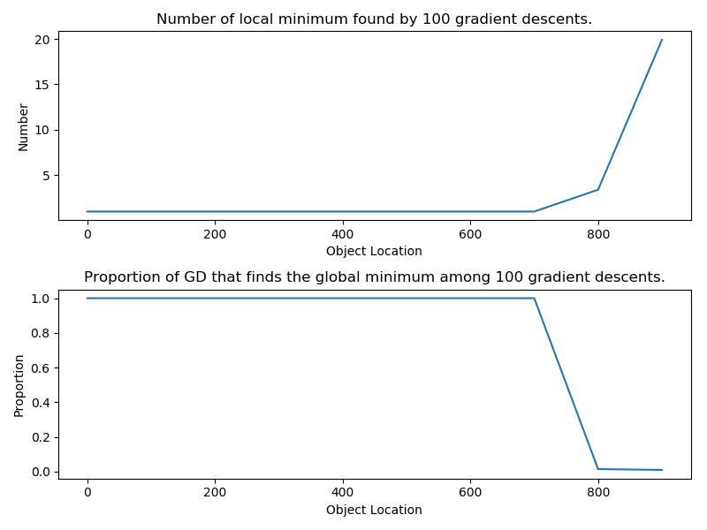

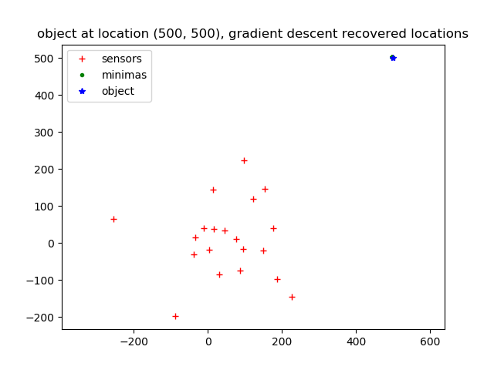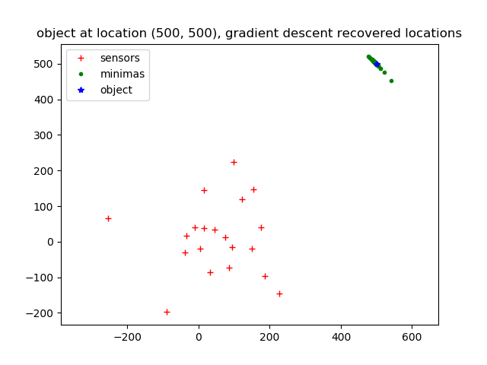

step_size = 0.05 step_size = 0.01

**4f**

The MSE for Case 1 is 5.927908379315981

The MSE for Case 2 is 226.22539833527367

The MSE for Case 2 (if we knew mu is [300,300]) is 1.306100883985725

------------------------code------------------------

from common import *

from part_b_starter import find_mle_by_grad_descent_part_b

from part_b_starter import compute_gradient_of_likelihood

from part_c_starter import log_likelihood

from numpy.linalg import norm

########################################################################

######### Gradient Computing and MLE ##################################

########################################################################

def compute_grad_likelihood(sensor_loc, obj_loc, distance):

"""

Compute the gradient of the loglikelihood function for part f.

Input:

sensor_loc: k * d numpy array.

Location of sensors.

obj_loc: n * d numpy array.

Location of the objects.

distance: n * k dimensional numpy array.

Observed distance of the object.

Output:

grad: k * d numpy array.

"""

grad = np.zeros(sensor_loc.shape)

# Your code: finish the grad loglike

for i in range(sensor_loc.shape[0]):

sensor_loc_diff = np.ones_like(obj_loc) @ np.diag(sensor_loc[i, :]) - obj_loc

sensor_loc_diff_norm = norm(sensor_loc_diff, axis = 1)

second_term = 1 - distance[:, i]/sensor_loc_diff_norm

grad[i, :] = (2*sensor_loc_diff.T @ second_term).T

return grad

def find_mle_by_grad_descent(initial_sensor_loc,

obj_loc, distance, lr=0.001, num_iters = 1000):

"""

Compute the gradient of the loglikelihood function for part f.

Input:

initial_sensor_loc: k * d numpy array.

Initialized Location of the sensors.

obj_loc: n * d numpy array. Location of the n objects.

distance: n * k dimensional numpy array.

Observed distance of the n object.

Output:

sensor_loc: k * d numpy array. The mle for the location of the object.

"""

sensor_loc = initial_sensor_loc

# Your code: finish the gradient descent

for i in range(num_iters):

sensor_loc = sensor_loc - lr * compute_grad_likelihood(sensor_loc, obj_loc, distance)

return sensor_loc

########################################################################

######### Gradient Computing and MLE ##################################

########################################################################

np.random.seed(0)

sensor_loc = generate_sensors()

obj_loc, distance = generate_data(sensor_loc, n = 100)

print('The real sensor locations are')

print(sensor_loc)

# Initialized as zeros.

initial_sensor_loc = np.random.randn(7,2)*100

estimated_sensor_loc = find_mle_by_grad_descent(initial_sensor_loc,

obj_loc, distance, lr=0.01, num_iters = 10000)

print('The predicted sensor locations are')

print(estimated_sensor_loc)

print('\n')

########################################################################

######### Estimate distance given estimated sensor locations. #########

########################################################################

def compute_distance_with_sensor_and_obj_loc(sensor_loc, obj_loc):

"""

stimate distance given estimated sensor locations.

Input:

sensor_loc: k * d numpy array.

Location of the sensors.

obj_loc: n * d numpy array. Location of the n objects.

Output:

distance: n * k dimensional numpy array.

"""

estimated_distance = scipy.spatial.distance.cdist(obj_loc,

sensor_loc,

metric='euclidean')

return estimated_distance

########################################################################

######### MAIN #######################################################

########################################################################

np.random.seed(100)

########################################################################

######### Case 1. #####################################################

########################################################################

mse =0

for i in range(100):

obj_loc, distance = generate_data(sensor_loc, k = 7, d = 2, n = 1, original_dist = True)

obj_loc, distance = generate_data_given_location(estimated_sensor_loc, obj_loc, k = 7, d = 2)

l = float('-inf')

initial_obj_loc = np.array([[0.,0.]])

mse += 1.0/100 * norm(find_mle_by_grad_descent_part_b(initial_obj_loc,

estimated_sensor_loc, distance[0], lr=0.01, num_iters = 1000) - obj_loc)

# Your code: compute the mse for this case

print('The MSE for Case 1 is {}'.format(mse))

########################################################################

######### Case 2. #####################################################

########################################################################

mse =0

for i in range(100):

obj_loc, distance = generate_data(sensor_loc, k = 7, d = 2, n = 1, original_dist = False)

obj_loc, distance = generate_data_given_location(estimated_sensor_loc, obj_loc, k = 7, d = 2)

l = float('-inf')

# Your code: compute the mse for this case

initial_obj_loc = np.array([[0.,0.]])

mse += 1.0/100 * norm(find_mle_by_grad_descent_part_b(initial_obj_loc,

estimated_sensor_loc, distance[0], lr=0.01, num_iters = 1000) - obj_loc)

print('The MSE for Case 2 is {}'.format(mse))

########################################################################

######### Case 3. #####################################################

########################################################################

mse =0

for i in range(100):

obj_loc, distance = generate_data(sensor_loc, k = 7, d = 2, n = 1, original_dist = False)

obj_loc, distance = generate_data_given_location(estimated_sensor_loc, obj_loc, k = 7, d = 2)

l = float('-inf')

# Your code: compute the mse for this case

initial_obj_loc = np.array([[300.,300.]])

mse += 1.0/100 * norm(find_mle_by_grad_descent_part_b(initial_obj_loc,

estimated_sensor_loc, distance[0], lr=0.01, num_iters = 1000) - obj_loc)

print('The MSE for Case 2 (if we knew mu is [300,300]) is {}'.format(mse))