Boilerplate Metrics

Amy Shuff

2023-04-14

## Growing Up Publications Indicators

POTENTIAL SHARED INDICATORS

Median wages (number of households with children living below poverty line) Median rents (Number of children living in households with a high housing cost burden) Age-specific coverage rates for health insurance SNAP application and enrollment rates vs eligibility (for families with children; WIC focus?) Housing stability (mobility rates amongst children; include school mobility?) Trade school and other post-secondary opportunities Unemployment rates and other labor and employment metrics Reports of child abuse and neglect from CPS –poses a challenge Chronic absenteeism Test scores? Immigration/linguistic indicators Child care availability

EL PASO INDICATORS (August or November release)

Number of immigrant children ([C@R](mailto:C@R) definition) Linguistic indicators? Other immigration specific indicators that highlight unique challenges posed to immigrant families Opportunity Youth focus UTEP Data for OY Food insecurity

SAN ANTONIO INDICATORS (Late September release)

Child abuse indicators (needs building out) Poverty and intergenerational barriers (mentioned during the check in with san antonio, unsure how to measure this) Social community engagement with families/parents (mentioned during the check in with san antonio, unsure how to measure this)

## Child Care Desert Indicators

## [1] "c3d12d20da12dc79099884d8e4a136a9f30a3b39"

## Census Data Examples

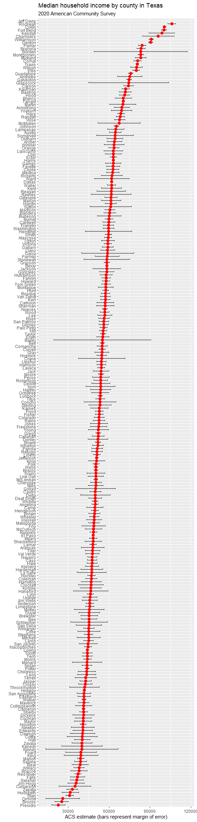

## | | | 0% | |= | 1% | |= | 2% | |== | 2% | |== | 3% | |=== | 4% | |=== | 5% | |==== | 5% | |==== | 6% | |===== | 7% | |====== | 8% | |====== | 9% | |======= | 9% | |======= | 10% | |======= | 11% | |======== | 11% | |======== | 12% | |========= | 12% | |========= | 13% | |========== | 14% | |========== | 15% | |=========== | 15% | |=========== | 16% | |============ | 17% | |============ | 18% | |============= | 18% | |============= | 19% | |============== | 19% | |============== | 20% | |=============== | 21% | |=============== | 22% | |================ | 23% | |================= | 24% | |================= | 25% | |================== | 26% | |=================== | 27% | |=================== | 28% | |==================== | 29% | |===================== | 29% | |===================== | 30% | |====================== | 31% | |====================== | 32% | |======================= | 32% | |======================= | 33% | |======================== | 34% | |======================== | 35% | |========================= | 36% | |========================== | 37% | |========================== | 38% | |=========================== | 39% | |============================ | 40% | |============================= | 41% | |============================= | 42% | |============================== | 42% | |============================== | 43% | |=============================== | 44% | |================================ | 45% | |================================ | 46% | |================================= | 47% | |================================== | 48% | |================================== | 49% | |=================================== | 50% | |=================================== | 51% | |==================================== | 52% | |===================================== | 53% | |====================================== | 54% | |======================================= | 55% | |======================================= | 56% | |======================================== | 57% | |========================================= | 58% | |========================================= | 59% | |========================================== | 60% | |=========================================== | 61% | |=========================================== | 62% | |============================================ | 63% | |============================================= | 64% | |============================================= | 65% | |============================================== | 65% | |============================================== | 66% | |=============================================== | 67% | |================================================ | 68% | |================================================ | 69% | |================================================= | 70% | |================================================== | 71% | |================================================== | 72% | |=================================================== | 73% | |==================================================== | 74% | |==================================================== | 75% | |===================================================== | 76% | |====================================================== | 76% | |====================================================== | 77% | |======================================================= | 78% | |======================================================= | 79% | |======================================================== | 80% | |========================================================= | 81% | |========================================================= | 82% | |========================================================== | 83% | |=========================================================== | 84% | |=========================================================== | 85% | |============================================================ | 86% | |============================================================= | 87% | |============================================================= | 88% | |============================================================== | 89% | |=============================================================== | 89% | |=============================================================== | 90% | |================================================================ | 91% | |================================================================= | 92% | |================================================================= | 93% | |================================================================== | 94% | |================================================================== | 95% | |=================================================================== | 96% | |==================================================================== | 97% | |==================================================================== | 98% | |===================================================================== | 99% | |======================================================================| 100%

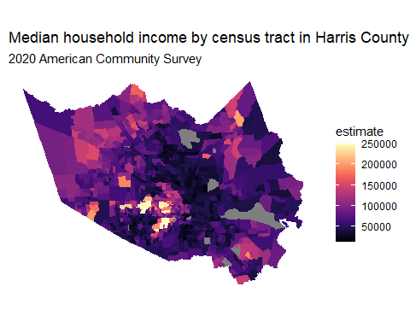

## | | | 0% | |= | 1% | |= | 2% | |== | 2% | |== | 3% | |=== | 4% | |=== | 5% | |==== | 5% | |==== | 6% | |===== | 7% | |===== | 8% | |====== | 8% | |====== | 9% | |======= | 10% | |======= | 11% | |======== | 11% | |======== | 12% | |========= | 13% | |========= | 14% | |========== | 14% | |========== | 15% | |=========== | 15% | |=========== | 16% | |============ | 16% | |============ | 17% | |============= | 18% | |============= | 19% | |============== | 19% | |============== | 20% | |=============== | 21% | |=============== | 22% | |================ | 22% | |================ | 23% | |================= | 24% | |================= | 25% | |================== | 25% | |================== | 26% | |=================== | 27% | |=================== | 28% | |==================== | 28% | |==================== | 29% | |===================== | 30% | |===================== | 31% | |====================== | 31% | |====================== | 32% | |======================= | 32% | |======================= | 33% | |======================== | 34% | |======================== | 35% | |========================= | 35% | |========================= | 36% | |========================== | 37% | |========================== | 38% | |=========================== | 38% | |=========================== | 39% | |============================ | 40% | |============================ | 41% | |============================= | 41% | |============================= | 42% | |============================== | 42% | |============================== | 43% | |=============================== | 44% | |=============================== | 45% | |================================ | 45% | |================================ | 46% | |================================= | 47% | |================================== | 48% | |================================== | 49% | |=================================== | 49% | |=================================== | 50% | |==================================== | 51% | |==================================== | 52% | |===================================== | 52% | |===================================== | 53% | |====================================== | 54% | |====================================== | 55% | |======================================= | 55% | |======================================= | 56% | |======================================== | 57% | |======================================== | 58% | |========================================= | 58% | |========================================= | 59% | |========================================== | 60% | |========================================== | 61% | |=========================================== | 61% | |=========================================== | 62% | |============================================ | 63% | |============================================= | 64% | |============================================= | 65% | |============================================== | 65% | |============================================== | 66% | |=============================================== | 67% | |=============================================== | 68% | |================================================ | 68% | |================================================ | 69% | |================================================= | 70% | |================================================= | 71% | |================================================== | 71% | |================================================== | 72% | |=================================================== | 72% | |=================================================== | 73% | |==================================================== | 74% | |==================================================== | 75% | |===================================================== | 75% | |===================================================== | 76% | |====================================================== | 77% | |====================================================== | 78% | |======================================================= | 78% | |======================================================= | 79% | |======================================================== | 79% | |======================================================== | 80% | |========================================================= | 81% | |========================================================= | 82% | |========================================================== | 82% | |========================================================== | 83% | |=========================================================== | 84% | |=========================================================== | 85% | |============================================================ | 85% | |============================================================ | 86% | |============================================================= | 87% | |============================================================= | 88% | |============================================================== | 88% | |============================================================== | 89% | |=============================================================== | 90% | |=============================================================== | 91% | |================================================================ | 91% | |================================================================ | 92% | |================================================================= | 93% | |================================================================= | 94% | |================================================================== | 94% | |================================================================== | 95% | |=================================================================== | 95% | |=================================================================== | 96% | |==================================================================== | 96% | |==================================================================== | 97% | |===================================================================== | 98% | |===================================================================== | 99% | |======================================================================| 99% | |======================================================================| 100%

