2023 Food Rankings

Amy Shuff

2023-04-05

Our 2023 Food Rankings analyze data from the 2022 Program Year (2021-2022 data).

The code used to create our rankings is available to the public on [github](https://github.com/amyshuff/Food-Rankings-2021-2022).

# Data Sources

## Texas Education Agency (TEA)

* Total Enrollment Counts in Student Program and Special Populations Reports, PEIMS Data 2021-2022

TEA data was obtained via Public Records Request. From this data we use the student enrollment counts and economically disadvantaged counts.

Student enrollment for small campuses are masked. In the case of the reported number being <10, we use 10. This means our district student counts are a slight overestimate.

Economically disadvantaged counts are sometimes unavailable, so in that case they are assumed zero.

Percent economically disadvantaged for each district is calculated from the campus student counts.

## Texas Department of Agriculture (TDA)

### School Nutrition Program (SNP)

* Although we obtained our data from a public information request, it is also available on the [Food and Nutrition Meals Served Dashboard, 2021-2022](https://data.texas.gov/stories/s/2021-2022-TDA-Food-and-Nutrition-Meals-Served-Dash/93tt-ffn6)

SNP Data includes meal counts from the National School Lunch Program (NSLP) and the School Breakfast Program (SBP).

Credit for participating in the Community Eligible Provision (CEP) was given to the entire district if they had any participating location.

### Seamless Summer Option (SSO)

SSO data was obtained from the TDA F&N Meals Served Dashboard.

* [2021-2022 Monthly SNP & SSO School Meal Count](https://data.texas.gov/dataset/2021-2022-Monthly-School-Meal-Count/dyrd-amq2)

Note from the data dashboard: “In March 2020, USDA began allowing flexibility in nutrition assistance program policies to support continued meal access during the coronavirus pandemic (COVID-19). This included offering School Nutrition Program sponsors the option to provide meals through Seamless Summer Option (SSO) in program year 2021-2022.”

The SSO is what schools used to offer free meals to all students regardless of income. Because of this, we are choosing to look at total number of meals served instead of only the free and reduced as we’ve done in years past. This option will not be available next year because the program has ended.

### Child and Adult Care Food Program (CACFP)

* [Child and Adult Care Food Programs (CACFP) – At Risk– Meal Reimbursement – Program Year 2021-2022](https://data.texas.gov/dataset/Child-and-Adult-Care-Food-Programs-CACFP-At-Risk-M/e4wr-4i5j)

CACFP data captures meals (supper) served in At-Risk afterschool care centers.

# Analysis

## Harmony Districts

Harmony Public Schools are listed under multiple district numbers (101858, 101862, 71806, 15828, 161807, 101846, 227816) in both the TEA and TDA data, but we combine them and consider them as a single district.

## Aggregate data up to district level

TDA data is reported monthly by Contracting Entities (CE) and participating sites. Usually October is used as the snapshot claim month for the year. This year fewer sites reported to TDA, and those that did didn’t report every month, instead favoring SSO for meal reimbursement, so we used their maximum claim month for the year instead.

Breakfast and lunch average daily participation (ADP) rates were found by dividing all meals served by the number of days meals were served.

Then the percent of breakfast and lunch participation was found by dividing their respective ADPs by the total number of students, as reported by the TEA data.

Our previous rankings found the percent of breakfast and lunch participation by dividing the free and reduced meals by the students that were eligible for them. We are looking at all meals for all students this year, since everyone was eligible for a free meal with SSO.

Credit for supper and snacks was given if any were offered by any site in the district at any point in the year.

## Overall Rankings

District scores were calculated as follows

* 25% lunch participation percent
* 50% breakfast participation percent
* 10% serving supper
* 15% serving after school snacks

We only include districts that have at least 1,000 students and at least 60% economically disadvantaged student population.

Top 10 Districts Overall

| District Name | Rank | County | ESC Region | Total Enrollment | % Economically Disadvantaged | Overall Score | % Lunch Participation | % Breakfast Participation | CACFP Supper | Afterschool Snack | CEP |
| --- | --- | --- | --- | --- | --- | --- | --- | --- | --- | --- | --- |
| CLINT ISD | 1 | EL PASO | 19 | 10,494 | 86.7 | 82.7 | 71.2 | 79.9 | Yes | Yes | Yes |
| DONNA ISD | 2 | HIDALGO | 1 | 13,080 | 93.9 | 81.3 | 80.1 | 72.5 | Yes | Yes | Yes |
| IDEA ACADEMY | 3 | HIDALGO | 1 | 67,988 | 83.3 | 81.1 | 79.5 | 72.3 | Yes | Yes | Yes |
| HARLANDALE ISD | 4 | BEXAR | 20 | 12,094 | 88.0 | 77.1 | 64.2 | 72.2 | Yes | Yes | Yes |
| MCALLEN ISD | 5 | HIDALGO | 1 | 20,410 | 73.8 | 77.0 | 70.5 | 68.7 | Yes | Yes | Yes |
| EAGLE PASS ISD | 6 | MAVERICK | 20 | 13,385 | 83.1 | 71.3 | 64.3 | 80.4 | No | Yes | Yes |
| LA JOYA ISD | 7 | HIDALGO | 1 | 24,163 | 93.2 | 71.1 | 73.4 | 55.6 | Yes | Yes | Yes |
| EDINBURG ISD | 8 | HIDALGO | 1 | 32,078 | 82.2 | 68.4 | 75.5 | 49.1 | Yes | Yes | Yes |
| SAN ANTONIO ISD | 9 | BEXAR | 20 | 44,731 | 87.9 | 67.3 | 67.1 | 51.1 | Yes | Yes | Yes |
| HARLINGEN CONS ISD | 10 | CAMERON | 1 | 17,037 | 76.5 | 66.9 | 71.9 | 47.8 | Yes | Yes | Yes |

## Large districts

Districts are considered large if they have at least 50,000 students.

Top 5 Large Districts

| District Name | Rank | County | ESC Region | Total Enrollment | % Economically Disadvantaged | Overall Score | % Lunch Participation | % Breakfast Participation | CACFP Supper | Afterschool Snack | CEP |
| --- | --- | --- | --- | --- | --- | --- | --- | --- | --- | --- | --- |
| IDEA ACADEMY | 1 | HIDALGO | 1 | 67,988 | 83.3 | 81.1 | 79.5 | 72.3 | Yes | Yes | Yes |
| ALDINE ISD | 2 | HARRIS | 4 | 61,642 | 89.7 | 61.8 | 70.6 | 38.4 | Yes | Yes | No |
| HOUSTON ISD | 3 | HARRIS | 4 | 194,622 | 79.2 | 58.5 | 55.2 | 39.4 | Yes | Yes | Yes |
| DALLAS ISD | 4 | DALLAS | 10 | 143,574 | 85.1 | 57.6 | 60.9 | 34.7 | Yes | Yes | Yes |
| GARLAND ISD | 5 | DALLAS | 10 | 53,685 | 73.9 | 53.5 | 63.6 | 25.2 | Yes | Yes | Yes |

## Middle-income districts

Districts are considered middle-income if they have 60-70% economically disadvantaged student population. This takes out high poverty schools and focuses on those which often face more challenges in implementing school food programs to scale.

Top 5 Middle-income Districts

| District Name | Rank | County | ESC Region | Total Enrollment | % Economically Disadvantaged | Overall Score | % Lunch Participation | % Breakfast Participation | CACFP Supper | Afterschool Snack | CEP |
| --- | --- | --- | --- | --- | --- | --- | --- | --- | --- | --- | --- |
| JUDSON ISD | 1 | BEXAR | 20 | 24,552 | 68.4 | 65.8 | 67.5 | 47.8 | Yes | Yes | Yes |
| WICHITA FALLS ISD | 2 | WICHITA | 9 | 13,380 | 65.8 | 63.9 | 69.7 | 42.9 | Yes | Yes | No |
| NEW CANEY ISD | 3 | MONTGOMERY | 6 | 17,116 | 67.1 | 52.3 | 72.5 | 38.3 | No | Yes | No |
| EAST CENTRAL ISD | 4 | BEXAR | 20 | 10,018 | 66.2 | 51.1 | 63.4 | 40.5 | No | Yes | Yes |
| VICTORIA ISD | 5 | VICTORIA | 3 | 13,315 | 68.5 | 50.4 | 58.2 | 21.7 | Yes | Yes | Yes |

# Key Take-Aways

All 5,429,895 students in Texas were offered free meals this year.

The top ranking districts all had over 70% of their student population participating in lunch

Even the lowest ranked district had 45.5% of their student population participating in lunch

Top 10 school districts overall: Clint ISD, Donna ISD, IDEA Academy, Harlandale ISD, McAllen ISD, Eagle Pass ISD, La Joya ISD, Edinburg ISD, San Antonio ISD, Harlingen Consolidated ISD

Top 5 large school districts: IDEA Academy, Aldine ISD, Houston ISD, Dallas ISD, Garland ISD

Top 5 middle-income school districts: Judson ISD, Wichita Falls ISD, New Caney ISD, East Central ISD, Victoria ISD

District with the highest lunch participation: Los Fresnos Consolidated ISD, with 87.8% of their total student population participating in lunch

District with the highest breakfast participation: Eagle Pass ISD, with 80.4% of their total student population participating in breakfast

16.6% of districts participate in the CACFP after-school meal program

# Longitudinal Data

* [Meal and Reimbursement Data, Program Years 2015-2021](https://data.texas.gov/stories/s/e2dm-5r4v)

Because the last two years had an unprecedented number of free meals available to students due to covid relief money, we wanted to see what impact that had on the total number of meals served from year to year. This will be especially interesting to look at next year now that the programs have ended.

Looking at the total number of breakfast and lunch meals served to all students from year to year, the number actually decreased for 2021-2022. Could be due to staffing issues, supply issues, and school shut downs.  
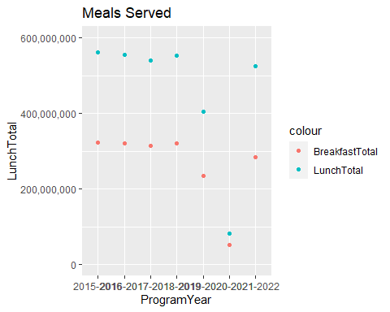

Looking at the number of days breakfast and lunch were served, there was a decrease in 2020-2021 as well.  
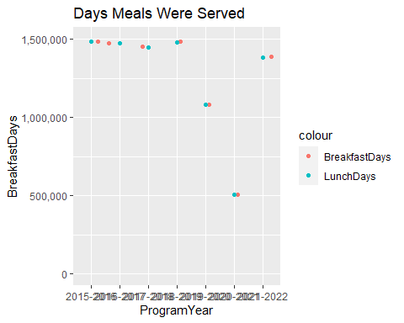

Finding the average daily participation rates (Total Meals divided by Total Days Served)

Note that the data is organized by site, so this is the average number of students served on each site each day. The rate was slightly higher in 2021-2022 for lunch but not for breakfast.  
