Breakdown of ‘Maintenance of biodiversity on islands’

Ryan Chisholm et al. 2016

1. Introduction

MacArthur & Wilson (The Theory of Island Biogeography, 1967)

Species richness on islands at colonization-extinction dynamic equilibrium is reduced by distance and increased by area.

Empirical examples where this theory breaks down! Archipelagos show unusual SARs.

The Small Island Effect

Below threshold of island area, species richness varies independently of area.

Observed in a wide range of taxa.

Need a general theory to explain this, and classic island biogeography. Need a theory to explain what goes on across all island sizes.

Two main hypotheses

1) Extinction rates on small islands are high because the habitats are unstable = rapid species turnover = could mean more species if no *one* species becomes dominant. This little island, big storm!

2) Small islands may be missing certain habitats (like a riparian zone) = could mean less species can coexist

Issues

Neither of these hypotheses explain exactly why, below a certain threshold, small islands are exempt from the target effect (more area = more immigration).

Hypothesis 1

For example, larger small islands should still have more species than smaller small islands, even if they are both exposed to catastrophic disturbances, because the larger island should still be more likely to receive immigrants, but this isn’t always the case. Why? What happens when I look at only islands with very few niches? How do patterns of SAR change?

Hypothesis 2

This predicts very low species richness, but often we see anomalously high species richness.

Also, these are qualitative, not quantitative – we need a mathematical description to test what is happening!

THIS THEORY!

Explains classical island biogeography (more area = more species), and the small island effect (less area = all sorts of weird stuff!)

Diversity on islands of any size (large or small) is maintained by niche constrains and immigration.

As area increases, niche diversity increases (slowly) and so does immigration (quickly). This means number of niches constrain small islands (where immigration is low) but immigration constrains on larger islands – SHOW THIS WITH MY DATA! Look at small islands with low immigration – does area matter? Look at large islands with high immigration, does area matter? Do niches matter?

Tests

1) Does this combination of mechanisms (number of niches, rate of immigration) produce biphasic island SARs? Make a mechanistic mathematical model and fit to 100 archipelago datasets.

2) Use datasets to test if the transition between niche regime and immigration regime happens at smaller island areas in archipelagos where immigration is higher.

1. Materials and Methods: Mathematical Model

Model includes – immigration and niche structure, how they vary with island area.

Used previously publish model (Niche and neutral models predict asymptotically equivalent species abundance distributions in high diversity ecological communities (2010), Theory predicts a rapid transition from niche structured to neutral biodiversity patterns across a speciation-rate gradient (2011)).

Model = simplified representation of island community dynamics.

Contains: local community (focal island) and metacommunity (other islands + mainland).

Metacommunity = equality sized, non-overlapping niches. Species within each niche are ecologically equivalent – so community dynamics within each niche follow neutral, zero-sum dynamics (for every death there is one birth, the number of individuals within each niche stays constant).

At each timestep: individual chosen to die in metacommunity and replaced with offspring of another individual within the same niche or by a new species (with probability nu).

Leads to a speciation-extinction balance in metacommunity and species abundance distribution in each niche approximately equal to log series. WHAT DOES THIS MEAN?

(To find out more about these species abundance distributions: The Relation Between the Number of Species and the Number of Individuals in a Random Sample of an Animal Population <https://www-jstor-org.iclibezp1.cc.ic.ac.uk/stable/1411?sid=primo&origin=crossref&seq=1#metadata_info_tab_contents>)

With parameter theta/number of niches (technically, it is asymptotically equivalent to a log-series in the limit of high diversity – WHAT DOES THIS MEAN?)

(To find out more about the metacommunity model:

Metacommunity diversity is FIXED on timescales relevant to island communities <https://www.pnas.org/content/107/36/15821>)

The island community follows same dynamics as metacommunity but with no speciation on island – diversity maintained by immigration from metacommunity only.

J = number of individuals

K = number of equally sized, non-overlapping niches

J/K = number of individuals in each niche

At each timestep an individual is chosen to die and is replaced by either a randomly chosen individual within the same niche, or a randomly chosen individual from the same niche in the metacommunity.

HERE RYAN MODELLED EACH NICHE AS DISTINCT, AND WITH INDIVIDUALS ONLY ABLE TO IMMIGRATE TO THE CORRESPONDING ISLAND NICHE.

Should I simulate the metacommunity as lots of individual niches (A-T would give you 20 niches), where immigration can only occur from one niche to another.

In the island community, the species abundance distribution (full **distribution** of commonness and rarity) within each niche is given by neutral theory. ???

The expected number of species with abundance n (for example 10 individuals) in a niche at the colonization-extinction dynamic equilibrium is:

Equation 1.

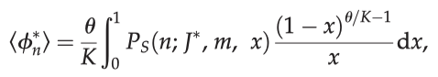

Where…

Weird r symbol mean gamma

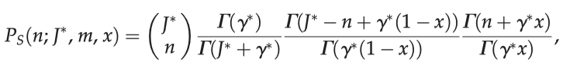

And…



Two numbers in brackets on top of eachother means a binomial coefficient…

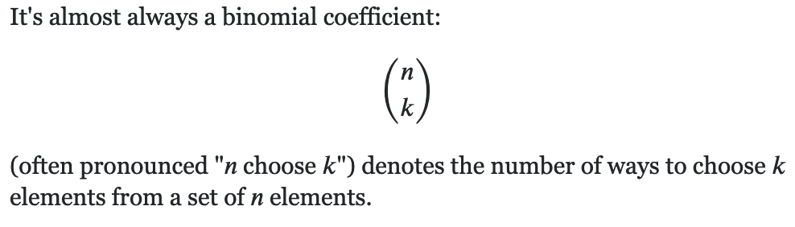

Equation 1 takes the number of individuals within the niche and the migration rate and tells you how many species will have 1 individual, 2 individuals, 3 individuals, 4, 5… up to the number of individuals in the niche.

So if I have a niche size = 30, the equation will give me answers like…

Species with 1 individual = 3 (3 individuals)

Species with 2 individuals = 3 (6 individuals)

Species with 3 individuals = 2 (6 individuals)

Species with 4 individuals = 1 (4 individuals)

Species with 5 individuals = 1 (5 individuals)

Species with 6 individuals = 1 (6 individuals)

Total = 30 individuals in the niche, and 11 species

11 species x number of niches on island = number of species on the island

To turn all this into a species area relationship, the model had to specify how the parameters (number of individuals within a niche, number of niches and migration rate) scale with area.

For number of individuals within a niche, it was assumed to scale linearly with area so that the number of individuals within a niche = the number of individuals per unit area x area / number of niches

So number of individuals in a niches = 1 x 10 / 5 = 2

For parameter K (number of niches) the theory posits that number of niches increases gradually with island area so K is considered to be constant with area.

So if area = 10, then K = 2. If area = 20, then K = 4. Is this right?

How does immigration rate increase with area? Assume the distance between island and metacommunity is much larger than the average dispersal distance.

M = probability a dead individual will be replaced with an immigrant propagule

M proportional to (∝) the number of immigrant propagules per unit time/the number of locally produced propagules on the island per unit time.

It is assumed the number of immigrant propagules is proportional to (∝) area (increases by the same amount with each additional unit area).

Because the number of local propagules also scales linearly with area (increases by the same amount with each additional unit area), the probability a dead individual will be replaced with an immigrant propagule is independent of area. I DON’T UNDERSTAND THIS.

The idea that the number of immigrant propagules is proportional to area is for species with undirected aerial dispersal. For those with directed or waterborne dispersal, it would be more appropriate to assume the number of immigrant propagules scales with island perimeter.

NUMBER OF SPECIES ON AN ISLAND =

THE SUM OF SPECIES RICHNESS OF EACH NICHE

(NICHE SPECIES RICHNESS = HOW MANY SPECIES THERE WOULD BE FOLLOWING THE KNOWN NEUTRAL RESULTS FOR THAT MANY INDIVIDUALS) (Equation 2.4)

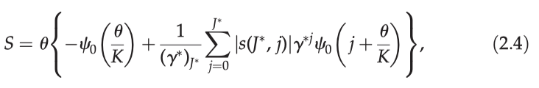

This equation is simplified for computational efficiency into this…

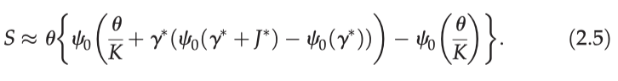

Which in R translates into this…

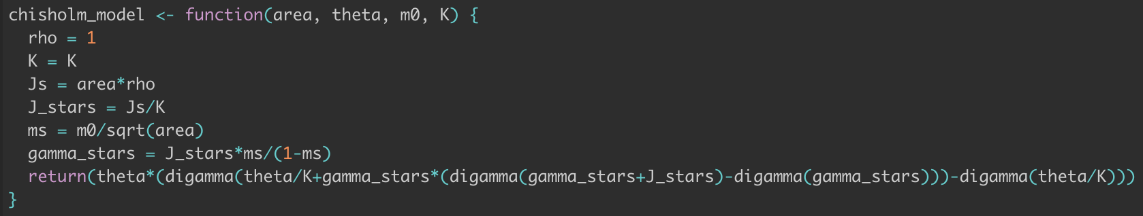

Where…

rho = number of individuals per unit area

K = number of niches

Js = number of individuals on the island (area * rho)

J_stars = number of individuals in each niche

Ms = m0/sqrt(area) = probability that a dead individual will be replaced with an immigrant propagule – what does m0 stand for?

Gamma_stars = number of individuals in each niche * probability that a dead individual will be replaced by an immigrant propagule/probability a dead individual will be replaced by a local propagule

The proximation came from the idea that the dynamics in an island community (where each species arises from a unique immigration event) is the same as the species dynamics in the metacommunity (where each species arises from a unique speciation event).

Also, the number of species on an island is constant at equilibrium.

So finding the species richness is then a case of working out the expected number of species on the island and working out the expected number of species in a sample from the metacommunity. I DON’T UNDERSTAND THIS BIT

For small area the expected number of species is equal to the number of niches.

The critical area at which the transition between the two regimes occurs can be estimated by …

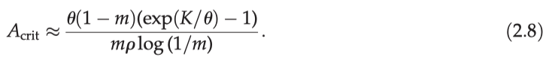

The equation shows that in the model the critical area at which the transition occurs is larger for island with more niches (K) and lower metacommunity diversity (theta) and lower immigration (m) and lower individual density (small p).

1. Materials and Methods: Datasets

100 datasets of SARs, range of taxa, range of archipelago types.

Only archipelagos with 10 or more islands were included.

Each archipelago was classified as either terrestrial, montane (mountainous), inland waters or marine.

Taxonomic groups classified as birds, herpetofauna (reptiles and amphibians), invertebrates, mammals or plants.

For each dataset, the number of individuals was taken from the study or from other studies about the same system.

System specific density estimates were unavailable so default values of densities for taxa were used, based on the literature.

1. Materials and Methods: Model fitting

For each dataset equation 2.5 was fitted. This was done by finding the best-fit values of the models 3 free parameters (number of niches, theta and immigration rate).

Number of niches was found by trying all values between 1 and the maximum number of species recorded on an island within the archipelago.

For each K, non-linear least squares fitting was used to find the best fit parameters of m and theta.

Initial guesses for migration rate (m) were found by:

- K/p * median area of islands in the archipelago * the lower branch of the Lambert W function(-K/p* median area of islands in the archipelago)

Initial guesses for theta were found by…

Y = (p * median area of islands – 1)*m/(1-m)

Species richness on the largest island*y * log(m) / species richness on largest island – y log(m) lower branch of the lambert W function ((species richness on the largest island / y log (m)) exp(species richness on the largest island / y log(m))

The formula for m comes from inverting the formula for critical area (eq. 2.8).

The formula for theta comes from inverting the neutral species-area formula (for more information: patterns of relative species abundance in rainforests and coral reefs, <https://repository.si.edu/bitstream/handle/10088/6672/Volkov_2007patterns_of_relative_sp.pdf?sequence=1&isAllowed=y> )

After finding best fit values of m and theta for each K, the m, theta and K values were chosen that gave the highest R-squared value.

For the smallest islands where the estimated number of individuals was less than the number of niches, the species richness was assumed to be equal to the number of individuals as it is biologically impossible to have more species than individuals.

1. Materials and Methods: Testing accuracy of approximate species-area relationship formula

The exact species-area equation (2.4) and the approximate species-area equation (2.5) were compared to test for error in 2.5.

This was done by taking the best fit parameters for each dataset and doing the exact and approximate equations for islands with an estimated community size J = p * A < 10 000. This was not done for larger islands as it was too computationally expensive.

The percentage error was computed as 100 x (the absolute value of >>> approx. species – exact species) / approx. species

1. Materials and Methods: Estimating critical area

For each archipelago dataset, critical area at which the transition from the niche regime to colonization extinction regime was calculated (eq 2.8) using the fitted values of K, theta and m.

The critical areas were used to test the theory’s key prediction that the critical area should be larger in archipelagos tthat are more isolated and for taxa that are dispersal limited.

A multiple regression analysis was carried out with log(critical area) as the dependent variable, and archipelago type and taxonomic group as categorical explanatory variables (using two way ANOVA).

There is no circularity because archipelago type and taxonomic group were not used to fit the model or estimate critical area. The test is a strong test of the theory’s predictive capabilities.

1. Results

100 datasets – mean r^2 0.91, adjusted mean 0.89, SD 0.09, range 0.55-0.99.

Mean value of fitted theta 3.9.

Median fitted immigration parameter 1.5 x10^-5

Median fitted number of niches was 2.

Off the three fitted parameters, immigration rate was the most variable across datasets.

Correlations between three fitted parameters and the independently estimated parameter (p) were weak to moderate.

Strongest correlation was between K and theta (found using spearman’s rank).

Error associated with using approx. formula was 1.6% average (at most 8.3%) – so eq 2.5 is reasonable approximation.

There were differences in average critical area across archipelago type and taxonomic group.

Multiple regression of critical area on archipelago type and taxonomic group (which satisfied normality and homoscedasticity assumptions) supported the prediction that critical value of island area should be smaller where immigration is greater.

Taxonomic group and archipelago type explained 51% of variance in log critical area.

1. Discussion

Unified theory of island diversity explains classic Macarthur and Wilson SARs and the small island effect (roughly constant diversity on small islands).

The regime at small areas comes from niche constraints.

The regime at large areas comes from colonization-extinction balance.

Mechanistic model accurately fits 100 SARs from broad range of archipelago types and taxa groups.

First mechanistic model fitted to datasets exhibiting small island effect. Past attempts have been phenomenological and poorer.

Verification of hypothesis that a biphasic archipelago SAR arises if niche diversity increases slowly (or not at all) with area, but total number of immigrants increases rapidly with area.

The critical area where the transition between niche-structured regime and colonization-extinction regime occurs at smaller areas where immigration is stronger.

Niche structured regime = classic deterministic niche theory

* Identity of islands species may change over time but total species roughly equal to number of niches
* Could then use study of abiotic factor (counting niches) to estimate how many species there will be

Colonization-extinction balance = stochastic community theory (neutral theory)

* Can’t estimate from abiotic factors

Theory can be used for mainland communities with high immigration rate – critical area would be low for mainland com. Most mainland communities should be in colonization-extinction balance regime.

There’s more in the discussion… come back to this