Simulation

Applying a neutral model to explore mechanisms of the small-island effect, as described by Chisholm et al., 2016.

Introduction

* What are we testing? What are we trying to understand?
* What is a neutral model?
* Why are we using a neutral model?

In order to further test the validity of the model presented by Chisholm et al., (2016) a neutral model of island biogeography was developed.

The Simulation

A total of 15 islands were simulated. The migration rate of each island was a multiple of 0.002. Migration rate was directly correlated with island size and, therefore, number of niches. The number of individuals in each niche was held constant at 10 individuals.

|  |  |  |  |
| --- | --- | --- | --- |
| Island Number | Migration Rate | Size (number of units of space per island) | Number of niches |
| 1 | 0.002 | 20 | 2 |
| 2 | 0.004 | 40 | 4 |
| 3 | 0.006 | 60 | 6 |
| 4 | 0.008 | 80 | 8 |
| 5 | 0.01 | 100 | 10 |
| 6 | 0.012 | 120 | 12 |
| 7 | 0.014 | 140 | 14 |
| 8 | 0.016 | 160 | 16 |
| 9 | 0.018 | 180 | 18 |
| 10 | 0.02 | 200 | 20 |
| 11 | 0.022 | 220 | 22 |
| 12 | 0.024 | 240 | 24 |
| 13 | 0.026 | 260 | 26 |

At the beginning of the simulation, the initial community, death indices, birth indices, speciation events and migration events for each niche on each island was calculated. These indices were stored, along with a timeseries of species richness, in a nested list. For each iteration of the simulation loop, the first island was selected and the first niche data unpacked. The simulation timestep would run on that niche, where if that timestep in the do_speciation indices is equal to 1, a new species is generated and replaces the island individual chosen to die. If the do_speciation indices is equal to 0, the simulation moves on to the do_migration indices, where if that timestep location equals 1, a migration event occurs from the meta community to that niche. If neither the do_speciation indices or do_migration indices is equal to 1 at that timestep location, the simulation replaces the individual chosen to die, with a propagule from within the niche. Once the simulation has acted on all niches within an island, the number of unique species across all combined niches is calculated and stored in the species richness timeseries of that island. The simulation loops through all niches of all islands, before moving to the next timestep and starting again. This simulation was repeated 100 times, with each simulation being run for one hour.

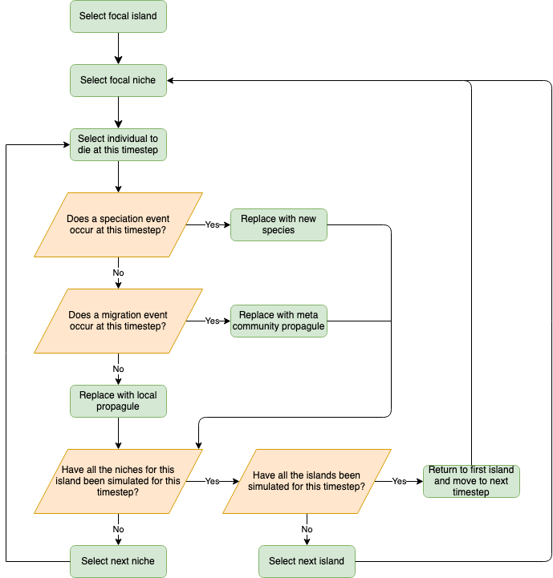

Figure 1. Flowchart of model logic

The results from the 100 simulation were loaded into a simulation processing script where the species richness timeseries were extracted. Species richness for each island was plotted against timestep to ensure the communities had reach equilibrium. The speciation rate (held constant at 0.01), migration rates, number of niches and species richness for each island was combined into a dataframe in R. The dataframe was then loading into a final processing script that used the specifications of each island to find estimates of species richness using the biphasic model of Chisholm et al., (2016). The final species richness values generated by the simulation were compared to those estimated by the model. By plotting the simulated and estimates results we can visually assess that….

Results

Conclusions

References