Notes from BVCN Metagenomics Lesson 1

What organisms are there and what are they doing?
It is NOT 16S rRNA sequencing (amplicon sequencing)
It IS shotgun metagenomics – sequencing a mixture of genomes from many different taxa – grind up environmental sample with lots of different taxa in it, grind it up and see how much you can sequence of the raw data - Illumina NovaSeq = $10,000 per mL of seawater
Incomplete because of how complex the environment is, information dense! Can afford to look at all the data, so just the bit we’re interested in. Not going to give quantitative measurements. Not great for looking at rare things, most of the things we see with metagenomics are the abundant groups – but this is okay if we’re looking at key players in carbon speciation.

What kinds of questions can metagenomics be used to answer?
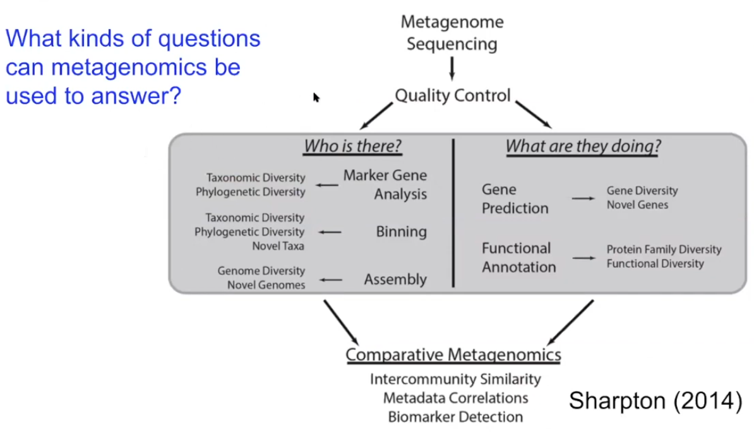
Who is there? (Marker gene analysis, binning, assembly)
Taxonomic diversity
Phylogenetic diversity
Novel taxa
Genome diversity
Novel genomes
Questions metagenomics can answer:
- Is this gene present in this sample?
- How many homologs of this gene appear in this sample?
- Which genomes encode this gene?
- Is this pathogen present in the environment?
- How closely related is this uncultured strain to this cultured representative?
- How many ecotypes (a distinct form of a particular organismal species occurring in a habitat) of this bacterium appear in this environment?
- How many prokaryotic Phyla are there in the world?

What are they doing? (Gene prediction, functional annotation)
Are there novel genes present? What is the diversity of those genes?
Diversity of protein families and other functional pathways.

What are protein families?
Ebi says: “A protein family is a group of proteins that share a common evolutionary origin, reflected by their related functions and similarities in sequence or structure.
Protein families are often arranged into hierarchies, with proteins that share a common ancestor subdivided into smaller, more closely related groups. The terms superfamily (describing a large group of distantly related proteins) and subfamily (describing a small group of closely related proteins) are sometimes used in this context.”

If we understand the diversity of protein families within an environmental sample we can understand the antibodies, enzymes and hormones present, how they are structured, how they transport and store molecules. For example, Ribulose-1,5-bisphosphate carboxylase/oxygenase (RuBisCO) is an enzyme in the first major step of carbon fixation. So protein families can tell us things about the way carbon is speciating through the ecosystem.

A functional pathway then is the way proteins and other molecules link in a series of chemical reactions to carry out a particular physiological function (e.g. metabolism, signalling).

Questions metagenomics can answer:
- What proteins do symbionts encode to mediate relationships with their host?
- Which genes/pathways/genomes co-occur in this environment?
- What antibiotic resistence genes does this community encode?
- How many different carbon fixation pathways exist in hydrothermal vents?
- Are there novel CRISPS-Cas systems yet to be discovered?

CAN I USE METAGENOMICS TO ASK:
- What proteins (e.g. resuscitation promoting factor Rpf protein) encode to control the transition of cells from dormant to active state in cryoconite sediment?
- How many different carbon fixation pathways are present in cryoconite sediment?

Is metagenomics right for me?
- Not great for eukaryotes!

Meta-/Transcriptomics

Nature says: “A transcriptome is the full range of messenger RNA, or mRNA, molecules expressed by an organism. The term "transcriptome" can also be used to describe the array of mRNA transcripts produced in a particular cell or tissue type.

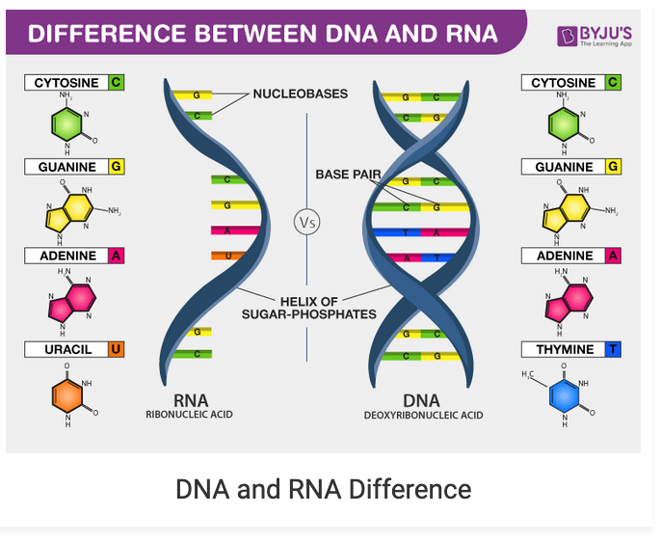
Taken from https://byjus.com/biology/difference-between-dna-and-rna/

RNA codes for amino acids and is a messenger to help make proteins. Proteins help to tell us what the organisms are doing! So a transcriptome is all the messenger RNA that helps to make proteins.

Notes from BVCN Meta-/Transcriptomics Lesson 1

Genome – measure DNA = what the community can do
Transcriptome - RNA = what they want to do
Proteome - Proteins = what they are trying to do
Metabolome – Sugars, Nucleotides, Amino acids, Lipids (Lipidome) = what they are doing

Transcriptomics used to:
Look for gene expression, as a function of different conditions (differential expression of genes as a function of substrate)
Look at gene expression of microbial community (metatranscriptomics)
Combine metatranscriptomics and metagenomics (good metagenomic reconstruct bins + metatranscriptome from same community = measure gene expression at the bin level see (Jewell et al., 2016))

Transcriptomics Pipeline:
- Isolate RNA
- Ribodepleted RNA
- Sheared and adapter ligated cDNA (strand-specific)
- Sequence reads
- Read mapping
- De novo assembly – gene prediction and functional annotation (nitrogen cycling, carbohydrate transport etc) or alternative splicing analysis (eukaryotes)

Deciding the insert size – go with overlapping read pairs
Transcript assemblers

WHAT IS A BIN?
NCBI says: “A “bin” is a position on the genetic map with a unique segregation pattern and is separated from adjacent bins by a single recombination event. This ordered set of bins is considered to be a “skeleton bin map” to which all original marker data can be fitted, using a maximum-likelihood method.”

Wiki says: “Metagenomic samples can contain reads from a huge number of organisms. For example, in a single gram of soil, there can be up to 18000 different types of organisms, each with its own genome. Metagenomic studies sample DNA from the whole community, and make it available as nucleotide sequences of certain length. In most cases, the incomplete nature of the obtained sequences makes it hard to assemble individual genes, much less recovering the full genomes of each organism. Thus, binning techniques represent a "best effort" to identify reads or contigs with certain groups of organisms designated as operational taxonomic units (OTUs).”

CAN I USE THIS:
- To look at the differential expression of dormancy regulating genes across temporal and spatial gradients?
- RNA data - To look at gene expression of cryoconite communities at bin level across temporal and spatial gradients?

