Sampling Regime and Chemical Analysis of Snow and Ice Samples

Hypotheses:
- Snow microbial community structure will be significantly different from ice microbial community structure.
- The physio-chemical composition of glacial snow will be significantly different from glacial ice.
- Active microbial communities will show a stronger DDR than bulk communities.
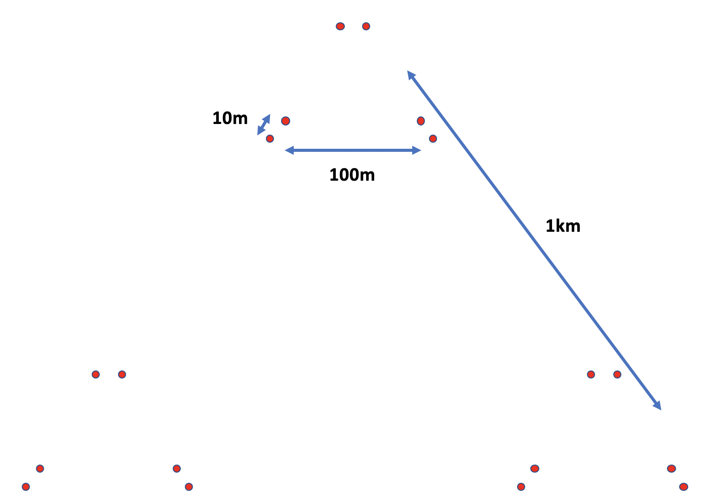
- Active microbial communities will exhibit different community assembly mechanisms than bulk communities.
- Snow communities will exhibit different community assembly mechanisms than ice communities.
- Ice community structure, DDR and community assembly mechanisms will be significantly different between spring and summer sampling events.

Sampling procedure

Field
Spatially nested sampling scheme with samples taken at 10m, 100m and 1km apart (Figure 1). Record GPS coordinates, elevation and temperature at each sampling point before collecting the sample. At each sample point, after collecting snow samples, remaining snow will be removed until ice is reached. An ice corer will then be used to extract ice samples. Each for snow and ice, 18 samples will be collected for microbial analysis and 54 samples (3x each sampling point) will be collected for chemical analysis (do I need 3 separate samples for DOC, anion and cation analysis?) (see Table 1). Keep snow and ice samples at -20°C and return to field laboratory.
Figure 1. Nested sampling regime for Foxfonna Glacier, Svalbard. With distances of 10m, 100m and 1km.

Field laboratory
In field laboratory for physio-chemical analysis: melt samples and measure pH and conductivity using a meters (can I measure this in my microbial samples or chemical analysis samples or do I need additional samples for measuring pH and conductivity?). DOC, anion and cation snow and ice samples will be melted, filtered, acidified and stored for shipping to the UK. In field laboratory for microbial analysis, melt all samples at room temperature, then filter as per method to be confirmed. For snow and ice samples, 18 filters each for 16S rRNA gene, 16S rRNA gene transcript, 18S rRNA gene and 18S rRNA gene transcript sequencing are to be extracted. Additionally, for snow and ice samples, 3 filters for metagenomics and 3 for metatranscriptomics should be prepared. Finally, subsets of 9 snow samples and 9 ice samples will be taken for BONCAT incubations in the field laboratory, after which filters will be taken. (Is this right that from the 18 snow and 18 ice samples I can extract everything I need for sequencing, metagenomics/transcriptomics and BONCAT?). Store filters in sterile bead-beating tubes at -80°C. Prepare procedural blanks for each sample collection/processing step.

Table 1. Number of samples to collect in the field and number of filters from those samples to return to UK for microbial analysis.
 | Chemical analysis samples | Microbial analysis samples | 16S/18S sequencing filters | Metagenomics and Metatranscriptomics filters | BONCAT filters | Blanks | Total
Snow | 18 for DOC  18 for anions  18 for cations | 18 | 18 for 16S DNA  18 for 16S RNA  18 for 18S DNA  18 for 18S RNA | 3 for DNA  3 for RNA | 9 | TBC | Samples: 72  Filters: 87
Ice | 18 for DOC  18 for anions  18 for cations | 18 | 18 for 16S DNA  18 for 16S RNA  18 for 18S DNA  18 for 18S RNA | 3 for DNA  3 for RNA | 9 | TBC | Samples: 72  Filters: 87
Total | 108 samples | 36 samples | 72 filters | 12 filters | 18 filters | TBC | 144 samples  174 filters

Table 2. Prospective field measurements with expected levels for snow and ice, and equipment/methods that can be used
Measurement | Levels | Equipment
GPS coordinates | NA
Elevation | NA
Temperature | Snow: 0°C (Lutz et al., 2016)
pH | Snow: 5.68-8.07 (Lutz et al., 2016)  Snow: 7.3-8.7 (Hell et al., 2013)  Ice: 3.47-3.8 (Grzesiak et al., 2015)  Snow: 7.64 (McCutcheon et al., 2021)  Ice: 5.26-7.28 (McCutcheon et al., 2021) | pH meter
Conductivity | Ice: 1 to 5 μS cm⁻¹ (per James email)  Snow: 3.6-10.1 μS cm⁻¹ (Hell et al., 2013)  Snow: 1.86 μS cm⁻¹ (McCutcheon et al., 2021)  Ice: 1.25-3.46 μS cm⁻¹ (McCutcheon et al., 2021) | Conductivity meter

Table 3. Prospective aqueous measurements with expected levels for snow and ice, and equipment/methods that can be used (< denotes LOD = limits of detection, ICP-MS = inductively coupled plasma mass spectrometry, IC = ion chromatography) NOTE ON UNITS: 1M (mol per litre) = 35,500 ppm = 35,500 mg/L
Measurement | Concentrations | Equipment
Dissolved organic carbon (DOC) | Snow: 36 $±$13 μM (Lutz et al., 2016)  Snow/Ice: 0.06–3.40 mg L⁻¹ (Gao et al., 2020)  Ice: 0.19 -0.20 mg C L⁻¹ (Hood et al., 2015)  GIS glacial meltwater: 0.1–4.1 mg L⁻¹  Snow: 0.1-0.3 mg C L⁻¹ (Fellman et al., 2015)  Ice/Snow: 0.1-0.35 mg C L-1 (Musilova et al., 2017)  Ice: 0.96-1.76 mg L⁻¹ (Grzesiak et al., 2015)  Ice: 12.3 μmoles L⁻¹ (Telling et al., 2014) (1.42 mg L⁻¹) | ICP-MS (Lutz et al., 2016)  ﻿Thermal oxidation (Thermalox TOC/TNAnalyzer) using the non-purgeable organic carbon (NPOC) method LOD = 1.0 mg L⁻¹ (Heppell et al., 2014)
Phosphate (PO₄ - anion) | Snow: 0.77 $±$ 1.71 μM (Lutz et al., 2016)  Ice: 0.02-0.03 mg L⁻¹ (Grzesiak et al., 2015)  Ice: 0.06 μmoles L⁻¹ (Telling et al., 2014) (0.007 mg L⁻¹) | ICP-MS LOD = 10 ppb (Lutz et al., 2016)  Automated colorimetric flow injection analysis (Seal AQ2) (Heppell et al., 2014)
Nitrate (NO3 - anion) | Snow: 1008 $±$ 1986 ppm (Lutz et al., 2016)  Ice: 0.01-0.05 mg L⁻¹ (Grzesiak et al., 2015)  Ice: 1.3 μmoles L⁻¹ (Telling et al., 2014) (0.005 mg L⁻¹)  Snow: 0.03-0.04 mg L⁻¹ (Samui et al., 2020)  Ice: 0.11 mg L⁻¹ (McCutcheon et al., 2021) | IC LOD = 96 ppb (Lutz et al., 2016)  IC (Dionex-ICS2500) LOD = ﻿0.04 mg N L-1 (Heppell et al., 2014)  IC (outsource) (Bradley email)
Sulfate (SO4 - anion) | Snow: 13 $±$46 ppm (Lutz et al., 2016)  Ice: 0.11-0.23 mg L⁻¹ (Grzesiak et al., 2015)  Ice: 1.0 μmoles L⁻¹ (Telling et al., 2014) (0.12 mg L⁻¹)  Snow: 0.02-0.03 mg L⁻¹ (Samui et al., 2020) | IC LOD = 121 ppb (Lutz et al., 2016)  IC (Dionex-ICS2500) LOD = ﻿0.3 mg S L1 (Heppell et al., 2014)  IC (outsource) (Bradley email)
Calcium (Ca - anion) | Snow: 381 $±$ 588 ppb (Lutz et al., 2016)  Ice: 2.93-3.46 mg L⁻¹ (Grzesiak et al., 2015)  Ice: 4.0 μmoles L⁻¹ (Telling et al., 2014) (0.46 mg L⁻¹)  Snow: 0.09-0.13 mg L⁻¹ (Samui et al., 2020)  Ice: 0.01 mg L⁻¹ (McCutcheon et al., 2021) | ICP-MS LOD = 1 ppb (Lutz et al., 2016)  IC (outsource) (Bradley email)
Chloride (Cl - anion) | Snow: 136-381 ppb (Lutz et al., 2016)  Ice: 0.49 – 0.80 mg L⁻¹ (Grzesiak et al., 2015)  Ice: 9.3 μmoles L-1 (Telling et al., 2014) (1.07 mg L⁻¹)  Snow: 0.10-0.27 mg L⁻¹ (Samui et al., 2020)  Ice: 0.29-10.47 mg L⁻¹ (McCutcheon et al., 2021) | IC LOC = 72 ppb (Lutz et al., 2016)  IC (Dionex-ICS2500) LOD = ﻿0.7 mg L-1 (Heppell et al., 2014)  IC (outsource) (Bradley email)
Ammonium (NH4 - cation) | Ice: 0 mg L⁻¹ (Grzesiak et al., 2015)  Ice: 0.04 μmoles L⁻¹ (Telling et al., 2014) | Automated colorimetric flow injection analysis (Seal AQ2) LOD = ﻿0.03mgN L-1 (Heppell et al., 2014)  ICP-MS (outsource) (Bradley email)
Iron (Fe - cation) | Snow: 1.9 $±$ 1.0 ppb (Lutz et al., 2016)  Ice: 0.2 mg L⁻¹ (Grzesiak et al., 2015)  Ice: 0.002-0.4mg L⁻¹ (McCutcheon et al., 2021) | ICP-MS LOD = 0.1 ppb (Lutz et al., 2016)  ﻿ICP-OES (Varian Vista-Pro) LOD = ﻿0.01 mgL-1 (Heppell et al., 2014)  ICP-MS (outsource) (Bradley email)
Potassium (K - cation) | Snow: 41 $±$ 20 ppb (Lutz et al., 2016)  Ice: 0.27-0.28 mg L⁻¹ (Grzesiak et al., 2015)  Ice: 2.3 μmoles L⁻¹ (Telling et al., 2014) (0.26 mg L⁻¹)  Snow: 0.04-0.05 mg L⁻¹ (Samui et al., 2020)  Ice: 0.02 mg L⁻¹ (McCutcheon et al., 2021) | ICP-MS LOD = 10 ppb (Lutz et al., 2016)  ICP-MS (outsource) (Bradley email)
Magnesium (Mg2 - cation) | Snow: 125 $±$206 ppb (Lutz et al., 2016)  Ice: 0.25-0.27 mg L⁻¹ (Grzesiak et al., 2015)  Ice: 1.0 μmoles L⁻¹ (Telling et al., 2014) (0.12 mg L⁻¹)  Snow: 0.06-0.22 mg L⁻¹ (Samui et al., 2020)  Snow: 0.00084 mg L⁻¹(McCutcheon et al., 2021)  Ice: 0.01-0.03mg L⁻¹ (McCutcheon et al., 2021) | ICP-MS LOD = 0.1 ppb (Lutz et al., 2016)  ICP-MS (outsource) (Bradley email)
Sodium (Na - cation) | Snow: 90 – 376 ppb (Lutz et al., 2016)  Ice: 12.4 μmoles L⁻¹ (Telling et al., 2014) (1.43 mg L⁻¹)  Ice: 1.22-1.40 mg L⁻¹ (Grzesiak et al., 2015)  Snow: 0.38-0.76 mg L⁻¹ (Samui et al., 2020)  Snow: 0.02 mg L⁻¹(McCutcheon et al., 2021)  Ice: 0.02-0.05 mg L⁻¹ (McCutcheon et al., 2021) | CP-MS LOD = 1 ppb (Lutz et al., 2016)

References

Fellman, J. B., Hood, E., Raymond, P. A., Stubbins, A., and Spencer, R. G. M. (2015). Spatial Variation in the Origin of Dissolved Organic Carbon in Snow on the Juneau Icefield, Southeast Alaska. Environ. Sci. Technol. 49, 11492–11499. doi:10.1021/acs.est.5b02685.
Gao, T., Kang, S., Zhang, Y., Sprenger, M., Wang, F., Du, W., et al. (2020). Characterization, sources and transport of dissolved organic carbon and nitrogen from a glacier in the Central Asia. Sci. Total Environ. 725, 138346. doi:10.1016/j.scitotenv.2020.138346.
Grzesiak, J., Górniak, D., Świątecki, A., Aleksandrzak-Piekarczyk, T., Szatraj, K., and Zdanowski, M. K. (2015). Microbial community development on the surface of Hans and Werenskiold Glaciers (Svalbard, Arctic): a comparison. Extremophiles 19, 885–897. doi:10.1007/s00792-015-0764-z.
Hell, K., Edwards, A., Zarsky, J., Podmirseg, S. M., Girdwood, S., Pachebat, J. A., et al. (2013). The dynamic bacterial communities of a melting High Arctic glacier snowpack. ISME J. 7, 1814–1826. doi:10.1038/ismej.2013.51.
Heppell, C., Louise Heathwaite, A., Binley, A., Byrne, P., Ullah, S., Lansdown, K., et al. (2014). Interpreting spatial patterns in redox and coupled water-nitrogen fluxes in the streambed of a gaining river reach. Biogeochemistry 117, 491–509. doi:10.1007/s10533-013-9895-4.
Hood, E., Battin, T. J., Fellman, J., O’neel, S., and Spencer, R. G. M. (2015). Storage and release of organic carbon from glaciers and ice sheets. Nat. Geosci. 8, 91–96. doi:10.1038/ngeo2331.
Lutz, S., Anesio, A. M., Raiswell, R., Edwards, A., Newton, R. J., Gill, F., et al. (2016). The biogeography of red snow microbiomes and their role in melting arctic glaciers. Nat. Commun. 7, 1–9. doi:10.1038/ncomms11968.
McCutcheon, J., Lutz, S., Williamson, C., Cook, J. M., Tedstone, A. J., Vanderstraeten, A., et al. (2021). Mineral phosphorus drives glacier algal blooms on the Greenland Ice Sheet. Nat. Commun. 12, 1–11. doi:10.1038/s41467-020-20627-w.
Musilova, M., Tranter, M., Wadham, J., Telling, J., Tedstone, A., and Anesio, A. M. (2017). Microbially driven export of labile organic carbon from the Greenland ice sheet. Nat. Geosci. 10, 360–365. doi:10.1038/ngeo2920.
Samui, G., Antony, R., and Thamban, M. (2020). Fate of Dissolved Organic Carbon in Antarctic Surface Environments During Summer. J. Geophys. Res. Biogeosciences 125, 1–14. doi:10.1029/2020jg005958.
Telling, J., Anesio, A. M., Tranter, M., Fountain, A. G., Nylen, T., Hawkings, J., et al. (2014). Spring thaw ionic pulses boost nutrient availability and microbial growth in entombed Antarctic Dry Valley cryoconite holes. Front. Microbiol. 5, 1–15. doi:10.3389/fmicb.2014.00694.

