Amy’s Guide to Chemistry

Atoms

Atomic structure

What are atoms made of?
Protons (part of the nucleus)
Neutrons (part of the nucleus)
Electrons

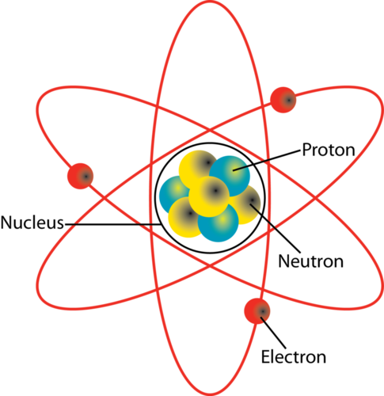
Figure 1. Diagram of an atom (https://www.pinterest.com/pin/315463148882587683/)

Tell me about electrons.
Move around the atom in electron shells.
They are negatively charged.
They are very small.
They have almost no mass.
The shells cover a large amount of space.
The volume of the electron shell orbits dictates the size of the atom.

Atomic charge

What is the charge of an atom?
Atoms have no charge, they are neutral because they have an equal number of protons (positively charged) and electrons (negatively charged).

What is the charge of the nucleus?
It is positively charged because it contains protons.

Atomic size and mass

What is the radius of an atom?
0.1 nanometres (nm) (1 x 10⁻¹⁰ m = 0.0000000001 m = 1e-10)

What is the radius of the nucleus?
1 x 10⁻¹⁴ m = 0.00000000000001 m = 1e-14

Where is most of the mass of the atom?
In the nucleus.

