Sampling Regime and Chemical Analysis of Snow and Ice Samples

Hypothesis:
- Snow community structure will be significantly different than ice community structure.
- Active communities will show a stronger DDR than bulk communities.
- Active communities will exhibit different community assembly mechanisms than bulk communities.
- Snow communities will exhibit different community assembly mechanisms than ice communities.
- Ice community structure, DDR and community assembly mechanisms will be significantly different between spring and summer sampling events.

1) What do we want to measure?
2) Why do we want to measure it?
3) What levels will we expect to find?
4) What equipment is available that will meet these detection levels?

Sampling regime
- Wear Tyvex body suit and latex gloves. What is the usual procedure for reducing contamination when collecting samples in the field?
- Spatially nested sampling scheme with samples taken at 10m, 100m and 1km apart = 18 samples for snow and 18 samples for ice. Is this an okay number of samples? Is 1km too far to travel on the glacier for samples?
- Record GPS coordinates, elevation and temperature at each sampling point before collecting the sample. What equipment is used to take these measurements? Do you measure snow temperature by poking a probe into the snow? What’s the best way to measure the temperature of ice?
- At each sampling point collect surface (first 3cm) snow samples with sterilised Teflon shovel into sterile sampling bags. Is the first 3cm a good depth? How much snow should be collected?
- At each sample point, after collecting snow sample, remaining snow will be removed until ice is reached. An ice corer will then be used to extract ice and samples transferred to sterile bags. Is it reasonable to remove remaining snow from those sample points and take the ice from there? How much ice should be extracted?
- Keep snow and ice samples at -20°C and return to field laboratory.
- In field laboratory for physio-chemical analysis: melt samples and measure pH and conductivity using a multi-meter. Is this the best way to measure pH and conductivity for snow and ice samples?
- In field laboratory for microbial analysis: melt all samples at room temperature, then filter (see Table 1). Store filters in sterile bead-beating tubes at -80°C. Prepare procedural blanks using same method. How many blanks do I need? From where? Do I need separate filters for DNA and RNA extraction of can they be extracted from the same filter? If I want to do metagenomic/metatranscriptomics on samples do I just prep them for DNA/RNA extraction like amplicon samples? Is 6 metagenomic and 6 metatranscriptomic samples a reasonable number?

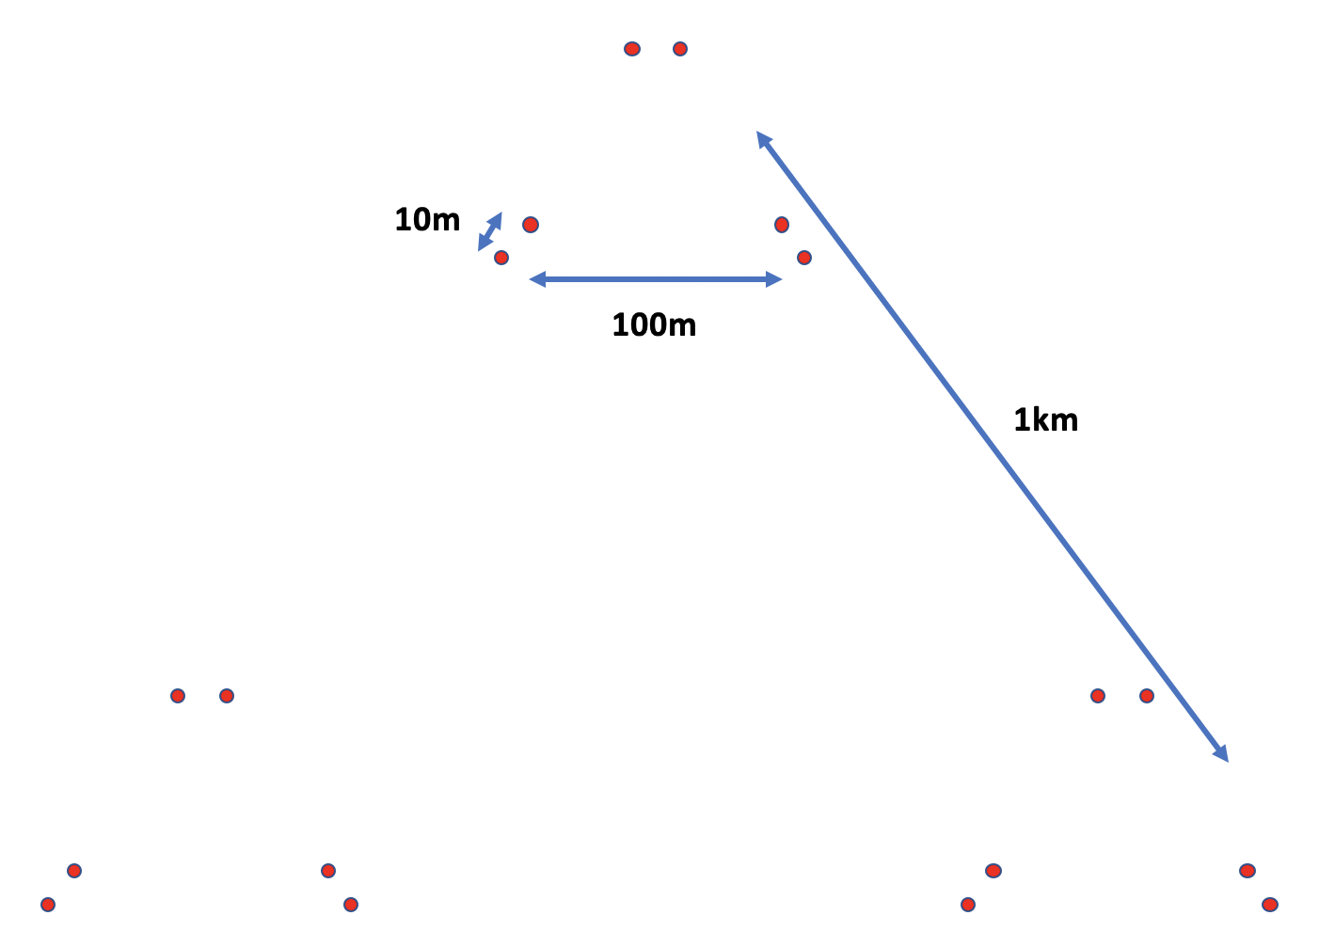
Table 1. Number of liquid samples and filters needed for physio-chemical/microbial analysis. Do we need separate filters for 16S rRNA gene and gene transcripts and 18S rRNA gene and gene transcripts = 4 filters per sample site?
 | Blanks | Physio-chemical analysis | 16S/18S sequencing | Metagenomics/Metatranscriptomics | BONCAT
Snow | TBC | 18 samples | 18 filters for DNA  18 filters for RNA | 3 filters for DNA  3 filters for RNA | 9 samples
Ice | TBC | 18 samples | 18 filters for DNA  18 filters for RNA | 3 filters for DNA  3 filters for RNA | 9 samples
Total | TBC | 36 samples | 72 filters | 12 filters | 18 samples

Table 2. Prospective field measurements with rationale for collecting the data, expected levels for snow and ice, and equipment/methods that can be used
Measurement | Rationale | Levels | Equipment
GPS coordinates | Used for investigating spatial autocorrelation | NA
Elevation | May impact physio-chemical properties of environment, thus impacting biogeography and community assembly | NA
Temperature | Impacts microbial biogeography, community assembly and activity by limiting/facilitating metabolic processes | Snow: 0°C (Lutz et al., 2016)
pH | Impacts microbial biogeography, community assembly and activity by limiting/facilitating metabolic processes | Snow: 5.68-8.07 (Lutz et al., 2016)
Conductivity | Indicative of total dissolved solids and salinity. This tells us how much is dissolved in the water and thus how much is available for microbial metabolic processes.

Table 3. Prospective aqueous measurements with rationale for collecting the data, expected levels for snow and ice, and equipment/methods that can be used (< denotes lLOD = imits of detection, ICP-MS = inductively coupled plasma mass spectrometry, IC = ion chromatography) NOTE ON UNITS: 1M (mol per litre) = 35,500 ppm = 35,500 mg/L
Measurement | Rationale | Levels | Equipment
Dissolved organic carbon | DOC is a measure of the carbon available for heterotrophic metabolism | Snow: 36 $±$13 μM (Lutz et al., 2016) | ICP-MS (Lutz et al., 2016)
Phosphate (PO₄ - anion) | Essential for forming DNA and cell membranes and alters community assembly | Snow: 0.77 $±$ 1.71 μM (Lutz et al., 2016) | ICP-MS LOD = 10 ppb (Lutz et al., 2016)
Ammonia (NH₃ - cation) | Important in the nitrogen cycle. Nitrogen needed to build proteins and nucleic acids. Habitats with low ammonia may preferentially select for nitrifying (a.k.a. ammonia-oxidizing) taxa.
Nitrate (NO3 - anion) | Important in the nitrogen cycle. Nitrogen needed to build proteins and nucleic acids. Nitrate availability may impact community structure by selecting for species most capable of exploiting those conditions. | Snow: 1008 $±$ 1986 ppm (Lutz et al., 2016) | IC LOD = 96 ppb (Lutz et al., 2016)
Sulfate (SO4 - anion) | Sulfate availability may impact community structure by selecting for species most capable of exploiting those conditions. | Snow: 13 $±$46 ppm (Lutz et al., 2016) | IC LOD = 121 ppb (Lutz et al., 2016)
Calcium (Ca - anion) | Calcium availability may impact community structure by selecting for species most capable of exploiting those conditions. | Snow: 381 $±$ 588 ppb (Lutz et al., 2016) | ICP-MS LOD = 1 ppb (Lutz et al., 2016)
Chloride (Cl - anion) | Chloride availability may impact community structure by selecting for species most capable of exploiting those conditions. | Snow: 136-381 ppb (Lutz et al., 2016) | IC LOC = 72 ppb (Lutz et al., 2016)
Iron (Fe - cation) | Iron availability may impact community structure by selecting for species most capable of exploiting those conditions. | Snow: 1.9 $±$ 1.0 ppb (Lutz et al., 2016) | ICP-MS LOD = 0.1 ppb (Lutz et al., 2016)
Potassium (K - cation) | Potassium availability may impact community structure by selecting for species most capable of exploiting those conditions. | Snow: 41 $±$ 20 ppb (Lutz et al., 2016) | ICP-MS LOD = 10 ppb (Lutz et al., 2016)
Magnesium (Mg - cation) | Magnesium availability may impact community structure by selecting for species most capable of exploiting those conditions. | Snow: 125 $±$206 ppb (Lutz et al., 2016) | ICP-MS LOD = 0.1 ppb (Lutz et al., 2016)
Manganese (Mn - cation) | Manganese availability may impact community structure by selecting for species most capable of exploiting those conditions. | Snow: 3.7 $±$ 3.9 ppb (Lutz et al., 2016) | CP-MS LOD = 0.01 ppb (Lutz et al., 2016)
Aluminium (Al) | Aluminium availability may impact community structure by selecting for species most capable of exploiting those conditions. | Snow: 0.2-2.3 ppb (Lutz et al., 2016) | ICP-MS LOD = 0.1 ppb (Lutz et al., 2016)
Barium (Ba) | Barium availability may impact community structure by selecting for species most capable of exploiting those conditions. | Snow: < - 6.7 ppb (Lutz et al., 2016) | ICP-MS LOD = 0.1 ppb (Lutz et al., 2016)
Bismuth (Bi) | Bismuth availability may impact community structure by selecting for species most capable of exploiting those conditions. | Snow: < ppb (Lutz et al., 2016) | CP-MS LOD = 0.01 ppb (Lutz et al., 2016)
Cadmium (Cd) | Cadmium availability may impact community structure by selecting for species most capable of exploiting those conditions. | Snow: < - 0.0 ppb (Lutz et al., 2016) | CP-MS LOD = 0.01 ppb (Lutz et al., 2016)
Cobalt (Co) | Cobalt availability may impact community structure by selecting for species most capable of exploiting those conditions. | Snow: < - 0.2 ppb (Lutz et al., 2016) | ICP-MS LOD = 0.1 ppb (Lutz et al., 2016)
Chromium (Cr) | Chromium availability may impact community structure by selecting for species most capable of exploiting those conditions. | Snow: < - 0.1 ppb (Lutz et al., 2016) | ICP-MS LOD = 0.1 ppb (Lutz et al., 2016)
Copper (Cu) | Copper availability may impact community structure by selecting for species most capable of exploiting those conditions. | Snow: < - 0.3 ppb (Lutz et al., 2016) | ICP-MS LOD = 0.1 ppb (Lutz et al., 2016)
Sodium (Na) | Sodium availability may impact community structure by selecting for species most capable of exploiting those conditions. | Snow: 90 – 376 ppb (Lutz et al., 2016) | CP-MS LOD = 1 ppb (Lutz et al., 2016)
Nickel (Ni) | Nickel availability may impact community structure by selecting for species most capable of exploiting those conditions. | Snow: < - 0.3 ppb (Lutz et al., 2016) | ICP-MS LOD = 0.1 ppb (Lutz et al., 2016)
Lead (Pb) | Lead availability may impact community structure by selecting for species most capable of exploiting those conditions. | Snow: < - 0.2 ppb (Lutz et al., 2016) | CP-MS LOD = 0.01 ppb (Lutz et al., 2016)
Sulfur (S) | Sulfur availability may impact community structure by selecting for species most capable of exploiting those conditions. | Snow: < - 61 ppb (Lutz et al., 2016) | ICP-MS LOD = 10 ppb (Lutz et al., 2016)
Silicon (Si) | Silicon availability may impact community structure by selecting for species most capable of exploiting those conditions. | Snow: < - 17 ppb (Lutz et al., 2016) | ICP-MS LOD = 0.1 ppb (Lutz et al., 2016)
Strontium (Sr) | Strontium availability may impact community structure by selecting for species most capable of exploiting those conditions. | Snow: 0.2 – 2.1 ppb (Lutz et al., 2016) | ICP-MS LOD = 0.1 ppb (Lutz et al., 2016)
Zinc (Zn) | Zinc availability may impact community structure by selecting for species most capable of exploiting those conditions. | Snow: 0.4 – 4.5 ppb (Lutz et al., 2016) | ICP-MS LOD = 0.1 ppb (Lutz et al., 2016)

Table 4. Prospective particulate measurements with rationale for collecting the data, expected levels for snow and ice, and equipment/methods that can be used
Measurement | Rationale | Levels | Equipment
Total carbon |  | Snow: 5.4 $±$ 4.4 % dry weight (Lutz et al., 2016)
Total nitrogen |  | Snow: 0.3 $±$ 0.2 % dry weight (Lutz et al., 2016)
Total sulphur |  | Snow: 0.12 $±$ 0.03 % dry weight (Lutz et al., 2016)
Total phosphorus |  | Snow: 0.07 $±$ 0.03 % dry weight (Lutz et al., 2016)
Organic nitrogen isotopes (δ15N) | The isotopic signature of nitrogen indicates the source i.e. negative δ15N is indicative of atmospheric nitrogen | Snow: -4.77 $±$2.41 ‰ (Lutz et al., 2016)
Organic carbon isotopes (δ13C) | The isotopic signature of carbon indicates the source i.e. negative | Snow: -27.76 $±$1.52 ‰ (Lutz et al., 2016)

Table 5. Prospective microbial measurements with rationale for collecting the data, expected levels for snow and ice, and equipment/methods that can be used
Measurement | Rationale | Levels | Equipment
Cell counts |  | Snow: 43,558 $±$50,308 mL⁻¹ (Lutz et al., 2016)
Cell volume |  | Snow: 2,044 $±$ 1,342 μm³ (Lutz et al., 2016)
Cell diameter |  | Snow: 6.4 – 20 μm (Lutz et al., 2016)
Biomass |  | Snow: 35 +/- 20 mm³ L⁻¹ (Lutz et al., 2016)

Table 6. Prospective mineralogical measurements with rationale for collecting the data, expected levels for snow and ice, and equipment/methods that can be used
Measurement | Rationale | Levels | Equipment
Quartz |  |  | X-ray diffraction analysis (Lutz et al., 2016)
Plagioclase |  |  | X-ray diffraction analysis (Lutz et al., 2016)
Pyroxene |  |  | X-ray diffraction analysis (Lutz et al., 2016)
Mica |  |  | X-ray diffraction analysis (Lutz et al., 2016)
Chlorite |  |  | X-ray diffraction analysis (Lutz et al., 2016)
Muscovite |  |  | X-ray diffraction analysis (Lutz et al., 2016)
Calcite |  |  | X-ray diffraction analysis (Lutz et al., 2016)
Dolomite |  |  | X-ray diffraction analysis (Lutz et al., 2016)

References
Lutz, S., Anesio, A. M., Raiswell, R., Edwards, A., Newton, R. J., Gill, F., et al. (2016). The biogeography of red snow microbiomes and their role in melting arctic glaciers. Nat. Commun. 7, 1–9. doi:10.1038/ncomms11968.

