Hypothesis:
- Active snow/ice communities will show a stronger DDR than bulk snow/ice communities.
- Active snow/ice communities will exhibit different community assembly mechanisms than bulk snow/ice communities.

Snow and ice sample plan
- Wear Tyvex body suit and latex gloves. What is the usual procedure for reducing contamination when collecting samples in the field?
- Spatially nested sampling scheme with samples taken at 10m, 100m and 1km apart = 18 samples for snow and 18 samples for ice. Is this an okay number of samples? Is 1km too far to travel on the glacier for samples?
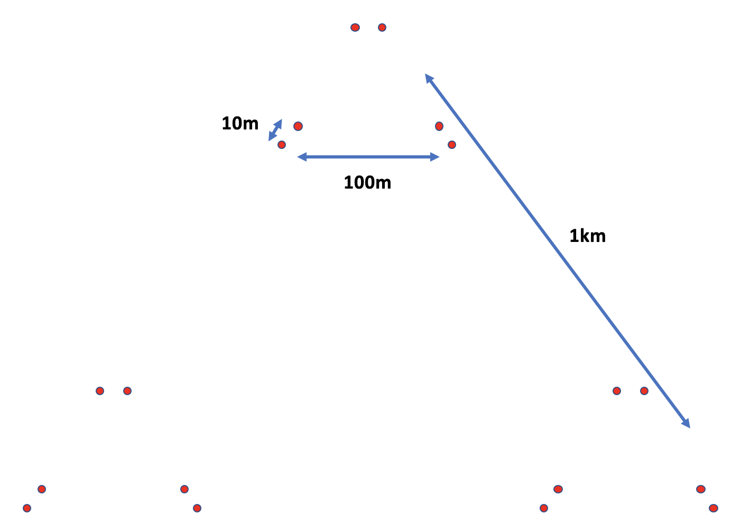

- Record GPS coordinates, elevation and temperature at each sampling point before collecting the sample. What equipment is used to take these measurements? Do you measure snow temperature by poking a probe into the snow? What’s the best way to measure the temperature of ice?
- At each sampling point collect surface (first 3cm) snow samples with sterilised Teflon shovel into sterile sampling bags. Is the first 3cm a good depth? How much snow should be collected?
- At each sample point, after collecting snow sample, remaining snow will be removed until ice is reached. An ice corer will then be used to extract ice and samples transferred to sterile bags. Is it reasonable to remove remaining snow from those sample points and take the ice from there? How much ice should be extracted?
- Keep snow and ice samples at -20°C and return to field laboratory.
- In field laboratory for physio-chemical analysis: melt samples and measure pH and conductivity using a multi-meter. Is this the best way to measure pH and conductivity for snow and ice samples?
- In field laboratory for microbial analysis: melt all samples at room temperature, then filter (see Table 1). Store filters in sterile bead-beating tubes at -80°C. Prepare procedural blanks using same method. How many blanks do I need? From where? Do I need separate filters for DNA and RNA extraction of can they be extracted from the same filter? If I want to do metagenomic/metatranscriptomics on samples do I just prep them for DNA/RNA extraction like amplicon samples? Is 6 metagenomic and 6 metatranscriptomic samples a reasonable number?
Table 1. Number of frozen samples/filters needed for analysis
 | Blanks | Physio-chemical analysis | Amplicon sequencing | Metagenomics/  Metatranscriptomics | BONCAT
Snow |  | 18 samples | 18 filters for DNA  18 filters for RNA | 3 filters for DNA  3 filters for RNA | 9 samples
Ice |  | 18 samples | 18 filters for DNA  18 filters for RNA | 3 filters for DNA  3 filters for RNA | 9 samples
Total |  | 36 samples | 72 filters | 12 filters | 18 samples

- Ship frozen filters and ice/snow samples to QMUL/NHM. Is this too many samples and filters? In what form do I need to bring back samples for BONCAT? Is this a good number of samples for BONCAT? For my physiochemical analysis, what volume of frozen snow/ice do I need?
- In UK laboratory for chemical analysis: inorganic ions (﻿F⁻, NO₃⁻, Cl⁻, SO₄²-, NH₄⁺,Ca²⁺,Na⁺,K⁺ and Mg²⁺) to be measured using ﻿suppressed ion chromatography for anions and inductively coupled plasma mass spectrometer for cations, total organic carbon analyser for DOC and segment flow injection analysis for dissolved phosphate.
- In UK laboratory for DNA/RNA extraction: DNA and RNA extracted from filters using extraction kits.
- Extracted DNA/RNA from all 27 samples will be used for 16S rRNA gene amplicon sequencing and 3 samples will be used for metagenomics/metatranscriptomics.
- In UK laboratory for BONCAT: Do I just need filters for this?

