Generated Flowchart

Description
Standard Operating Procedure (SOP)
Report path: Reports – Design Report
System: SJE PLUS (GATI)
Objective:
To guide users on how to access and generate service-related invoices and reports through the Design Report menu in the SJE PLUS(GATI) system under the
Reports > Design Report > Service Final section.
Step-by-Step Instructions:
Step 1: Login
- Open the SJE PLUS application.
- Login using your punching credentials in Uni.
- Confirm successful login by checking the bottom status bar which should show: Login as : __________________
Step 2: Open the Reports Menu
- On the top menu bar, click on Reports.
Step 3: Navigate to Design Report
- In the dropdown under Reports, hover over Design Report (last option).
Step 4: Navigate to Service Final
- A side menu will open. (If not visible, request access from the IT department.)
- Scroll down and hover over the Service Final section.
1) Title: Accessing “Apply Service Amt in Invoice” from SJE PLUS
Step-by-Step Instructions:
Figure: Apply Service Amt in Invoice screen interface
Step-by-Step Instructions (Continued):
Step 1: Select D B Master
- Choose the ‘Emr’ Or 'Gati' from the Dropdown.
Step 2: Select Company
- Use the dropdown to select the appropriate company based on the database (EMR or GATI) for which the data needs to be updated.
Step 3: Select Date Range
- Choose the 'From Date' and 'To Date' using the calendar picker to define the invoice period.
Step 4: Select Client Code
- Select a specific client only applicable client codes are displayed based on the chosen database (EMR or GATI).
Step 5: Select Inv Exp No
- Select a specific client invoice (Only invoices with applicable client codes are shown here, and only if custom matching is pending.)
Step 6: Generate the Report
- Click the "Print" button at the bottom right of the screen to generate the Apply Service Amt in Invoice Report.
Output:
2) Title: Accessing “Invoice + Memo Invoice” from SJE PLUS
Step-by-Step Instructions:
Figure: Invoice + Memo Invoice screen interface
Step-by-Step Instructions (Continued):
Step 1: Select D B Master
- Choose the 'Emr' Or 'Gati' from the Dropdown.
Step 2: Select Company
- Use the dropdown to select company for which data is to be Shown.
Step 3: Select Date Range
- Choose the 'From Date' and 'To Date' using the calendar picker to define the invoice period.
Step 4: Select Client Code
- Select a specific client only applicable client codes are displayed based on the chosen database (EMR or GATI).
Step 5: Select Inv
- Select a specific client invoice (Only invoices with applicable client codes are shown here, and only if custom matching is Done.)
Step 6: Generate the Report
- Click the "Print" button at the bottom right of the screen to generate the Invoice + Memo Invoice Report.
Output : (Invoice Report)
Memo Invoice
3) Title: Accessing “Generate Service Invoice” from SJE PLUS
Step-by-Step Instructions:
Figure: Generate Service Invoice screen interface
Step-by-Step Instructions (Continued):
Step 1: Select D B Master
- Choose the 'Emr' Or 'Gati' from the Dropdown.
Step 2: Select Memo From Company
- Select Source Company of memo Invoice
Step 3: Select Memo to Company
- Select the company issuing receiving the memo.
Step 4: Select Date Range
- Choose the 'From Date' and 'To Date' using the calendar picker to define the invoice period.
Step 5: Select Memo Client
- Choose specific client for whom memo is being issued.
Step 6: Select Memo Invoice
- Enter a specific invoice number.
Step 7: Generate the Report
- Click the "Print" button at the bottom right of the screen to generate the Generate Service Invoice Report.
Output :
4) Title: Accessing “Service MIS Report” from SJE PLUS
Step-by-Step Instructions:
Figure: Service MIS Report screen interface
Step-by-Step Instructions (Continued):
Step 1: Select D B Master
- Choose the 'Emr' Or 'Gati' from the Dropdown.
Step 2: Select Company
- Select the company.
Step 3: Select Date Range
- Choose the 'From Date' and 'To Date' using the calendar picker to define the invoice period.
Step 4: Select Party Code
- Choose the party/client if looking for a specific one.
Step 5: Select Service InvNo
- Enter a specific invoice number.
Step 6: Generate the Report
- Click the "Show" button at the bottom right of the screen to generate the Service MIS Report.
Output :
Thank You
Adarsh Yadav / Prince Verma
IT TEAM….

Flowchart Diagram
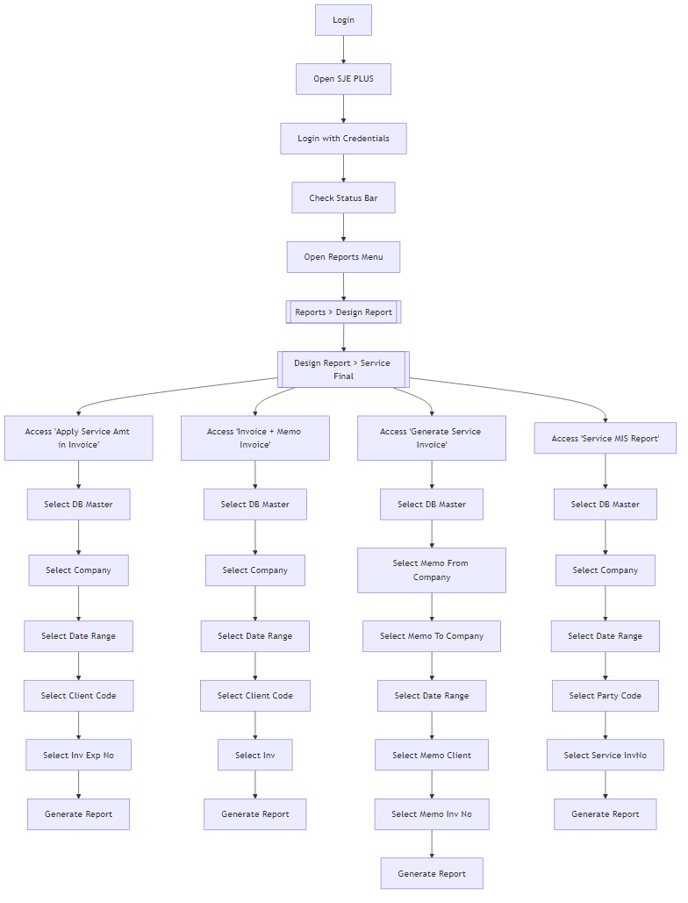

Mermaid Code
graph TD;
A[Login] --> B[Open SJE PLUS];
B --> C[Login with Credentials];
C --> D[Check Status Bar];
D --> E[Open Reports Menu];
E --> F[[Reports > Design Report]];
F --> G[[Design Report > Service Final]];
G --> H[Access 'Apply Service Amt in Invoice'];
H --> I[Select DB Master];
I --> J[Select Company];
J --> K[Select Date Range];
K --> L[Select Client Code];
L --> M[Select Inv Exp No];
M --> N[Generate Report];
G --> O[Access 'Invoice + Memo Invoice'];
O --> P[Select DB Master];
P --> Q[Select Company];
Q --> R[Select Date Range];
R --> S[Select Client Code];
S --> T[Select Inv];
T --> U[Generate Report];
G --> V[Access 'Generate Service Invoice'];
V --> W[Select DB Master];
W --> X[Select Memo From Company];
X --> Y[Select Memo To Company];
Y --> Z[Select Date Range];
Z --> AA[Select Memo Client];
AA --> AB[Select Memo Inv No];
AB --> AC[Generate Report];
G --> BD[Access 'Service MIS Report'];
BD --> BE[Select DB Master];
BE --> BF[Select Company];
BF --> BG[Select Date Range];
BG --> BH[Select Party Code];
BH --> BI[Select Service InvNo];
BI --> BJ[Generate Report];

