Flowchart Generation Report

Processing Steps
- Step 1: File uploaded - extracting text from document
- Step 1 Complete: Extracted 4377 characters from SOP_Service_Final.docx
- Step 2: Generating Mermaid flowchart code using granite3.3:8b
- Step 2 Complete: Mermaid code generated and sanitized
- Step 3: Rendering Mermaid code to image
- Step 3 Complete: Diagram successfully rendered
- Step 5: Creating comprehensive DOCX document

Input Content
Source: SOP_Service_Final.docx
Length: 4377 characters
Standard Operating Procedure (SOP)
Report path: Reports – Design Report
System: SJE PLUS (GATI)
Objective:
To guide users on how to access and generate service-related invoices and reports through the Design Report menu in the SJE PLUS(GATI) system under the
Reports > Design Report > Service Final section.
Step-by-Step Instructions:
Step 1: Login
- Open the SJE PLUS application.
- Login using your punching credentials in Uni.
- Confirm successful login by checking the bottom status bar which should show: Login as : __________________
Step 2: Open the Reports Menu
- On the top menu bar, click on Reports.
Step 3: Navigate to Design Report
- In the dropdown under Reports, hover over Design Report (last option).
Step 4: Navigate to Service Final
- A side menu will open. (If not visible, request access from the IT department.)
- Scroll down and hover over the Service Final section.
1) Title: Accessing “Apply Service Amt in Invoice” from SJE PLUS
Step-by-Step Instructions:
Figure: Apply Service Amt in Invoice screen interface
Step-by-Step Instructions (Continued):
Step 1: Select D B Master
- Choose the ‘Emr’ Or 'Gati' from the Dropdown.
Step 2: Select Company
- Use the dropdown to select the appropriate company based on the database (EMR or GATI) for which the data needs to be updated.
Step 3: Select Date Range
- Choose the 'From Date' and 'To Date' using the calendar picker to define the invoice period.
Step 4: Select Client Code
- Select a specific client only applicable client codes are displayed based on the chosen database (EMR or GATI).
Step 5: Select Inv Exp No
- Select a specific client invoice (Only invoices with applicable client codes are shown here, and only if custom matching is pending.)
Step 6: Generate the Report
- Click the "Print" button at the bottom right of the screen to generate the Apply Service Amt in Invoice Report.
Output:
2) Title: Accessing “Invoice + Memo Invoice” from SJE PLUS
Step-by-Step Instructions:
Figure: Invoice + Memo Invoice scre
[... text truncated for brevity ...]

Generated Flowchart Diagram
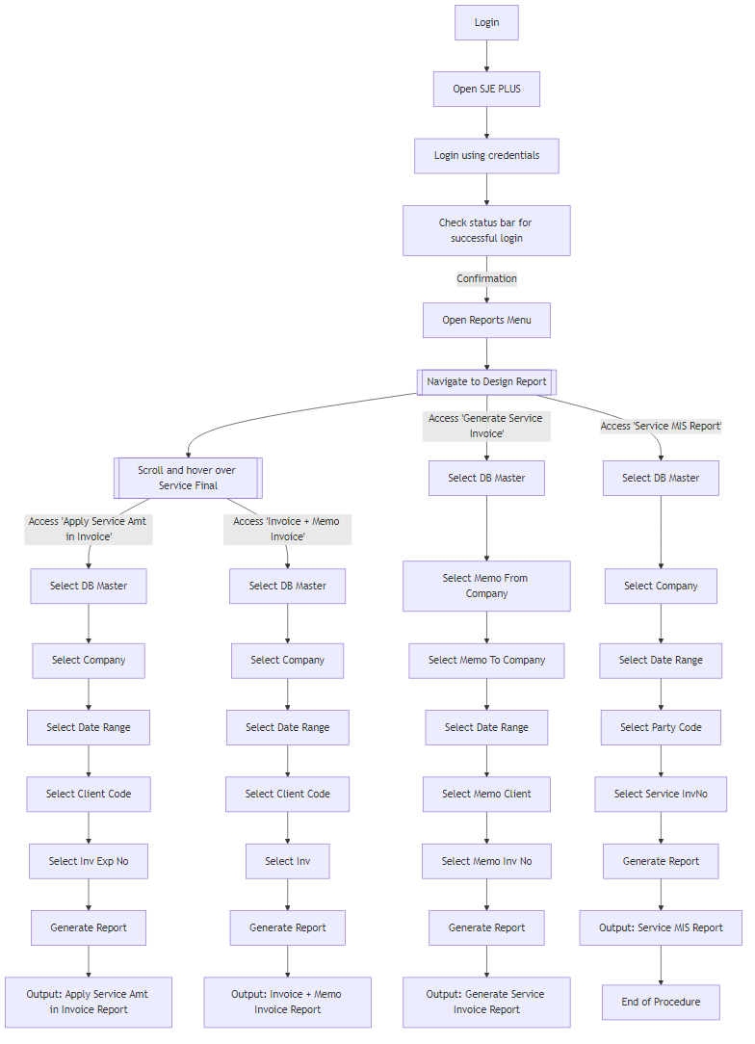

Mermaid Source Code
graph TD;
A[Login] --> B[Open SJE PLUS];
B --> C[Login using credentials];
C --> D[Check status bar for successful login];
D -- Confirmation --> E[Open Reports Menu];
E --> F[[Navigate to Design Report]];
F --> G[[Scroll and hover over Service Final]];
G -- Access 'Apply Service Amt in Invoice' --> H[Select DB Master];
H --> I[Select Company];
I --> J[Select Date Range];
J --> K[Select Client Code];
K --> L[Select Inv Exp No];
L --> M[Generate Report];
G -- Access 'Invoice + Memo Invoice' --> N[Select DB Master];
N --> O[Select Company];
O --> P[Select Date Range];
P --> Q[Select Client Code];
Q --> R[Select Inv];
R --> S[Generate Report];
F -- Access 'Generate Service Invoice' --> T[Select DB Master];
T --> U[Select Memo From Company];
U --> V[Select Memo To Company];
V --> W[Select Date Range];
W --> X[Select Memo Client];
X --> Y[Select Memo Inv No];
Y --> Z[Generate Report];
F -- Access 'Service MIS Report' --> AA[Select DB Master];
AA --> AB[Select Company];
AB --> AC[Select Date Range];
AC --> AD[Select Party Code];
AD --> AE[Select Service InvNo];
AE --> AF[Generate Report];
M --> AG[Output: Apply Service Amt in Invoice Report];
S --> AH[Output: Invoice + Memo Invoice Report];
Z --> AI[Output: Generate Service Invoice Report];
AF --> AJ[Output: Service MIS Report];
AJ --> AK[End of Procedure];

Generation Metadata
- Model Used: granite3.3:8b
- Vision Model: qwen2.5vl:3b
- Output Format: PNG
- Mermaid Code Length: 1322 characters
- Repair Required: No
- Total Processing Steps: 8

