Standard Operating Procedure
Step-by-Step Workflow Documentation

Step 1: Step 1
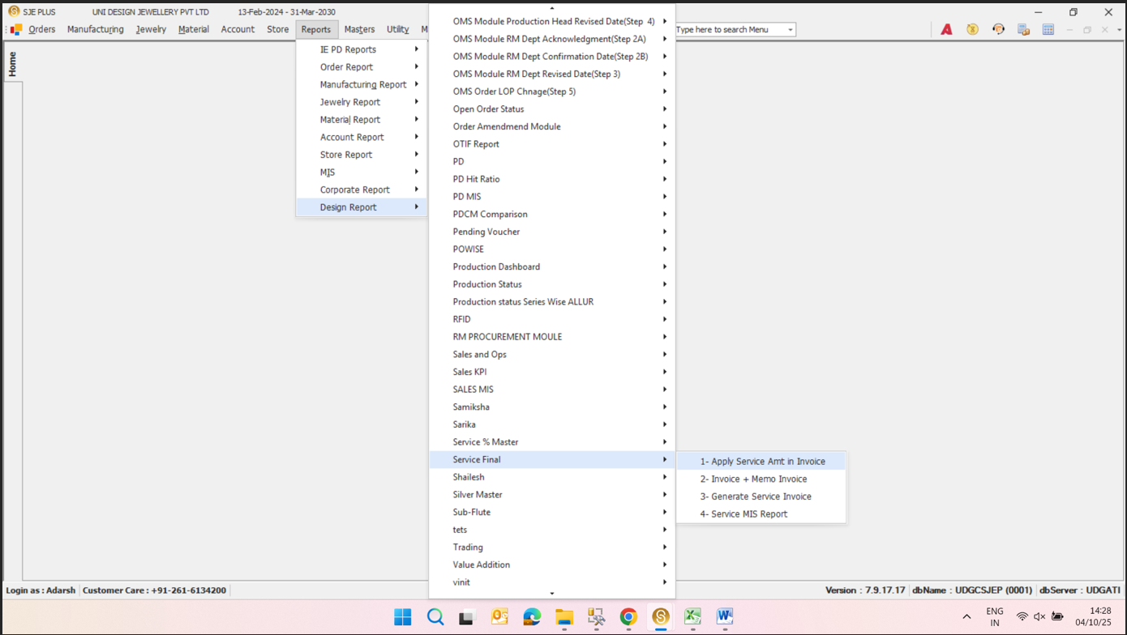
**Design Report**
Key objects & actions:
- **Design Report** —
- **PD Hit Ratio** —
- **PD MIS** —
- **PDCM Comparison** —
- **Production Dashboard** —
- **Production Status** —
- **Production Status Series Wise ALLUR** —
- **RFID** —
- **RM PROCUREMENT MOULE** —
- **Sales and Ops** —
- **Sales KPI** —
- **Sales MIS** —
- **Samiksha** —
- **Samiksha** —
- **Service % Master** —
- **Service Final** —
- **1- Apply Service Amt in Invoice** —
- **2- Invoice + Memo Invoice** —
- **3- Generate Service Invoice** —
- **4- Service MIS Report** —

Step 2: Step 2
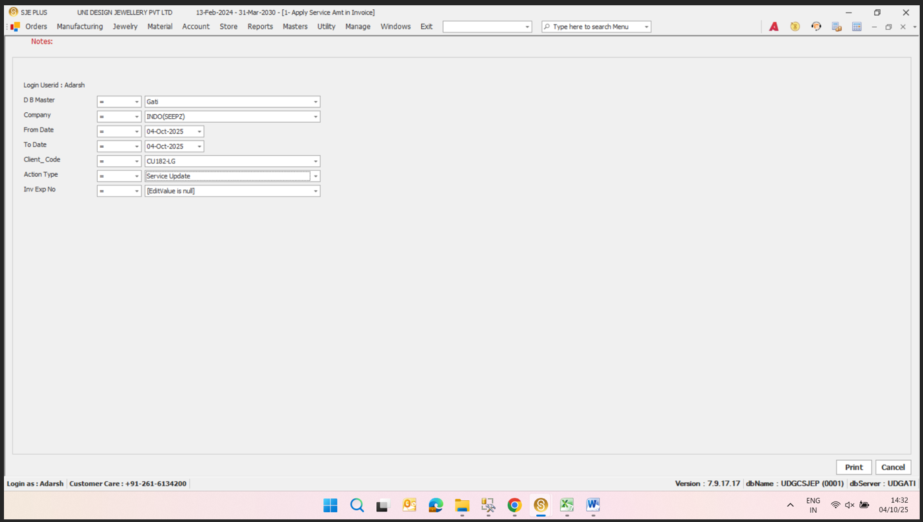
Unable to analyze step 2
Key objects & actions:
- Unable to analyze step 2 —

Step 3: Step 3
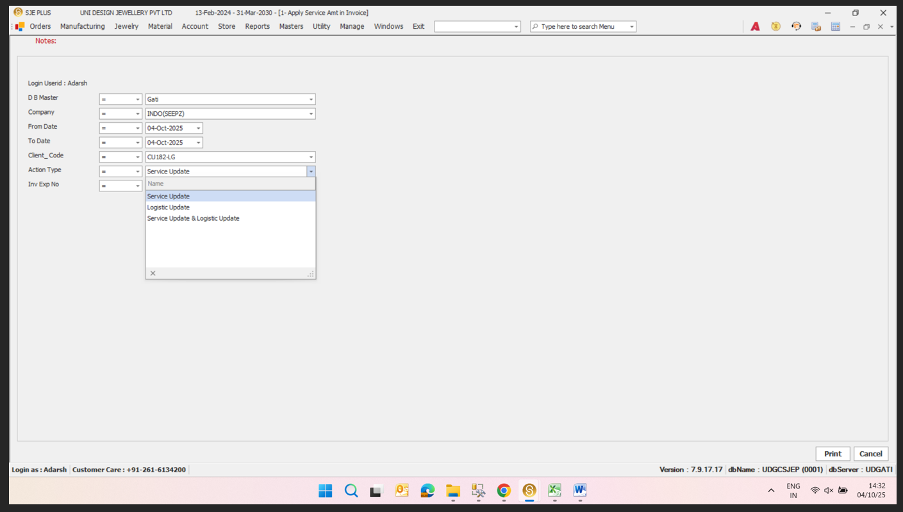
Service Update
Key objects & actions:
- Service Update —
- Logistic Update —
- Service Update & Logistic Update —

