# Standard Operating Procedure (SOP)

Report path: Reports – Design Report

System: SJE PLUS (GATI)

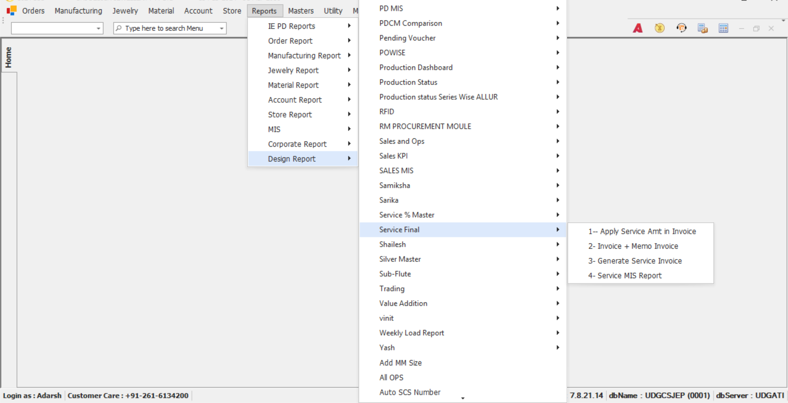

## Objective:

To guide users on how to access and generate service-related invoices and reports through the Design Report menu in the SJE PLUS(GATI) system under the

**Reports > Design Report > Service Final section.**

## Step-by-Step Instructions:

### Step 1: Login

* - Open the SJE PLUS application.
* - Login using your punching credentials in Uni.
* - Confirm successful login by checking the bottom status bar which should show: Login as : __________________

### Step 2: Open the Reports Menu

* - On the top menu bar, click on Reports.

### Step 3: Navigate to Design Report

* - In the dropdown under Reports, hover over Design Report (last option).

### Step 4: Navigate to Service Final

* - A side menu will open. (If not visible, request access from the IT department.)
* - Scroll down and hover over the Service Final section.

**1) Title: Accessing “Apply Service Amt in Invoice” from SJE PLUS**

## Step-by-Step Instructions:

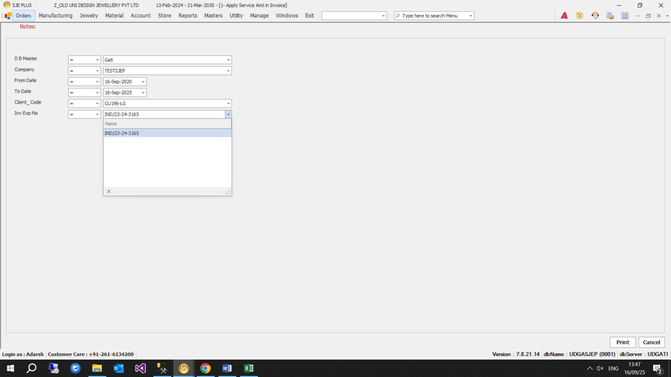

Figure: Apply Service Amt in Invoice screen interface

## Step-by-Step Instructions (Continued):

### Step 1: Select D B Master

* - Choose the ‘Emr’ Or 'Gati' from the Dropdown.

### Step 2: Select Company

* - Use the dropdown to select the appropriate company based on the database (EMR or GATI) for which the data needs to be updated.

### Step 3: Select Date Range

* - Choose the 'From Date' and 'To Date' using the calendar picker to define the invoice period.

### Step 4: Select Client Code

* - Select a specific client only applicable client codes are displayed based on the chosen database (EMR or GATI).

### Step 5: Select Inv Exp No

* - Select a specific client invoice (Only invoices with applicable client codes are shown here, and only if custom matching is pending.)

### Step 6: Generate the Report

* - Click the **"Print"** button at the bottom right of the screen to generate the Apply Service Amt in Invoice Report.

**Output:**

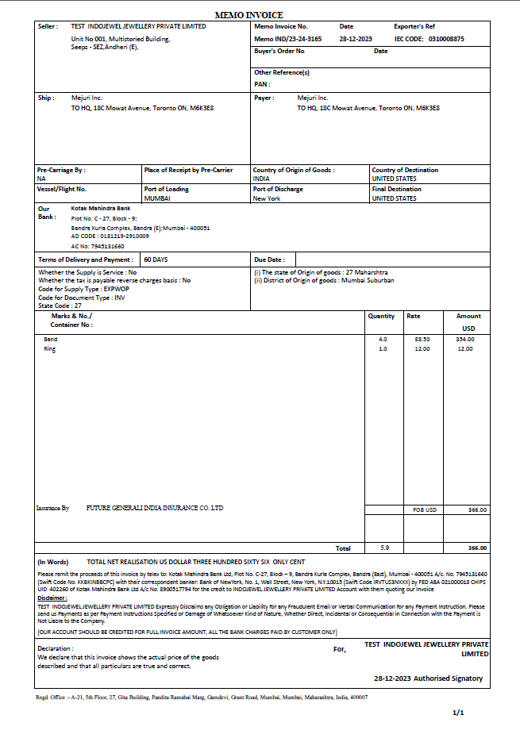

**2) Title: Accessing “Invoice + Memo Invoice” from SJE PLUS**

## Step-by-Step Instructions:

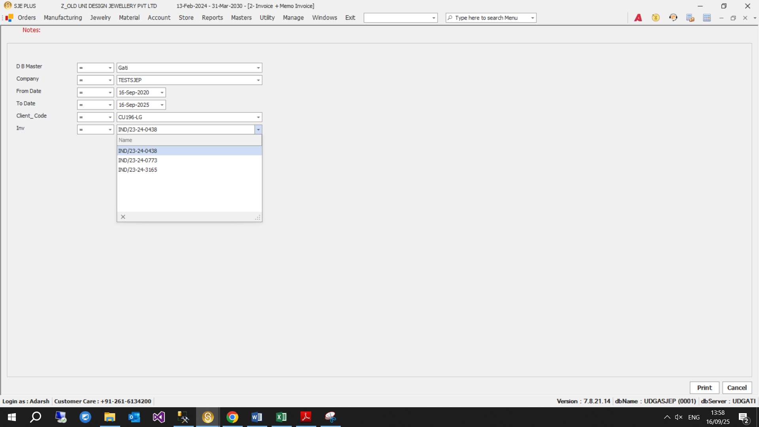

Figure: Invoice + Memo Invoice screen interface

## Step-by-Step Instructions (Continued):

### Step 1: Select D B Master

* - Choose the 'Emr' Or 'Gati' from the Dropdown.

### Step 2: Select Company

* - Use the dropdown to select company for which data is to be Shown.

### Step 3: Select Date Range

* - Choose the 'From Date' and 'To Date' using the calendar picker to define the invoice period.

### Step 4: Select Client Code

* - Select a specific client only applicable client codes are displayed based on the chosen database (EMR or GATI).

### Step 5: Select Inv

* - Select a specific client invoice (Only invoices with applicable client codes are shown here, and only if custom matching is Done.)

### Step 6: Generate the Report

* - Click the **"Print"** button at the bottom right of the screen to generate the Invoice + Memo Invoice Report.

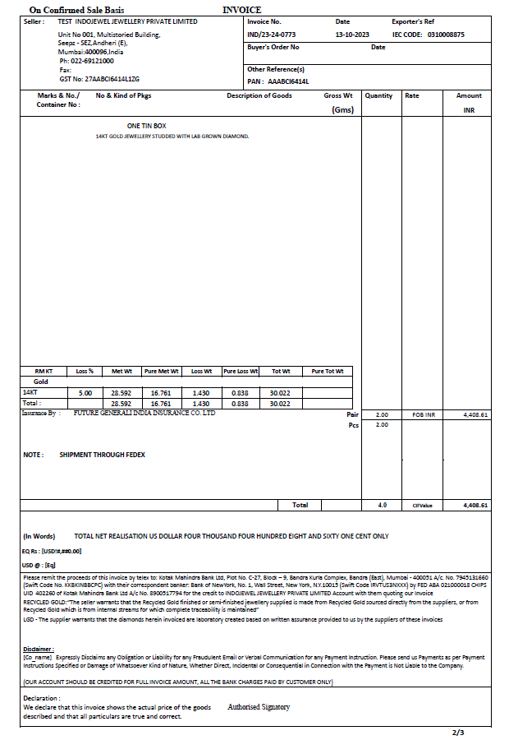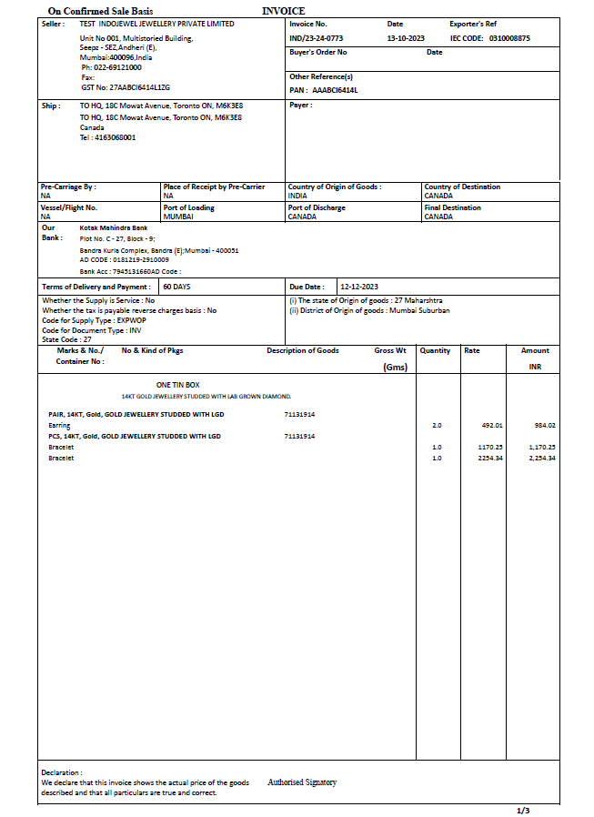**Output : (Invoice Report)**

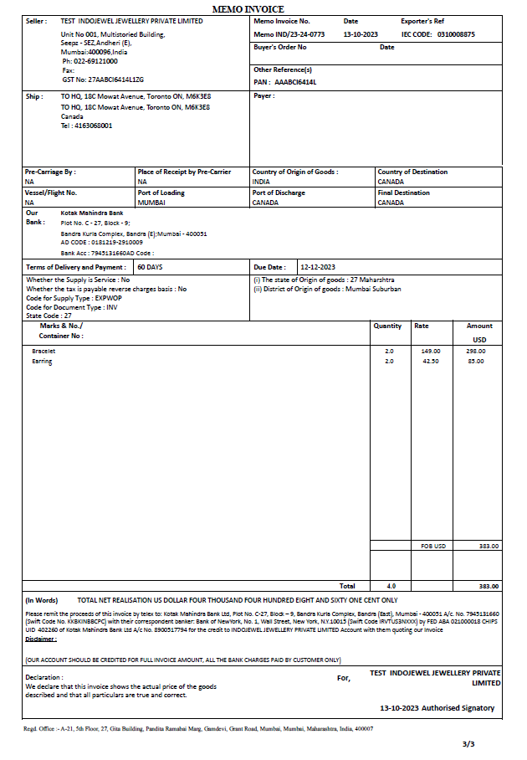**Memo Invoice**

**3) Title: Accessing “Generate Service Invoice” from SJE PLUS**

## Step-by-Step Instructions:

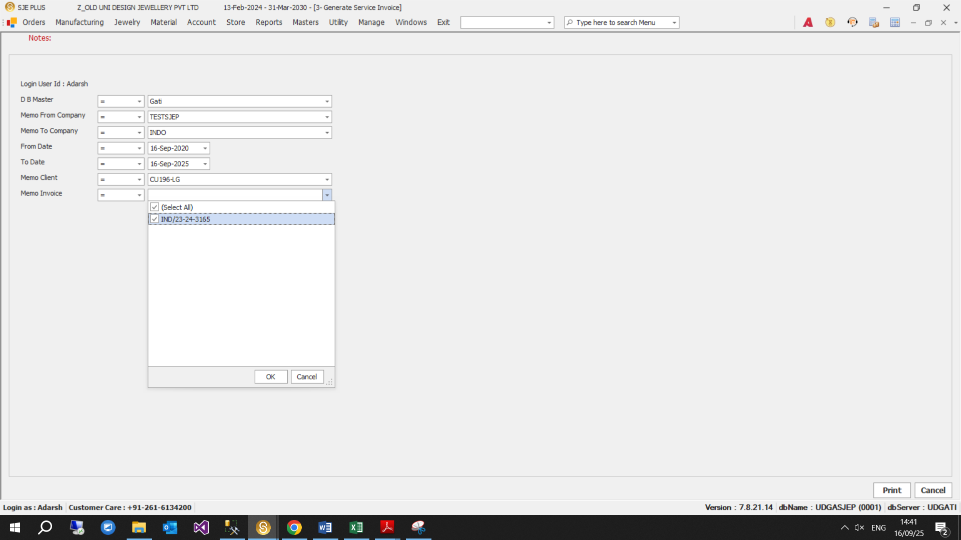

Figure: Generate Service Invoice screen interface

## Step-by-Step Instructions (Continued):

### Step 1: Select D B Master

* - Choose the 'Emr' Or 'Gati' from the Dropdown.

### Step 2: Select Memo From Company

* - Select Source Company of memo Invoice

### Step 3: Select Memo to Company

* - Select the company issuing receiving the memo.

### Step 4: Select Date Range

* - Choose the 'From Date' and 'To Date' using the calendar picker to define the invoice period.

### Step 5: Select Memo Client

* - Choose specific client for whom memo is being issued.

### Step 6: Select Memo Invoice

* - Enter a specific invoice number.

### Step 7: Generate the Report

* - Click the **"Print"** button at the bottom right of the screen to generate the Generate Service Invoice Report.

**Output :**

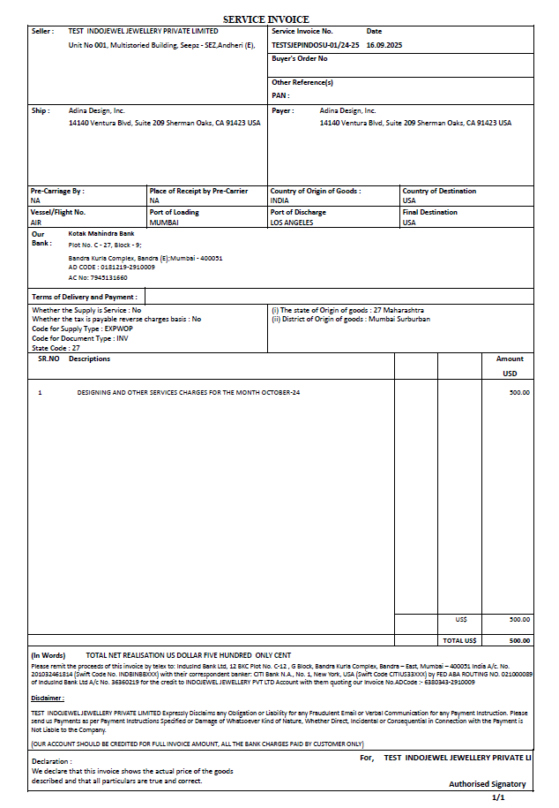

**4) Title: Accessing “Service MIS Report” from SJE PLUS**

## Step-by-Step Instructions:

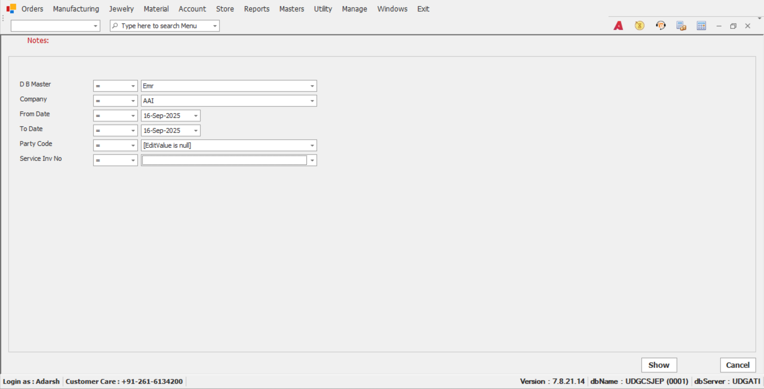

Figure: Service MIS Report screen interface

## Step-by-Step Instructions (Continued):

### Step 1: Select D B Master

* - Choose the 'Emr' Or 'Gati' from the Dropdown.

### Step 2: Select Company

* - Select the company.

### Step 3: Select Date Range

* - Choose the 'From Date' and 'To Date' using the calendar picker to define the invoice period.

### Step 4: Select Party Code

* - Choose the party/client if looking for a specific one.

### Step 5: Select Service InvNo

* - Enter a specific invoice number.

### Step 6: Generate the Report

* - Click the **"Show"** button at the bottom right of the screen to generate the Service MIS Report.

**Output :**

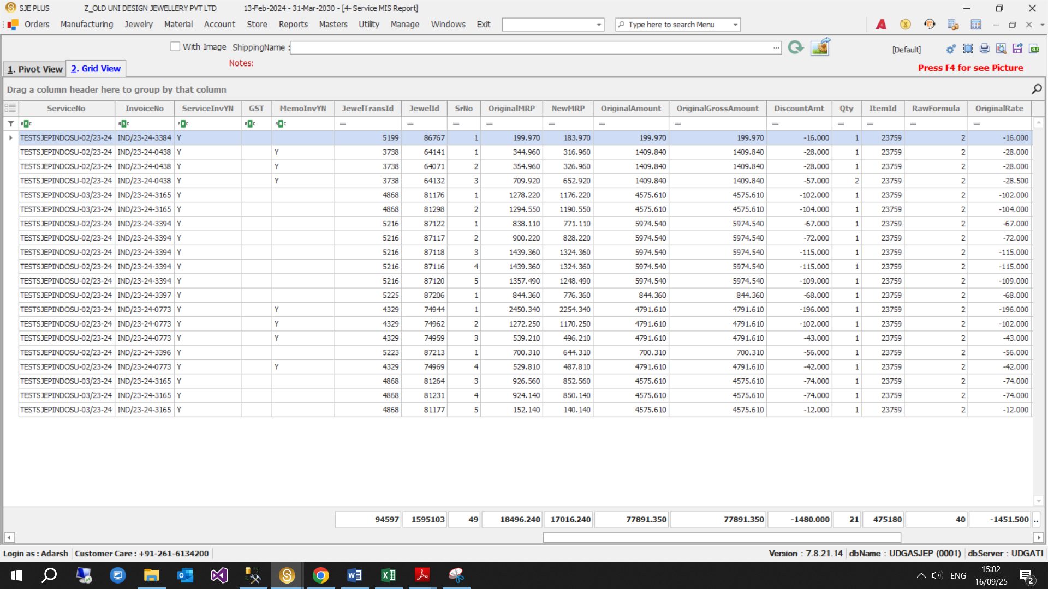

**Thank You**

**Adarsh Yadav / Prince Verma**

**IT TEAM….**