**UNSW Human Research Ethics Advisory Panel C: Psychology**

Application Form – 2021

**HREAP File No:**

**Sona No:**

**HREC No:**

* **For a NEW project, submit this application plus any additional documents bundled as a single pdf to your lab or research group Compliance Checker. If you do not know who your Compliance Checker is, please ask your supervisor. (Word files, zip files, and multiple attachments will be returned.)**
* **You may not start data collection (e.g., advertising for your study and/or recruiting participants) until you receive an official approval letter from the Research Ethics & Compliance Support unit via email**
* **Instructions for completing this form and additional forms can be downloaded from:** [**http://www.psy.unsw.edu.au/research/research-resources**](http://www.psy.unsw.edu.au/research/research-resources)

**Project Title:**

|  |
| --- |
| Optimising Health Communication |

**Location of Study** [e.g., Building and room number]**:** Mathews Building, UNSW Sydney; online

**Declaration of Investigators:**

I/we apply for approval to conduct the research. If approval is granted, it will be undertaken in accordance with the protocol described in this application and other relevant guidelines, regulations and laws.

I/we have read and understood the applicable UNSW and School’s Workplace Health and Safety policies, including Covid-Safe policies,. We will undertake all appropriate training in Workplace Health and Safety as dictated by UNSW and School policy.

Students see: <http://www.psy.unsw.edu.au/current-students/health-safety-students>

Staff and others see: <http://www.ohs.unsw.edu.au/ohs_training/index.html>



**Chief Investigator/Supervisor** [Must have academic appointment] **Signature\***

**Name/Title/Pos’n:** Benjamin Rhodri Newell/ Dr./ Professor

**Email Contact:** ben.newell@unsw.edu.au **Date:** 16/03/2022

**Investigators (including students)**

**Name & Status** UNSW email address Signature\***



Amy X. Li, Research Assistant amy.x.li@unsw.edu.au

**Status = Academic Staff, Post-doc, PhD student, MPsych student, Honours student, Research Assistant

**\* Written signatures are optional provided the email from the Chief Investigator contains the following declaration: “All investigators and I are aware of this project and understand our ethical duties.”**

**ETHICS APPROVAL:** As of_____________, the Human Research Ethics Advisory Panel C (Behavioral) has recommended to the DVC (Research) that this project, being of minimal ethical impact, should proceed. When granted, this is valid for five years from this date.

­­­­­­­­­­­­­­­­­­­­________________________________ Co-Convenors, HREA Panel C, K Martire/K Faasse

________________________________ Reviewing Member Panel C, ___________________________

________________________________ Head of School, Simon Killcross

**SONA Registration and Request for Allocation of Psychology 1 Participants**

[1: **You must have an ACTIVE SONA-1 RESEARCHER ACCOUNT in order to submit this application**. If you need a researcher account, please email [**sona@psy.unsw.edu.au**](mailto:sona@psy.unsw.edu.au) with the following information: 1. Indicate that you would like a researcher account, 2. Include your first and last name, 3. Include your preferred email address, and 4.CC your supervisor if you are a student.

You **must** **receive an acknowledgement of this registration before submitting an application** for *both* an allocation of Psychology 1 students *and*ethics clearance. Your application may be **delayed** if you fail to register for SONA before submitting the application.

Note that researcher account can be used across several projects – a new researcher account **not required for every project.]**

**Tick this box to indicate that you ARE REGISTERED on the SONA system**

[**2:** For previously approved projects (i.e., you have an HREAP-C File Number), you may request additional Psychology 1 participants by completing the “Additional Participants Form” available at <http://www.psy.unsw.edu.au/research/research-resources>]

**The privilege of using Psychology 1 students carries with it the following responsibilities:**

1. You must **promptly allocate credits** to participants on SONA within 5 working days of a session, and no later than the Monday following the last week of the teaching term.
2. You must **debrief participants** with additional pedagogical information regarding your study in the following manner:
   1. Please prepare answers to items listed under Item 6d.
   2. When conducting **face-to-face** debriefings, provide an electronic display of the answers to each participant, ask for questions, and then ask the participant to indicating that they have received a satisfactory debriefing
   3. When conducting **online** debriefings, provide an electronic version of the answers to the questions, provide a point of contact for any questions, and ask participants to tick a box indicating that they have received the debriefing content.
   4. The consent forms and debriefing registers/responses should be retained by the researcher or academic supervisor.
3. All research participation, including all parts of multipart studies and debriefings, with students from first year psychology must be **completed by 12 midnight on the Friday of the last week of term.**
4. For every 10 sessions posted to SONA, 1 session must be **offered after 5pm**.

**[Continue to NEXT PAGE for requesting and allocating Psychology 1 student participants]**

**Request for allocation of Psychology 1 Participants (cont.)**

**Tick this box if *either/both* Part 1 or Part 2 of your study will be run online**

|  |  |  |
| --- | --- | --- |
| **PART 1** | **PART 2** | **Home- or Pre-Work** |
| 30 minutes | N/A | N/A |

**Duration** [in 15 min increments – minimum of 15 minutes; If **MORE** than 1 hour provide your **justification** in the box below]

|  |
| --- |
| Click here to enter text. |

|  |  |  |
| --- | --- | --- |
| **PART 1** | **PART 2** | **Home- or Pre-Work** |
| 0.5 points | N/A | N/A |

**Requested Credit Per Participant** [in 0.25 increments – minimum: 0.5 point for in-person, 0.25 for online; for multipart studies state credit per part, see also Home / Pre-Work Policy p.11 and the ‘Additional Points’ guide p.12]

**Requested Number of Participants** [In total]**:** 200

**Total Requested Hours** [= *Credit Per Participant* X *Number of Participants*]: 100 hours

**If Total Requested Hours** is **MORE** than **100 HOURS** provide justification below

|  |
| --- |
| N/A |

**Preparation Instructions** [Describe below; Optional; Indicate tasks participants will need to do or not do prior to arriving at the study]:

|  |
| --- |
| N/A |

**Eligibility Criteria** [Describe below; Optional; *Note* this is **NOT** based on pre-screening]

|  |
| --- |
| N/A |

**Tick this box if your study has Pre-Screening Criteria.**

**Brief Description of Study** [Describe below; **Required;** Indicating the overall purposes and what the participants will be asked to do; **STRICTLY** no more than **245 characters** (including spaces and punctuation) If your study is a two- part study you **must** include this fact in the 245 characters. Student participants will view this information before signing up for the study. **Your application will be returned to you and may encounter a two-week delay if your description exceeds the 245-character limit**]

|  |
| --- |
| This study examines how risk communication formats can influence people’s attitudes towards, and understanding of, health-related risk information. You will choose between and rate different options, and answer some simple questionnaires. |

**Character Count** [including spaces and punctuation]**:** 238

**Tick this box to DECLARE that your description contains 245 CHARACTERS or fewer.**

**THE UNIVERSITY OF NEW SOUTH WALES**

**Human Research Ethics Advisory Panel (HREAP) C – APPLICATION FORM**

**IMPORTANT:** A**nswer ALL questions,** and **attach** documentation where required

1. **Investigator’s School/Unit/Centre:**

|  |  |  |  |  |  |  |
| --- | --- | --- | --- | --- | --- | --- |
| **Investigators** | **Family Name** | **First Name and Title** | **UNSW ZID** | **UNSW Email** | **Phone/Mobile** | **Status \*** |
| Chief Investigator/  Supervisor | Newell | Benjamin Rhodri, Professor | z9801543 | [ben.newell@unsw.edu.au](mailto:ben.newell@unsw.edu.au) | +61 2 9385 1606 | Academic Staff |
| Investigator | Li | Amy X. | z5077197 | [amy.x.li@unsw.edu.au](mailto:amy.x.li@unsw.edu.au) | +61 434 986 183 | Research Assistant |

*Status = Academic Staff, Post-doc, PhD student, MPsych student, Honours student, Research Assistant

1. **Project Title:**

|  |
| --- |
| Optimising Health Communication |

[In answering the following questions, please be guided by *both* the **instructions accompanying each question** and the NHMRC **National Statement on Ethical Conduct in Human Research:** [**html version**](http://www.nhmrc.gov.au/book/national-statement-ethical-conduct-human-research)**;** [**pdf version**](http://www.nhmrc.gov.au/_files_nhmrc/publications/attachments/e72_national_statement_130813.pdf)**]**

1. **Project Description:** [Please provide a **description** of the project **(300 word max)** in the text box below. This description should briefly summarise the aims and general hypotheses. However, for reaching a judgment about the ethics of the project, **this description should focus on what *will happen to the participants***(i.e., a summary of the procedure). Think about what the participant will be exposed to. Please **attach** a copy of **questionnaires**/**task instructions**/**examples** of other stimulus materials, where feasible].

|  |
| --- |
| The project examines how different risk communication formats may affect a person’s understanding of, and attitudes towards, complex health-related risk information. In particular, we are interested in how different features in risk communication impact people’s assessment of vaccine-related risks.  In this study, participants will choose the best and worst options from a number of different screenshots. Between screenshots, we will manipulate the features via which the health risks (e.g., myocarditis risks) associated with a single, unnamed vaccine are communicated (e.g., base rates, comparison categories, visual formats). Critically, all options that are viewed by participants contain objectively the same information about the same unnamed vaccine; only features of the presentation format are manipulated. Please see Attachment 1 for an example trial.  After the main task, participants will fill out questionnaire items about general demographics questions and their overall health- and vaccine-related attitudes. Please see Attachment 2 for example demographics and questionnaire items. Participants will be able to skip any and all questions.  To ensure that the study does not interfere with people’s attitudes and responses towards potential vaccines, all information and risk comparisons presented will be based on verified data for existing vaccines. |

1. **Risks and Mitigation**

|  |  |
| --- | --- |
| a. Is there a plausible risk greater than discomfort, either physical, psychological, social, cultural or financial to participants ? [**See (https://research.unsw.edu.au/more-low-risk-research)**  DECEPTION should be addressed under **Item 9**] | 4a. **YES** **NO** |
| b.Are there plausible risks greater than discomfort to researchers?  c. Have you read the guidelines for managing distressed participants? [**See p.5 of Ethics Approval Applicant Instructions]** | 4b. **YES NO**  4c. **YES NO** |

|  |
| --- |
| N/A |

d. This project will comply with the Covid-Safe policy for **Human Testing (Physical Distancing Possible)** [**See pp. 10-14 of Ethics Approval Applicant Instructions]** 4d. **YES N/A**

e. This project will comply with the Covid-Safe policy for **Human Testing (Physical Distancing Not Possible)** [**See p.15-19 of Ethics Approval Applicant Instructions]** 4e. **YES N/A**

1.  **Recruitment of Participants:** [**See National Statement**: Sections 4, 5, 6, 7, 8 and 9.

|  |  |
| --- | --- |
| a. Is there any possibility of coercion of participants to enroll in the study? | 5a. **YES NO**` |
| b.Are participants in a dependent relationship with the Investigator (e.g., teacher-student)? | 5b. **YES NO** |
| c. Will participants be offered an inducement to encourage their involvement? | 5c. YES NO |

[If you answered **YES** to **any** of these questions (5a-c) please describe fully how participants are to be recruited and how other issues are to be resolved below. Please **attach** any **recruitment advertisements** and **posters**. The credit offered to Psychology 1 students is considered an inducement.]

|  |
| --- |
| Participants from the SONA-I participant pool will be offered 0.5 SONA points for their participation. Participants from Amazon Mechanical Turk and Prolific will be paid an amount commensurate with study length, at $3.34 USD (equivalent to $10.02 USD per hour) on Amazon MTurk, and £2.50 GBP (equivalent to £7.50 GBP per hour) on Prolific. Please see section 5.e) for information on how non-SONA online participants are recruited. |

|  |  |
| --- | --- |
| d. Will you be using Psychology 1 participants? | 5d. YES NO |

[If you answered **YES** provide responses to the debriefing questions listed below in the text box. Participants must confirm that they have been debriefed by signature (in-person) or a check-box response (online). This information should be discussed with participants during a 5-10 minute **mandatory** debriefing at the end of each session.

1. What are the research questions?  
2. How does this study extend previous research on this topic?  
3. What are some potential real-world implications of this research?  
4. Briefly describe a potential issue (e.g., ethical, practical) or limitation of the study (e.g., design, ecological validity).  
5. Briefly describe the study methodology (e.g., design, dependent/ independent variables, materials).  
6. Further reading (i.e., a reference to a reading/s related to the current study for curious students).

|  |
| --- |
| 1. The primary research question in this study is how risk communication formats may affect people’s attitudes/perceptions towards vaccine-related risks, and vaccination more broadly.  2. This study extends previous research on vaccine hesitancy by investigating potential interventions based on the cognitive psychology literature. For example, the ratio-bias phenomenon (Denes-Raj et al., 1995) suggests that people judge events as being more likely when its probability is presented in the form of an equivalent ratio of larger (“10 in a million”), compare to smaller (“1 in 100,000”) numbers, and hence suggests that vaccine-related side effect risks may be perceived as being greater in the former instance. We manipulate such factors in a series of screenshots which are presented to participants.  3. The success of vaccines in preventing serious illness and death depends heavily on uptake. However, a common barrier to vaccination is hesitancy due to concerns about vaccine-related side effects (e.g., Reno et al., 2021). The findings of our study can help optimise communication about risks of vaccine-related side effects, so that concerns about such risks can be appropriate weighted. More broadly, these findings can help increase positive community responses towards vaccination.  4. One issue is that we need to be careful about in this study is the veracity of supplied information, since inaccurate information may influence people’s attitudes towards real-life vaccines. We address this issue by sourcing all information from reliable and trustworthy sources.  5. The study employs a within-subjects design, with each factor being a manipulated feature of interest (e.g., base rate: a million vs. 100,000). The dependent variable is people’s preference ratings regarding the screenshots that they see.   6. Dubé E, Gagnon D, Vivion M. Optimizing communication material to address vaccine hesitancy. Can Commun Dis Rep 2020;46(2/3):48–52. http://doi.org/10.14745/ccdr.v46i23a05 |

|  |  |
| --- | --- |
| 1. Will you be using participants who are **NOT** Psychology 1 students? | 5d. YES NO |

[If you answered **YES** provide a **description** of how those participants will be recruited for your project**.** Among other things, please indicate the targeted sample size, places where you will recruit, rate of any reimbursement, your recruiting advertisements, any personal approaches, and special characteristics of the target population. **Recruiting advertisements** should be **attached**]

|  |
| --- |
| Participants will be recruited online, from Amazon Mechanical Turk and Prolific, in addition to the SONA-I participant pool. Recruitment will involve advertising the study online on the Amazon Mechanical Turk and Prolific platforms, and the base rate of reimbursement for participating in the study will be commensurate with study length, at $3.34 USD (equivalent to $10.02 USD per hour) on Amazon MTurk, and £2.50 GBP (equivalent to £7.50 GBP per hour) on Prolific. We do not anticipate that the online population will have any special characteristics. Our recruitment target is 200 participants.  The advertisement will be in the form of a short, simple study description: “This study examines how risk communication formats can influence people’s perceptions and attitudes towards health-related risks. In this study you will choose between different options, respond using rating scales, and answer some simple questionnaires. “  When participants click on the study to proceed with participation, they will be shown an instruction screen (see attachment number 3) that will then direct them to the exact same task that  SONA-I participants will complete. |

1.  **Informed Consent and Debriefing:** [**See National Statement**: Sections 1, 6, 14, 15 and 16]

|  |  |
| --- | --- |
| * 1. Will you seek informed consent from participants, either in writing or electronically, e.g. 'button' push?" | 6a. YES NO |

[If you answered **NO**, please justify why not. If you answered **YES attach** **Participant Information Sheet(s)** and **Consent Form(s)** prepared in *close accordance* with the **HREC proforma**.]

|  |
| --- |
| Please see the attached PISCF. Separate PISCFs have been attached for each of the recruitment samples: Psychology 1 (SONA-1), Amazon Mechanical Turk, and Prolific. |

|  |  |
| --- | --- |
| * 1. Will you be providing a debriefing? | 6b. YES NO |

[If you answered **NO**, please justify why not **below**. If you answered **YES** please **describe** the debriefing **below**. Note: Debriefing is MANDATORY whenever Psychology 1 students (see Item 6d) and/or deception (see Item 10) are used.]

|  |
| --- |
| Debriefing will be provided to both Psychology 1 students and non-Psychology 1 students who participate in the study. Please see response for item 5d) for debriefing provided to Psychology 1 students, and Attachment 4 for debriefing provided to non-Psychology 1 students. |

1. **Privacy, Confidentiality, Anonymity:** [**See National Statement**: Section 17]

|  |  |
| --- | --- |
| * 1. Is there a requirement for the researchers to identify, collect, use, or disclose information of a personal nature (either identifiable or potentially identifiable) about individuals without their consent? | 7a. YES NO |

[This question primarily concerns situations covered by the *Privacy Act*, in which you are collecting information from databases kept by third parties such as government departments or human resource departments in a business. If you do wish to obtain data about identifiable individuals from such data bases, please complete the **HREA Panel Privacy Form**.]

|  |  |
| --- | --- |
| * 1. Is there a possibility of participants being inappropriately identified or confidential data being divulged during or after the research has taken place? | 7b. YES NO |

[If you answered **YES** please **describe** the measures you will take **below** to ensure privacy, confidentiality and anonymityare preserved. One favoured measure is to irretrievably strip the names and other identifying information from the data records.]

|  |
| --- |
| N/A |

* 1. Please complete the table below regarding storage of research data and materials. Please ensure this is compliant with the [*UNSW Handling Research Material & Data Procedure*](https://www.gs.unsw.edu.au/policy/documents/researchdataproc.pdf)

|  |  |  |  |  |  |  |  |  |  |  |  |  |  |  |  |  |  |  |  |  |  |  |  |  |  |
| --- | --- | --- | --- | --- | --- | --- | --- | --- | --- | --- | --- | --- | --- | --- | --- | --- | --- | --- | --- | --- | --- | --- | --- | --- | --- |
| |  |  |  |  |  |  | | --- | --- | --- | --- | --- | --- | | **Data Type** | **Campus/Location** | **Building/Server Name** | **How is data stored securely** | **How is access restricted** | **Estimated date of data destruction**  **(NB* Data must be stored for a minimum period of 5 years after publication)** | | **Hard Copies**  (add additional rows for multiple locations) | UNSW Sydney, Kensington | Mathews Building | Inside locked filing cabinet in MAT701 | Only BN has access to MAT701; room is kept locked when not occupied. The filing cabinet in which hard copies will be stored is kept locked at all times. | Indefinitely | | **Electronic Copies**  (add additional rows for multiple locations) | N/A | ResData | Data will be in deidentified format | N/A | Indefinitely | | **Audio/Visual**  (add additional rows for multiple locations) |  |  |  |  |  | |  |

1. **Observation and Records:**

|  |  |
| --- | --- |
| * 1. Is it necessary in your research to make recorded observations of participants? [e.g., audiotapes, videotapes] | 8a. YES NO |
| * 1. Is it necessary to use records or database information? | 8b. YES NO |

[If you answered **YES** to either question, please **explain below** why and how this will be done].

|  |
| --- |
| N/A |

1. **Deception/Limited Disclosure/Debriefing:** In your research, is it necessary to:

|  |  |
| --- | --- |
| * 1. deceive the participants? | 9a. YES NO |
| * 1. disclose limited information to participants? | 9b. YES NO |

[See **National Statement**: ‘Deception’ is defined where relevant material is withheld from research participants and/or they are intentionally misled about procedures and/or purposes of the research. Please note that if the research involves deception, the project must be reviewed by the Human Research Ethics Committee as per section 2.3.4 of the National Statement

‘Limited Disclosure’ refers to not disclosing to research participants all of the aims and/or methods of the research.

|  |
| --- |
| N/A |

1.  **Funding and Conflicts of Interest:**

|  |  |
| --- | --- |
| * 1. Is the research being funded by an agency outside the University of New South Wales? | 10a. YES NO |
| * 1. Is there any conflict of interest (including financial gain) likely to result from this project? | 10b. YES NO |

[If you answered **YES** to either of these questions, please provide **details** below and **attach** documentation. Note: **Externally-funded projects that are of minimal ethical impact can be approved by the HREAP**].

|  |
| --- |
| N/A |

1.  **Organisations other than the University of New South Wales:**

|  |  |
| --- | --- |
| * 1. Are there organisations other than UNSW or another collaborating university involved in this research? | 11a. YES NO |

[If you answered **YES**, please provide **details** below**.** Please **attach** a **letter of support** for the research from the organization. Provisional approval can be given pending receipt of a letter of support.]

|  |
| --- |
| The work will be conducted jointly with Dr. Carissa Bonner at the University of Sydney. Please see attachment 5 for letter of support. |

1.  **Publications and Disseminations of results:**

|  |  |
| --- | --- |
| Please detail how the research results will be reported/published and how the results will be reported back to the participants of the study. |  |

We hope to eventually publish the findings in a peer-reviewed journal; data may be shared in a de-identified   
form. If participants wish to hear about the findings of the study, they will be informed via email when   
findings are disseminated, if they have provided their email address with the consent form.

**13. Participant Information Statement and Consent Form (PISCF):** The next pages (9-11) show the template of the PISCF that is suitable for the vast majority of projects. However, should you wish to conduct phone interviews where the participant provides verbal consent, please see <https://research.unsw.edu.au/forms-and-templates> for a script that is complies with NHMRC ethics requirements. There are also PISCFs for parents/guardians and for participants who may need an easy-to read format.

|  |  |
| --- | --- |
| School of Psychology |  |
| **PARTICIPANT INFORMATION STATEMENT AND CONSENT FORM**  Psychology 1A/1B | |
| *Improving Health communication* | |

1. **What is the research study about?**

You are invited to take part in this research study. The research study aims to examine how risk communication formats can influence people’s perceptions and attitudes towards health-related risks.You have been invited because you have responded to an advertisement for this study via SONA-1.

1. **Who is conducting this research?**

The study is being carried out by the following researchers: Professor Benjamin Newell and Amy Li at the School of Psychology, at UNSW Sydney.

1. **Inclusion/Exclusion Criteria**

Not applicable.

1. **Do I have to take part in this research study?**

Participation in this research study is voluntary. If you do not want to take part, you do not have to. If you decide to take part and later change your mind, you are free to withdraw from the study at any stage (See Item 11).

1. **What does participation in this research require, and are there any risks involved?**

If you decide to take part in the research study, we will ask you to complete a simple task which will take approximately 30 minutes. In this task, you will be asked to choose between different options and respond using rating scales.

We don’t expect this research to cause any harm. However, you may skip any or all written or verbal questions if you wish. Please let the researchers know if you need any assistance for any reason.

1. **Total participation time**

In total, participation in this study will require 30 minutes. This will include one single session in which you will complete the task described above.

1. **Recompense to participants**

You will receive 0.5 SONA creditsas recompense for your participation.

1. **What are the possible benefits to participation?**

We cannot promise that you will receive any benefits from this study, but we hope to use the findings from this study to further our understanding of the factors influencing people’s judgements about algorithms, and hence shed light on what might affect their acceptability to users.

1. **What will happen to information about me?**

The information that you give us will be kept for a minimum of 5 yearsafter the project’s completion. We will store information about you in a deidentified format at a secure location in the School of Psychology at UNSW Sydney.

Researchers at UNSW are requested to store their aggregated research data in the UNSW data repository, this is a system called ResData. Once the aggregated data are deposited into this repository, they will be retained in this system permanently, but in a format where your data will not be individually identifiable.

We hope to publish the results of this study, but this will not include information that identifies you. Information collected for this research project may be shared with other researchers in de-identified form only; for example, in order to verify that our findings are robust, or form the basis of future research.

The information you provide is personal information for the purposes of the Privacy and Personal Information Protection Act 1998 (NSW). You have the right of access to personal information held about you by the University, the right to request correction and amendment of it, and the right to make a compliant about a breach of the Information Protection Principles as contained in the PPIP Act. Further information on how the University protects personal information is available in the [**UNSW Privacy Management Plan**](https://www.legal.unsw.edu.au/compliance/privacyhome.html).

1. **How and when will I find out what the results of the research study are?**

The research team intend to publish and/ report the results of the research study in a variety of ways. All information published will be done in a way that will not identify you. If you would like to receive a copy of the results, you can let the research team know by contacting Amy Li via email (amy.x.li@unsw.edu.au).

1. **What if I want to withdraw from the research study?**

If you do consent to participate, you may withdraw at any time. You can do this by closing the questionnaire. If you withdraw from the research, we will destroy any information has already been collected. Once you have submitted the questionnaire however, we will not be able to withdraw your responses as the questionnaire is anonymous.

Your decision not to participate or to withdraw from the study will not affect your relationship with UNSW Sydney. If you decide to withdraw from the research study, the researchers will not collect additional information from you. Any identifiable information about you will be withdrawn from the research project.

1. **What should I do if I have further questions about my involvement in the research study?**

If you require further information regarding this study or if you have any problems that may be related to your involvement in the study, you can contact the following member/s of the research team:

**Research Team Contact Details**

|  |  |
| --- | --- |
| **Chief Investigator** | Benjamin Newell |
| **Position** | Professor |
| **Telephone** | +61 2 9385 1606 |
| **Email** | ben.newell@unsw.edu.au |

|  |  |
| --- | --- |
| **Investigator** | Amy X. Li |
| **Position** | Research Assistant |
| **Telephone** | +61 434 986 183 |
| **Email** | amy.x.li@unsw.edu.au |

**What if I have a complaint or any concerns about the research study?**

If you have a complaint regarding any aspect of the study or the way it is being conducted, please contact the UNSW Human Ethics Coordinator:

**Complaints Contact**

|  |  |
| --- | --- |
| **Position** | UNSW Human Research Ethics Coordinator |
| **Telephone** | + 61 2 9385 6222 |
| **Email** | [humanethics@unsw.edu.au](mailto:humanethics@unsw.edu.au) |
| **HC Reference Number** | 3597 |

|  |  |
| --- | --- |
| School of Psychology |  |
| **PARTICIPANT INFORMATION STATEMENT AND CONSENT FORM**  Prolific | |
| *Improving Health communication* | |

1. **What is the research study about?**

You are invited to take part in this research study. The research study aims to examine how risk communication formats can influence people’s perceptions and attitudes towards health-related risks.You have been invited because you have responded to an advertisement for this study via Prolific.

1. **Who is conducting this research?**

The study is being carried out by the following researchers: Professor Benjamin Newell and Amy Li at the School of Psychology, at UNSW Sydney.

1. **Inclusion/Exclusion Criteria**

Not applicable.

1. **Do I have to take part in this research study?**

Participation in this research study is voluntary. If you do not want to take part, you do not have to. If you decide to take part and later change your mind, you are free to withdraw from the study at any stage (See Item 11).

1. **What does participation in this research require, and are there any risks involved?**

If you decide to take part in the research study, we will ask you to complete a simple task which will take approximately 20 minutes. In this task, you will be asked to choose between different options, respond using rating scales, and answer some simple questionnaire items.

We don’t expect this research to cause any harm. However, you may skip any or all written or verbal questions if you wish. Please let the researchers know if you need any assistance for any reason.

1. **Total participation time**

In total, participation in this study will require 20 minutes. This will include one single session in which you will complete the task described above.

1. **Recompense to participants**

You will receive £2.50as recompense for your participation, equivalent to £7.50 per hour.

1. **What are the possible benefits to participation?**

We cannot promise that you will receive any benefits from this study, but we hope to use the findings from this study to further our understanding of the factors influencing people’s judgements about algorithms, and hence shed light on what might affect their acceptability to users.

1. **What will happen to information about me?**

The information that you give us will be kept for a minimum of 5 yearsafter the project’s completion. We will store information about you in a deidentified format at a secure location in the School of Psychology at UNSW Sydney.

Researchers at UNSW are requested to store their aggregated research data in the UNSW data repository, this is a system called ResData. Once the aggregated data are deposited into this repository, they will be retained in this system permanently, but in a format where your data will not be individually identifiable.

We hope to publish the results of this study, but this will not include information that identifies you. Information collected for this research project may be shared with other researchers in de-identified form only; for example, in order to verify that our findings are robust, or form the basis of future research.

The information you provide is personal information for the purposes of the Privacy and Personal Information Protection Act 1998 (NSW). You have the right of access to personal information held about you by the University, the right to request correction and amendment of it, and the right to make a compliant about a breach of the Information Protection Principles as contained in the PPIP Act. Further information on how the University protects personal information is available in the [**UNSW Privacy Management Plan**](https://www.legal.unsw.edu.au/compliance/privacyhome.html).

1. **How and when will I find out what the results of the research study are?**

The research team intend to publish and/ report the results of the research study in a variety of ways. All information published will be done in a way that will not identify you. If you would like to receive a copy of the results, you can let the research team know by contacting Amy Li via email (amy.x.li@unsw.edu.au).

1. **What if I want to withdraw from the research study?**

If you do consent to participate, you may withdraw at any time. You can do this by closing the questionnaire. If you withdraw from the research, we will destroy any information has already been collected. Once you have submitted the questionnaire however, we will not be able to withdraw your responses as the questionnaire is anonymous.

Your decision not to participate or to withdraw from the study will not affect your relationship with UNSW Sydney. If you decide to withdraw from the research study, the researchers will not collect additional information from you. Any identifiable information about you will be withdrawn from the research project.

1. **What should I do if I have further questions about my involvement in the research study?**

If you require further information regarding this study or if you have any problems that may be related to your involvement in the study, you can contact the following member/s of the research team:

**Research Team Contact Details**

|  |  |
| --- | --- |
| **Chief Investigator** | Benjamin Newell |
| **Position** | Professor |
| **Telephone** | +61 2 9385 1606 |
| **Email** | ben.newell@unsw.edu.au |

|  |  |
| --- | --- |
| **Investigator** | Amy X. Li |
| **Position** | Research Assistant |
| **Telephone** | +61 434 986 183 |
| **Email** | amy.x.li@unsw.edu.au |

**What if I have a complaint or any concerns about the research study?**

If you have a complaint regarding any aspect of the study or the way it is being conducted, please contact the UNSW Human Ethics Coordinator:

**Complaints Contact**

|  |  |
| --- | --- |
| **Position** | UNSW Human Research Ethics Coordinator |
| **Telephone** | + 61 2 9385 6222 |
| **Email** | [humanethics@unsw.edu.au](mailto:humanethics@unsw.edu.au) |
| **HC Reference Number** | *[INSERT HC reference number] or HREAP-C File Number, as relevant.* |

|  |  |
| --- | --- |
| School of Psychology |  |
| **PARTICIPANT INFORMATION STATEMENT AND CONSENT FORM**  Amazon Mechanical Turk | |
| *Improving Health communication* | |

1. **What is the research study about?**

You are invited to take part in this research study. The research study aims to examine how risk communication formats can influence people’s perceptions and attitudes towards health-related risks.You have been invited because you have responded to an advertisement for this study via Amazon Mechanical Turk.

1. **Who is conducting this research?**

The study is being carried out by the following researchers: Professor Benjamin Newell and Amy Li at the School of Psychology, at UNSW Sydney.

1. **Inclusion/Exclusion Criteria**

Not applicable.

1. **Do I have to take part in this research study?**

Participation in this research study is voluntary. If you do not want to take part, you do not have to. If you decide to take part and later change your mind, you are free to withdraw from the study at any stage (See Item 11).

1. **What does participation in this research require, and are there any risks involved?**

If you decide to take part in the research study, we will ask you to complete a simple task which will take approximately 20 minutes. In this task, you will be asked to choose between different options, respond using rating scales, and answer some simple questionnaire items.

We don’t expect this research to cause any harm. However, you may skip any or all written or verbal questions if you wish. Please let the researchers know if you need any assistance for any reason.

1. **Total participation time**

In total, participation in this study will require 20 minutes. This will include one single session in which you will complete the task described above.

1. **Recompense to participants**

You will $3.34 USDas recompense for your participation, equivalent to $10.02 USD per hour.

1. **What are the possible benefits to participation?**

We cannot promise that you will receive any benefits from this study, but we hope to use the findings from this study to further our understanding of the factors influencing people’s judgements about algorithms, and hence shed light on what might affect their acceptability to users.

1. **What will happen to information about me?**

The information that you give us will be kept for a minimum of 5 yearsafter the project’s completion. We will store information about you in a deidentified format at a secure location in the School of Psychology at UNSW Sydney.

Researchers at UNSW are requested to store their aggregated research data in the UNSW data repository, this is a system called ResData. Once the aggregated data are deposited into this repository, they will be retained in this system permanently, but in a format where your data will not be individually identifiable.

We hope to publish the results of this study, but this will not include information that identifies you. Information collected for this research project may be shared with other researchers in de-identified form only; for example, in order to verify that our findings are robust, or form the basis of future research.

The information you provide is personal information for the purposes of the Privacy and Personal Information Protection Act 1998 (NSW). You have the right of access to personal information held about you by the University, the right to request correction and amendment of it, and the right to make a compliant about a breach of the Information Protection Principles as contained in the PPIP Act. Further information on how the University protects personal information is available in the [**UNSW Privacy Management Plan**](https://www.legal.unsw.edu.au/compliance/privacyhome.html).

1. **How and when will I find out what the results of the research study are?**

The research team intend to publish and/ report the results of the research study in a variety of ways. All information published will be done in a way that will not identify you. If you would like to receive a copy of the results, you can let the research team know by contacting Amy Li via email (amy.x.li@unsw.edu.au).

1. **What if I want to withdraw from the research study?**

If you do consent to participate, you may withdraw at any time. You can do this by closing the questionnaire. If you withdraw from the research, we will destroy any information has already been collected. Once you have submitted the questionnaire however, we will not be able to withdraw your responses as the questionnaire is anonymous.

Your decision not to participate or to withdraw from the study will not affect your relationship with UNSW Sydney. If you decide to withdraw from the research study, the researchers will not collect additional information from you. Any identifiable information about you will be withdrawn from the research project.

1. **What should I do if I have further questions about my involvement in the research study?**

If you require further information regarding this study or if you have any problems that may be related to your involvement in the study, you can contact the following member/s of the research team:

**Research Team Contact Details**

|  |  |
| --- | --- |
| **Chief Investigator** | Benjamin Newell |
| **Position** | Professor |
| **Telephone** | +61 2 9385 1606 |
| **Email** | ben.newell@unsw.edu.au |

|  |  |
| --- | --- |
| **Investigator** | Amy X. Li |
| **Position** | Research Assistant |
| **Telephone** | +61 434 986 183 |
| **Email** | amy.x.li@unsw.edu.au |

**What if I have a complaint or any concerns about the research study?**

If you have a complaint regarding any aspect of the study or the way it is being conducted, please contact the UNSW Human Ethics Coordinator:

**Complaints Contact**

|  |  |
| --- | --- |
| **Position** | UNSW Human Research Ethics Coordinator |
| **Telephone** | + 61 2 9385 6222 |
| **Email** | [humanethics@unsw.edu.au](mailto:humanethics@unsw.edu.au) |
| **HC Reference Number** | *[INSERT HC reference number] or HREAP-C File Number, as relevant.* |

**Consent Form – Participant providing own consent**

**Declaration by the participant**

* I understand I am being asked to provide consent to participate in this research study;
* I have read the Participant Information Sheet or someone has read it to me in a language that I understand;
* I understand the purposes, study tasks and risks of the research described in the study;
* I provide my consent for the information collected about me to be used for the purpose of this research study only.
* I have been given contact details of the researchers to enable me to ask questions about my participation.
* I freely agree to participate in this research study as described and understand that I am free to withdraw at any time during the study and withdrawal will not affect my relationship with any of the named organisations and/or research team members;

**I consent to participate in this research.** YES NO

**Attachment No. 1: An example trial.**

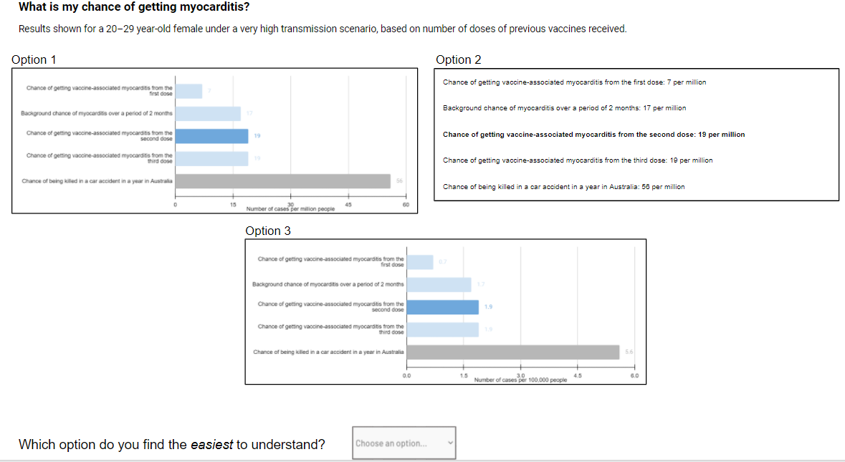

**Attachment No. 2: Examples of questionnaire items.** Participants will complete some simple questionnaire items about demographics, general health-related attitudes, and COVID-19. Vaccine-related questions will additionally contain a “prefer not to say” option.

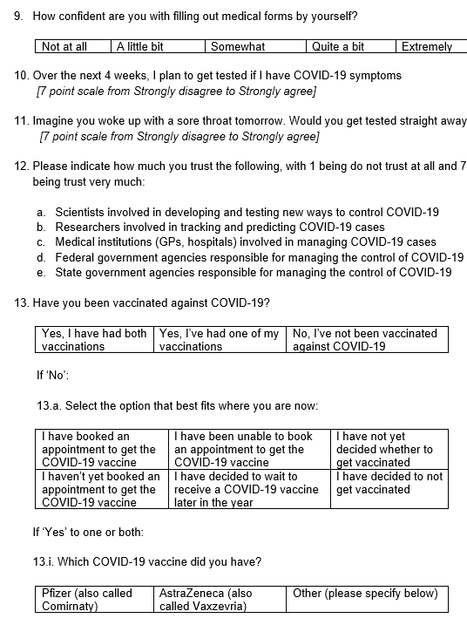

**Attachment No. 3: Example of the screen that online participants will be shown after they indicate that they would like to participate in the study.**

Clicking on the external link will direct them to the exact same task that SONA-I participants will complete.

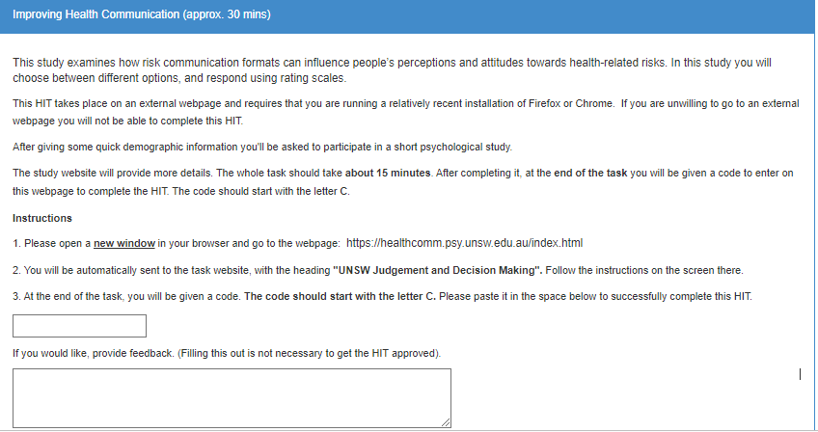

**Attachment No. 4: Example of debriefing that a non-SONA 1 online participant would receive.**

This debrief would be displayed on-screen at the end of the task.

Thank you for participating in our study, **Improving Health Communication**. We would just like to take a brief moment to tell you a bit about the study you just participated in. This is for your interest only, and you can now close the browser window to exit the study if you wish.

The success of vaccines in preventing serious illness and death depends heavily on uptake. However, a common barrier to vaccination is hesitancy due to concerns about vaccine-related side effects (e.g., Reno et al., 2021).

This study extends previous research on vaccine hesitancy by investigating potential evidenced-based ways to improve people’s understanding of complex risk information. For example, the ratio-bias phenomenon (Denes-Raj et al., 1995) suggests that people judge events as being more likely when its probability is presented in the form of an equivalent ratio of larger (“10 in a million”), compare to smaller (“1 in 100,000”) numbers, and hence suggests that vaccine-related side effect risks may be perceived as being greater in the former instance. We manipulate such factors in a series of screenshots which are presented to participants.

The findings of our study can help optimise communication about risks of vaccine-related side effects, so that concerns about such risks can be better understood appropriate weighted. More broadly, these findings can help increase positive community responses towards vaccination.

If you have any questions or concerns about the task you just completed, or encountered any difficulties while completing the task, please do not hesitate to get in touch with us: Amy Li at amy.x.li@ unsw.edu.au, or Prof Benjamin Newell at ben.newell@unsw.edu.au. Our contact details can also be found on the informed consent form you had viewed and agreed to prior to commencing this task.

You can also click here to download the informed consent form if you have not yet done so.

**Attachment No. 5: Letter of Support.**

