Untitled

Amy

2023-10-15

library('vcd')

## Loading required package: grid

help("goodfit")

dbinom( x = 5, prob = 0.5, size = 15)

## [1] 0.09164429

v = dbinom( 0: 15, prob = 0.5, size = 15)  
v

## [1] 3.051758e-05 4.577637e-04 3.204346e-03 1.388550e-02 4.165649e-02  
## [6] 9.164429e-02 1.527405e-01 1.963806e-01 1.963806e-01 1.527405e-01  
## [11] 9.164429e-02 4.165649e-02 1.388550e-02 3.204346e-03 4.577637e-04  
## [16] 3.051758e-05

plot(0:15, v, type = 'h')

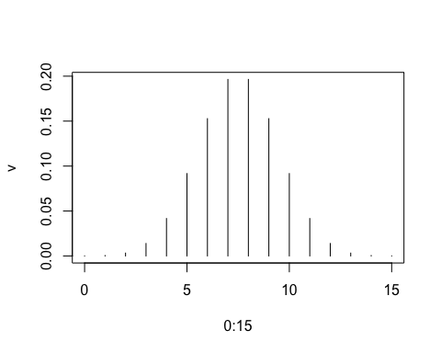

x <- seq( 0, 5, by = 0.1 )  
x

## [1] 0.0 0.1 0.2 0.3 0.4 0.5 0.6 0.7 0.8 0.9 1.0 1.1 1.2 1.3 1.4 1.5 1.6 1.7 1.8  
## [20] 1.9 2.0 2.1 2.2 2.3 2.4 2.5 2.6 2.7 2.8 2.9 3.0 3.1 3.2 3.3 3.4 3.5 3.6 3.7  
## [39] 3.8 3.9 4.0 4.1 4.2 4.3 4.4 4.5 4.6 4.7 4.8 4.9 5.0

y <- log(x)  
y

## [1] -Inf -2.30258509 -1.60943791 -1.20397280 -0.91629073 -0.69314718  
## [7] -0.51082562 -0.35667494 -0.22314355 -0.10536052 0.00000000 0.09531018  
## [13] 0.18232156 0.26236426 0.33647224 0.40546511 0.47000363 0.53062825  
## [19] 0.58778666 0.64185389 0.69314718 0.74193734 0.78845736 0.83290912  
## [25] 0.87546874 0.91629073 0.95551145 0.99325177 1.02961942 1.06471074  
## [31] 1.09861229 1.13140211 1.16315081 1.19392247 1.22377543 1.25276297  
## [37] 1.28093385 1.30833282 1.33500107 1.36097655 1.38629436 1.41098697  
## [43] 1.43508453 1.45861502 1.48160454 1.50407740 1.52605630 1.54756251  
## [49] 1.56861592 1.58923521 1.60943791

plot(x, y, type = 'l')

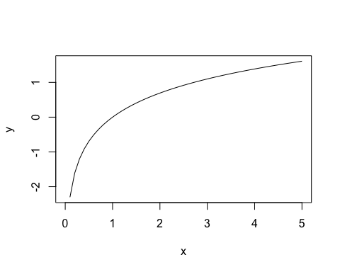

help(log)