correlation analysis：

 

 

AHT：

**All AHT data**

**[2020/08/05~2020/09/01]**

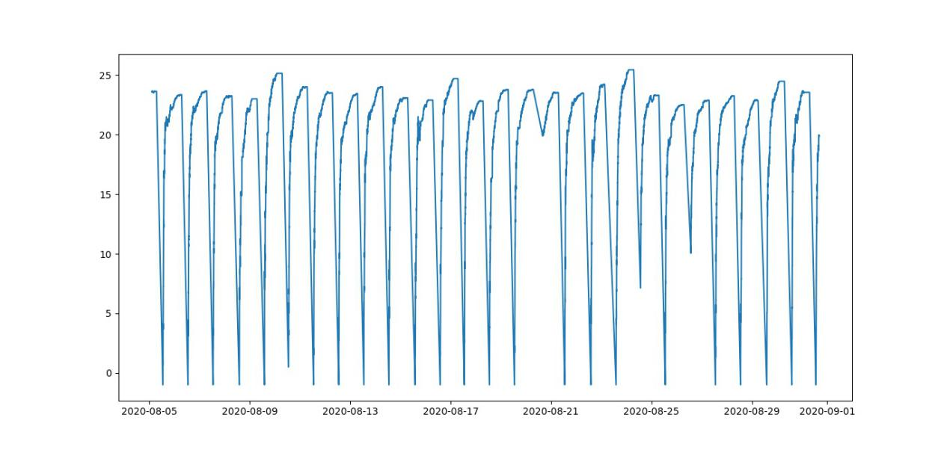

**One day AHT data**

**UTC🡪NA**

**0:00~07:00:**

**None**

**07:00~11:00:**

**grows from -1 to 23**

**11:00~24:00:**

**almost unchanged**

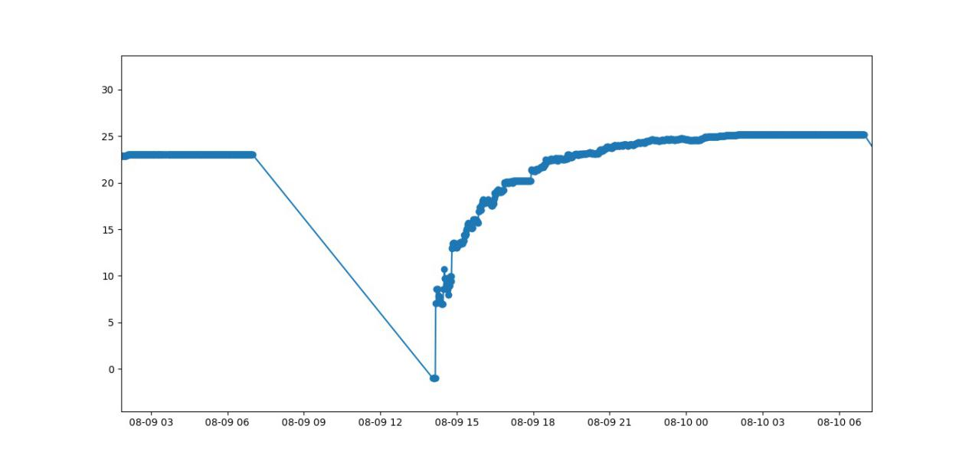

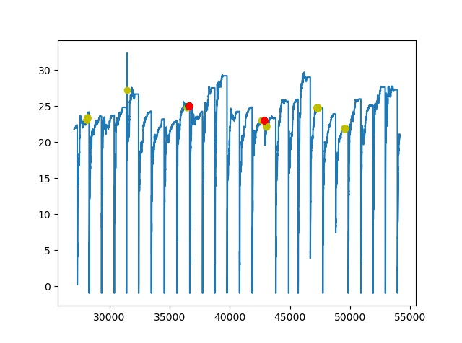231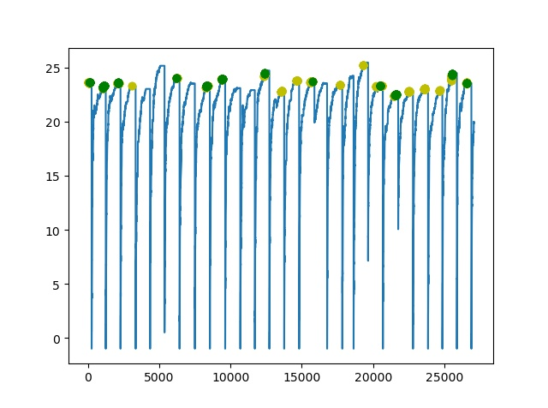232

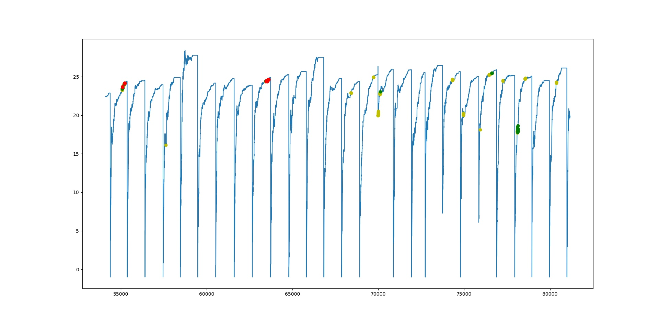

233

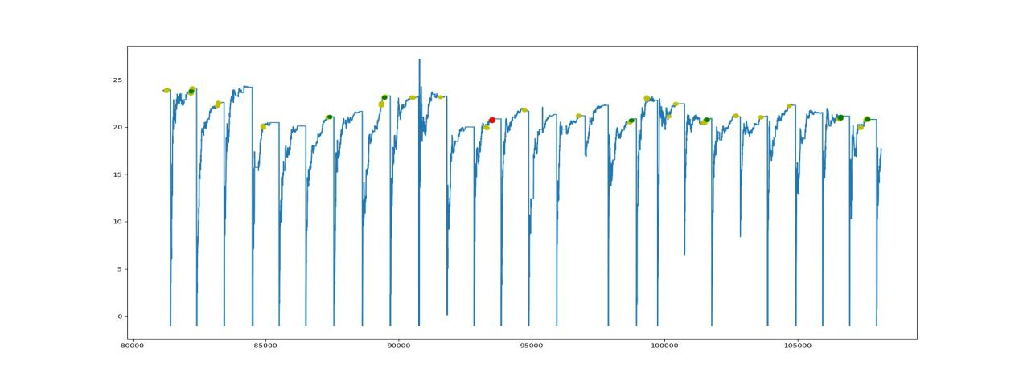

234

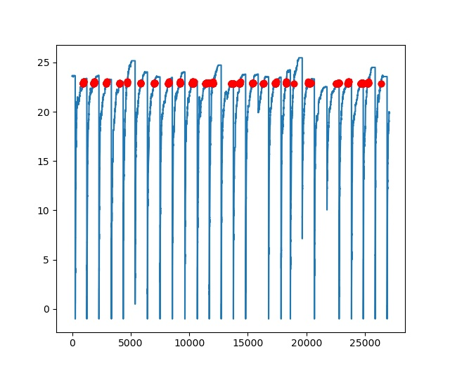

Anomaly detection