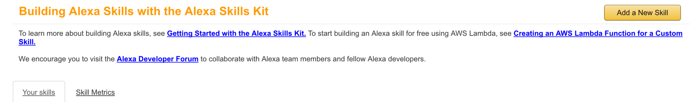

Create a new skill, ensuring you select Smart Home Skill API –

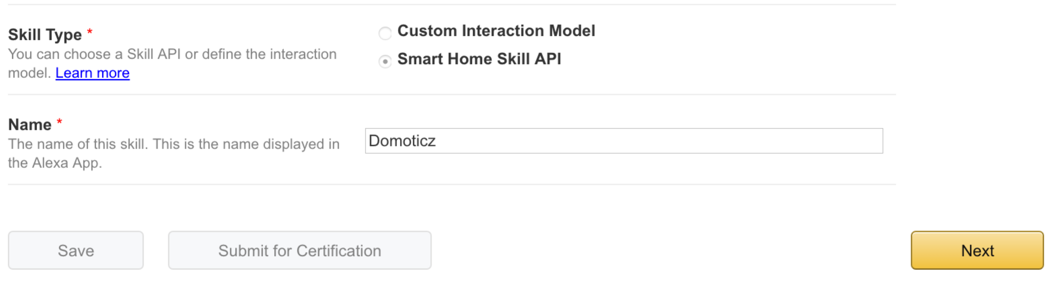

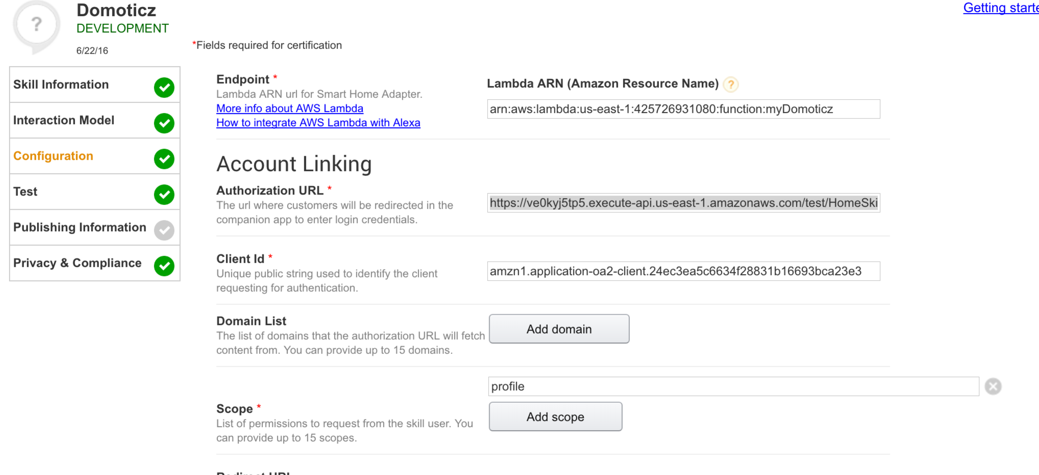

So Alexa requires OAUTH2, but it’s a pain, and if the alexa app is for your own consumption, unnecessary!

This is a fake OAUTH server, which allows you to use this as a workaround:

Account Linking [b]Authorization URL:[/b] <https://ve0kyj5tp5.execute-api.us-east-1.amazonaws.com/test/HomeSkillAuthorization>

Client id: alexa - any value is fine, since it's ignored

Domain List: Ignore this

Scope: alexa - any value is fine, since it's ignored

Access Token URI:[/b] <https://ve0kyj5tp5.execute-api.us-east-1.amazonaws.com/test/OAuthAccessToken>

Client Secret: alexa - any value is fine, since it's ignored

Privacy Policy: https://ve0kyj5tp5.execute-api.us-east-1.amazonaws.com/test/PrivacyPolicy - any value is fine).

Click **SAVE**

Then create your lambda instance:

<https://aws.amazon.com/lambda/>

**Make sure to select N.Virginia as your region, it’s the only region that accepts Alexa at this time.**

Step 1: Select blueprint – press the skip button (bottom right)

Step 2: Configure function

Take the node_modules folder, the domapi.js, and package.json from <https://github.com/madgeni/alexa_domo/tree/master/Downloads/domapi/fullyworking>

You will need to edit the domapi.js file to put in your own domoticz dns name/external IP, as well as username and password:

var api = new Domoticz({protocol: "http", host: "127.0.0.1", port: 8080, username: "abcd", password: "1234"});

Save it, and zip these three things together.

Back to Lambda:

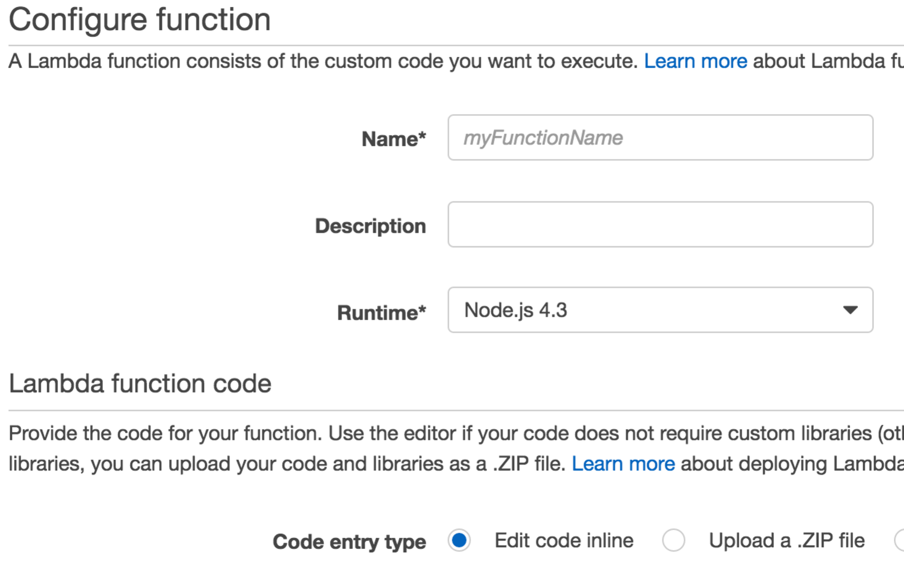

Give it a name and description, leave the runtime as Node.js, then upload that zip file.

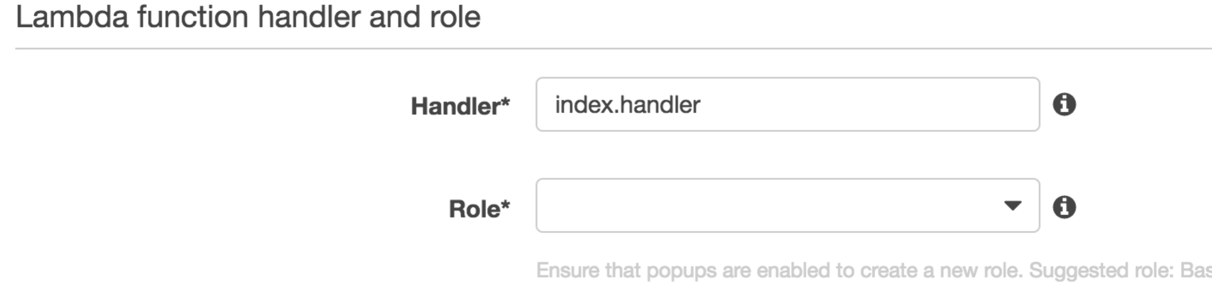

change the handler name to domapi.handler (or if you change the domapi.js filename, then to whatever you change it to) and select the Role to * Basic execution role. This whole piece is simply setting up the conditions for the lambda instance that runs the code, rather than interacting with your domoticz.

It will open a new window when you choose that, so select below.

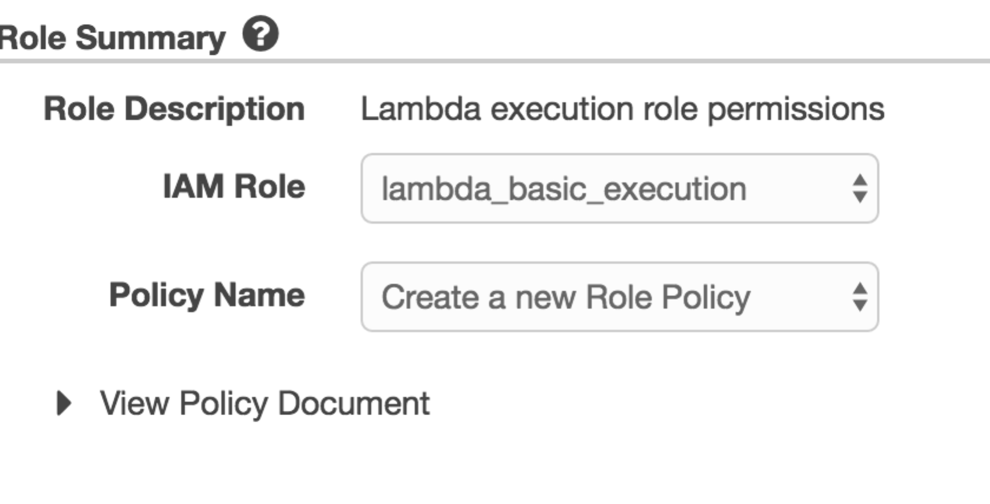

Click on Allow, which will then take you back to your configuration page.

Then click Next:

Step 3: Review – click Create Function.

You will now see several tabs –

Go to Event Source:

Add event source – select Event Source Type – Alexa Smart Home

Go back to your Smart Skill, and on the Skill Information you will see Application ID – copy that, and paste into the field in the Event Source

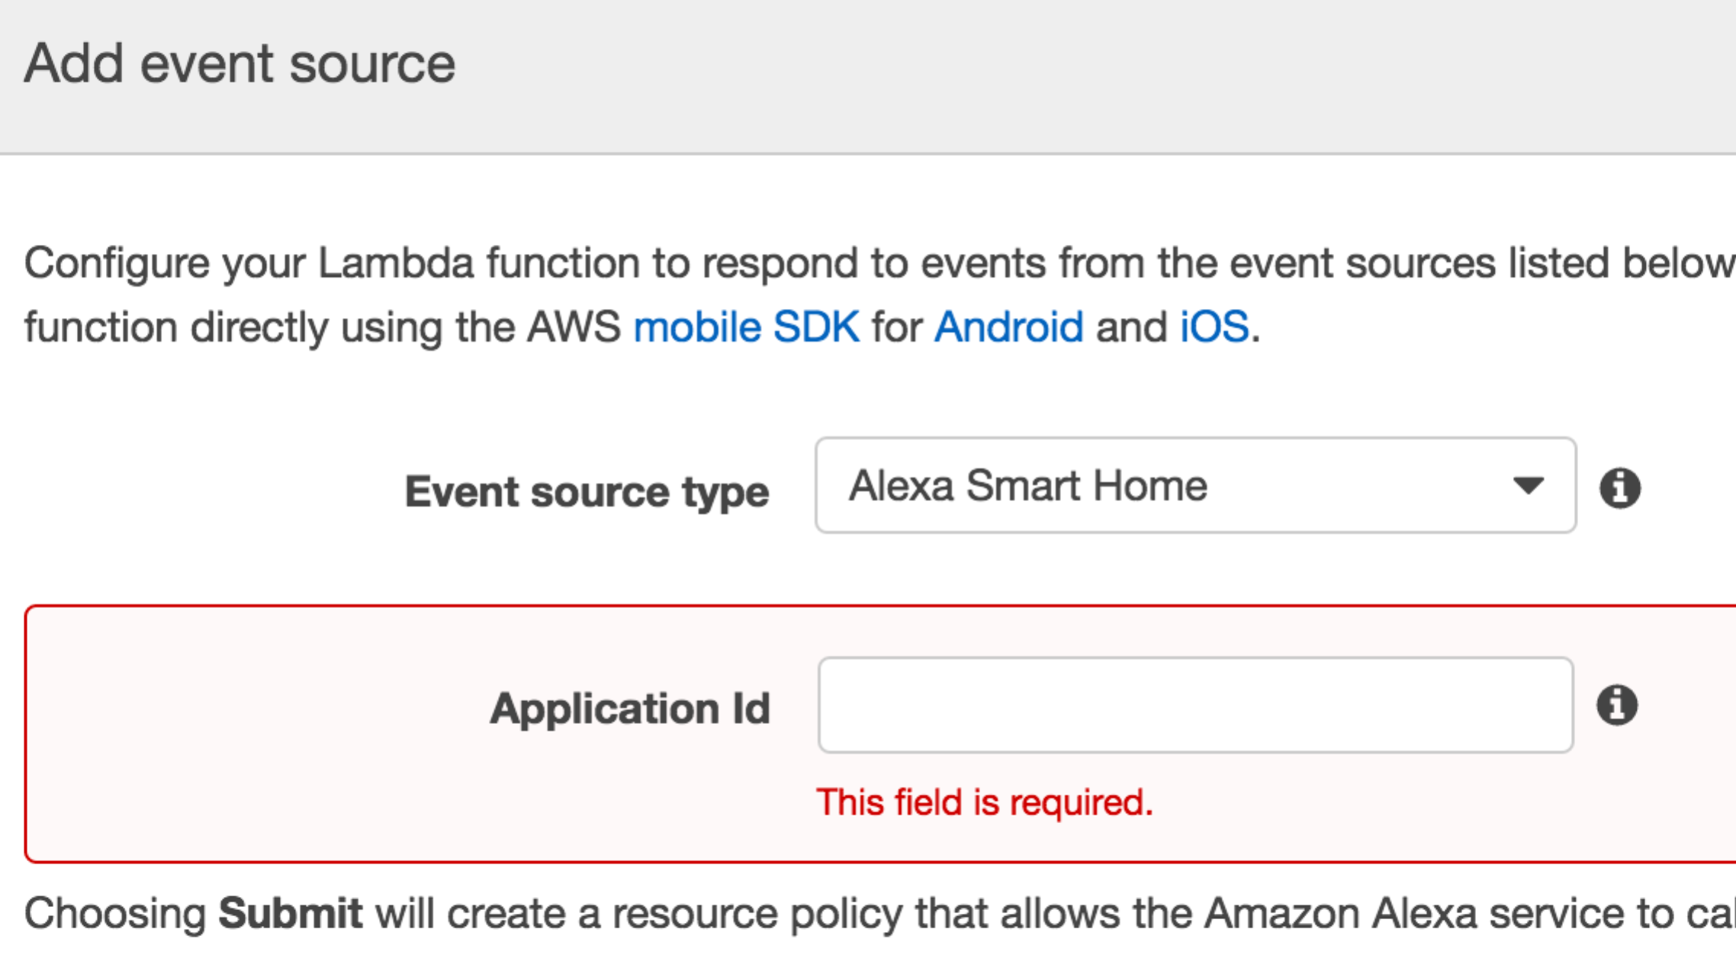

That’s it. – You should now be able to see your domoticz app in <http://www.alexa.amazon.com> - or the app on your phone.

Appendix - TESTING

Under the Actions dropdown:

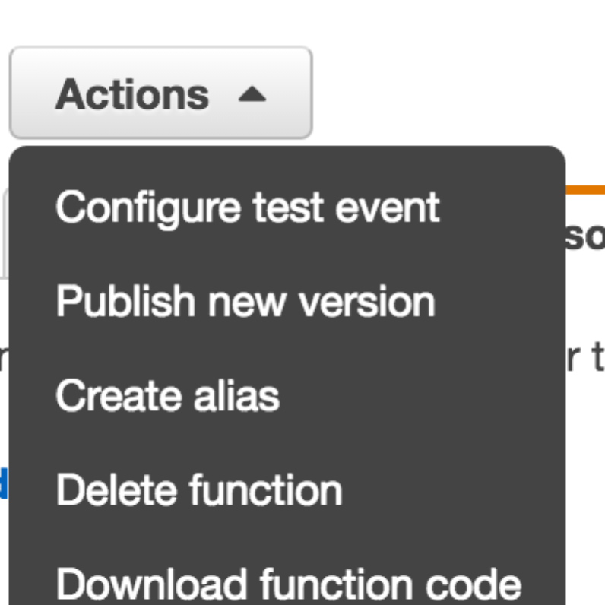

Configure test event allows you to send requests to your domoticz and interact with it, without having to install the smart skill on your alexa.

Here are a 3 – 1 discovery, 1 for lights, 1 for scenes:

Just copy one in, change the applicationId to a Domoticz IDX and test it.

{

"header": {

"messageId": "01ebf625-0b89-4c4d-b3aa-32340e894688",

"name": "TurnOffRequest",

"namespace": "Alexa.ConnectedHome.Control",

"payloadVersion": "2"

},

"payload": {

"accessToken": "123",

"appliance": {

"additionalApplianceDetails": {

"switchis": "On/Off",

"WhatAmI": "light"

},

"applianceId": CHANGETHISTOANIDXINYOURDOMOTICZ

}

}

}

{

"header": {

"messageId": "01ebf625-0b89-4c4d-b3aa-32340e894688",

"name": "TurnOffRequest",

"namespace": "Alexa.ConnectedHome.Control",

"payloadVersion": "2"

},

"payload": {

"accessToken": "123",

"appliance": {

"additionalApplianceDetails": {

"WhatAmI": "scene"

},

"applianceId": CHANGETHISTOANIDXINYOURDOMOTICZ

}

}

}

{

"header": {

"messageId": "6d6d6e14-8aee-473e-8c24-0d31ff9c17a2",

"name": "DiscoverAppliancesRequest",

"namespace": "Alexa.ConnectedHome.Discovery",

"payloadVersion": "2"

},

"payload": {

"accessToken": "123"

}

}