## **Amazon Product Add via Upload SOP**

### **Objective**

This document details the streamlined process for uploading multiple products to Amazon Seller Central, ensuring consistency, accuracy, and compliance with Amazon’s guidelines.

Also, we use “Product Via Upload” when it gives **8541 error** while updating product listing content from manage inventory:  
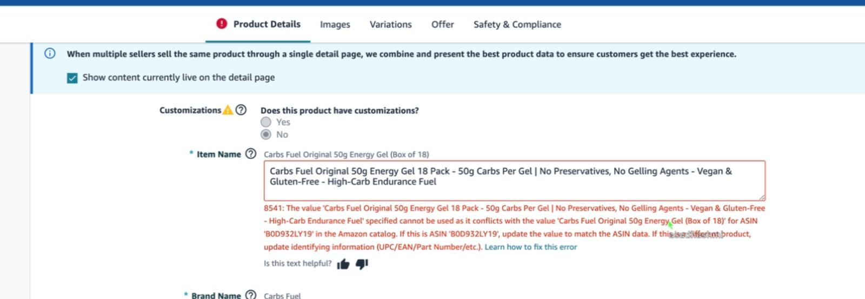

### **Prerequisites**

* **Brand Name:** Clearly indicate the manufacturer or brand.
* **Bullet Points/Key Features:** Highlight the main benefits and features of the product.
* **Category & Browse Node:** Specify the exact category and subcategory (browse node) for accurate placement.
* **Product Variations:** Include options such as size, color, style, etc., if applicable.
* **Dimensions & Weight:** Provide accurate measurements and weight information, which is crucial for shipping and display.
* **Inventory & Stock Levels:** Detail the available quantity and any relevant fulfillment information.
* **Additional Attributes:** Depending on your product category, this may include materials, technical specifications, usage instructions, warranty details, or compliance certifications.
* **Backend Keywords/Search Terms:** Optimize your listing with relevant search terms for better discoverability.

## **Step-by-Step Process**

### **Step 1: Log in to Amazon Seller Central**

1. Go to [Amazon Seller Central](https://sellercentral.amazon.com/).  
   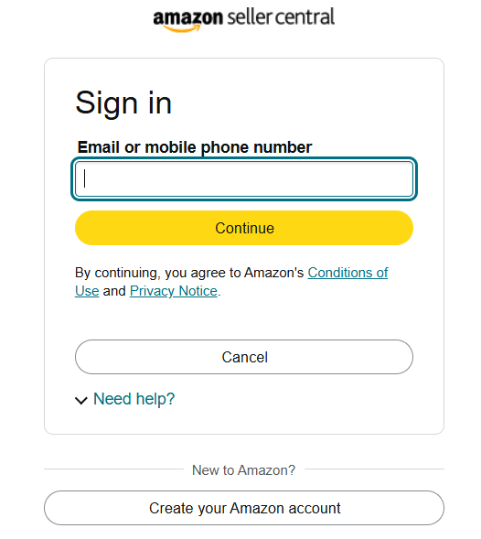

### **Step 2: Navigate to the Bulk Upload Section**

1. From the **main dashboard**, click on **Inventory** > **Add Products via Upload**.

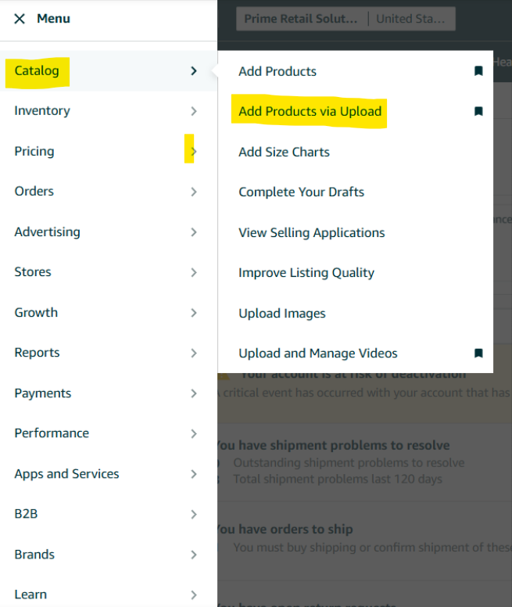

1. Review the available bulk upload options displayed under the tab.
2. Choose a template “List Products that are not currently in Amazon’s catalog” for creating new listing using UPC/EAN

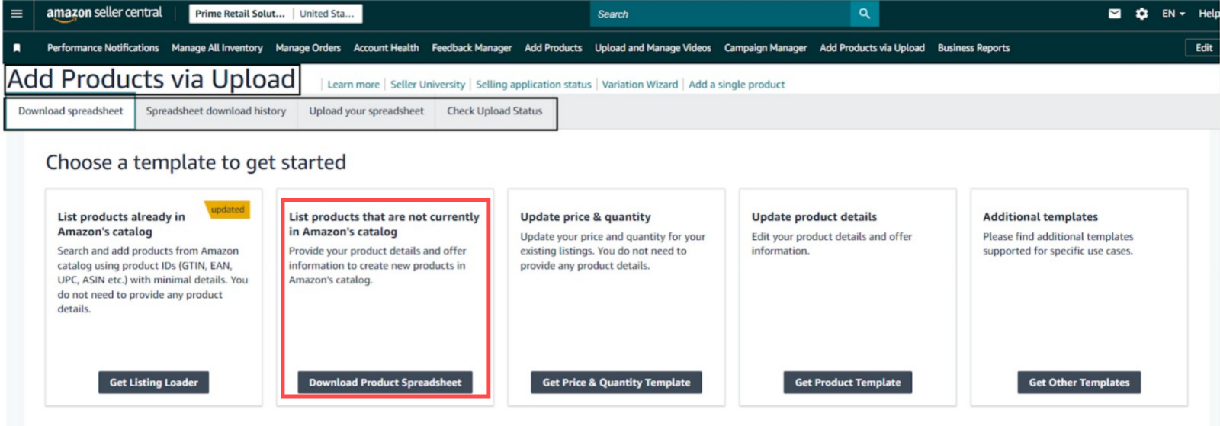

1. Choose a template “update product details” for updating existing product listing content on Amazon.  
     
   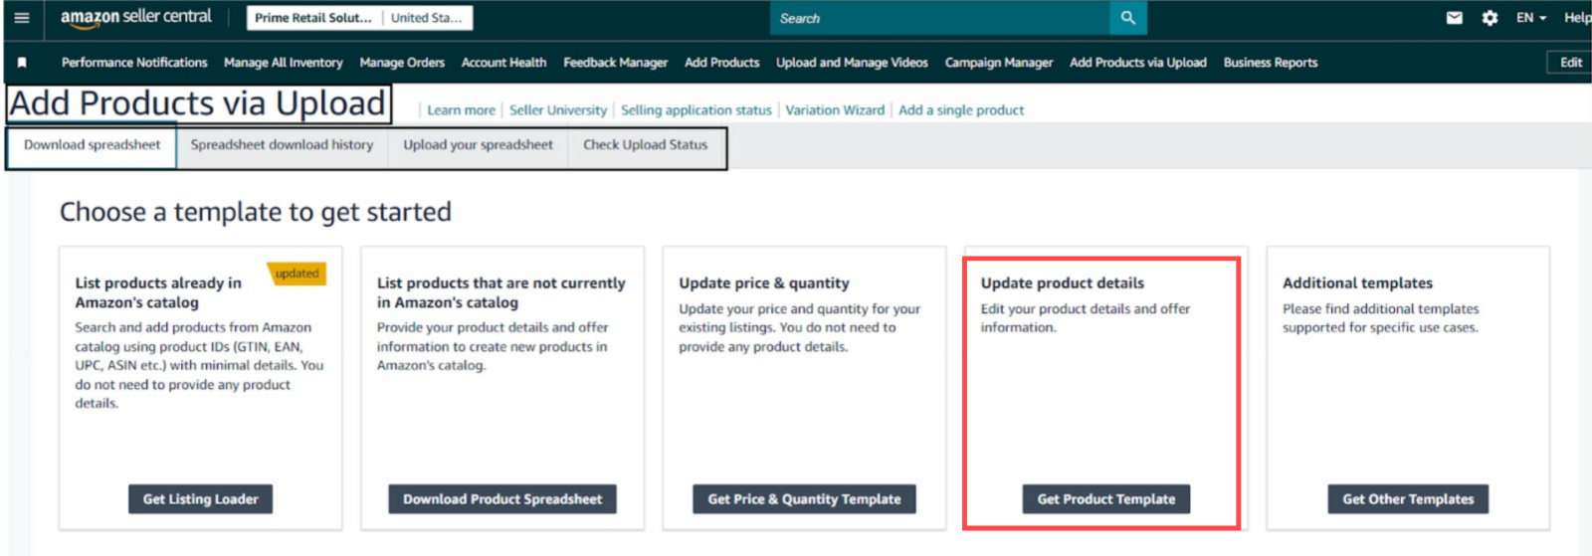

### **Step 3: Download the Appropriate Template**

1. Scroll to the **Download an Inventory File** section.

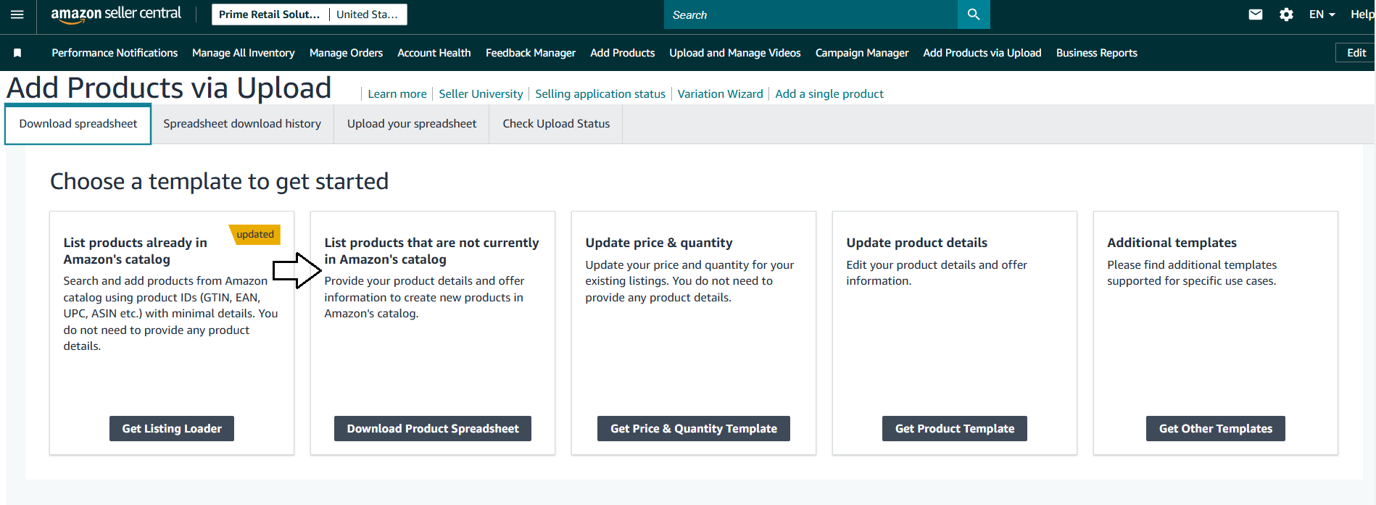

1. Select your product category:
2. Enter a relevant product keyword or title in the search bar.  
   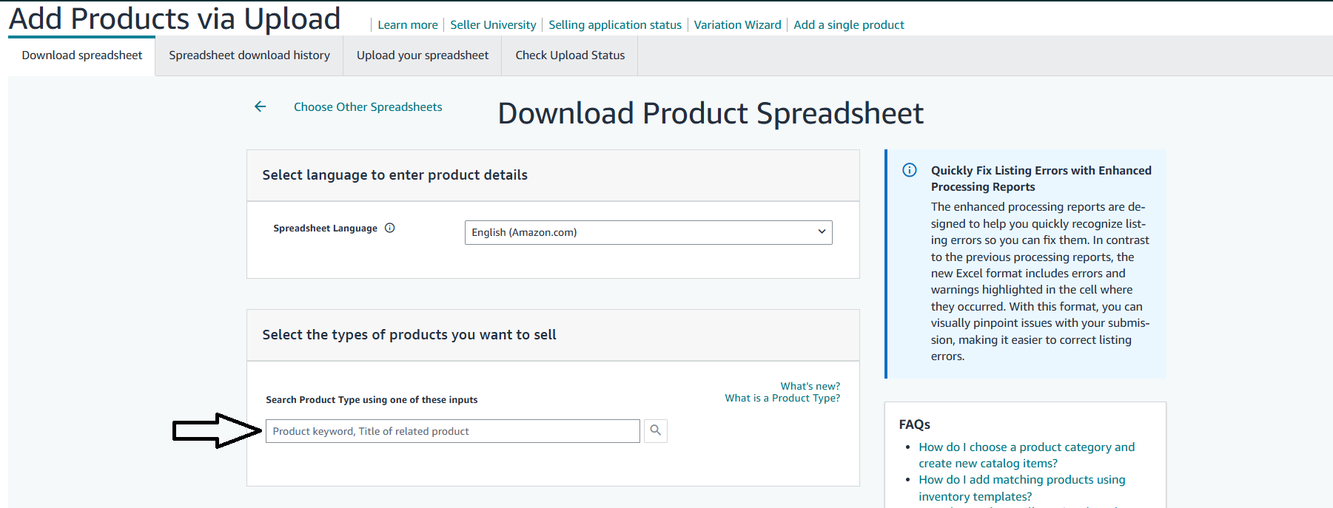
3. If the category isn’t located via search, manually select the correct one.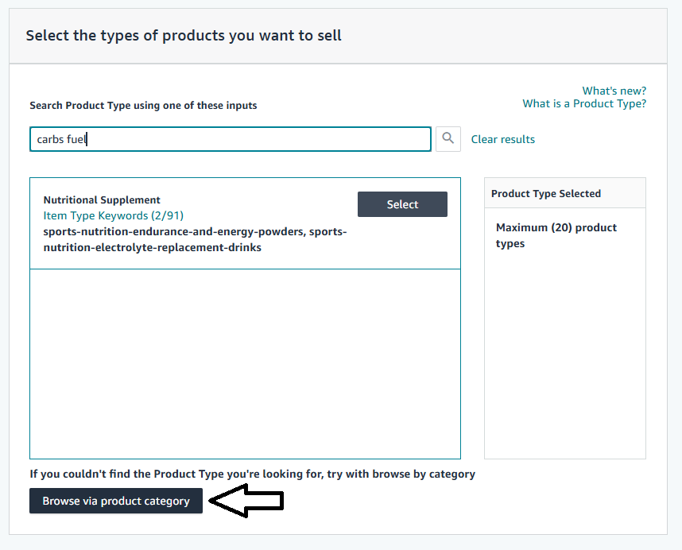
4. Choose the desired marketplace, disable the BETA version option, then click **Generate Spreadsheet** to download the Excel file.

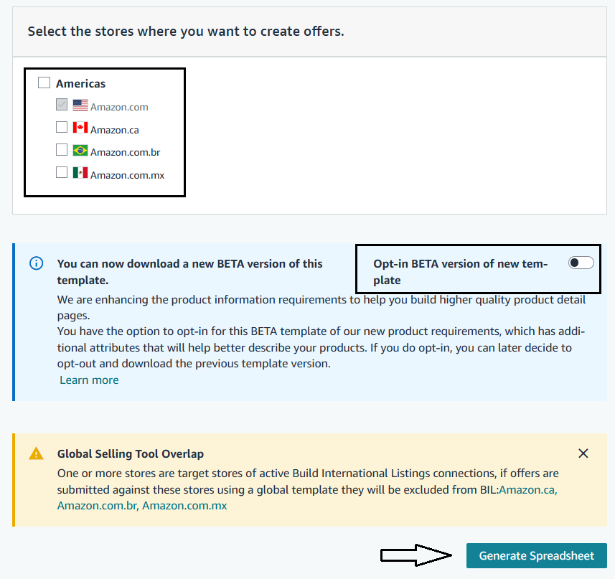

### **Step 4: Populate the Template**

1. Open the downloaded Excel file.
2. Complete all mandatory fields, such as:
   * **SKU (Stock Keeping Unit)**
   * **Product Title**
   * **Brand Name**
   * **Product Description & Bullet Points**
   * **Product Price**
   * **Main and Additional Images**
   * **Category & Browse Node**
3. Ensure compliance with Amazon’s formatting and character limits, then save the file.

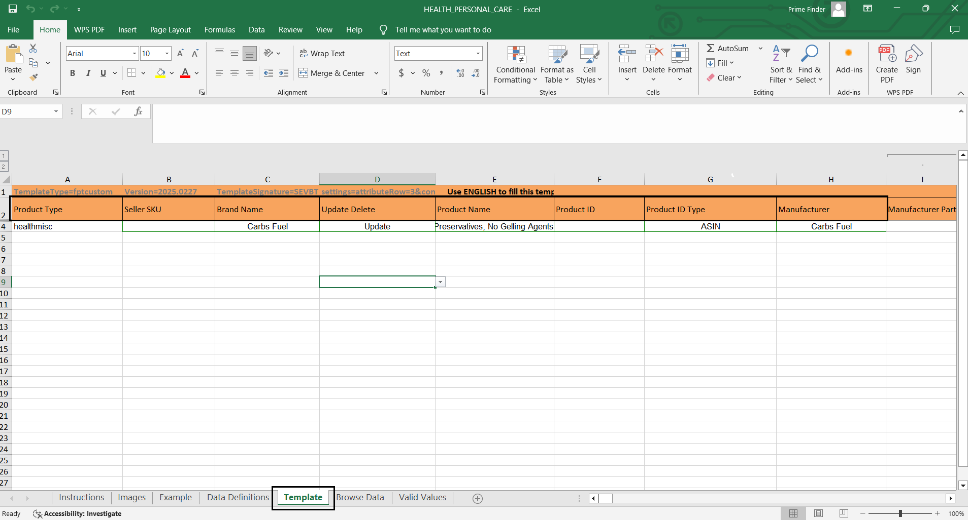

### **Step 5: Upload the Completed File**

1. Return to Inventory > Add Products via Upload.
2. Under **Upload Inventory Files**, click **Choose File** to select your completed spreadsheet, and then click **Upload**.

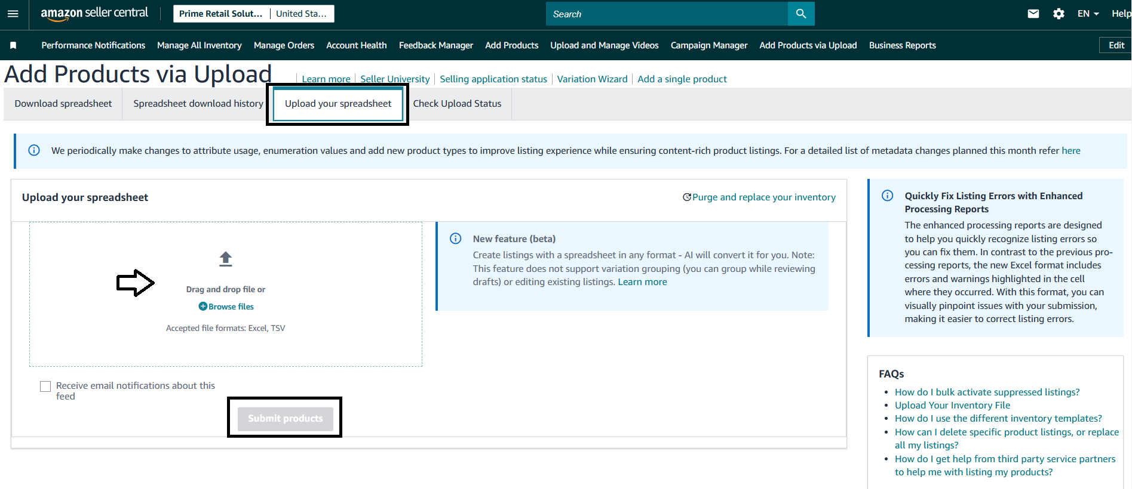

### **Step 6: Check for Processing Errors**

* After upload, check for any initial errors by clicking on error notifications.
* If no immediate errors appear, proceed by clicking **Submit Products**.

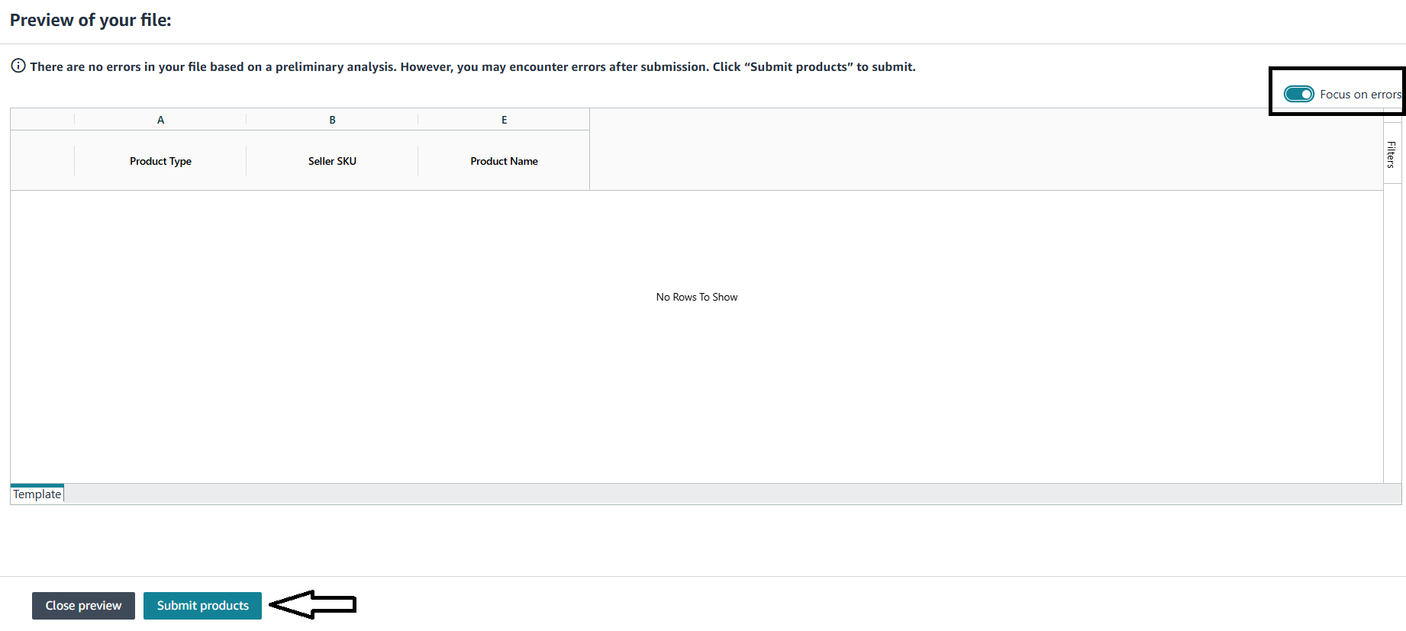

1. Navigate to **Check Upload Status** under the **Add Products via Upload** tab.

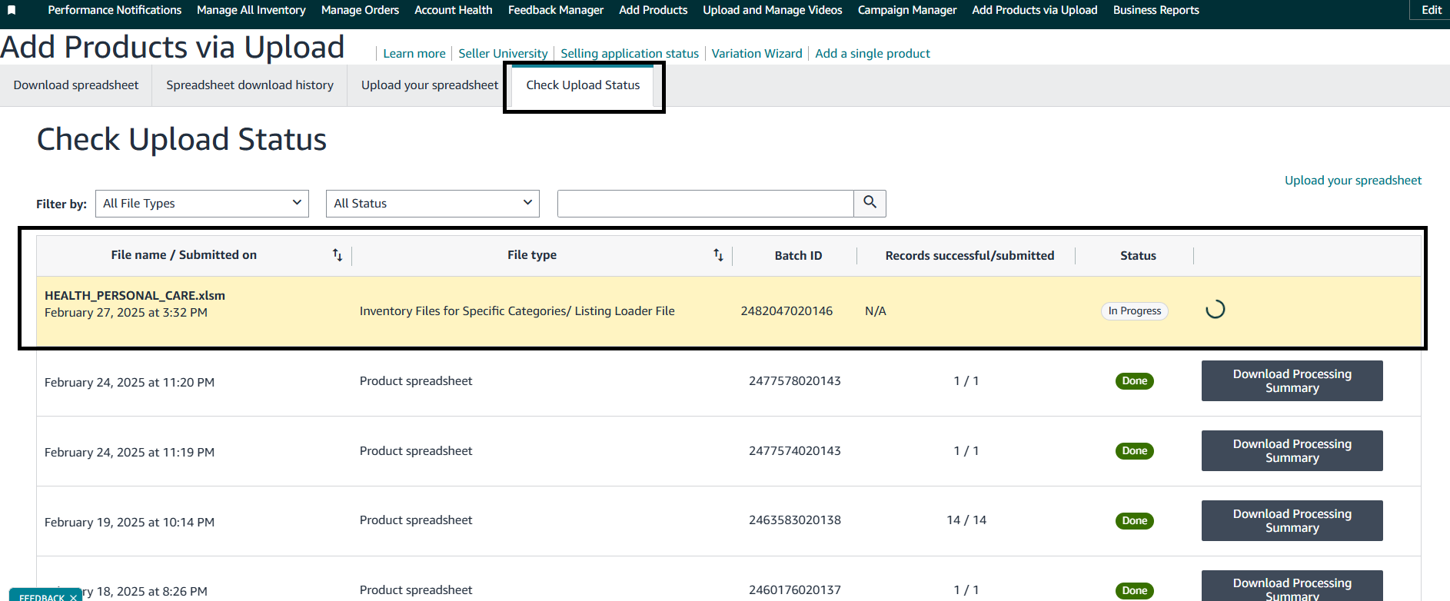

1. To confirm full processing, navigate to **Check Upload Status** and download the Processing Report via **Action > Download Process Summary**.

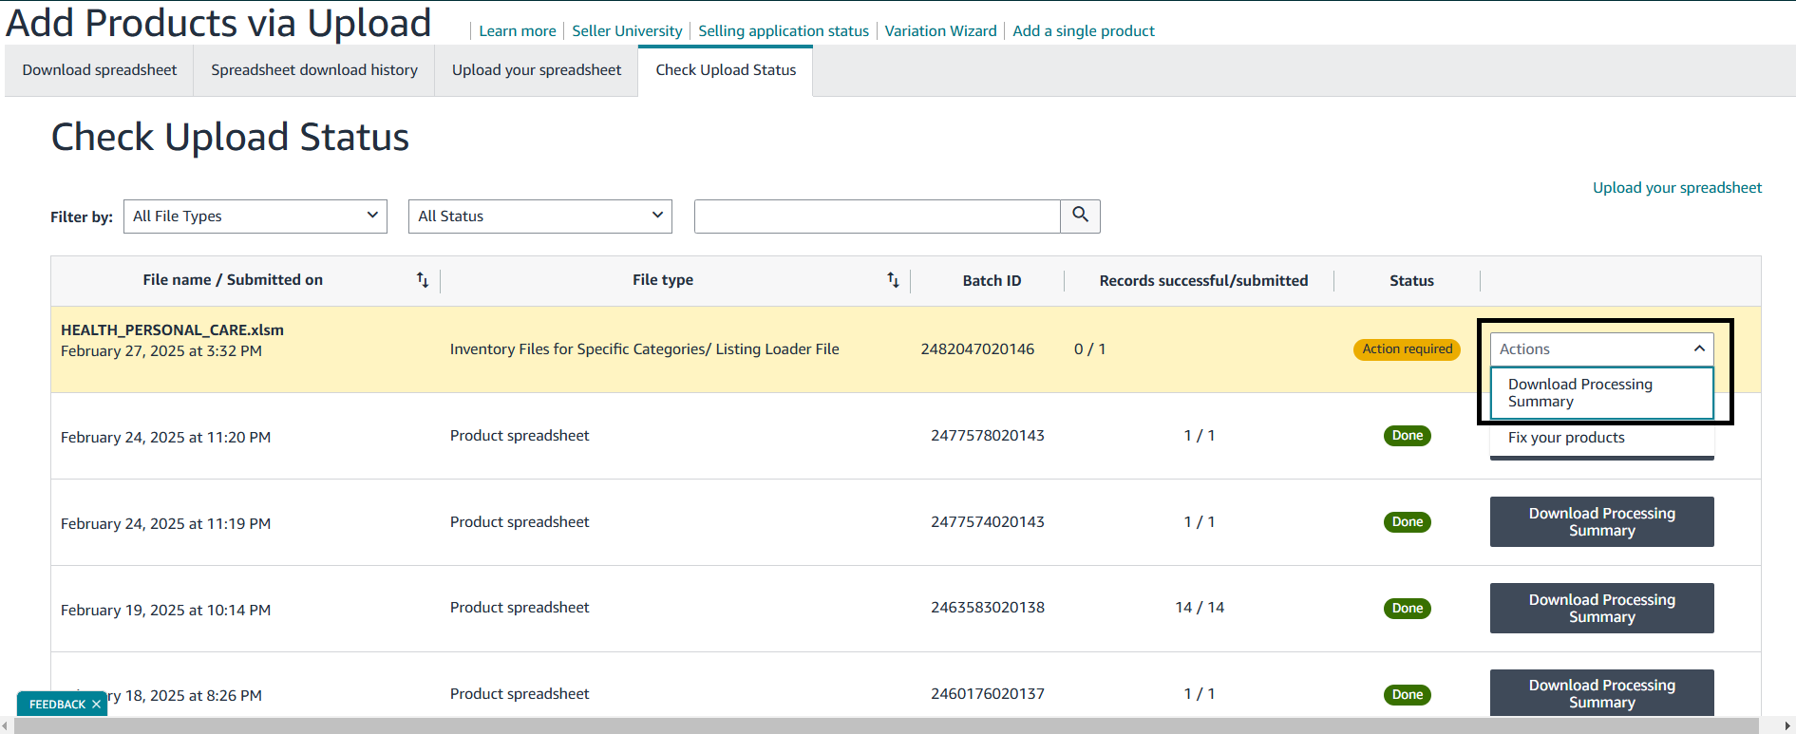

1. If errors are found, update the original file accordingly and re-upload.

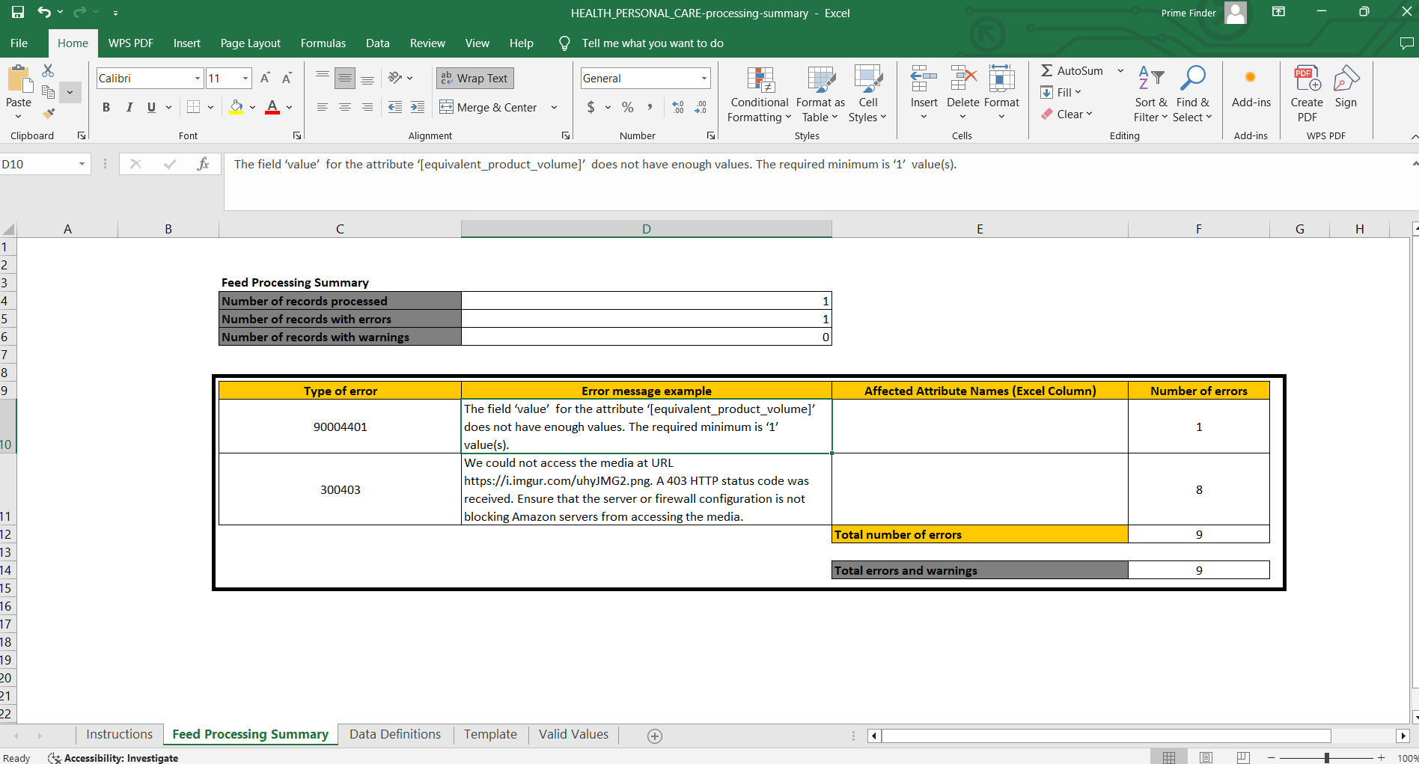

### **Step 7: Verify Product Listings**

1. Once processing is complete, go to **Manage Inventory**.

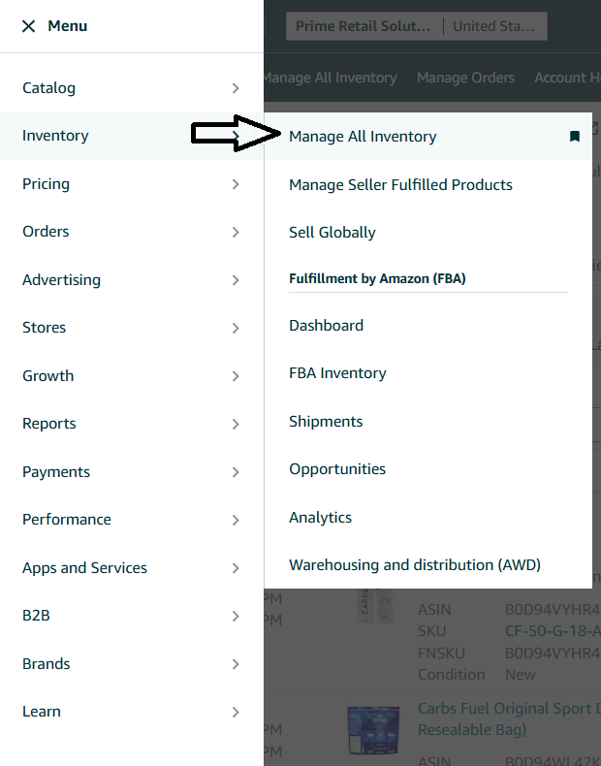

1. Search for your newly uploaded products and verify that all details are correct.

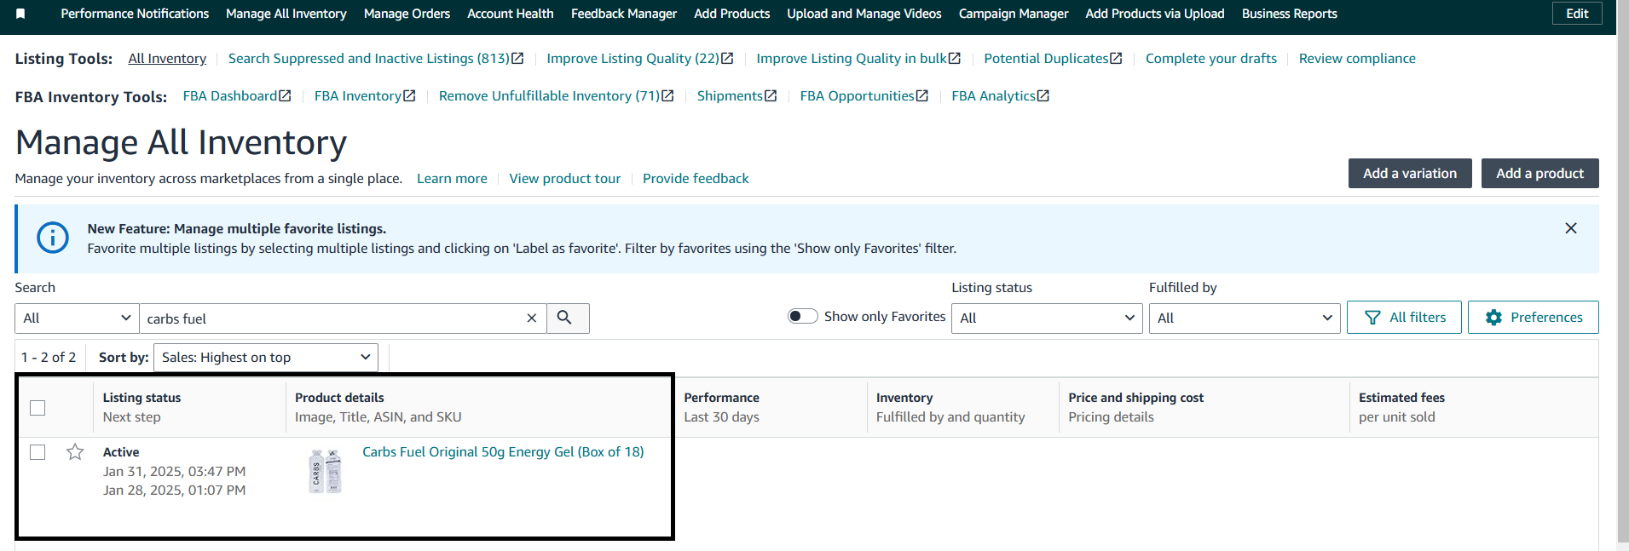

## **Best Practices & Tips**

* **Use Correct Product Categories** – Wrong categories may lead to listing rejections.
* **Unique & Clear Titles** – Avoid unnecessary symbols and keyword stuffing.
* **Accurate Pricing** – Double-check pricing to avoid incorrect listings.
* **Monitor Upload Errors** – Always download the processing report after upload.

This SOP ensures a smooth and efficient **bulk product upload** process on Amazon. Add relevant screenshots or images for better clarity.