# **Ad Optimization Strategies | SOP**

**1. Campaign Management**

### **1.1 Objective**

The goal of campaign management is to continuously monitor, analyze, and optimize campaigns based on their performance to maximize ROI and maintain strong visibility.

### **1.2 Campaign Categorization**

| **Category** | **Definition** | **Actions** |
| --- | --- | --- |
| **Performing Campaigns** | Generating sales at or below target ACoS/ROAS. | Scale budget, expand keywords. |
| **Underperforming Campaigns** | Low impressions, clicks, or CTR due to weak targeting, bids, or budget. | Increase bids, revise targeting. |
| **Non-Performing Campaigns** | High spend with low/no sales (poor CVR). | Pause or shift budget. |

### 

### **1.3 Campaign Optimization Workflow**

| **Step** | **Task** | **Frequency** |
| --- | --- | --- |
| 1 | Review Performance Metrics (Impressions, Clicks, CTR, CPC, ACoS, ROAS) | Daily, Twice in a week, or Weekly |
| 2 | Identify Campaign Category (Performing, Underperforming, Non-Performing) | Daily, Twice in a week, or Weekly |
| 3 | Apply Corrective Actions (bids, targeting, budgets) | Weekly |
| 4 | Document Changes & Rationale | Every Adjustment |

### 

## **2. Budget Management**

### **2.1 Objective**

Efficiently distribute and reallocate budgets to campaigns delivering the best return while limiting waste.

### **2.2 Budget Allocation Process**

| **Campaign Type** | **Priority Level** | **Budget Rule** |
| --- | --- | --- |
| Ranking & Conversion (Phase 2 & 3) | High | Maintain strong funding. |
| Discovery (Phase 1) | Medium | Fund to gather data, but limit excessive spend. |
| Competitor Targeting | Medium | Allocate based on conversion success. |
| Branded Defense | High | Always funded to protect brand terms. |

### 

### **2.3 Budget Reallocation Workflow**

| **Step** | **Task** | **Frequency** |
| --- | --- | --- |
| 1 | Identify Low ROAS / High ACoS Campaigns | Daily, Twice in a week, or Weekly |
| 2 | Reallocate Budget to Performing Campaigns | Daily, Twice in a week, or Weekly |
| 3 | Review Discovery Campaign Output (Keywords/ASINs Found) | Daily, Twice in a week, or Weekly |
| 4 | Fund Best-Performing Keywords into Exact-Match Campaigns | Weekly |
| 5 | Document Changes & Rationale | Every Adjustment |

### 

### **2.4 Breakeven Budget Rules**

* Calculate **Breakeven ACoS** and **Breakeven CPC** per product.
* Example:
  + Product Price: $30
  + Profit Margin: 30%
  + Breakeven ACoS: 30%
  + Breakeven Spend per Order: $30 x 30% = $9
  + Expected Conversion Rate: 10% (1 in 10 clicks converts)
  + Breakeven CPC = $9 / 10 = $0.90

Compare keywords’ CPC/ACoS with breakeven CPC/ACoS to make data-driven decisions based campaign objectives — either:

* **Product Scaling**: Increase bids for high-potential terms even if CPC is slightly above breakeven to capture market share.
* **Profitability Focus**: Lower bids or pause keywords exceeding breakeven CPC/ACoS to maintain healthy margins.

## **3. Bid Management**

### **3.1 Objective**

Optimize bids to ensure maximum visibility for performing terms while controlling CPC to maintain profitability.

### **3.2 Bid Management Rules**

| **Scenario** | **Action** |
| --- | --- |
| Low Impressions & Clicks | Increase bids by 10-15% until visibility improves. |
| High Clicks, Low Conversions | Lower bid slightly (5-10%) or review listing quality. |
| High Spend, Low ROAS | Lower bid and/or add negatives. |
| High-Converting Terms | Increase bid to win more impressions. |
| Branded Terms | Aggressively bid for Top of Search placement. |

### **3.3 Bid Adjustment Calculation (Placement)**

In Amazon Sponsored Product campaigns, **you can tell Amazon to bid higher for specific placements**, such as:

* **Top of Search (First Page)** – The premium spot that gets the highest click-through rates (CTR) and visibility.
* **Product Pages** – Ads shown on competitor product detail pages.
* **Rest of Search** – Ads shown in lower placements (middle of page 1, page 2, etc.).

#### Why it Matters

Not all placements perform equally. For example, **Top of Search** tends to have the highest conversion rates because shoppers see these ads first. However, this premium position often comes with **higher CPC**.

Formula:

**Final Bid = Base Bid x (1 + Placement Percentage)**

For example:

* Base Bid = $0.50
* Top of Search Adjustment = 80%
* Final Bid = $0.50 x (1+0.80) = $0.90

This tells Amazon you are willing to **increase your bid by 80% for Top of Search clicks**.

#### Placement Bids Calculator

This calculator helps you **pre-calculate** your actual bids based on placement adjustments, so you can forecast your real CPC across placements **before setting bids in Amazon**.

[Placement Calculator](https://docs.google.com/spreadsheets/d/1_Ct1JeTBD0boMKr1wr-UEgsBhJtAubKGO2ZXawVS1q8/edit?gid=2098574489#gid=2098574489)

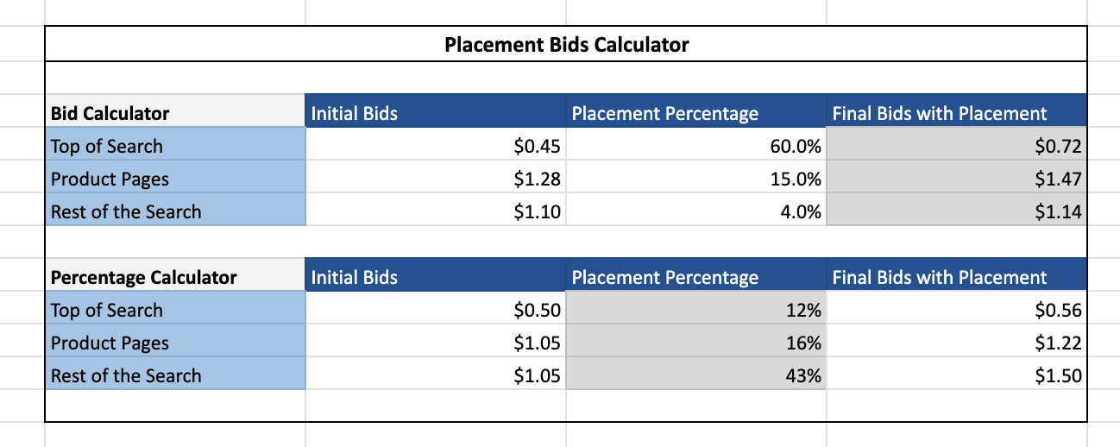

#### Additional Insights from Your Calculator Explanation

1. **Higher placement adjustments = More aggressive bidding for visibility.**
   * Example: Setting a **60% boost for Top of Search** makes sure your ad competes harder for those prime spots.
2. **Product Pages often need smaller boosts.**
   * Since product page clicks have lower CTR and lower purchase intent (shoppers are already looking at another product), you don’t want to overpay.
3. **Rest of Search is usually cheaper.**
   * Lower visibility = Lower intent = Lower bids.
4. **This calculator ensures your bidding strategy aligns with your campaign objective.**
   * **Scaling campaigns**: You may go aggressive on Top of Search.
   * **Profitability campaigns**: You may reduce placement boosts if CPC starts eating into margins.

**Summary of Key Rules**

| **Focus Area** | **Core Rule** |
| --- | --- |
| Campaign Performance | Identify performing, underperforming, non-performing weekly |
| Budget | Shift spend to performing campaigns |
| Bids | Adjust bids based on visibility & conversion |

### 