

实 验 报 告
（2019 / 2020 学年 第 2 学期）

课程名称 | JAVA 程序设计
实验名称 | 综合图形界面程序设计
实验时间 | 2020 | 年 | 4 | 月 | 26 | 日
指导单位 | 计算机学院计算机系统与网络教学中心
指导教师 | 邓玉龙

学生姓名 | 张承扬 | 班级学号 | B18030620
学院(系) | 计算机学院 | 专 业 | 计算机科学与技术

实 验 报 告
实验名称 | 线程程序设计 |  |  | 指导教师 | 邓玉龙
实验类型 | 上机 | 实验学时 | 2 | 实验时间 | 2020.4.26
- 实验目的和要求
学习和理解JAVA SWING中的容器，部件，布局管理器和部件事件处理方法。
通过编写和调试程序，掌握JAVA图形界面程序设计的基本方法。
二、实验环境(实验设备)
PC微型计算机系统，Microsoft Windows操作系统，SUN Java Development Kit开发工具包，NetBeans开发工具，IDEA开发工具。

三、实验原理及内
容（实验过程中软件工具的选择，对实验课题进行的分析，设计，编写，调试和测试实验程序等各个环节）

（1）基本功能

基本功能为将人民币转换为等值的美元，增加可选输入美元或人民币，转换为相对应的货币。
使用TextField获取输入信息，判断JComboBox获取当前输入的货币类型，并在Jlabel中输出通过另一TextField获取的转换比率计算后的信息。
需要对输入的兑换比率以及源货币进行判断，不符合要求的需要弹窗提醒。设计和编写一个编写一个指针式时钟程序，应用线程实现时钟的走动。

（2）基本界面设计

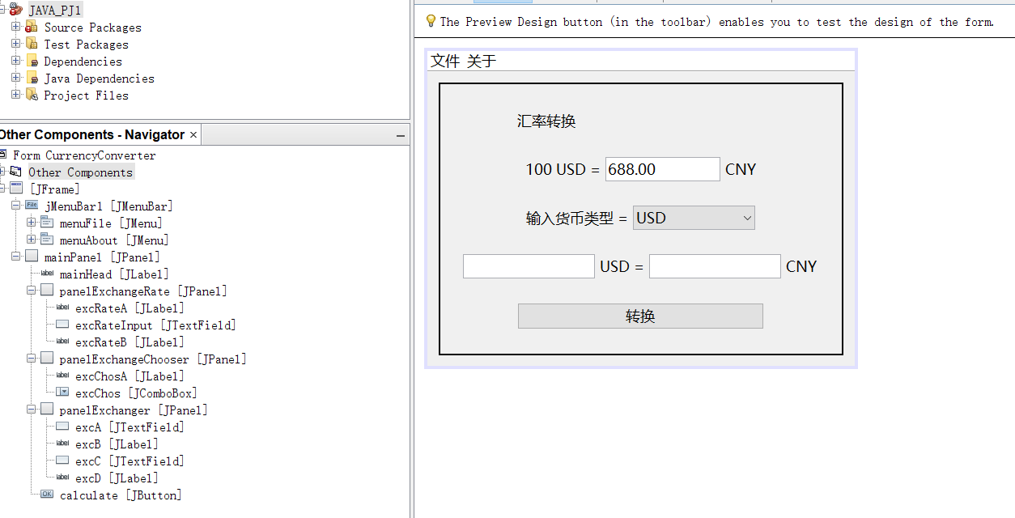

（3）实验代码（完整工程与编译jar见附件）
1、变量对应关系
private javax.swing.JButton calculate; // 计算按钮
private javax.swing.JTextField excA; // 输入货币
private javax.swing.JLabel excB; // 输入货币单位
private javax.swing.JTextField excC; // 输出货币
private javax.swing.JComboBox<String> excChos; // 输入类型选择
private javax.swing.JLabel excChosA; // 输入类型选择提示文字
private javax.swing.JLabel excD; // 输出货币单位
private javax.swing.JLabel excRateA; // 汇率输入提示文字
private javax.swing.JLabel excRateB; // 汇率输入提示文字
private javax.swing.JTextField excRateInput; // 汇率输入
private javax.swing.JMenuBar jMenuBar1; // 菜单栏
private javax.swing.JLabel mainHead; // 大标题
private javax.swing.JPanel mainPanel;
private javax.swing.JPanel panelExchangeChooser;
private javax.swing.JPanel panelExchangeRate;
private javax.swing.JPanel panelExchanger;

2、 转换 Action Listener
excChos.setModel(new javax.swing.DefaultComboBoxModel<>(new String[] { "USD", "CNY" }));
excChos.addActionListener(new java.awt.event.ActionListener() {
public void actionPerformed(java.awt.event.ActionEvent evt) {
excChosActionPerformed(evt);
}
});
private void excChosActionPerformed(java.awt.event.ActionEvent evt) {
String nowSelect = excChos.getSelectedItem().toString();
if (nowSelect.equals("USD")) {
excB.setText("USD =");
excC.setText("");
excD.setText("CNY");
} else {
excB.setText("CNY =");
excC.setText("");
excD.setText("USD");
}
}
calculate.setText("转换");
calculate.addActionListener(new java.awt.event.ActionListener() {
public void actionPerformed(java.awt.event.ActionEvent evt) {
calculateActionPerformed(evt);
}
});
private void calculateActionPerformed(java.awt.event.ActionEvent evt) {
String nowSelect = excChos.getSelectedItem().toString();
double nowSource = Double.parseDouble(excA.getText());
double rate = Double.parseDouble(excRateInput.getText());
if (rate <= 0) {
JOptionPane.showMessageDialog(this, "请输入大于 0 的货币兑换比率", "错误", JOptionPane.WARNING_MESSAGE);
return;
}
if (nowSelect.equals("USD")) {
if (nowSource == 0) {
excC.setText("0");
} else if (nowSource < 0) {
JOptionPane.showMessageDialog(this, "请输入大于等于 0 的源货币", "错误", JOptionPane.WARNING_MESSAGE);
excC.setText("");
} else {
double nowResult = nowSource / 100 * rate;
excC.setText(String.format("%.2f", nowResult));
}
} else {
if (nowSource == 0) {
excC.setText("0");
} else if (nowSource < 0) {
JOptionPane.showMessageDialog(this, "请输入大于等于 0 的源货币", "错误", JOptionPane.WARNING_MESSAGE);
excC.setText("");
} else {
double nowResult = nowSource / rate * 100;
excC.setText(String.format("%.2f", nowResult));
}
}
}
3、完整源代码
package cc.amzrk2.java_pj1;

import javax.swing.JOptionPane;

public class CurrencyConverter extends javax.swing.JFrame {
public CurrencyConverter() {
initComponents();
}

// <editor-fold defaultstate="collapsed" desc="Generated Code">
private void initComponents() {

mainPanel = new javax.swing.JPanel();
mainHead = new javax.swing.JLabel();
panelExchangeRate = new javax.swing.JPanel();
excRateA = new javax.swing.JLabel();
excRateInput = new javax.swing.JTextField();
excRateB = new javax.swing.JLabel();
panelExchangeChooser = new javax.swing.JPanel();
excChosA = new javax.swing.JLabel();
excChos = new javax.swing.JComboBox<>();
panelExchanger = new javax.swing.JPanel();
excA = new javax.swing.JTextField();
excB = new javax.swing.JLabel();
excC = new javax.swing.JTextField();
excD = new javax.swing.JLabel();
calculate = new javax.swing.JButton();
jMenuBar1 = new javax.swing.JMenuBar();
menuFile = new javax.swing.JMenu();
menuFileExit = new javax.swing.JMenuItem();
menuAbout = new javax.swing.JMenu();
menuAboutAbout = new javax.swing.JMenuItem();

setDefaultCloseOperation(javax.swing.WindowConstants.EXIT_ON_CLOSE);
setTitle("汇率转换");

mainPanel.setBorder(javax.swing.BorderFactory.createLineBorder(new java.awt.Color(0, 0, 0), 2));
mainPanel.setFont(new java.awt.Font("微软雅黑", 0, 18)); // NOI18N

mainHead.setFont(new java.awt.Font("微软雅黑", 0, 18)); // NOI18N
mainHead.setText("汇率转换");

panelExchangeRate.setFont(mainPanel.getFont());

excRateA.setFont(panelExchangeRate.getFont());
excRateA.setText("100 USD =");

excRateInput.setFont(panelExchangeRate.getFont());
excRateInput.setText("688.00");

excRateB.setFont(panelExchangeRate.getFont());
excRateB.setText("CNY");

javax.swing.GroupLayout panelExchangeRateLayout = new javax.swing.GroupLayout(panelExchangeRate);
panelExchangeRate.setLayout(panelExchangeRateLayout);
panelExchangeRateLayout.setHorizontalGroup(
panelExchangeRateLayout.createParallelGroup(javax.swing.GroupLayout.Alignment.LEADING)
.addGroup(panelExchangeRateLayout.createSequentialGroup()
.addContainerGap(javax.swing.GroupLayout.DEFAULT_SIZE, Short.MAX_VALUE)
.addComponent(excRateA)
.addPreferredGap(javax.swing.LayoutStyle.ComponentPlacement.RELATED)
.addComponent(excRateInput)
.addPreferredGap(javax.swing.LayoutStyle.ComponentPlacement.RELATED)
.addComponent(excRateB)
.addContainerGap(javax.swing.GroupLayout.DEFAULT_SIZE, Short.MAX_VALUE))
);
panelExchangeRateLayout.setVerticalGroup(
panelExchangeRateLayout.createParallelGroup(javax.swing.GroupLayout.Alignment.LEADING)
.addGroup(panelExchangeRateLayout.createSequentialGroup()
.addGap(15, 15, 15)
.addGroup(panelExchangeRateLayout.createParallelGroup(javax.swing.GroupLayout.Alignment.LEADING)
.addComponent(excRateB, javax.swing.GroupLayout.PREFERRED_SIZE, 30, javax.swing.GroupLayout.PREFERRED_SIZE)
.addComponent(excRateA, javax.swing.GroupLayout.PREFERRED_SIZE, 30, javax.swing.GroupLayout.PREFERRED_SIZE)
.addComponent(excRateInput, javax.swing.GroupLayout.PREFERRED_SIZE, 30, javax.swing.GroupLayout.PREFERRED_SIZE))
.addGap(15, 15, 15))
);

panelExchangeChooser.setFont(mainPanel.getFont());

excChosA.setFont(panelExchangeChooser.getFont());
excChosA.setText("输入货币类型 =");

excChos.setFont(panelExchangeChooser.getFont());
excChos.setModel(new javax.swing.DefaultComboBoxModel<>(new String[] { "USD", "CNY" }));
excChos.addActionListener(new java.awt.event.ActionListener() {
public void actionPerformed(java.awt.event.ActionEvent evt) {
excChosActionPerformed(evt);
}
});

javax.swing.GroupLayout panelExchangeChooserLayout = new javax.swing.GroupLayout(panelExchangeChooser);
panelExchangeChooser.setLayout(panelExchangeChooserLayout);
panelExchangeChooserLayout.setHorizontalGroup(
panelExchangeChooserLayout.createParallelGroup(javax.swing.GroupLayout.Alignment.LEADING)
.addGroup(panelExchangeChooserLayout.createSequentialGroup()
.addContainerGap(javax.swing.GroupLayout.DEFAULT_SIZE, Short.MAX_VALUE)
.addComponent(excChosA)
.addPreferredGap(javax.swing.LayoutStyle.ComponentPlacement.RELATED)
.addComponent(excChos, 0, javax.swing.GroupLayout.DEFAULT_SIZE, Short.MAX_VALUE)
.addContainerGap(javax.swing.GroupLayout.DEFAULT_SIZE, Short.MAX_VALUE))
);
panelExchangeChooserLayout.setVerticalGroup(
panelExchangeChooserLayout.createParallelGroup(javax.swing.GroupLayout.Alignment.LEADING)
.addGroup(panelExchangeChooserLayout.createSequentialGroup()
.addGap(15, 15, 15)
.addGroup(panelExchangeChooserLayout.createParallelGroup(javax.swing.GroupLayout.Alignment.LEADING)
.addComponent(excChos, javax.swing.GroupLayout.PREFERRED_SIZE, 30, javax.swing.GroupLayout.PREFERRED_SIZE)
.addComponent(excChosA, javax.swing.GroupLayout.PREFERRED_SIZE, 30, javax.swing.GroupLayout.PREFERRED_SIZE))
.addGap(15, 15, 15))
);

panelExchanger.setFont(mainPanel.getFont());

excA.setFont(panelExchanger.getFont());

excB.setFont(panelExchanger.getFont());
excB.setText("USD =");

excC.setFont(panelExchanger.getFont());

excD.setFont(panelExchanger.getFont());
excD.setText("CNY");

javax.swing.GroupLayout panelExchangerLayout = new javax.swing.GroupLayout(panelExchanger);
panelExchanger.setLayout(panelExchangerLayout);
panelExchangerLayout.setHorizontalGroup(
panelExchangerLayout.createParallelGroup(javax.swing.GroupLayout.Alignment.LEADING)
.addGroup(panelExchangerLayout.createSequentialGroup()
.addContainerGap(javax.swing.GroupLayout.DEFAULT_SIZE, Short.MAX_VALUE)
.addComponent(excA, javax.swing.GroupLayout.DEFAULT_SIZE, 163, Short.MAX_VALUE)
.addPreferredGap(javax.swing.LayoutStyle.ComponentPlacement.RELATED)
.addComponent(excB)
.addPreferredGap(javax.swing.LayoutStyle.ComponentPlacement.RELATED)
.addComponent(excC, javax.swing.GroupLayout.DEFAULT_SIZE, 163, Short.MAX_VALUE)
.addPreferredGap(javax.swing.LayoutStyle.ComponentPlacement.RELATED)
.addComponent(excD)
.addContainerGap(javax.swing.GroupLayout.DEFAULT_SIZE, Short.MAX_VALUE))
);
panelExchangerLayout.setVerticalGroup(
panelExchangerLayout.createParallelGroup(javax.swing.GroupLayout.Alignment.LEADING)
.addGroup(panelExchangerLayout.createSequentialGroup()
.addGap(15, 15, 15)
.addGroup(panelExchangerLayout.createParallelGroup(javax.swing.GroupLayout.Alignment.LEADING)
.addComponent(excD, javax.swing.GroupLayout.PREFERRED_SIZE, 30, javax.swing.GroupLayout.PREFERRED_SIZE)
.addGroup(panelExchangerLayout.createParallelGroup(javax.swing.GroupLayout.Alignment.BASELINE)
.addComponent(excB, javax.swing.GroupLayout.PREFERRED_SIZE, 30, javax.swing.GroupLayout.PREFERRED_SIZE)
.addComponent(excA, javax.swing.GroupLayout.PREFERRED_SIZE, javax.swing.GroupLayout.DEFAULT_SIZE, javax.swing.GroupLayout.PREFERRED_SIZE))
.addComponent(excC, javax.swing.GroupLayout.PREFERRED_SIZE, 30, javax.swing.GroupLayout.PREFERRED_SIZE))
.addGap(15, 15, 15))
);

calculate.setFont(mainPanel.getFont());
calculate.setText("转换");
calculate.addActionListener(new java.awt.event.ActionListener() {
public void actionPerformed(java.awt.event.ActionEvent evt) {
calculateActionPerformed(evt);
}
});

javax.swing.GroupLayout mainPanelLayout = new javax.swing.GroupLayout(mainPanel);
mainPanel.setLayout(mainPanelLayout);
mainPanelLayout.setHorizontalGroup(
mainPanelLayout.createParallelGroup(javax.swing.GroupLayout.Alignment.LEADING)
.addGroup(mainPanelLayout.createSequentialGroup()
.addContainerGap()
.addGroup(mainPanelLayout.createParallelGroup(javax.swing.GroupLayout.Alignment.LEADING)
.addComponent(panelExchangeRate, javax.swing.GroupLayout.DEFAULT_SIZE, javax.swing.GroupLayout.DEFAULT_SIZE, Short.MAX_VALUE)
.addComponent(panelExchangeChooser, javax.swing.GroupLayout.DEFAULT_SIZE, javax.swing.GroupLayout.DEFAULT_SIZE, Short.MAX_VALUE)
.addComponent(panelExchanger, javax.swing.GroupLayout.DEFAULT_SIZE, javax.swing.GroupLayout.DEFAULT_SIZE, Short.MAX_VALUE)
.addGroup(mainPanelLayout.createSequentialGroup()
.addGap(0, 81, Short.MAX_VALUE)
.addGroup(mainPanelLayout.createParallelGroup(javax.swing.GroupLayout.Alignment.LEADING)
.addComponent(mainHead)
.addComponent(calculate, javax.swing.GroupLayout.PREFERRED_SIZE, 305, javax.swing.GroupLayout.PREFERRED_SIZE))
.addGap(0, 82, Short.MAX_VALUE)))
.addContainerGap())
);
mainPanelLayout.setVerticalGroup(
mainPanelLayout.createParallelGroup(javax.swing.GroupLayout.Alignment.LEADING)
.addGroup(mainPanelLayout.createSequentialGroup()
.addGap(30, 30, 30)
.addComponent(mainHead, javax.swing.GroupLayout.PREFERRED_SIZE, 30, javax.swing.GroupLayout.PREFERRED_SIZE)
.addGap(15, 15, 15)
.addComponent(panelExchangeRate, javax.swing.GroupLayout.PREFERRED_SIZE, javax.swing.GroupLayout.DEFAULT_SIZE, javax.swing.GroupLayout.PREFERRED_SIZE)
.addGap(0, 0, 0)
.addComponent(panelExchangeChooser, javax.swing.GroupLayout.PREFERRED_SIZE, javax.swing.GroupLayout.DEFAULT_SIZE, javax.swing.GroupLayout.PREFERRED_SIZE)
.addGap(0, 0, 0)
.addComponent(panelExchanger, javax.swing.GroupLayout.PREFERRED_SIZE, javax.swing.GroupLayout.DEFAULT_SIZE, javax.swing.GroupLayout.PREFERRED_SIZE)
.addGap(15, 15, 15)
.addComponent(calculate)
.addContainerGap(30, Short.MAX_VALUE))
);

jMenuBar1.setFont(new java.awt.Font("Microsoft YaHei UI", 0, 18)); // NOI18N

menuFile.setText("文件");
menuFile.setFont(new java.awt.Font("Microsoft YaHei UI", 0, 18)); // NOI18N

menuFileExit.setFont(new java.awt.Font("Microsoft YaHei UI", 0, 18)); // NOI18N
menuFileExit.setText("退出");
menuFileExit.addActionListener(new java.awt.event.ActionListener() {
public void actionPerformed(java.awt.event.ActionEvent evt) {
menuFileExitActionPerformed(evt);
}
});
menuFile.add(menuFileExit);

jMenuBar1.add(menuFile);

menuAbout.setText("关于");
menuAbout.setFont(new java.awt.Font("Microsoft YaHei UI", 0, 18)); // NOI18N

menuAboutAbout.setFont(new java.awt.Font("Microsoft YaHei UI", 0, 18)); // NOI18N
menuAboutAbout.setText("关于");
menuAboutAbout.addActionListener(new java.awt.event.ActionListener() {
public void actionPerformed(java.awt.event.ActionEvent evt) {
menuAboutAboutActionPerformed(evt);
}
});
menuAbout.add(menuAboutAbout);

jMenuBar1.add(menuAbout);

setJMenuBar(jMenuBar1);

javax.swing.GroupLayout layout = new javax.swing.GroupLayout(getContentPane());
getContentPane().setLayout(layout);
layout.setHorizontalGroup(
layout.createParallelGroup(javax.swing.GroupLayout.Alignment.LEADING)
.addGroup(layout.createSequentialGroup()
.addContainerGap()
.addComponent(mainPanel, javax.swing.GroupLayout.DEFAULT_SIZE, javax.swing.GroupLayout.DEFAULT_SIZE, Short.MAX_VALUE)
.addContainerGap())
);
layout.setVerticalGroup(
layout.createParallelGroup(javax.swing.GroupLayout.Alignment.LEADING)
.addGroup(layout.createSequentialGroup()
.addContainerGap()
.addComponent(mainPanel, javax.swing.GroupLayout.DEFAULT_SIZE, javax.swing.GroupLayout.DEFAULT_SIZE, Short.MAX_VALUE)
.addContainerGap())
);

pack();
}// </editor-fold>

private void excChosActionPerformed(java.awt.event.ActionEvent evt) {
// TODO add your handling code here:
String nowSelect = excChos.getSelectedItem().toString();
if (nowSelect.equals("USD")) {
excB.setText("USD =");
excC.setText("");
excD.setText("CNY");
} else {
excB.setText("CNY =");
excC.setText("");
excD.setText("USD");
}
}

private void calculateActionPerformed(java.awt.event.ActionEvent evt) {
// TODO add your handling code here:
String nowSelect = excChos.getSelectedItem().toString();
double nowSource = Double.parseDouble(excA.getText());
double rate = Double.parseDouble(excRateInput.getText());
if (rate <= 0) {
JOptionPane.showMessageDialog(this, "请输入大于 0 的货币兑换比率", "错误", JOptionPane.WARNING_MESSAGE);
return;
}
if (nowSelect.equals("USD")) {
if (nowSource == 0) {
excC.setText("0");
} else if (nowSource < 0) {
JOptionPane.showMessageDialog(this, "请输入大于等于 0 的源货币", "错误", JOptionPane.WARNING_MESSAGE);
excC.setText("");
} else {
double nowResult = nowSource / 100 * rate;
excC.setText(String.format("%.2f", nowResult));
}
} else {
if (nowSource == 0) {
excC.setText("0");
} else if (nowSource < 0) {
JOptionPane.showMessageDialog(this, "请输入大于等于 0 的源货币", "错误", JOptionPane.WARNING_MESSAGE);
excC.setText("");
} else {
double nowResult = nowSource / rate * 100;
excC.setText(String.format("%.2f", nowResult));
}
}
}

private void menuFileExitActionPerformed(java.awt.event.ActionEvent evt) {
// TODO add your handling code here:
System.exit(0);
}

private void menuAboutAboutActionPerformed(java.awt.event.ActionEvent evt) {
// TODO add your handling code here:
JOptionPane.showMessageDialog(this, "B18030620 张承扬", "关于", JOptionPane.INFORMATION_MESSAGE);
}

public static void main(String args[]) {
java.awt.EventQueue.invokeLater(new Runnable() {
public void run() {
new CurrencyConverter().setVisible(true);
}
});
}

// Variables declaration - do not modify
private javax.swing.JButton calculate;
private javax.swing.JTextField excA;
private javax.swing.JLabel excB;
private javax.swing.JTextField excC;
private javax.swing.JComboBox<String> excChos;
private javax.swing.JLabel excChosA;
private javax.swing.JLabel excD;
private javax.swing.JLabel excRateA;
private javax.swing.JLabel excRateB;
private javax.swing.JTextField excRateInput;
private javax.swing.JMenuBar jMenuBar1;
private javax.swing.JLabel mainHead;
private javax.swing.JPanel mainPanel;
private javax.swing.JMenu menuAbout;
private javax.swing.JMenuItem menuAboutAbout;
private javax.swing.JMenu menuFile;
private javax.swing.JMenuItem menuFileExit;
private javax.swing.JPanel panelExchangeChooser;
private javax.swing.JPanel panelExchangeRate;
private javax.swing.JPanel panelExchanger;
// End of variables declaration
}

（4）测试

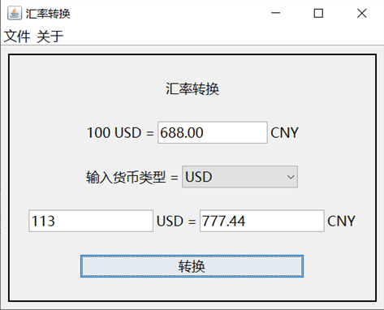

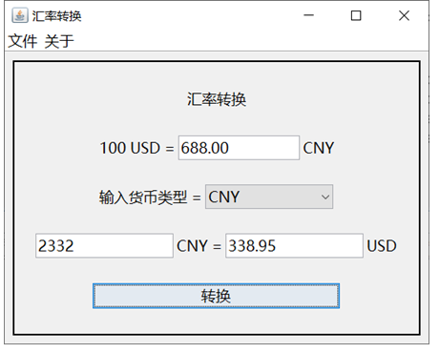
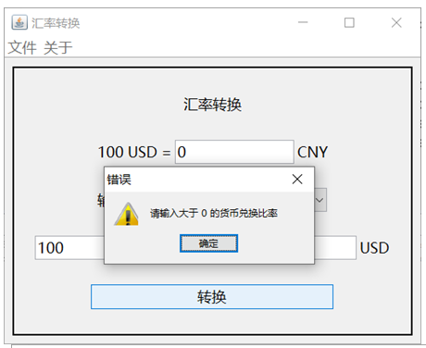
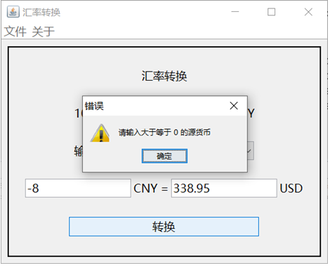

实 验 报 告
四、实验小结（实验过程中出现的综合问题和解决方法、心得体会、意见与建议等）
对于货币double类型计算小数点后位数过多
使用格式化String解决

界面元素不随窗口大小变化
设置边距时将左右同时设置为可调整距离即可使元素居中
并将元素本身设置为水平大小可调整即可实现控件随窗口大小变化

输入内容错误时发生意外情况 使用try…catch…解决

五、指导教师评阅（此栏目为评阅教师使用，学生请勿填写，谢谢）
学生此次上机实验的上机准备和预习状况
□ A 优秀 □ B良好 □ C 中等 □ D合格 □ E不合格
学生此次上机实验中编写、调试和测试程序的能力和理论知识点理解能力
□ A 优秀 □ B良好 □ C 中等 □ D合格 □ E不合格
学生此次实验提交的实验报告的撰写质量
□ A 优秀 □ B良好 □ C 中等 □ D合格 □ E不合格
 | 综合成绩 |  |  |  | 批阅人 |  |  | 日 期

