test collaboration

This is a test collaboration!

library(tidyverse)

Warning: package 'tidyverse' was built under R version 4.2.3

Warning: package 'ggplot2' was built under R version 4.2.3

Warning: package 'tibble' was built under R version 4.2.3

Warning: package 'tidyr' was built under R version 4.2.3

Warning: package 'readr' was built under R version 4.2.3

Warning: package 'purrr' was built under R version 4.2.3

Warning: package 'dplyr' was built under R version 4.2.3

Warning: package 'stringr' was built under R version 4.2.3

Warning: package 'forcats' was built under R version 4.2.3

Warning: package 'lubridate' was built under R version 4.2.3

── Attaching core tidyverse packages ──────────────────────── tidyverse 2.0.0 ──  
✔ dplyr 1.1.2 ✔ readr 2.1.4  
✔ forcats 1.0.0 ✔ stringr 1.5.0  
✔ ggplot2 3.4.2 ✔ tibble 3.2.1  
✔ lubridate 1.9.2 ✔ tidyr 1.3.0  
✔ purrr 1.0.1   
── Conflicts ────────────────────────────────────────── tidyverse_conflicts() ──  
✖ dplyr::filter() masks stats::filter()  
✖ dplyr::lag() masks stats::lag()  
ℹ Use the conflicted package (<http://conflicted.r-lib.org/>) to force all conflicts to become errors

ggplot(data = mtcars, aes(x = cyl, y = mpg)) +  
 geom_point()

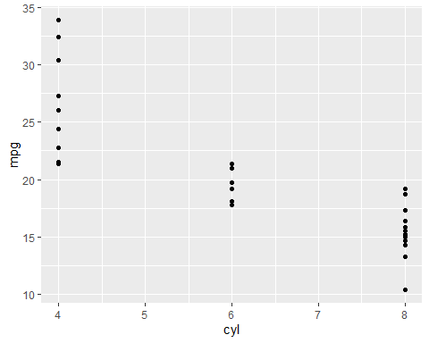

Hopefully everyone can get authentication issues sorted! (fingers crossed)