**Bex**

агрегаты пробовали создавать? (должна работать статистика BW)  
еще можно отключать кэш запроса в rsrt, если отчет не открывает одновременно много пользователей.

*I\_*

В rsrv для композита BCALLSLS3

при выборе теста

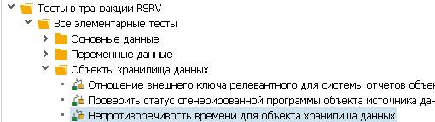

Получил сообщение



*From* [*Brian Keenan*](https://answers.sap.com/users/430/briankeenan.html)

<https://answers.sap.com/questions/7610922/index.html>

Check RSA1 Data Warehouse Workbench -> Modeling -> InfoProvider;

Search for InfoCube 0TCT\_VC01; in the context, check "Activate Direct Access";

Then, click on the "Source Syst.for InfoSource 3.x" tab, you have to activate the direct access by marking the source system (system name) and save.

Please also refer to SAP Note 934848(action 5).

As you may know, ST03N BI workload retrieves data of frontend and OLAP statistics largely from MultiProvider 0TCT\_MC01, which consists of two InfoProviders 0TCT\_C01 and 0TCT\_VC01. Correct activation of BI technical contents is a prerequisite for ST03N BI workload to behave properly.

From [Elena\_Lyndova@atlantconsult.com](mailto:Elena_Lyndova@atlantconsult.com)

Эта проверка релевантна для инфо-кубов и DSO

### cid:_1_10C3F3D810C3EF0400484168432584A4

### Replacement Path In Variable Reporting

<http://sapbibw2010.blogspot.com/2010/10/replacement-path-in-variable-reporting.html>

# **How To Build Dynamic Selections And Filters In SAP BW BEx Queries**

<https://www.saptraininghq.com/how-to-building-dynamic-selections-and-filters-in-sap-bw-bex-queries/>

## **How to Calculate a Period of Time in SAP BW**

<https://www.sapbwconsulting.com/blog/how-to-calculate-the-days-in-a-selected-period-sap-bw-report>

Если вам нужно сделать свою глобальную переменную - то милости просим в транзакцию **CMOD** и расширение.

# **Bex query - formula variable using Replacement path**

<https://blogs.sap.com/2013/04/30/replacement-path/>

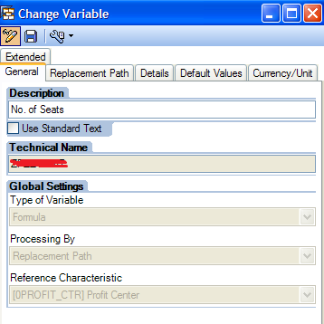 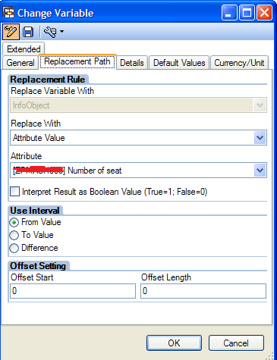

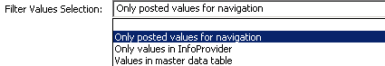

Filter Values Selection

* Only posted values for navigation
* Only values in InfoProvider
* Values in master data table