**PSA**

**Удаление данных из PSA**

− How to delete error record from PSA. I got duplicate records in the PSA. because of this load failed.

− I will delete the previous initialization settings /the full load/ and will upload the data with *request for delta*.

− I think you cannot delete individual record from psa - to prevent duplicate error, you can set in infopackage option

* *psa only*,
* *subsequent update*,
* *ignore double record*...

− You can delete the record by program, using the tech name of PSA. You can find it so - RSA1 -> PSA -> Right click on the Infosource and select delete PSA data -> A new screen is shown where the technical name of the PSA is displayed. It should be /BIC/*******. Copy that and come out of the screen

*declaration of table

TABLES /BIC/B0000000X.

EX DELETE /BIC/B0000000X

. WHERE FIELD1 = 'sihgdhfg'

. AND FIELD2 = 333333.

**RSPSADEL** is a SAP **standard transp table** used *for storing* ***Delete PSA request* in batch** related data. It comes under the package RSSM.

См. <https://sapbrainsonline.com/bw-tutorial/rspsadel-table-in-sap.html>.

### **Process types**

In order to delete requests from *PSA tables* or *Changelog tables* it is recommended to use process chains. SAP provides 3 different kind of process types

#### Deletion of Requests from PSA

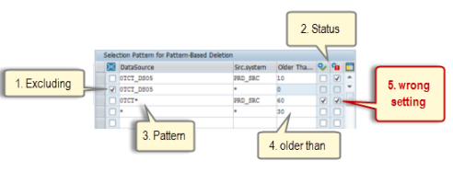

 1. ***Excluding*** - to make sure that PSA requests from a certain datasource should not be deleted. This option can be useful in case you use the placeholder '*'.

2. ***Status*** –

* Delete Successfully Updated Requests Only
* Delete Incorrect Requests that were not Updated

3. ***Pattern*** - pattern are allowed, but consider the long text in case you have maintained * for datasource and source system as this kind of usage can have a big impact for the system.

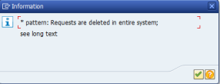

 4. ***Older than*** - for each row entry the number of days which should be kept in the PSA table can be selected.

#### Deletion of Requests from the Change Log

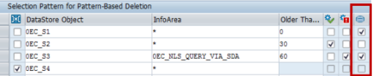

Point 1 to 4 of the 'Deletion of Requests from PSA' are also valid for the changelog deletion.

**Additionally what has to considered**

Changelog tables can include REQ* /loading/ requests and ODSR* /activation/ requests, therefore the last column is important.

If you need to delete REQ* requests, don't select the option 'Delete Activation Requests Only, No Load Requests'. If you need to delete ODSR* requests, set the flag.

In the example above - ODSR* requests will be deleted from 0EC_S1 and 0EC_S3. REQ* requests will be deleted from 0EC_S2

If you need to delete ODSR* and REQ* requests for the same DataStore Object, you need to create two variants as it is not allowed to maintain the same objects twice.

#### **Delete Requests from Write-Optimized DSO**

Maintenance screen

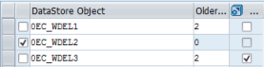

 Also in this variant you can exclude Datastore Objects and can use '*' (asterix) as a placeholder.

**ABAP DELETE table statements**

* DELETE <dbtab> FROM <wa>. – удаляет из dbtab запись, соответствующую wa /work area/.
* DELETE <dbtab> FROM TABLE <itab>. ‘itab - internal table

## **Delete from the Cluster database tables**

* DELETE FROM DATABASE <dbtab>(<ar>) ID <key>. - удаляет из *кластерной* dbtab записи cluster area *ar* /cluster area/ с ключом *key*.
* DELETE FROM SHARED BUFFER <dbtab>(<ar>) ID <key>. - удаляет из *кластерной* dbtab записи cluster area *ar* с ключом *key*., находящиеся в *cross-transaction application buffer*.

## **Delete lines from the internal table.**

* **DELETE TABLE <itab> FROM <wa>.**
* **DELETE TABLE <itab> WITH TABLE KEY <k1> = <f 1>… <k n> = <f n>.**
* **DELETE <itab> WHERE <cond>.**
* **DELETE ADJACENT DUPLICATE ENTRIES FROM <itab> [COMPARING… ]. - d**eletes adjacent duplicate entries, either by *comparing the key fields* or the *comparison fields specified explicitly in the COMPARING* addition.

## **Delete lines from an Index table**

* **DELETE <itab> [INDEX <idx>]. -** the line with the specified index will be deleted.
* **DELETE <itab> [FROM <n1>] [TO <n 2>] [WHERE <cond>].**