Поле дельты в источнике данных
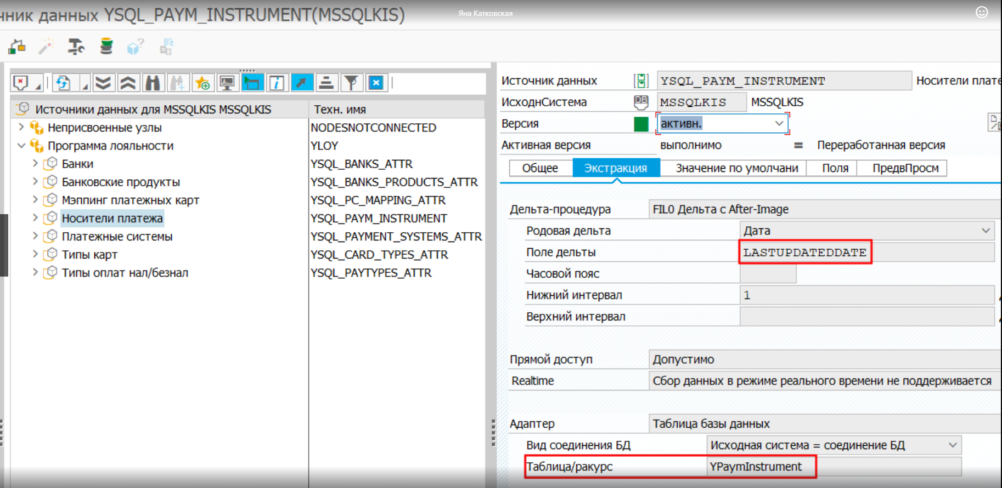

Delta

Unlike InfoPackage, delta transfer using a DTP doesn’t require an explicit initialization. When DTP is executed with Extraction mode Delta for the first time, all existing request till then are retrieved from the source and the delta is automatically initialized.
Опции
- Delta init without data
- Get All New Data Request By Request
- Only get delta once

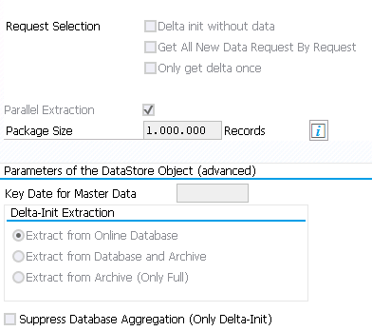

How to do Repeat Delta in SAP BI

http://explore-sapbw.blogspot.com/2012/02/how-to-do-repeat-delta-in-sap-bi.html

Опция Only get delta once
1.
It can select this option where the most recent data required in data target. In case delete overlapping request from data target have to select this option and use delete overlapping request process type in process chain.
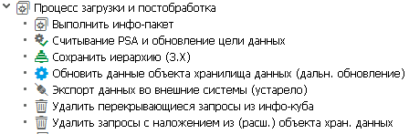
If used these setting then from the second loads it will delete the overlapping request from the data target and keeps only the last loaded request in data target.

2.
If this indicator is set, a snapshot scenario is built. The Data available in the Target is an exact replica of the Source Data.
Scenario
Let us consider a scenario wherein Data is transferred from a Flat File to an InfoCube. The Target needs to contain the data from the latest Flat File data load only. Each time a new Request is loaded, the previous request needs to be deleted from the Target. For every new data load, any previous Request loaded with the same selection criteria is to be removed from the InfoCube automatically. This is necessary, whenever the source delivers only the last status of the key figures, similar to a Snap Shot of the Source Data.
Solution – Only Get Delta Once
A DTP with a Full load should su’ffice (səˈfaɪs удовлетворять) the requirement. However, it is not recommended to use a Full DTP; the reason being, a full DTP loads all the requests from the PSA regardless of whether these were loaded previously or not. So, in order to avoid the duplication of data due to full loads, we have to always schedule PSA deletion every time before a full DTP is triggered again.
‘Only Get Delta Once’ does this job in a much efficient way; as it loads only the latest request (Delta) from a PSA to a Data target.
    - Delete the previous Request from the data target.
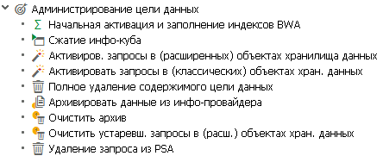
    - Load data up to PSA using a Full InfoPackage.
    - Execute DTP in Extraction Mode Delta with ‘Only Get Delta Once’ checked.
The above 3 steps can be incorporated in a Process Chain which avoids any manual intervention.

Опция Get all new data request by request
1.
If don’t select this option then the DTP will load all new requests from source into a single request. Have to select this option when the number of new requests is more in source and the amount of data volume is more. If selected this option then the DTP will load request by request from source and keep the same request in target.

2.
If you set this indicator in combination with ‘Retrieve Until No More New Data’, a DTP gets data from one request in the source. When it completes processing, the DTP checks whether the source contains any further new requests. If the source contains more requests, a new DTP request is automatically generated and processed.
NOTE If ‘Retrieve Until No More New Data’ is unchecked, the above option automatically changes to ‘Get One Request Only’. This would in turn get only one request from the source.
Also, once DTP is activated, the option ‘Retrieve Until No More New Data’ no more appears in the DTP maintenance.

Опция Delta Init without Data
This option specifies whether the first request of delta DTP should be transferred without any data. This is same as Initialization without data transfer in Delta Info Package.
If we select this option, the source data is only flagged as extracted and is not moved to the target (first request of delta DTP will get successful with one record). This option will sets the data mart (витрина данных) status for the requests in source and we cannot extract this requests using delta DTP anymore.
We will have this option in Extraction tab of Data transfer Process and can be seen in the below screen as well.
Note
If we are running any DTP for testing purpose, then it is not recommended to use this option. Instead, on Execute tab page, set the processing type to “Mark Source Data as Retrieved”.

You use 0RECORDMODE value X to mark rows to be skipped in the delta data load.

2nd option (no data transfer delta status in source fetched) is used for one time initializations. For eg. you have a delta dtp and you want to just run the initialization without data transfer once without changing the DTP settings. Also this option does not change the status of DTP to Revised.
1st option (Delta init without data) is used when you want to run the DTP with this option in a process chain. This option changes the status of DTP to Revised/Changed, you will have to activate the DTP again after this change to use it.

Both options do the same action.
But using it at different stages .
Init with out data transfer - Which is available at info pack level only and useful for us to set delta pointer for data source.
the other option - available at DTP level to set delta pointer while loading between targets in BW server.
Example
this is my data flow.
Data source--->Dso--->cube and daily running delta loads.
After some time, we got some requirement to enhance info cube with some more info objects and filling them thru some routine.
Now we need to historic data for added info objects as well. So, now we delete whole data from cube and will reload from DSO with selections(full mode). After reload, we need to set delta pointer here - in this we case we run dtp with above option and will set delta. Later whatever data loaded to dso, will load to cube thru delta dtp.

Delta queue
https://www.stechies.com/faq-bw-delta-queue-rsa7-questions-and-answers/

sap bw data transfer process semantic groups
https://blogs.sap.com/2013/06/16/semantic-groups-in-dtp/

RECORDMODE

The field ROCANCEL in DataSource serves the same purpose at R/3 side which its counterpart 0RECORDMODE does at BW side.
The values for 0recordmode
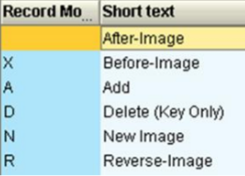

A - the record provides an additive image. Only the differences for all the numeric values are available.
R - the record provides a reverse image. The content of this record is equivalent to a before image. The only difference occurs when updating a DataStore object - an existing record with the same key is deleted.

How do we identify the Delta?

The delta process for the DataSource is determined in the table ROOSOURCE (in the source system) or in the table RSOLTPSOURCE (in BI for DataSources3.x) or in the table RSDS (in BI for DataSources) respectively.
Properties of the delta process are determined in the table RODELTAM (in BI or in the source system).

Semantic Groups

Choose Semantic Groups to specify how you want to build the data packages that are read from the source (DataSource or InfoProvider). To do this, define key fields - data records that have the same key are combined in a single data package.
This setting is only relevant for DataStore objects with data fields that are overwritten. This setting also defines the key fields for the error stack. By defining the key for the error stack, you ensure that the data can be updated in the target in the correct order once the incorrect data records have been corrected.
Aon the right side of the ‘Semantic Groups’ button indicates the Semantic keys exist for the DTP.

How Data is Brought to BI

Data is brought to BI using one of the following delta processes
- ABR – after, before and Reverse image
- AIE/AIM - after image
- ADD - additive image

ABR (возможно Addition, Overwrite)
Once a new entry is posted or an existing posting is changed at R/3 side, an after image shows the status after the change, a before image shows the status before the change with a negative sign and the reverse image shows the negative sign next to the record while indicating it for deletion.
Пример
Вставили новую запись
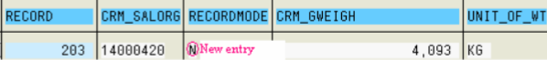

Изменили значение поля CRM_GWEIGH на 5,360
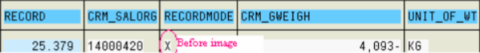
После активации
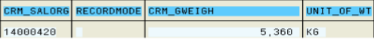

AIE/AIM (только Overwrite)
Once a new entry is posted or an existing posting is changed at R/3 side, an after image shows the status after the change.
Пример(нет Befor-image)
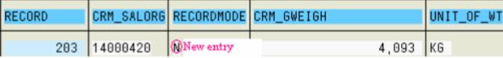
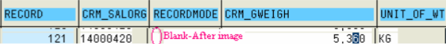

ADD (только Addition)
Once a new entry is posted or an existing posting is changed at R/3 side, an additive image shows the difference between the numeric values.
Пример
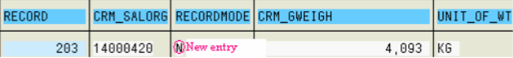
When the value of CRM_GWEIGH is changed to 5,360 in the source system, the datasource sends one entry to BI with the CRM_GWEIGH value 1,267, i.e. the Difference between the new value and the original value
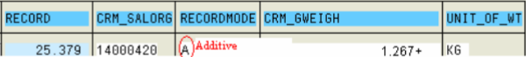
Upon activation, the final entry in active table is the result of the addition of the original value and the new value (4093+1267=5360) KG
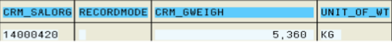

Data mart (витрина данных) status for the requests

Data mart status
- Request Not Updated to any data target.
- Request updated to some data targets.
- Request updated to all data targets.

http://www.sdn.sap.com/irj/scn/go/portal/prtroot/docs/library/uuid/10339304-7ce5-2c10-f692-fbcd25915c36?QuickLink=index&overridelayout=true
https://it.toolbox.com/question/reset-deletion-of-datamart-status-063012

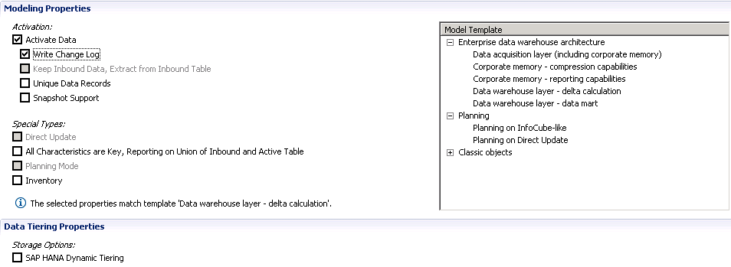

Обсуждение дельты
Экстрактор → PSA → ODS1 → ODS2 → Инфокуб
− Отказался от стандартной дельты в экстракторе, завел собственную табличку, в которой хранится пороговое значение времени (фактически собственная дельта).
Экстрактор обслуживает несколько источников данных - для каждого источника в табличке свое пороговое значение, которое обновляется в случае успешной загрузки. Данные из экстрактора идут в PSA, из кторого попадают в группирующий ODS. Первый ODS обрабатывает записи вида
key_1 val_1 val_2
1 10 0
1 0 15
2 30 0
2 0 40
и приводит к виду
1 10 15
2 30 40
Этот ODS настроен на суммирование показателей и отчищается перед
началом экстракции. Второй ODS принимает данные от первого и выполняет уже изменение. В нем данные хранятся постоянно. Из второго ODS дельты журнала изменения попадают в куб, а затем куб сжимается.
− Если нужно контролировать удаление записей, необходимо ввести в инфоисточник признак 0RECORDMODE, который определяет статус записи, например, 'D' - удалена.

The delta records can be monitored from RSA7.

