Power Consumption

ble_beacon

Schule der ansprechenden Künste

*Andreas Erdmann*

1 Power Consumption – ble_beacon 3

1.1 Summary 3

1.2 Baseline – the starting point 4

1.2.1 Calculation 4

1.2.2 SoftDevice flashed, no app flashed 5

1.2.3 SoftDevice, just go to idle mode 5

1.2.4 SoftDevice, init bsp (led off), and just go to idle mode 6

1.2.5 SoftDevice, init bsp (with one led on), and just go to idle mode 6

1.2.6 SoftDevice, init bsp (led off) + twi_config + (both) sensor_init 6

1.2.7 SoftDevice, init bsp (led off) + twi_config + no sensor_init 7

1.2.8 SoftDevice, init bsp (led off) + twi_config + only kx022 init 7

1.2.9 SoftDevice, init bsp (led off) + twi_config + only SHT3 init 7

1.2.10 SoftDevice, init bsp (led off) + twi_config + SHT3 but no KX022, no sensor data + BLE adv 8

1.2.11 SoftDevice, init bsp (led off) + twi_config + SHT3 but no KX022, no sensor data + BLE adv + SAADC measurement 8

1.2.12 SoftDevice, init bsp (led off) + twi_config + SHT3 but no KX022, no sensor data + without BLE init/adv + SAADC measurement 8

1.2.13 SoftDevice, init bsp (led off) + twi_config + SHT3 but no KX022, SHT3 measurement + without BLE init/adv + SAADC measurement 9

1.2.14 all but KX022 measurement, 1/8 data acquisition for SHT and SAADC 9

1.2.15 on top of 1.2.14 use different parameter 9

1.3 Power Optimization KX022 Accelerometer 10

1.3.1 Baseline, no BLE, no sensor init 11

1.3.2 Change to TWI without transaction manager, SHT3 init and KX022 init to standby 11

1.3.3 With KX022 and SHT3 “one shot” measurement, 1 Hz 11

1.3.4 Overall 12

1.3.5 Cycle 13

1.4 Use RTC INT for while waiting for accel data 13

1.4.1 Baseline 13

1.4.2 Use RTC counter (freq 1/256) for KX022 “put to operation”, “wait for accel data”, and during SHT3 temp/hum measurement (w/max. 15ms time) 13

1.4.3 one minute, analog to 1.3.4 13

1.5 Further optimization 14

1.5.1 Using nested approach: start long running SHT3 first, complete KX022 tasks and read SHT3 values KX022: ODR 1600 -> delay time 3ms 14

1.5.2 one minute, analog to 1.4.3 14

1.5.3 KX022: ODR 200 -> delay time 7ms 14

1.5.4 one minute, analog to 1.4.3 14

1.6 Longer intervals between adv and samples 15

1.7 Button functionality introduced 15

2 Original Beacon Firmware (for comparison) 16

3 Development: adding offline functionality and download services 16

3.1 Starting point on MDK Keil, #29964f7 16

3.1.1 One Minute 16

3.1.2 One sensor retrieval 17

3.1.3 One advertisement 17

3.1.4 Idle 17

3.2 First implementation 17

3.3 Removed m_offlinebuffer, not DIS, not CTS, not GATT 18

3.3.1 One minute 18

3.3.2 One Advertisment 18

3.3.3 One sensor value retrieval 18

3.3.4 BLE Connected 18

3.4 Moved to SES, #f5aaef5 but main.c from #2677a05 (before rewriting advertising/connect code) 20

3.4.1 One minute 20

3.4.2 One advertisement 20

3.4.3 One sensor retrieval 20

3.4.4 Idle 20

4 Used configuration 20

5 Actual Power Consumption 0

5.1 13.04.2019 – 03.06.2019 0

5.2 13.04.2019 – 03.06.2019 0

# Power Consumption – ble_beacon

In the first part in chapter 1.2 we measure the power consumption with the current implementation. We’ll identify in sections 1.2.14 and 1.2.15.1 that everything is ok but the accelerometer. Thus, in the following chapter 1.3 we will focus on optimizing the accelerometer usage.

Anyway, the different measurements and information we get from different configurations is interesting, so we will keep this information in the document, too, as a reference and starting point for other interested people during their optimization.

## Summary

In this document we show on how we did the power consumption optimization on the Bluetooth low energy (BLE) device based on Nordic Semiconductor NRF52832.

Our first straight forward implementation states a high usage of around 3.6 mA (see section 1.2.6), which gives a life time based on one cell coin battery (CR2032) of ~1.8 days (220mAh/3.6mA * 70% = ~42h), which is far too short. In comparison, the supplier’s original firmware of that devices has a consumption of 577 µA, which corresponds to ~11 days (220mAh/577µA * 70% = ~267h), and which is not acceptable, too.

With our optimization we were able to reach an average consumption of 14.4 µA, which gives:

220mAh / 0,0144mA * 0,7 = 10.694 h = ~1.2 Years

The **main reason** we identified was the usage of the KX022 accelerometer. In the IIC initialization sequence we must allow the device a 1.2/ODR delay time when transitioning from stand-by to operating mode to allow new settings to load (as stated in the data sheet). Otherwise, the power consumption will stay high. Because there is no delay function in the TWI transaction manager (but you can use blocking functions), we decided to switch to a blocking TWI mode and don’t use the transaction manager in a combined blocking and non-blocking mode. See section 1.3.3.1 for the specific results.

A further optimization is to use the RTC INT and go to sleep while waiting for accel data by setting a timer with the appropriate delay, see section 1.4.2. With these measures the power consumption goes down to 15 µA.

Another approach was to use a **nested approach** to first initiate the long running temperature and humidity data request, get the accel data, and then retrieve the temperature/humidity data. Section 1.5.4 shows the results. This gives no noteworthy further improvement.

Finally, **tuning the intervals** between BLE advertising and samples leads us to a result of ~14.4 µA, see section 1.6, which is considered as our new baseline.

I recommend a check against these values for all upcoming releases, e.g. the button introduction, as done in section 1.7.

## Baseline – the starting point

The baseline for the device is measured with only the SoftDevice S132 (Bluetooth 5 Central and Peripheral protocol stack) and no app flashed.

### Calculation

From the data sheets for the NRF52832, KX022 (accelerometer) and SHT3 (temperature/humidity sensor) we get the following data which leads to a calculated power consumption.

|  |  |
| --- | --- |
| NRF52 device |  |
| Idle current | 2.4 µA |
| Total average current | 13 µA |

The NRF52 power consumption is based on this calculator ([Link](https://devzone.nordicsemi.com/power/)) with this results:

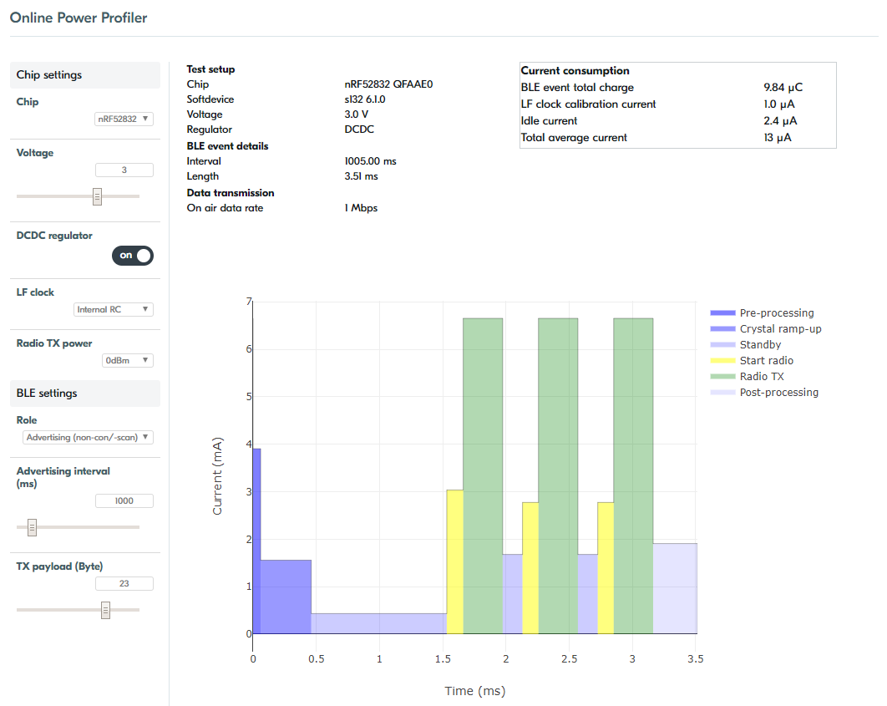

|  |  |
| --- | --- |
| KX022 device |  |
| High power mode | 145 µA@2.5 V |
| Low power mode | 10 µA |
| Standby | 0.9 µA |

|  |  |
| --- | --- |
| SHT3 device |  |
| Idle state | 0.2 µA (max 2 µA) |
| Average | 2 µA (while measuring w/lowest repeatability + single shot, 1 Hz) |

Overall, we thus can expect a power consumption in idle mode as stated in the following table:

|  |  |
| --- | --- |
| Overall Idle Current |  |
| NRF52 (Idle current) | 2.4 µA |
| KX022 (standby) | 0.9 µA |
| SHT3 (Idle state) | 0.2 µA (max. 2 µA) |
| SUM | 3.5 µA |

### 

With the active configuration stated in section 1.6 we can expect an average current as summarized in the following table:

|  |  |
| --- | --- |
| Overall Current |  |
| NRF52 (Total average current) | 13 µA * 60 s |
| KX022 (each 15 sec = 4/min) | + 320 µA (= 10 µA * 8 ms * 4) |
| SHT3 (each 15 sec = 4/min) | + 96 µA (= 2 µA * 12 ms * 4) |
| SAADC (each 60 sec = 1/min) | + Xxx (= 10 µA * x ms) |
| SUM | ~13-14 µA (average current) |

With all the measurements and optimization, we reach a value which is close to this theoretical bottom line. Done!

### SoftDevice flashed, no app flashed

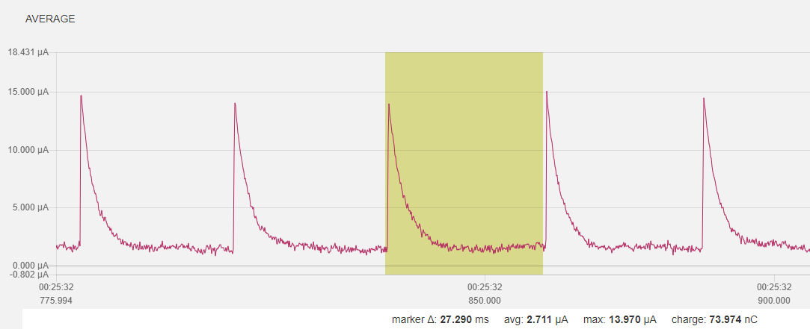

### SoftDevice, just go to idle mode

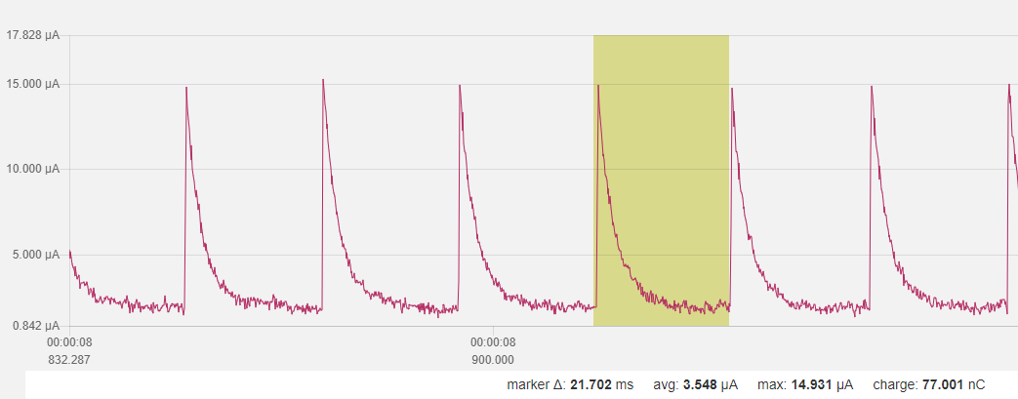

### SoftDevice, init bsp (led off), and just go to idle mode

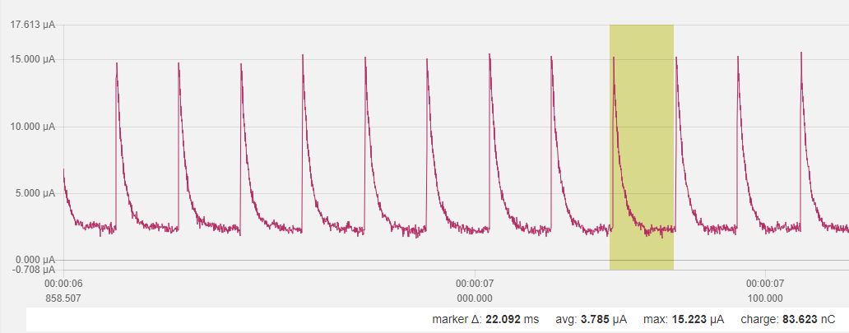

### SoftDevice, init bsp (with one led on), and just go to idle mode

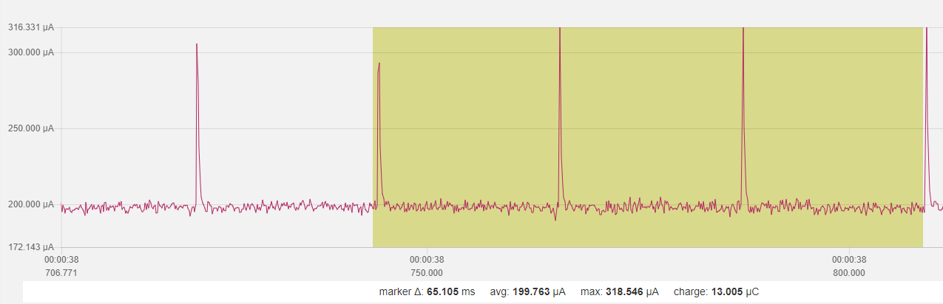

### SoftDevice, init bsp (led off) + twi_config + (both) sensor_init

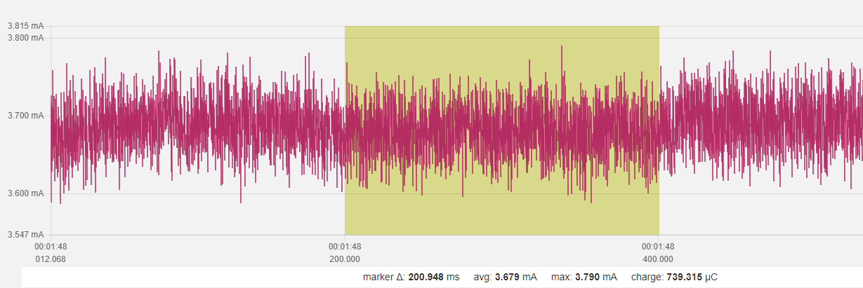

### SoftDevice, init bsp (led off) + twi_config + no sensor_init

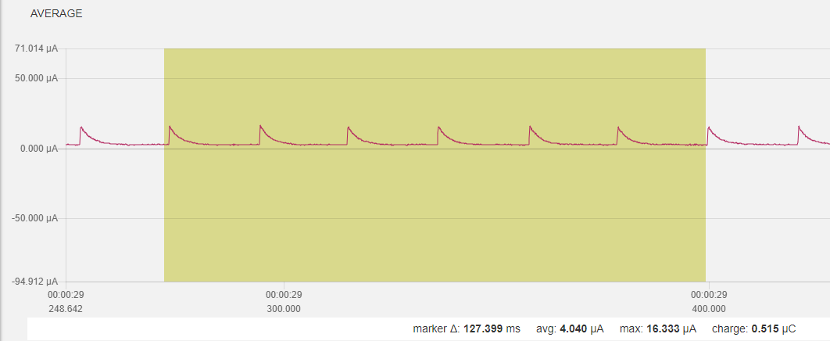

### SoftDevice, init bsp (led off) + twi_config + only kx022 init

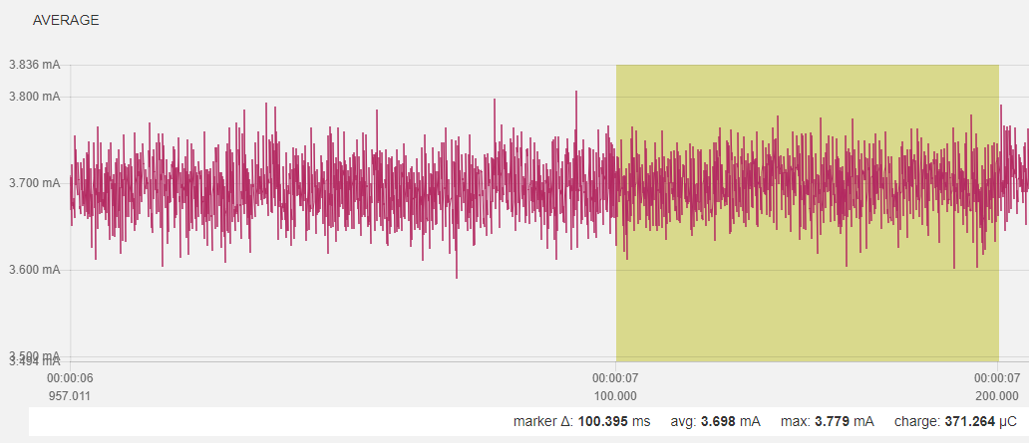

### SoftDevice, init bsp (led off) + twi_config + only SHT3 init

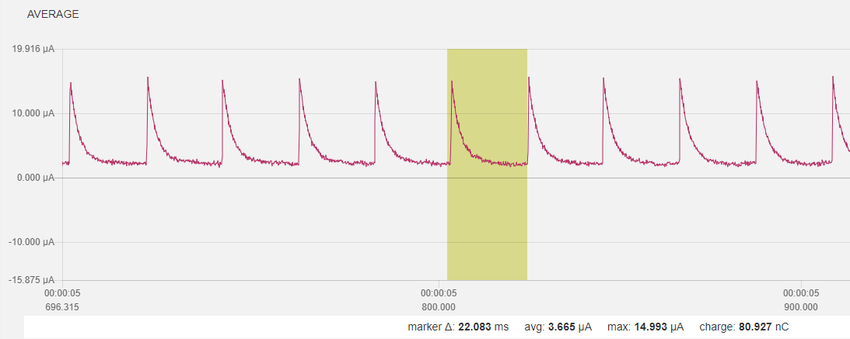

### SoftDevice, init bsp (led off) + twi_config + SHT3 but no KX022, no sensor data + BLE adv

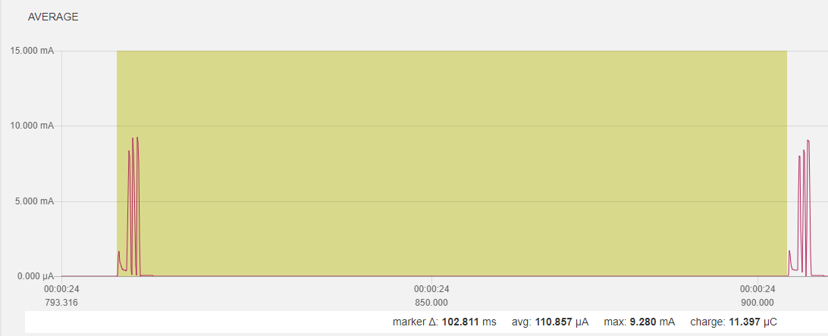

### SoftDevice, init bsp (led off) + twi_config + SHT3 but no KX022, no sensor data + BLE adv + SAADC measurement

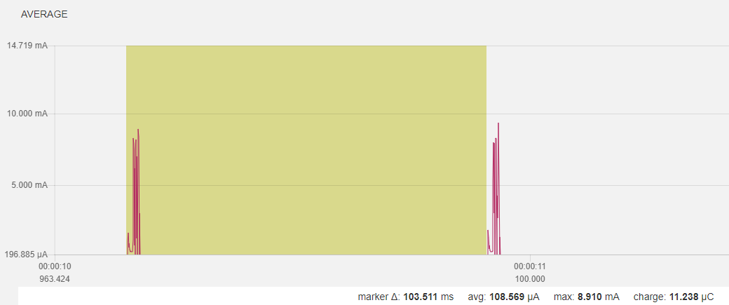

### SoftDevice, init bsp (led off) + twi_config + SHT3 but no KX022, no sensor data + without BLE init/adv + SAADC measurement

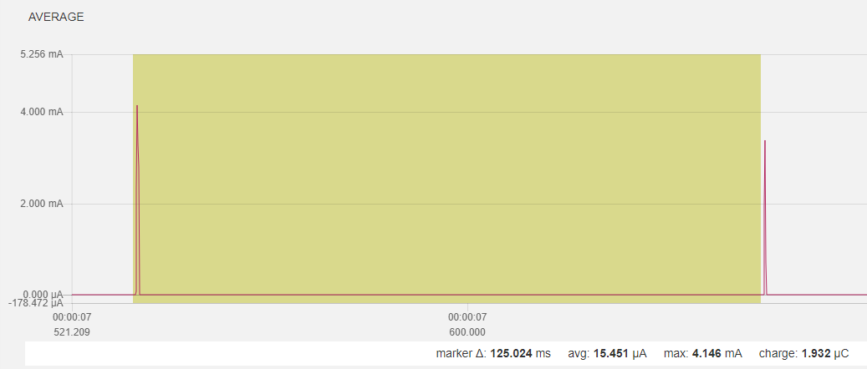

### SoftDevice, init bsp (led off) + twi_config + SHT3 but no KX022, SHT3 measurement + without BLE init/adv + SAADC measurement

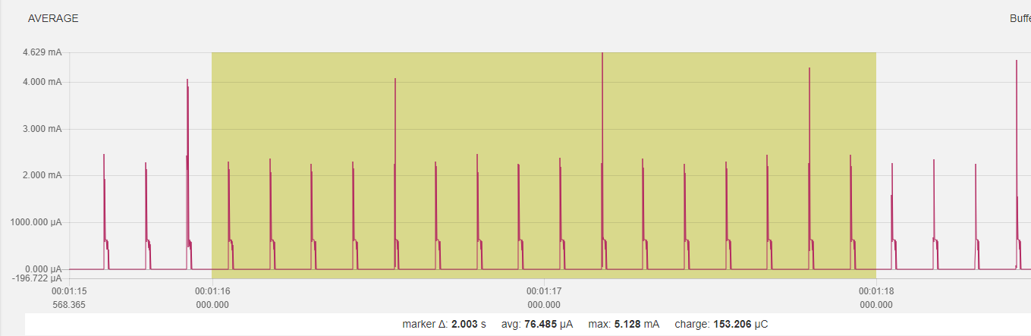

### all but KX022 measurement, 1/8 data acquisition for SHT and SAADC

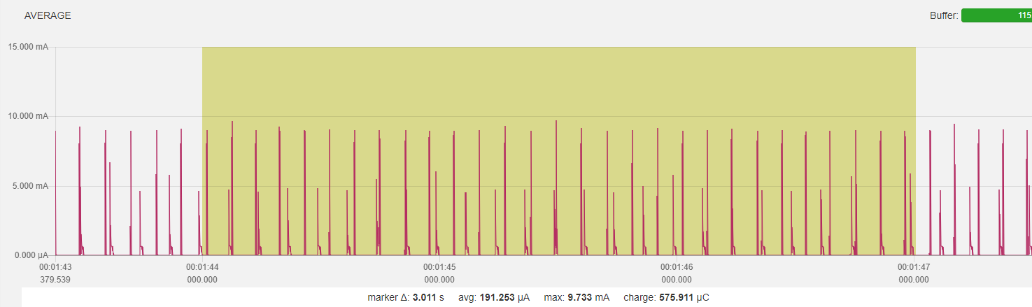

### on top of 1.2.14 use different parameter

* reduce transmit power to 0dBm from +4dBm
* adv int to 1 sec from 1/10 sec
* SHT update int to 5 sec from 1/8 sec
* SADC update int to 10 sec from 1/8 sec

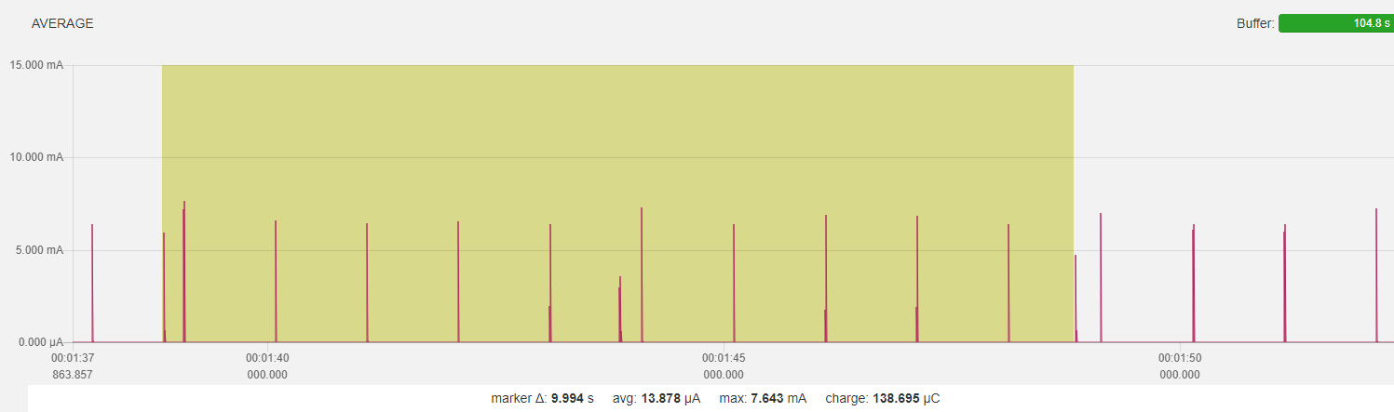

#### Sensor update (all 5 sec)

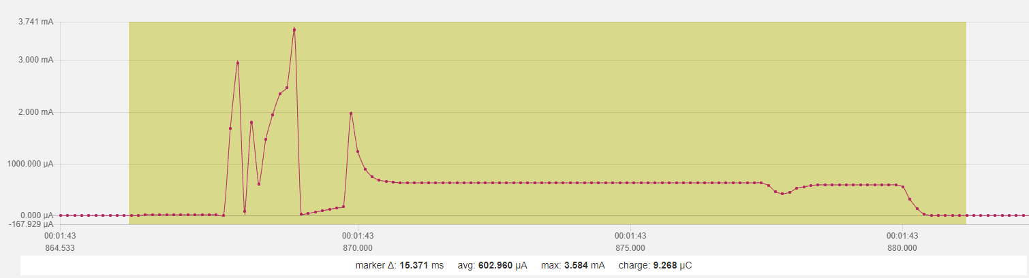

#### Adv (all 1 sec)

#### 

#### Startup

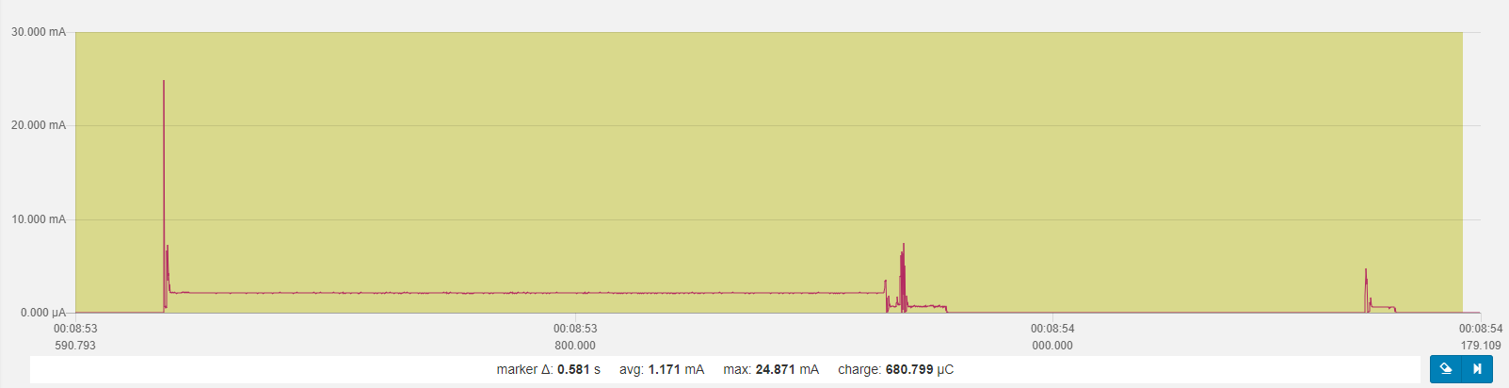

* Peaks
  + Power on peak
  + First adv
  + First sensor acquisition

## Power Optimization KX022 Accelerometer

As we saw in the previous chapter, we need to focus on optimizing the KX022 accelerometer power consumption.

### Baseline, no BLE, no sensor init

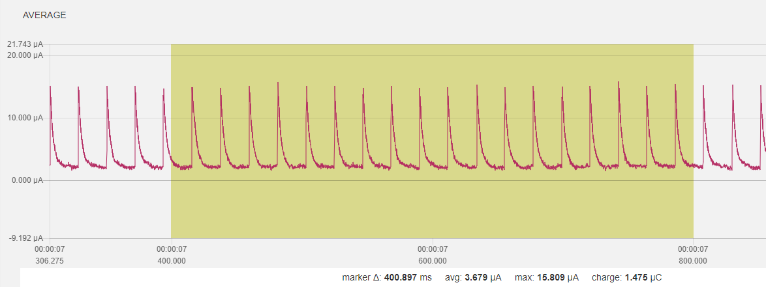

### Change to TWI without transaction manager, SHT3 init and KX022 init to standby

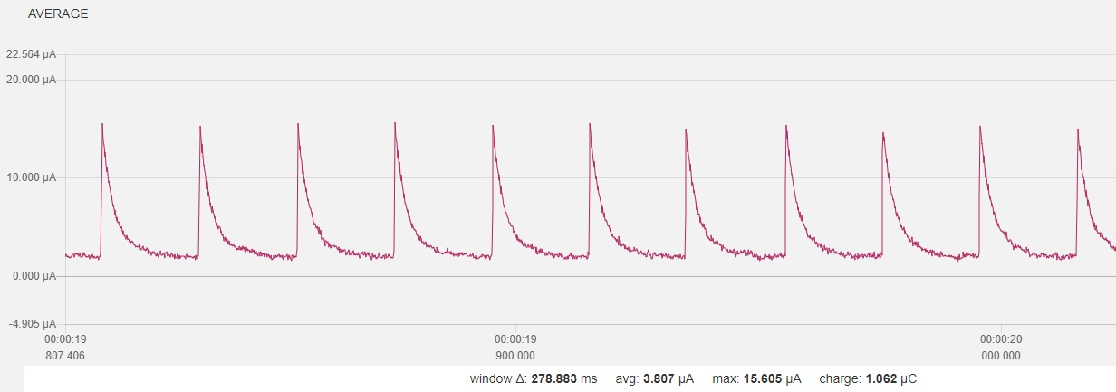

### With KX022 and SHT3 “one shot” measurement, 1 Hz

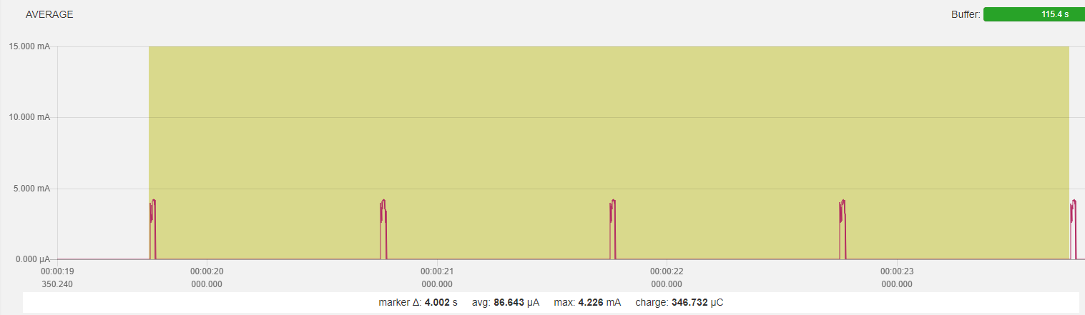

#### One measurement

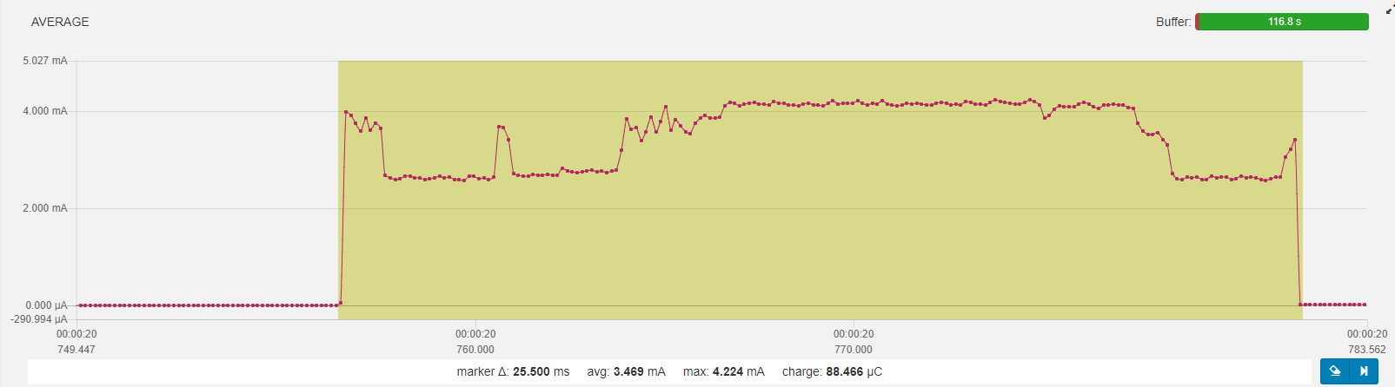

Init KX022, Standby 1,2ms  
wait 1.2/ODR 3ms  
set to operate 0,5ms  
wait 1.2/ODR for value 3ms  
read accel values …  
SUM ~8ms

Set SHT3 to SHT3_MEAS_HIGHREP_STRETCH  
wait clock stretch 12,5ms  
read temperature and humidity 2,8ms  
SUM ~15ms

Process data and sleep again…  
Overall cycle 25ms, avg. power consumption 3,5mA, idle < 4uA

### Overall

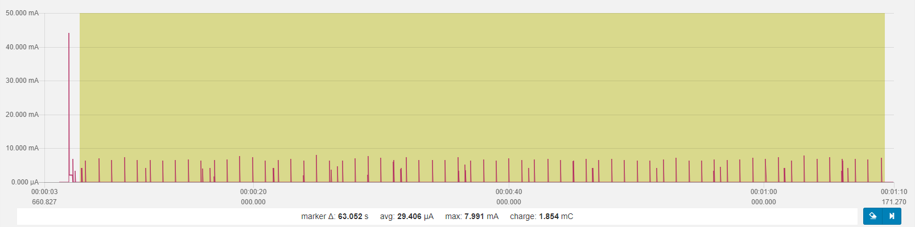

#### One 10sec cycle

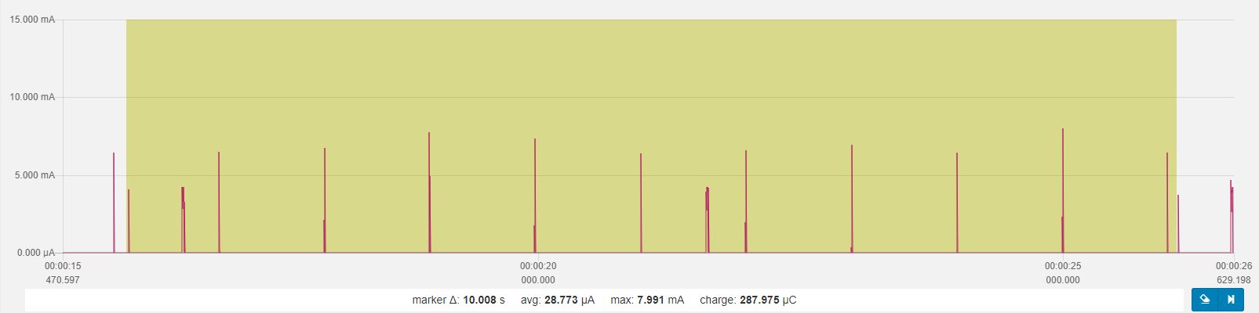

### Cycle

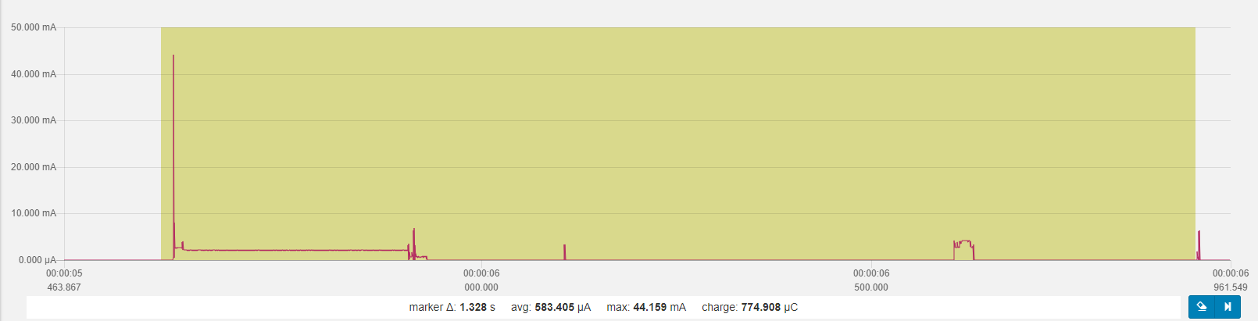

BLE 0 dBm, adv. interval 1s  
sensor (SHT3 and KX022) interval 5s  
SAADC (battery level) interval 10s  
overall power consumption ~30uA (28,77uA)  
idle power consumption 3,5uA

## Use RTC INT for while waiting for accel data

### Baseline

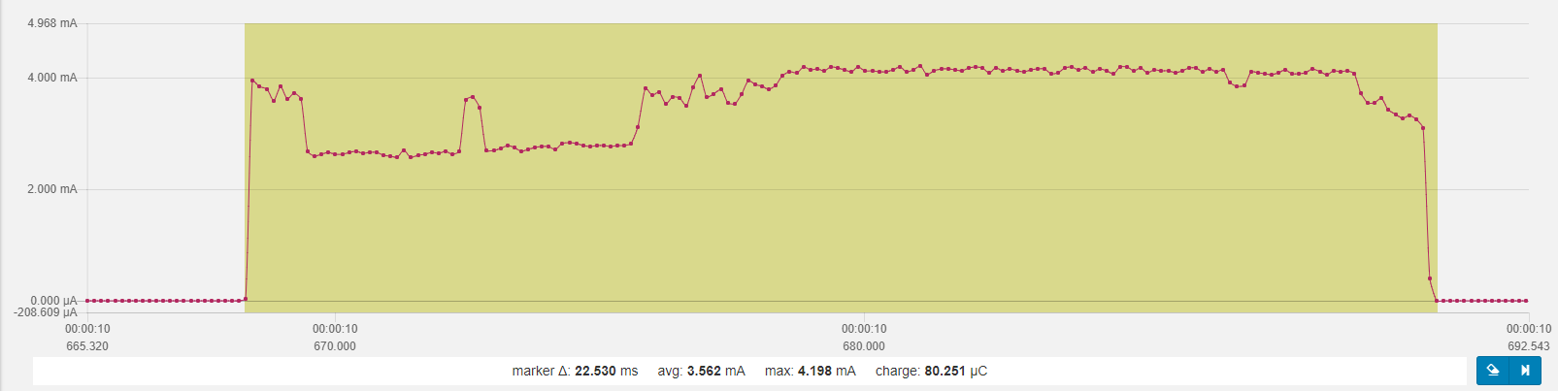

### Use RTC counter (freq 1/256) for KX022 “put to operation”, “wait for accel data”, and during SHT3 temp/hum measurement (w/max. 15ms time)

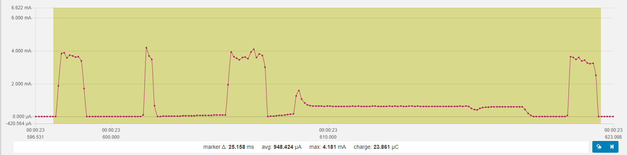

### one minute, analog to 1.3.4

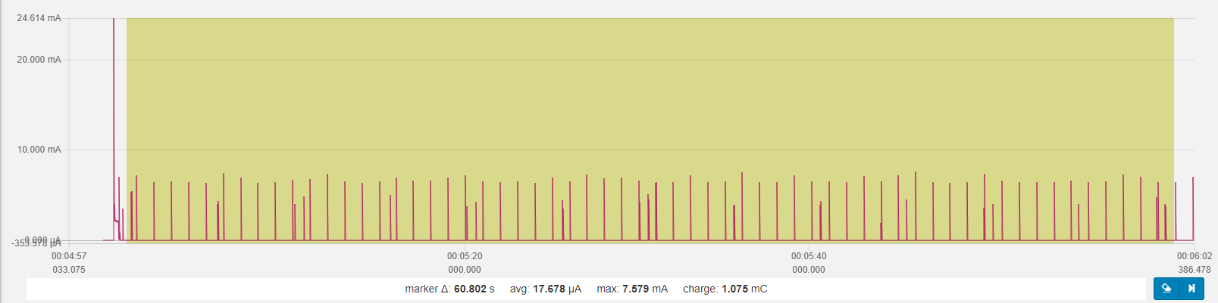

Optimization summary (1.3.4🡪1.4.3)  
BLE 0 dBm, adv. interval 1s  
sensor (SHT3 and KX022) interval 5s  
SAADC (battery level) interval 10s  
overall power consumption ~30uA (28,77uA) 🡪 17,68uA   
idle power consumption 3,5uA 🡪 3,5 uA

## Further optimization

### Using nested approach: start long running SHT3 first, complete KX022 tasks and read SHT3 values KX022: ODR 1600 -> delay time 3ms

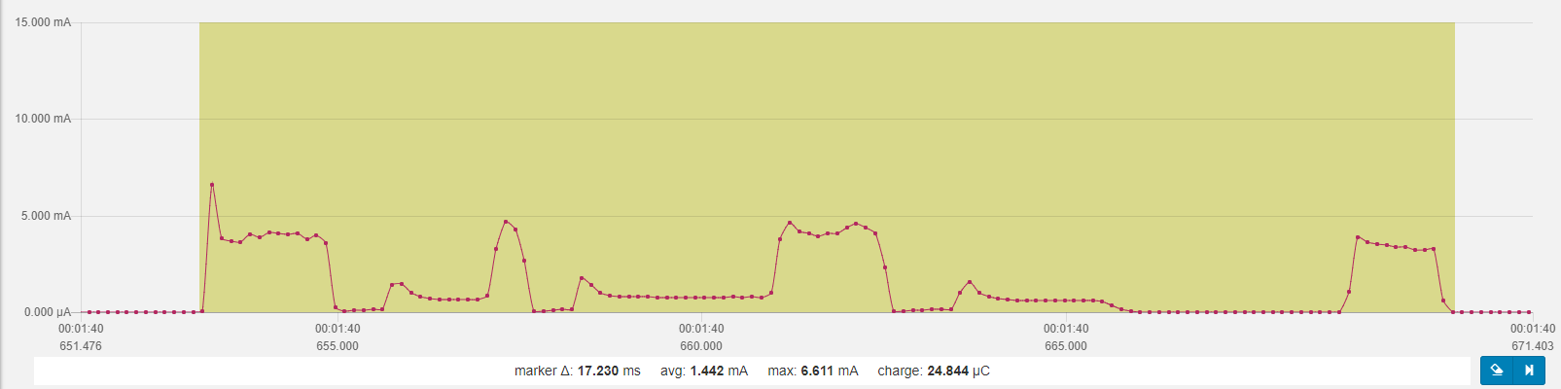

### one minute, analog to 1.4.3

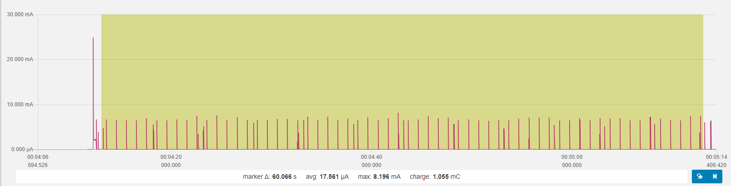

thus, no real further improvement

### KX022: ODR 200 -> delay time 7ms

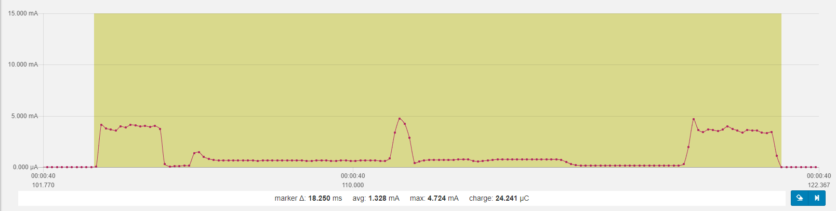

### one minute, analog to 1.4.3

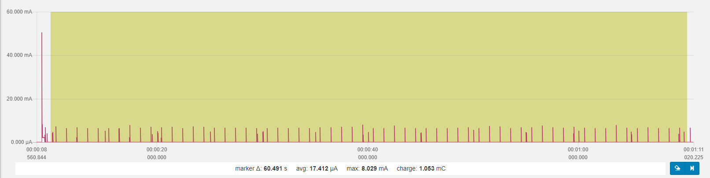

thus, no real further improvement

## Longer intervals between adv and samples

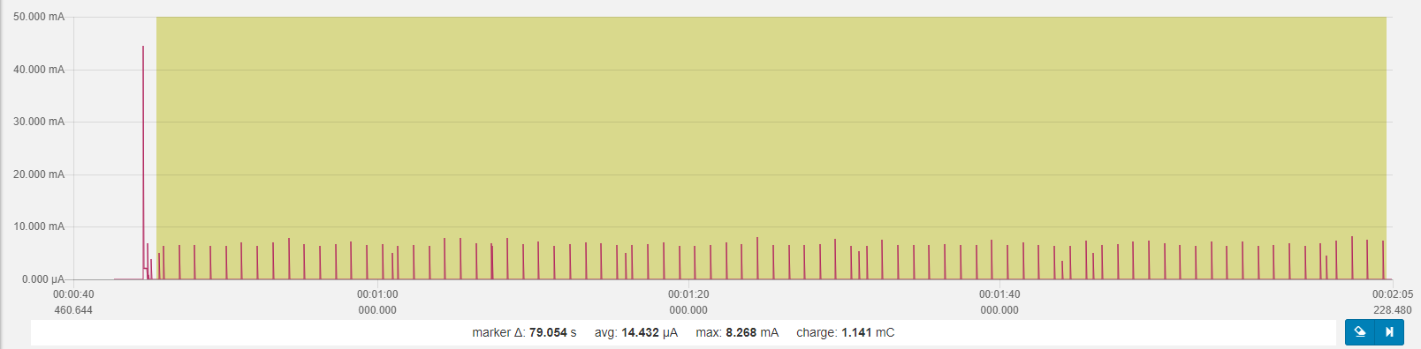BLE 0 dBm, adv. interval 1s  
sensor (SHT3 and KX022) interval 15s  
SAADC (battery level) interval 60s  
overall power consumption 14,4uA   
idle power consumption 3,6 uA

220mAh / 0,0144mA * 0,7 = 10.694 h = ~1.2 Years

(> 1 Year = 365 * 24h = 8760h; CR2032 = 220 mAh)

## Button functionality introduced

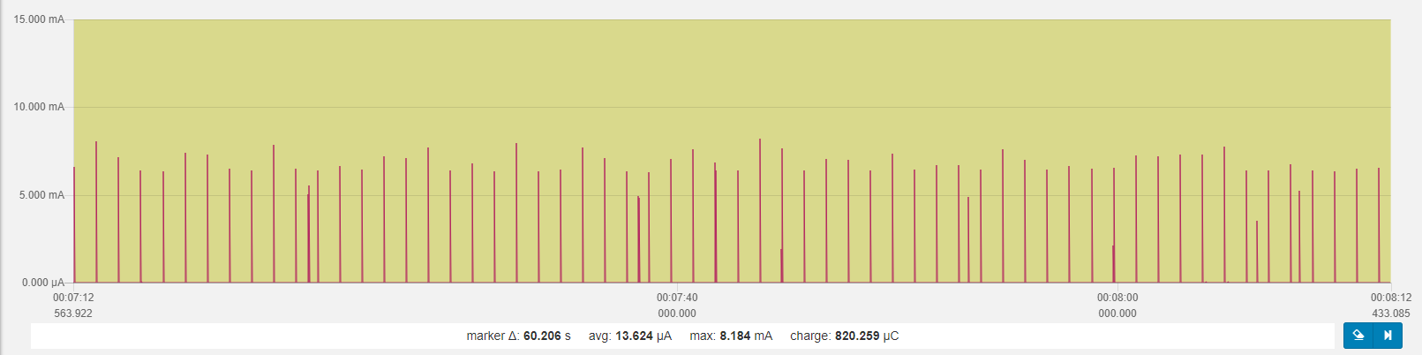

Single button press  
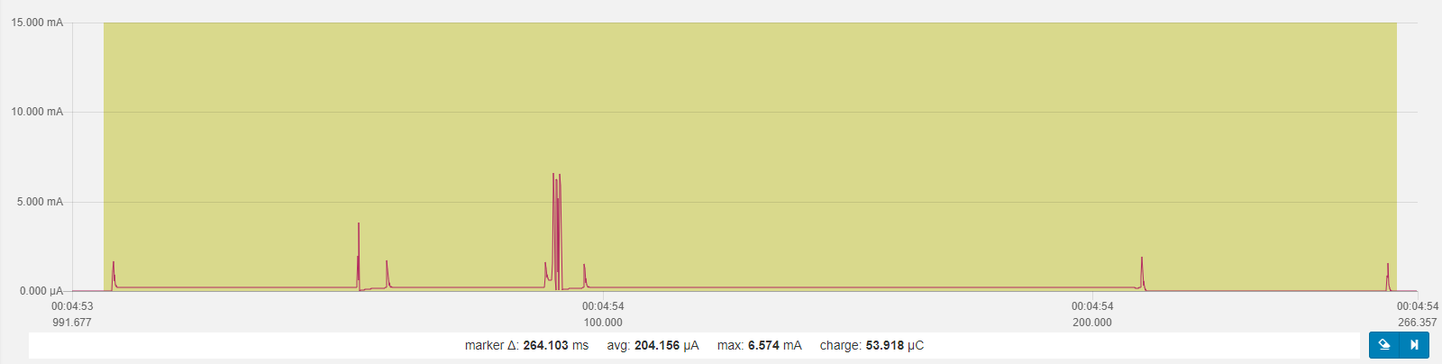

# Original Beacon Firmware (for comparison)

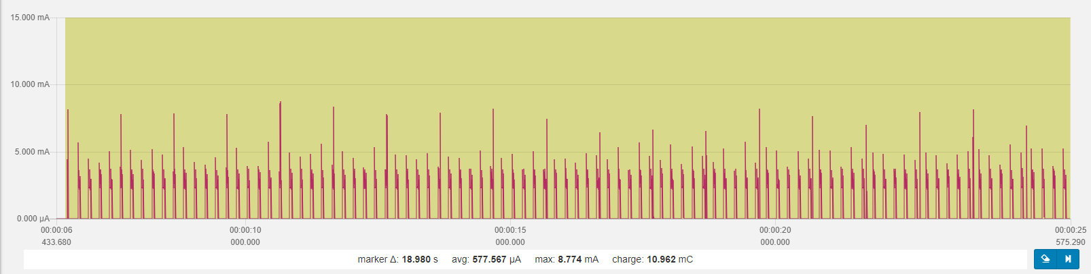

Frequent spikes (5 Hz)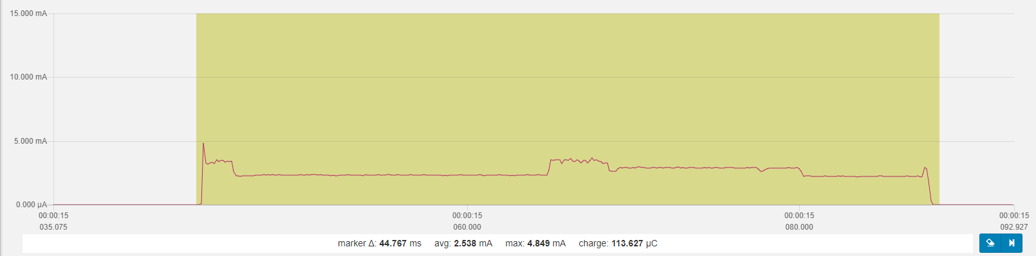

Larger but rarer spikes (1 Hz)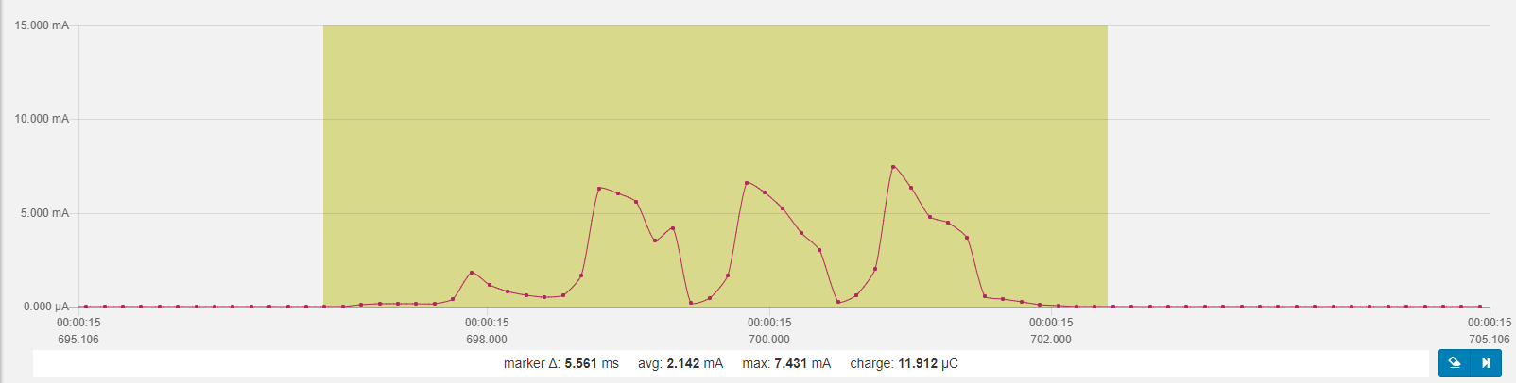

# Development: adding offline functionality and download services

## Starting point on MDK Keil, #29964f7

### One Minute

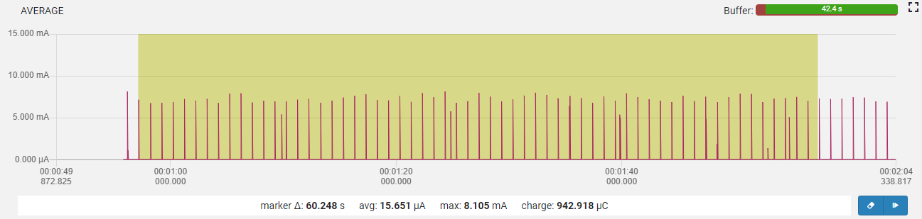

### One sensor retrieval

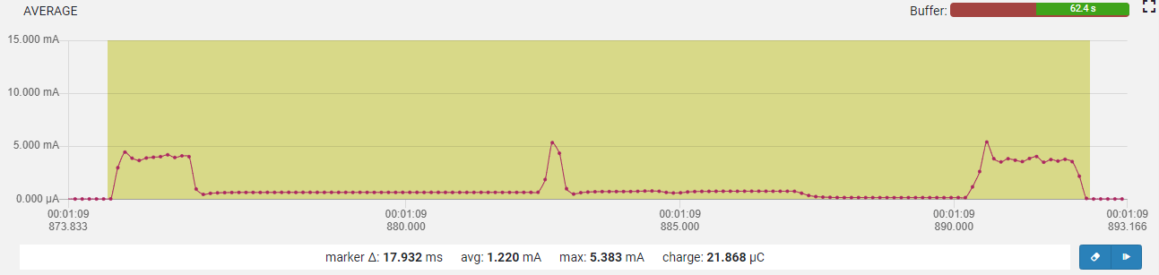

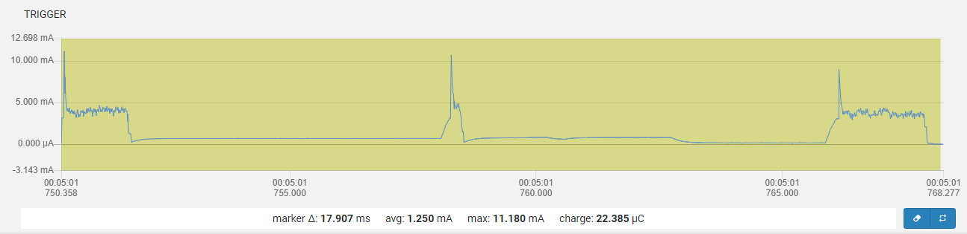

### One advertisement

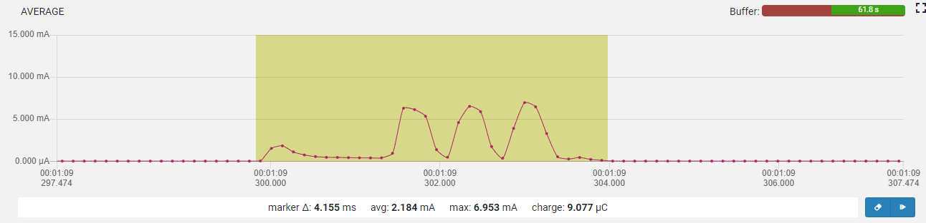

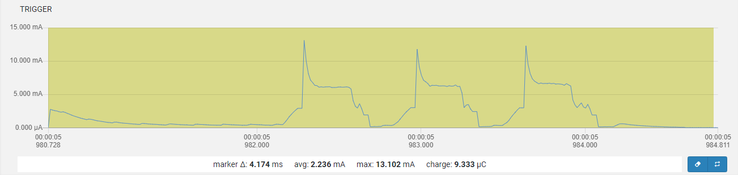

### Idle

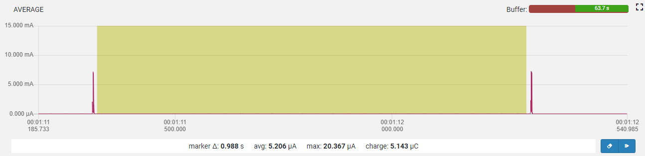

## First implementation

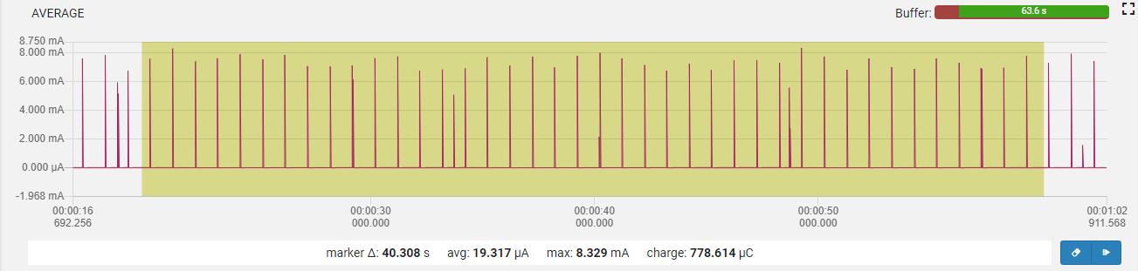

## Removed m_offlinebuffer, not DIS, not CTS, not GATT

### One minute

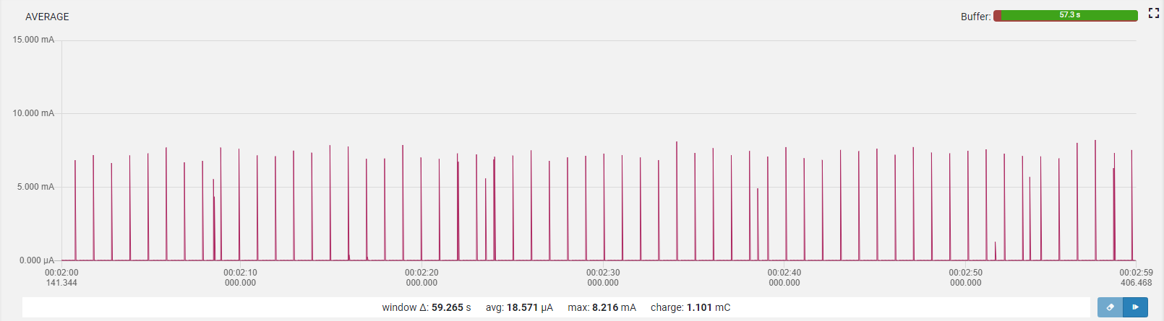

### One Advertisement

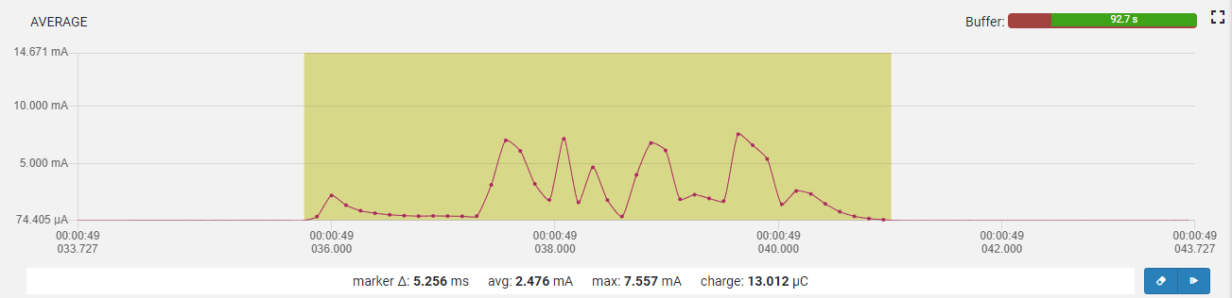

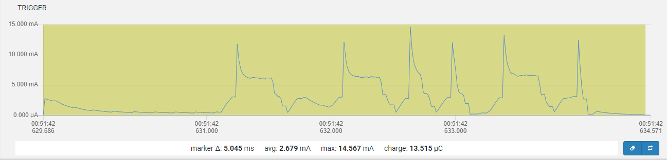

### One sensor value retrieval

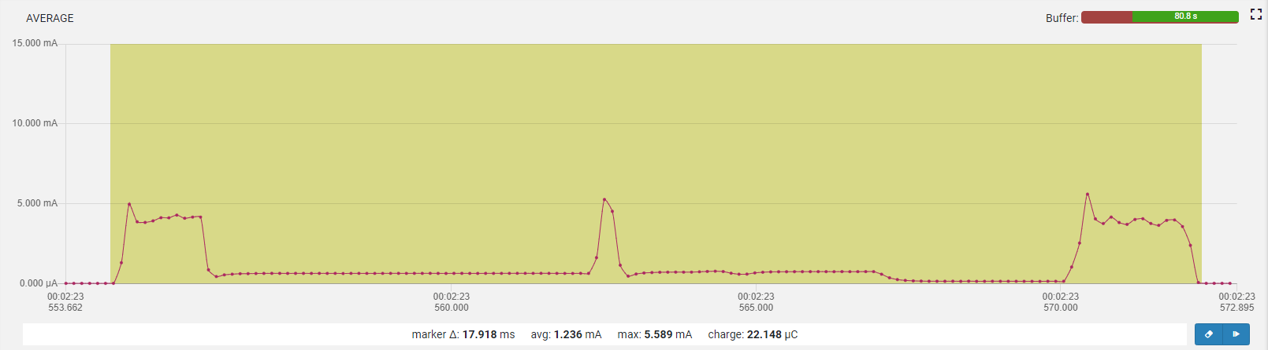

### BLE Connected

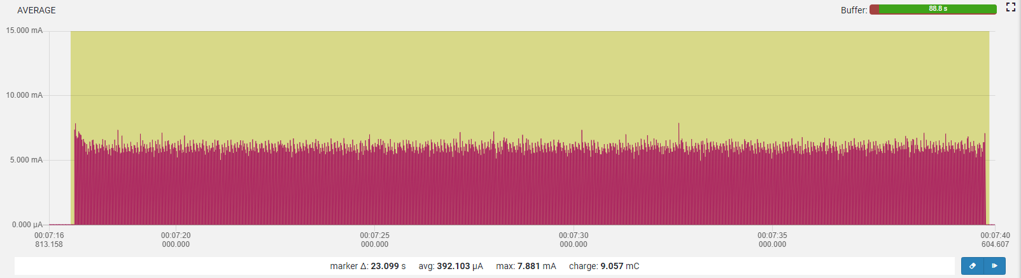

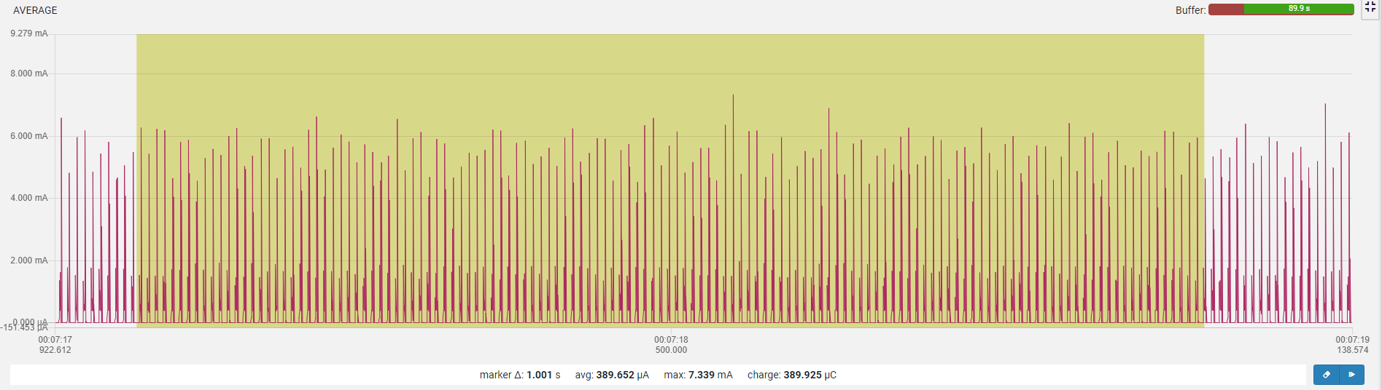

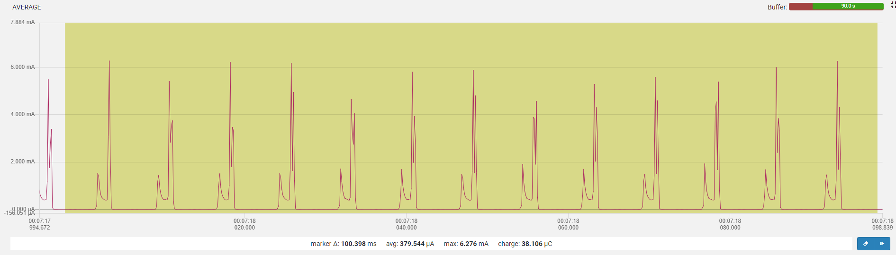

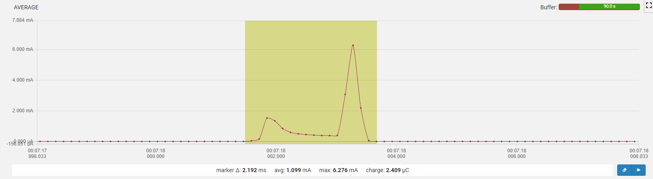

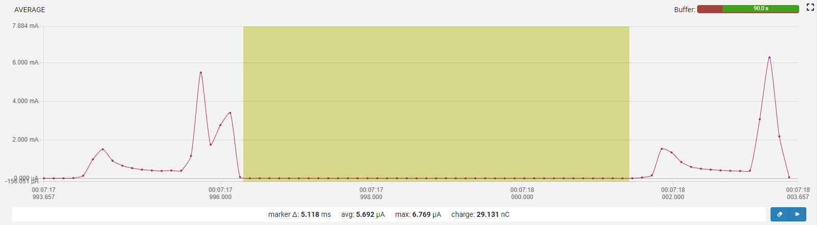

## Moved to SES, #f5aaef5 but main.c from #2677a05 (before rewriting advertising/connect code)

### One minute

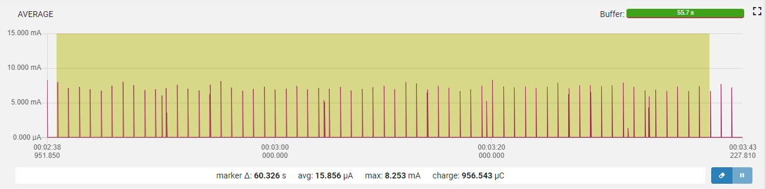

### One advertisement

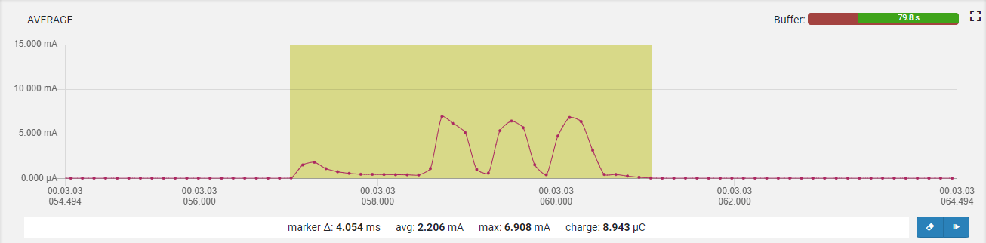

### One sensor retrieval

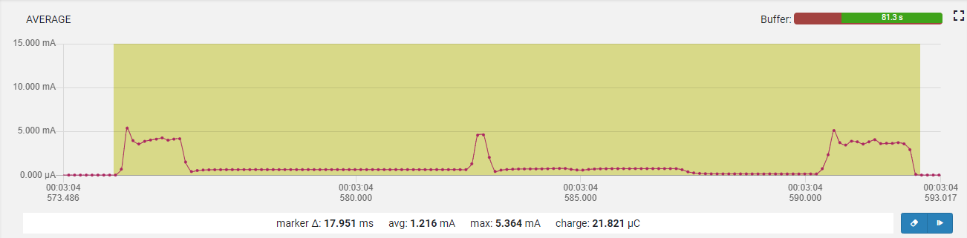

### Idle

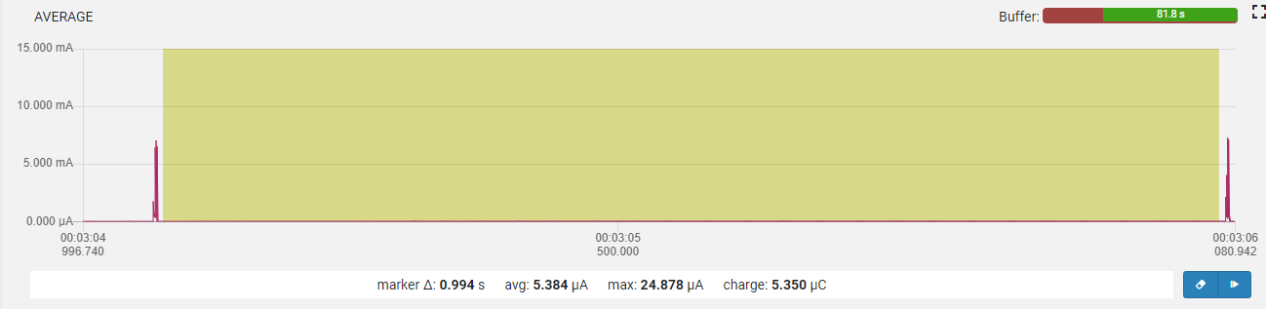

# ble_app_pwr_profiling

## Minimum

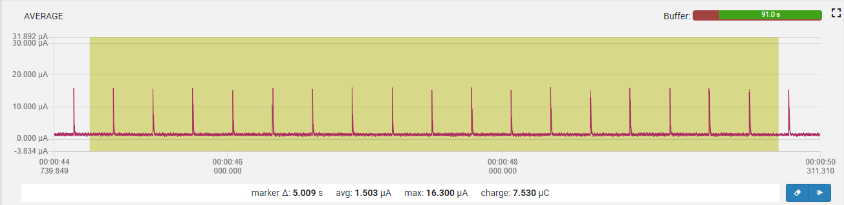

Without NRF_POWER->DCDCEN = 1

## With NRF_POWER->DCDCEN = 1

## 

## With LFCLK started, no NRF_POWER->DCDCEN = 1

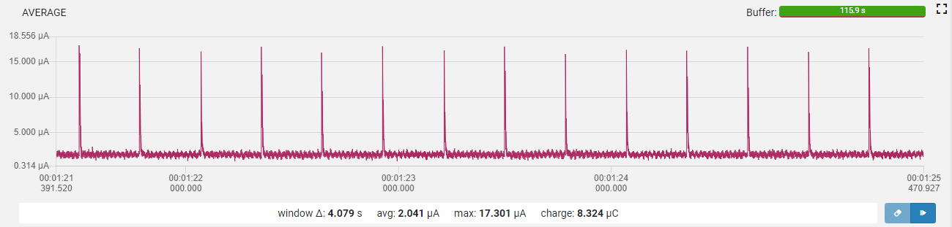

## Advertising, non-connectable

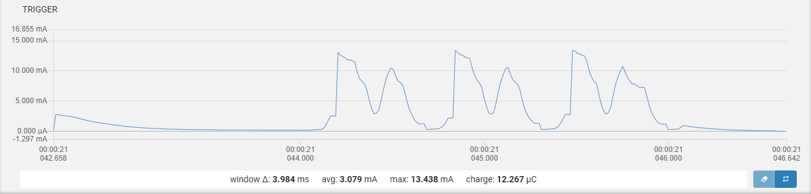 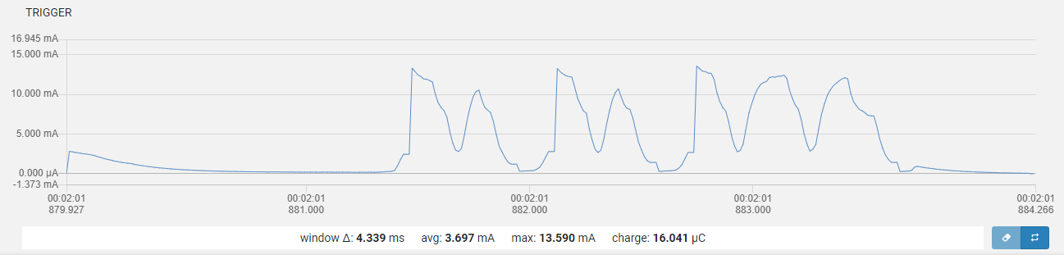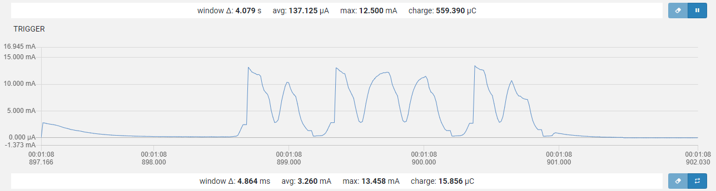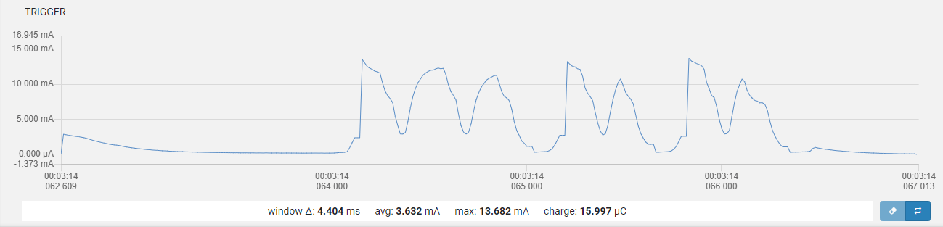

## Advertising, connectable

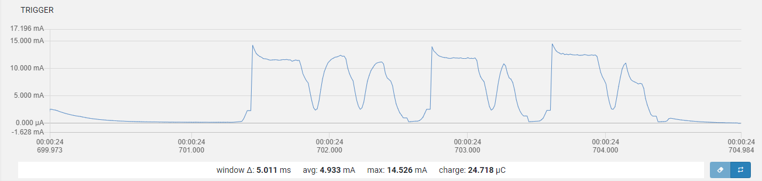

And

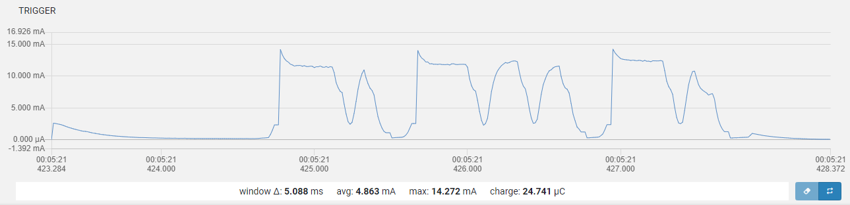

# Used configuration

|  |  |
| --- | --- |
| Component | Remark |
| BLE Beacon with KX022, SHT3, Button, LED | Product [Link](https://radioland-china.en.alibaba.com/product/60798177518-807354582/BLE_52832_Beacon_3_axis_Acceleromter_Sensor_Temperature_And_Humidity_Sensor_Optional_Programmable_BLE_Sensor_Beacon_Waterproof.html?spm=a2700.icbuShop.82.21.154417b5LEcoCg) from Alibaba |
| Nordic Semiconductor NRF52832 |  |
| nRF5 SDK | Version: 15.2.0 |
| SoftDevice S132 | S132 SoftDevice v6.1.0 |
| J-LINK EDU MINI | Segger Microcontroller Systems |
| Nordic Power Profiler Kit | Nordic Semiconductor |
| nRF52840 Dongle | Nordic Semiconductor |
| KEIL MDK-Lite | Version: 5.27.0.0 |
| Github repository | https://github.com/an-erd/ble_beacon |

# Actual Power Consumption

## 13.04.2019 – 03.06.2019

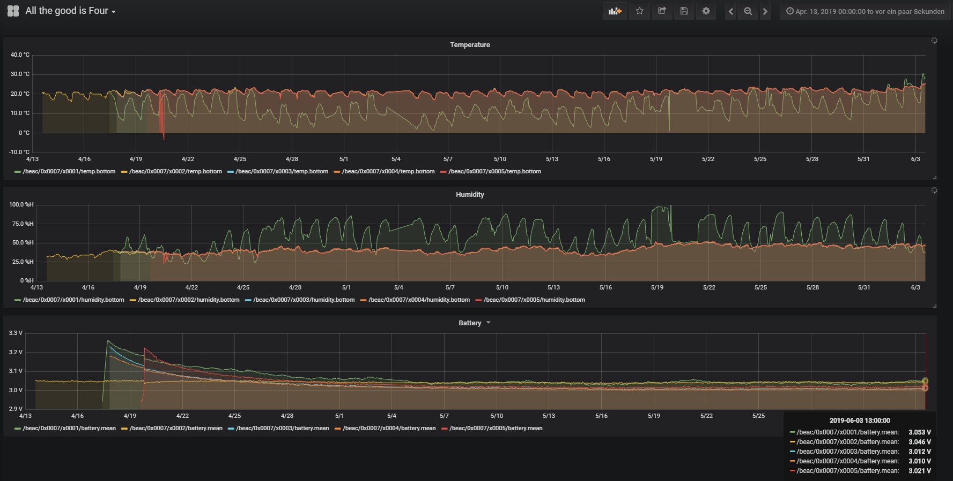

## 13.04.2019 – 03.06.2019

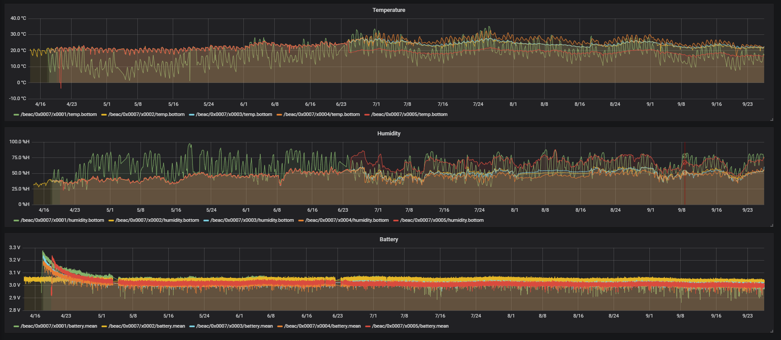

* 19.05.2019: hail, sensor temperature down to ~0°C, and humidity up to ~100%   
  