Program Documentation

ble_beacon

Schule der ansprechenden Künste

*Andreas Erdmann*

1 Chapter 1 2

1.1 Work on advertising_init() 2

1.1.1 Barebone 2

1.1.2 Adding uuids in advdata 3

# Chapter 1

In the first chapter …

## Work on advertising_init()

### Bare, almost nothing

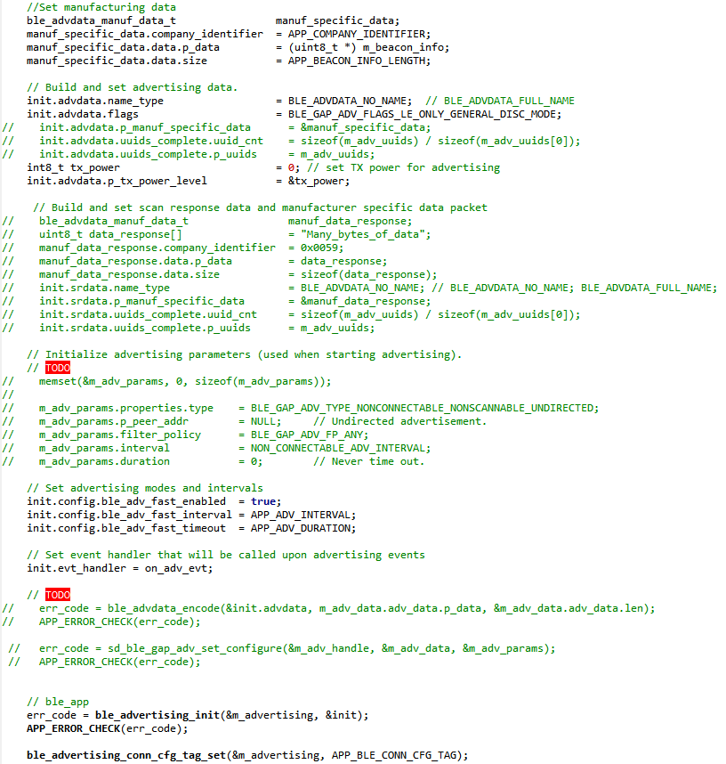

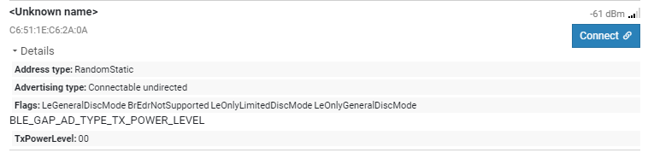

Connect:

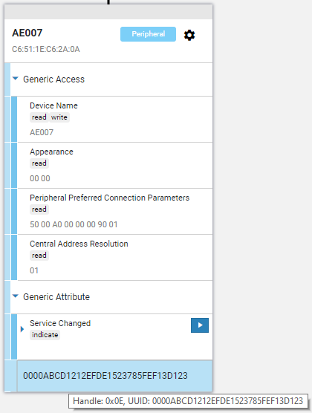

### Adding uuids in advdata



With





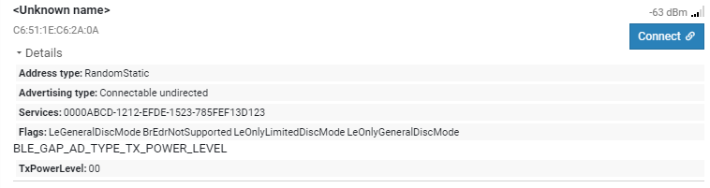

Connect:

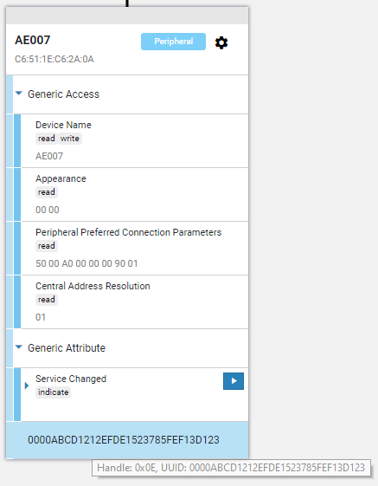

### Adding short UUIDs in advdata

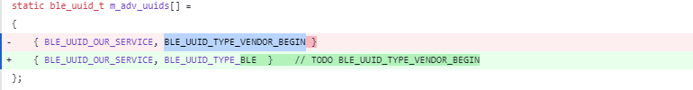

Gives

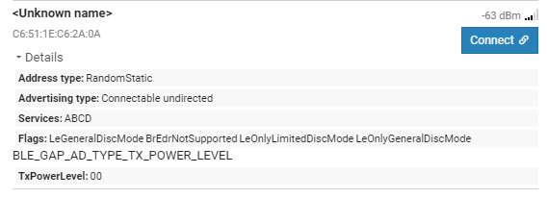

### Advdata packet

The array m_advertising.enc_advdata contains:

Flags 0..2 02 01 06

TX Power Level 3..5 02 0A 00

UUIDs 6..9 03 03 CD AB // short UUID „ABCD“

Manuf. Spec. Data 10 13 // length

11 FF // BLE_GAP_AD_TYPE_MANUFACTURER_SPECIFIC_DATA

12..13 59 00 // Company Identifier

14..17 00 07 00 08 // MAJ MIN

18..19 FE FE // Temperature

20..21 FD FD // Humidity

22..23 AA AA // X

24..25 BB BB // Y

26..27 CC CC // Z

28..29 0B B8 // Battery

30 00 // ?



