|  |
| --- |
| **HTML**  **Template Guide** |



## Contents

1. **HTML** **Layout structure**  **3**
2. **CSS** **Naming Convention 4**
3. **File Description 5**

*1. HTML Layout structure*

The following figure shows the basic template structure of HTML.

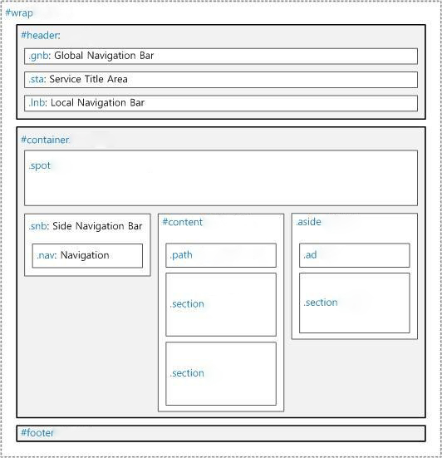

*2. CSS Naming Convention*

**A.****General Rules**   
The name should be written in lowercase letters, numbers, and underscores (_).

**B. Name First character**

The name must start with a lowercase letter.

C. **Lowercase letters, numbers and underscore combinations.**

• Only lowercase letters, numbers, and underscores (_) can be used.

• The underscore (_) is only used when combining words and words.

• An appointment with an underscore (_) can be used in combination with a number or a lowercase letter.

|  |  |  |
| --- | --- | --- |
| Basic type | Incorrect example | Correct example |
| .section | .sectionList | .section_list |

*3. File Description*

|  |  |  |
| --- | --- | --- |
| Folder Name | **File Name** | Description |
| css | / | bundle css file |
| animate.css | animated css file |
| common.css | common css file |
| font.css | font css file |
| layout.css | Layout css running on 768px or higer on responsive web. |
| layout767.css | Layout css running on 480~768px responsive web |
| layout479.css | Layout css running on below 479px responsive web |
| reset.css | Initialize the default style of html tags |
| style.css | Desinged css file |
| font | / | bundle font file |
| js | / | bundle javascript file |