Ashley Nixon  
CIS 1111  
03/16/2019

Basketball Statistics

Program records and analyses basketball quarter scores and determine the winner, by how much, and the average per quarter.

Enter the basketball teams short name (ie Lakers not Los Angeles Lakers) for the first team, then for the second team as prompted.

Enter the scores for each team by quarter as prompted.

Quarter Scores will print to the screen and declare a winner.

In the case of a tie score, overtime will be initiated, and you will enter the overtime scores for the first time and the second team until the tie is broken.

You may then choose to display

Team Q1 Q2 Q3 Q4

Pistons 27 19 31 34

Lakers 22 18 22 35

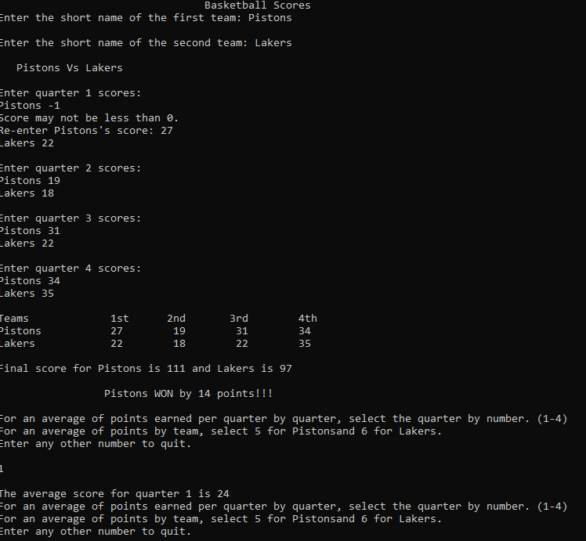

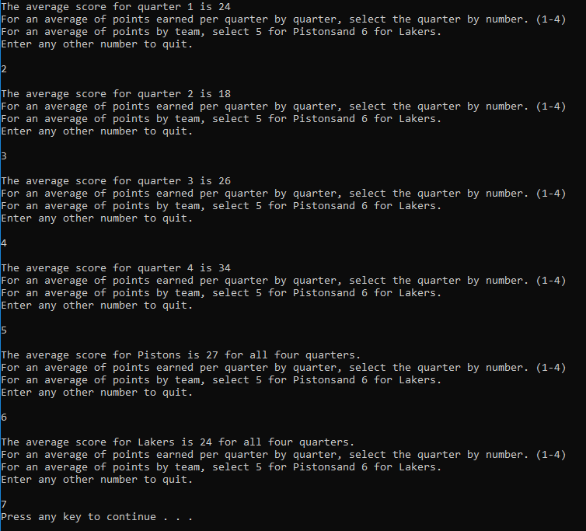

Team Q1 Q2 Q3 Q4

Bulls 34 29 21 37

Clippers 29 28 45 26

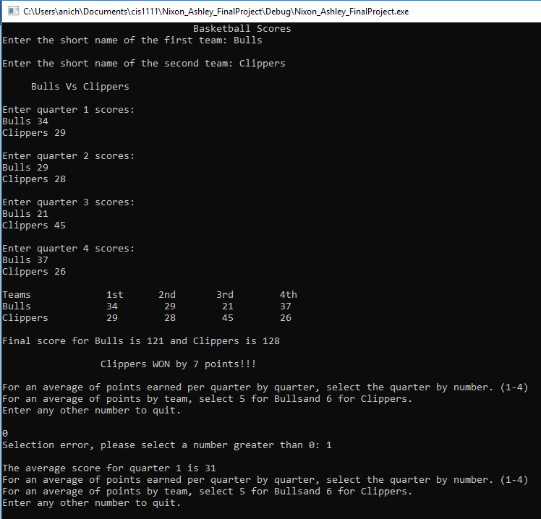

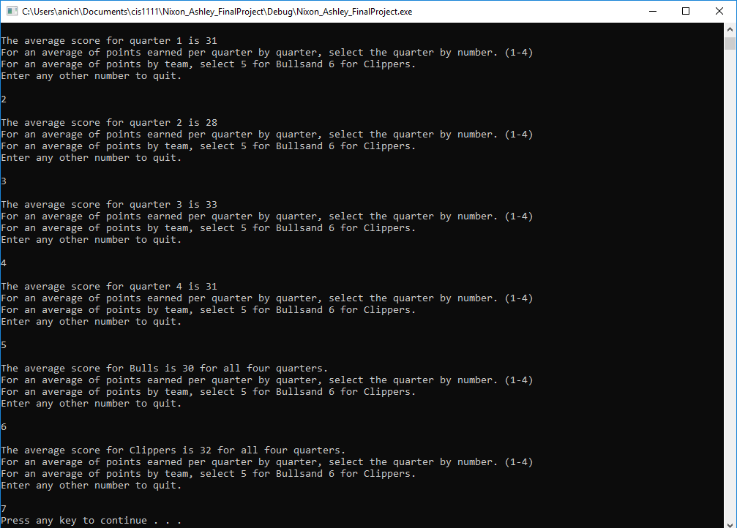

Team Q1 Q2 Q3 Q4 OT

Suns 31 26 28 17 0

Rockets 26 29 28 19 2

