

.main_nav

{

position: absolute;

left: 0px;

top: 0px;

width: 1000px;

height: 1500px;

z-index: 42;

}

.PROTFOLIO {

font-size: 18px;

font-family: "Microsoft YaHei UI";

color: rgb(183, 104, 224);

font-weight: bold;

line-height: 1.667;

position: absolute;

left: 541px;

top: 80.514px;

width: 105px;

height: 15px;

z-index: 40;

}

.ABOUT {

font-size: 18px;

font-family: "Microsoft YaHei UI";

color: rgb(183, 104, 224);

font-weight: bold;

line-height: 1.667;

position: absolute;

left: 720px;

top: 80.514px;

width: 66px;

height: 15px;

z-index: 39;

}

.CONTACT {

font-size: 18px;

font-family: "Microsoft YaHei UI";

color: rgb(183, 104, 224);

font-weight: bold;

line-height: 1.667;

position: absolute;

left: 842px;

top: 80.514px;

width: 90px;

height: 15px;

z-index: 38;

}

.nav_background {

background-color: rgb(154, 242, 220);

position: absolute;

left: -1px;

top: -2px;

width: 1001px;

height: 111px;

z-index: 37;

}

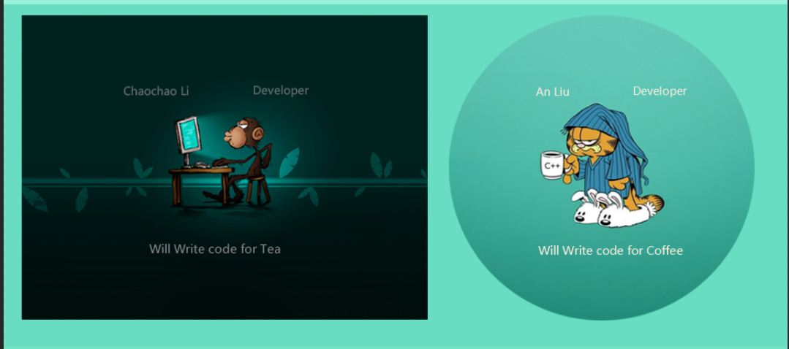

.content {

position: absolute;

left: 0px;

top: 0px;

width: 1000px;

height: 1500px;

z-index: 35;

}

.content_image_1 {

background-image: url("content_image_1.png");

position: absolute;

left: 23px;

top: 123px;

width: 518px;

height: 389px;

z-index: 24;

}

.content_image_2 {

background-image: url("content_image_2.png");

position: absolute;

left: 568px;

top: 123px;

width: 390px;

height: 390px;

z-index: 30;

}

.content_2 {

position: absolute;

left: 0px;

top: 0px;

width: 1000px;

height: 1500px;

z-index: 34;

}

.Will_Write_code_for_Coffee {

font-size: 24px;

font-family: "Microsoft YaHei UI";

color: rgb(242, 235, 218);

line-height: 1.25;

-moz-transform: matrix( 0.62691131498471,0,0,0.62691131498471,0,0);

-webkit-transform: matrix( 0.62691131498471,0,0,0.62691131498471,0,0);

-ms-transform: matrix( 0.62691131498471,0,0,0.62691131498471,0,0);

position: absolute;

left: 627.498px;

top: 441.922px;

width: 294.004px;

height: 19px;

z-index: 33;

}

._Developer {

font-size: 36px;

font-family: "Microsoft YaHei UI";

color: rgb(242, 235, 218);

line-height: 0.833;

-moz-transform: matrix( 0.39503610371542,0,0,0.39503610371542,0,0);

-webkit-transform: matrix( 0.39503610371542,0,0,0.39503610371542,0,0);

-ms-transform: matrix( 0.39503610371542,0,0,0.39503610371542,0,0);

position: absolute;

left: 736.996px;

top: 230.133px;

width: 172px;

height: 38px;

z-index: 32;

}

.An_Liu {

font-size: 36px;

font-family: "Microsoft YaHei UI";

color: rgb(242, 235, 218);

line-height: 0.833;

-moz-transform: matrix( 0.39503610371542,0,0,0.39503610371542,0,0);

-webkit-transform: matrix( 0.39503610371542,0,0,0.39503610371542,0,0);

-ms-transform: matrix( 0.39503610371542,0,0,0.39503610371542,0,0);

position: absolute;

left: 646.994px;

top: 233.633px;

width: 106.012px;

height: 28px;

z-index: 31;

}

.content_image_2 {

background-image: url("content_image_2.png");

position: absolute;

left: 568px;

top: 123px;

width: 390px;

height: 390px;

z-index: 30;

}

.content_1 {

position: absolute;

left: 0px;

top: 0px;

width: 1000px;

height: 1500px;

z-index: 28;

}

.Will_Write_code_for_Tea {

font-size: 14.702px;

font-family: "Microsoft YaHei UI";

color: rgb(133, 132, 137);

line-height: 2.041;

-moz-transform: matrix( 1.02371541501976,0,0,1.02368421052632,0,0);

-webkit-transform: matrix( 1.02371541501976,0,0,1.02368421052632,0,0);

-ms-transform: matrix( 1.02371541501976,0,0,1.02368421052632,0,0);

position: absolute;

left: 188.087px;

top: 444.395px;

width: 162.826px;

height: 12px;

z-index: 27;

}

.Chaochao_Li {

font-size: 22px;

font-family: "Microsoft YaHei UI";

color: rgb(106, 109, 113);

line-height: 1.361;

-moz-transform: matrix( 0.64507457306412,0,0,0.64505491015293,0,0);

-webkit-transform: matrix( 0.64507457306412,0,0,0.64505491015293,0,0);

-ms-transform: matrix( 0.64507457306412,0,0,0.64505491015293,0,0);

position: absolute;

left: 129.381px;

top: 239.599px;

width: 128.238px;

height: 18px;

z-index: 26;

}

._Developer {

font-size: 22px;

font-family: "Microsoft YaHei UI";

color: rgb(106, 109, 113);

line-height: 1.361;

-moz-transform: matrix( 0.64507457306412,0,0,0.64505491015293,0,0);

-webkit-transform: matrix( 0.64507457306412,0,0,0.64505491015293,0,0);

-ms-transform: matrix( 0.64507457306412,0,0,0.64505491015293,0,0);

position: absolute;

left: 291.38px;

top: 237.599px;

width: 108.204px;

height: 23px;

z-index: 25;

}

.content_image_1 {

background-image: url("content_image_1.png");

position: absolute;

left: 23px;

top: 123px;

width: 518px;

height: 389px;

z-index: 24;

}

.content_background_ {

background-color: rgb(105, 222, 193);

position: absolute;

left: -28px;

top: 108px;

width: 1073px;

height: 438px;

z-index: 22;

}

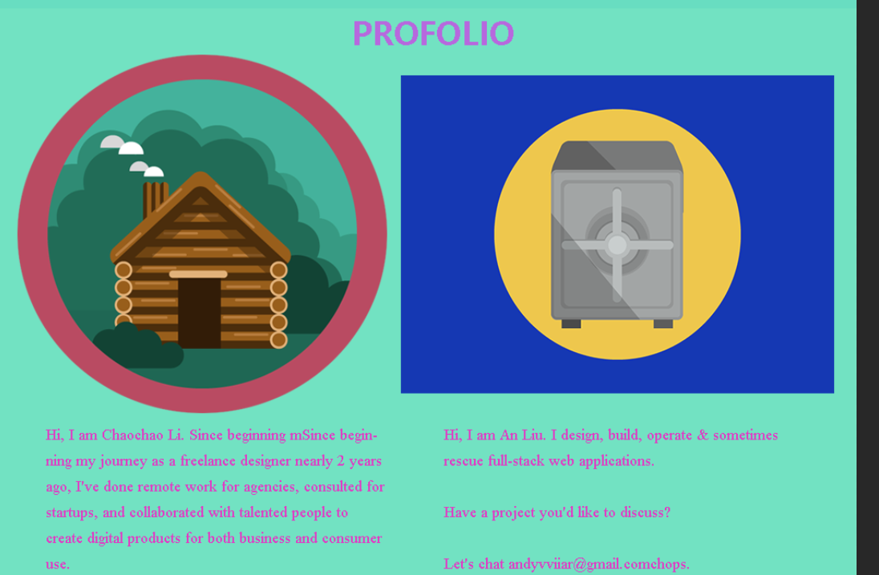

.profolio_ {

position: absolute;

left: 0px;

top: 0px;

width: 1000px;

height: 1500px;

z-index: 20;

}

.PROFOLIO {

font-size: 57px;

font-family: "Microsoft YaHei UI";

color: rgb(183, 104, 224);

font-weight: bold;

line-height: 0.525;

-moz-transform: matrix( 0.6301307605607,0,0,0.6301307605607,0,0);

-webkit-transform: matrix( 0.6301307605607,0,0,0.6301307605607,0,0);

-ms-transform: matrix( 0.6301307605607,0,0,0.6301307605607,0,0);

position: absolute;

left: 356.88px;

top: 577.347px;

width: 293.24px;

height: 45px;

z-index: 19;

}

.content_image_3 {

background-image: url("content_image_3.png");

position: absolute;

left: 24px;

top: 600px;

width: 430px;

height: 417px;

z-index: 17;

}

.Hi__I_am_An_Liu__I_design__build__operate___som {

font-size: 18px;

font-family: "Times New Roman";

color: rgb(223, 60, 198);

line-height: 1.667;

position: absolute;

left: 520px;

top: 1063.041px;

width: 388px;

height: 167px;

z-index: 16;

}

.Hi__I_am_Chaochao_Li__Since_beginning_mSince_be {

font-size: 18px;

font-family: "Times New Roman";

color: rgb(223, 60, 198);

line-height: 1.667;

position: absolute;

left: 57px;

top: 1063.041px;

width: 394px;

height: 197px;

z-index: 15;

}

.profilio_background {

background-color: rgb(115, 227, 194);

position: absolute;

left: -41px;

top: 546px;

width: 1053px;

height: 699px;

z-index: 14;

}



.Footer {

position: absolute;

left: 0px;

top: 0px;

width: 1000px;

height: 1500px;

z-index: 12;

}

.PROTFOLIO {

font-size: 18px;

font-family: "Microsoft YaHei UI";

color: rgb(183, 104, 224);

font-weight: bold;

line-height: 1.667;

position: absolute;

left: 184px;

top: 1297.514px;

width: 105px;

height: 15px;

z-index: 10;

}

.LOCATION {

font-size: 18px;

font-family: "Microsoft YaHei UI";

color: rgb(183, 104, 224);

font-weight: bold;

line-height: 1.667;

position: absolute;

left: 670px;

top: 1317.514px;

width: 96px;

height: 15px;

z-index: 9;

}

.London__ON {

font-size: 18px;

font-family: "Microsoft YaHei UI";

color: rgb(107, 19, 152);

line-height: 1.667;

position: absolute;

left: 670px;

top: 1350.567px;

width: 101px;

height: 17px;

z-index: 8;

}

.ABOUT {

font-size: 18px;

font-family: "Microsoft YaHei UI";

color: rgb(183, 104, 224);

font-weight: bold;

line-height: 1.667;

position: absolute;

left: 206px;

top: 1331.514px;

width: 66px;

height: 15px;

z-index: 7;

}

.Copyright_©_Chaochao_LI___An_Liu_All_rights_res {

font-size: 18px;

font-family: "Microsoft YaHei UI";

color: rgb(183, 104, 224);

line-height: 1.667;

position: absolute;

left: 304px;

top: 1421.567px;

width: 457px;

height: 18px;

z-index: 6;

}

.CONTACT {

font-size: 18px;

font-family: "Microsoft YaHei UI";

color: rgb(183, 104, 224);

font-weight: bold;

line-height: 1.667;

position: absolute;

left: 191px;

top: 1365.514px;

width: 90px;

height: 15px;

z-index: 5;

}

.nav_background {

background-color: rgb(154, 242, 220);

position: absolute;

left: 0px;

top: 1245px;

width: 1001px;

height: 133px;

z-index: 4;

}

.copyright {

background-color: rgb(27, 204, 160);

position: absolute;

left: 0px;

top: 1373px;

width: 1004px;

height: 49px;

z-index: 3;

}

div, p, body, header, footer, section, article, nav, h1, h2, h3, h4

{

    margin: 0;

    padding: 0;

}

img

{

    border: none;

    margin: 0;

    padding: 0;

}

body

{

    margin: 0 auto;

max-width: 75em;

height: 90em;

}

#mainHeader

{

background-color: #6bd6bc;

// height: 7em;

width: 75em;

}

#title_logo

{

height: 80px;

width: 350px;

margin-top: 20px;

margin-left: 30px;

}

#main-nav

{

margin-top: 40px;

}

#main-nav a{

font-size: 24px;

font-family: "Microsoft YaHei UI";

color: rgb(183, 104, 224);

font-weight: bold;

line-height: 1.667;

display: inline;

opacity:1;

}

#main-nav a:hover

{

-moz-box-shadow: -1px 6px 4px #000000;

-webkit-box-shadow: -1px 6px 4px #000000;

box-shadow: -1px 6px 4px #000000;

opacity:0.7;

background:rgb(124, 173, 206);

}

#content_1-2

{

background-color: rgb(105, 222, 193);

width: 1200em;

height: 430px;

}

#content-1

{

text-align: center;

width: 560px;

height: 420px;

}

#content-image-1

{

margin-top: 20px;

margin-left: 25px;

width: 560px;

height: 420px;

}

#content-1-text

{

position: absolute;

font-family: "Microsoft YaHei UI";

color: #6a6d71;

line-height: 1.25;

}

#name_1

{

position: relative;

margin-top: -360px;

margin-left: -50px;

}

#position_1

{

position: absolute;

margin-top: -43px;

margin-left: 300px;

}

#text_1

{

// position: absolute;

margin-top: 180px;

margin-left: 100px;

}

#content-2

{

margin-top: 21px;

margin-right: -20px;

}

#content-2-text

{

position: absolute;

font-size: 24px;

font-family: "Microsoft YaHei UI";

color: rgb(242, 235, 218);

line-height: 1.25;

}

#name_2

{

position: relative;

margin-top: -329px;

margin-left: 90px;

}

#position_2

{

position: absolute;

margin-top: -43px;

margin-left: 300px;

}

#text_2

{

// position: absolute;

margin-top: 180px;

margin-left:90px;

}

#content-3-4

{

height: 680px;

background-color: #73e3c2;

}

#content-title h3

{

font-size: 40px;

font-family: "Microsoft YaHei UI";

color: rgb(183, 104, 224);

font-weight: bold;

line-height: 0.525;

text-align: center;

margin-top: 30px;

}

#content-3-image

{

margin-top: 30px;;

}

#content-4-image

{

margin-top: 20px;

opacity: 0.8;

}

#content-3-text h3{

font-size: 18px;

font-family: "Times New Roman";

color: rgb(223, 60, 198);

line-height: 2;

margin-left: 30px;

}

#content-4-text h3{

font-size: 18px;

margin-top: 7px;

font-family: "Times New Roman";

color: rgb(223, 60, 198);

line-height: 2.667;

}

footer

{

background: #68dec1;

height: 160px;

}

#footer-1 ul

{

margin-top: 10px;

margin-left: 30px;

}

#footer-1 ul li

{

display: inline;

margin-left: 180px;

}

#footer-ul a

{ font-size: 24px;

font-family: "Microsoft YaHei UI";

color: rgb(183, 104, 224);

font-weight: bold;

line-height: .967;

}

#footer-logo

{

margin-left: 90px;

margin-top: 30px;

width: 400px;

}

#footer-location

{

width: 490px;

}

#footer-location h3

{

font-size: 24px;

font-family: "Microsoft YaHei UI";

color: rgb(183, 104, 224);

font-weight: bold;

margin-top: -150px;

margin-left: 800px;

}

#footer-location h4

{

font-size: 24px;

font-family: "Microsoft YaHei UI";

color: #6b1398;

font-weight: bold;

margin-top: 14px;

margin-left: 800px;

}

#copyright

{

height: 25px;

background-color: #38e2b8;

margin-top: -20px;

}

#copyright h3

{

text-align: center;

font-size: 15px;

font-family: "Microsoft YaHei UI";

color: rgb(183, 104, 224);

line-height: 1.667;

}