For this project, there are three main part designs: parent, home, kids. And also some simplified layout change for login, detail, user select page.

The home page is putting everything inside, which include Roku ads and Roku TV ads form Roku official site, and Movies, TV, Music part, and News part. The original home page, which is in the userhomeComponent.js, performs as the detail page, because there are a lot details about movies and music. Therefore, once custom click the exact movie, it will jump into this page and show the information and the custom also can look through other movies’ details in this page by click the thumbnail.

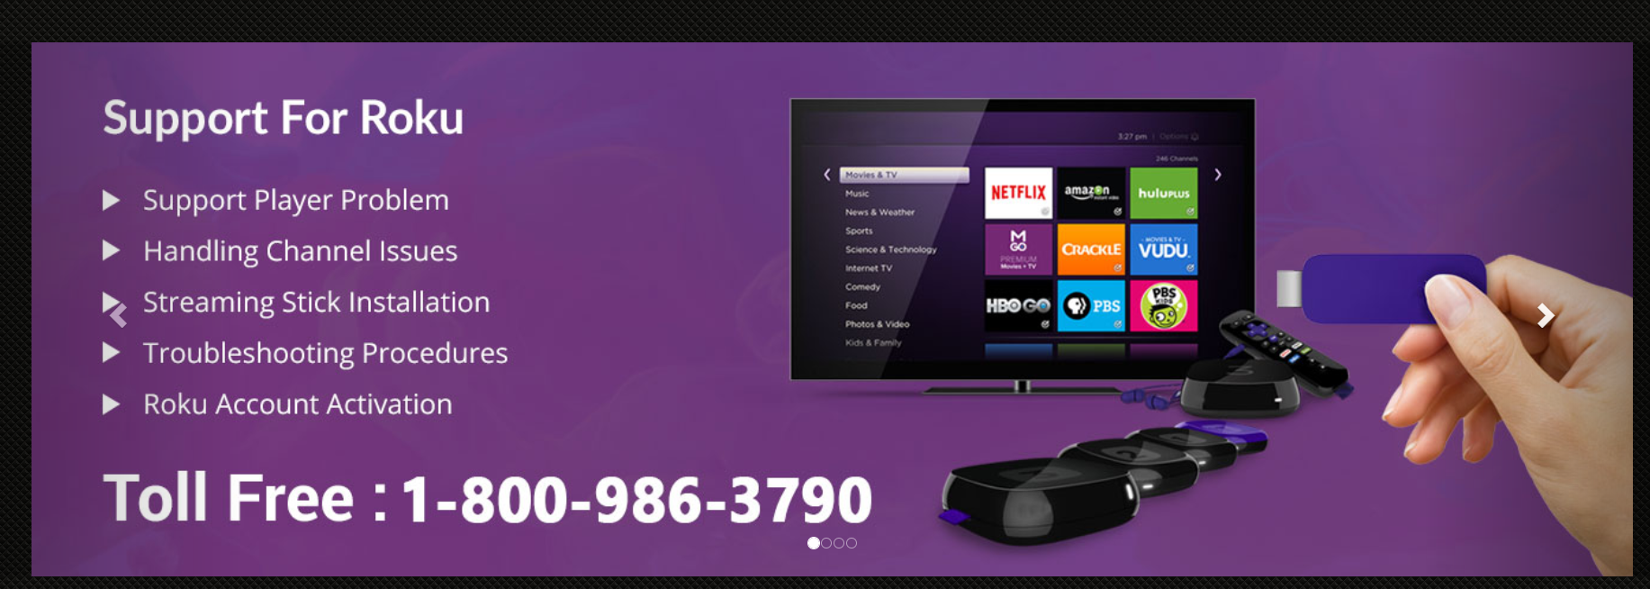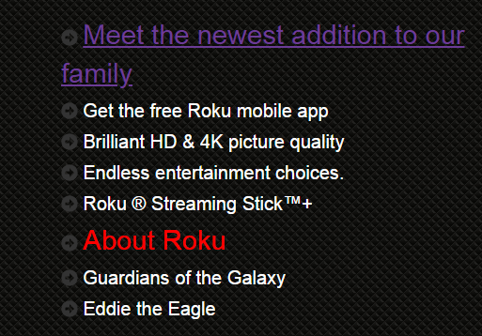

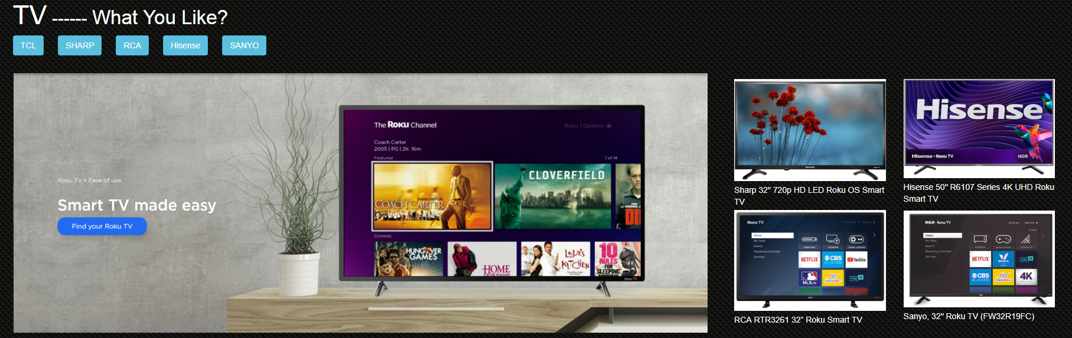

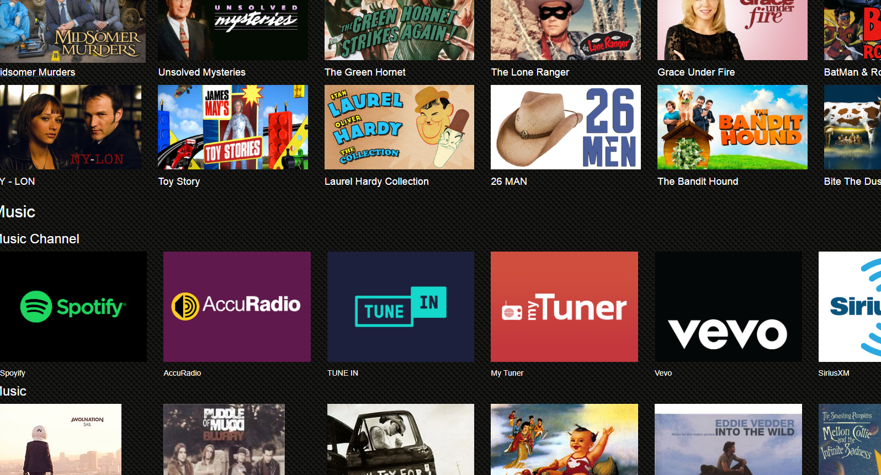
For the original home page, which is in the userhomeComponent.js, I just did simply layout change to make it be responsive.

The parent page is similar as home page, just adding some editing icon to add or delete media for kid or parent page.
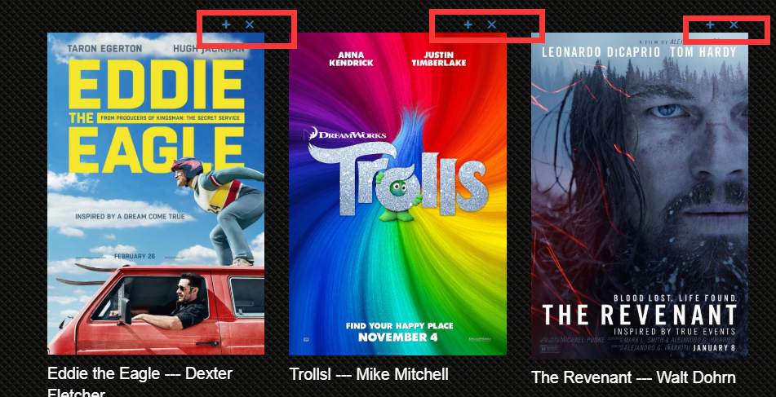

The kid page delete all ads and news part, just keeping media part. I also added some funny cartoon elements in this page.
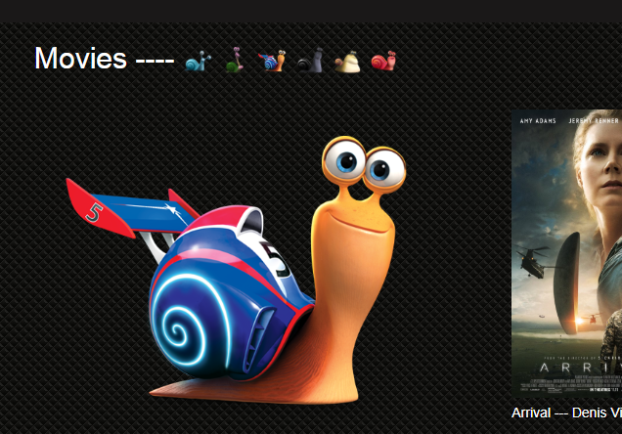

Simple CSS layout change to login page and user select page. Custom can click the Parent or children button in the Navbar ro jump into these page, but custom need to input the password first.
