Banner：

Organ and Tissue Donation

One donor can save up to 8 lives.

Age alone does not disqualify someone from becoming a donor.

Your current or past medical history does not prevent you from registering to be a donor.

About:

Today, in Ontario, there are over 1,500 people

waiting for a lifesaving organ transplant. This is their

only treatment option, and every 3 days someone

will die because they did not get their transplant

in time.

But you can help. When you register your consent

for organ and tissue donation, you let those waiting

know that you would help them if you could.

Read more:

All major religions support organ and tissue

donation, or respect an individual’s choice.

One donor can save up to 8 lives through organ

donation and enhance the lives of up to 75 more

through the gift of tissue.

Organ and tissue donation does not impact funeral

plans. An open casket funeral is possible.

Age alone does not disqualify someone from

becoming a donor. The oldest organ donor

was over 90 and the oldest tissue donor

was over 100. There’s always potential to be

a donor; it shouldn’t stop you from

registering.

Your current or past medical history does not

prevent you from registering to be a donor.

Individuals with serious illnesses can, sometimes,

be organ and/or tissue donors. Each potential

donor is evaluated on a case-by-case basis.

Ontario data:

Left :

The need for organ donors in Ontario.

Currently, around 1,600 people in Ontario are waiting for a life-saving organ transplant. And though most of us believe that organ donation is a good thing, just over a quarter of us are registered as donors. Some great strides have been made in Ontario over the past year, but still more needs to be done. You can Spread the Word by encouraging your friends and family to register their consent to become organ and tissue donors.

Right :

1. Ontarians are currently waiting for an organ

transplant. As of December 31, 2018

1. Ontarians have received a lifesaving organ transplant since 2003.
2. Reached 67% of our total goal as of December 31, 2018

The goal is to achieve over 250,000 new registrations April 1, 2018 - March 31, 2019

168,650

Ontarians that have registered to become organ and tissue donors.

1. The Ontarians are registered donors. That’s 4.2 million out of an eligible 12.5 million.

Events :

National Pediatric Transplant Week

This observance is a week at the end of National Donate Life Month that offers donation and transplantation organizations the platform to talk about the powerful message of ending the pediatric waiting list, to engage clinical partners to share their innovative work and patient stories (candidates and recipients), and to honor donor families whose children have saved and healed lives through organ, eye, and tissue donation.

Transplant Games

The Transplant Games are modeled after the Olympics and feature transplant recipients of all ages competing in various athletic events, illustrating the ability of transplantation to extend and enhance life. Athletes receive medals, and living donors and families of deceased donors are honored in special ceremonies for their life-enabling gifts. The National Kidney Foundation started the Games in 1990 and sponsored them every 2 years through 2010.

Storys:

Read some amazing stories about people whose lives have been affected by organ donation and discover what a difference it can make.

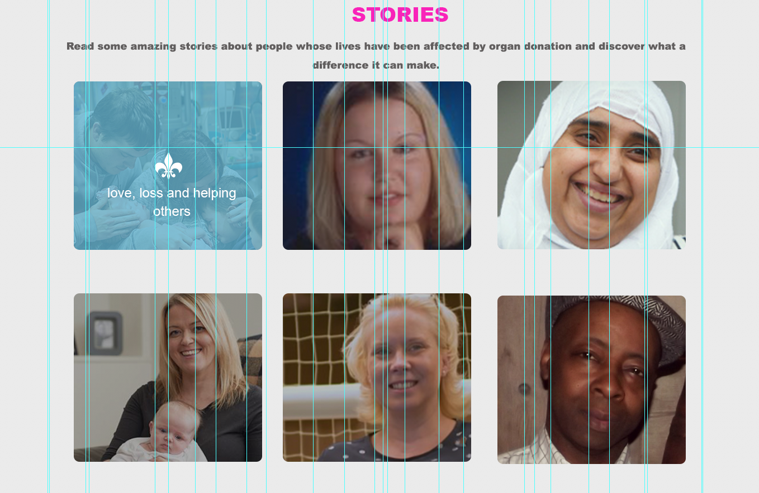

Footer:

For general inquiries, call:

You can also register:

in person at any ServiceOntario centre

by completing a Gift of Life consent form and sending it to:

ServiceOntario

Organ Donor Consent

PO Box 48

Kingston ON K7L 5J3

1-800-263-2833 (Canada).