

INTERNATIONAL PROGRAMMERS TRAINING CENTER
SOFTECH APTECH
----  ----

PROJECT: BEAUTY CARE

Lecturer: Mr Nguyen Ho Long Hai

Group Name: 1
Batch: 146
Semester: 1
Members:
- Ngo Thien An
- Nguyen Dinh Minh Duc
- Vo Van Duc
- Nguyen Thanh Kien
- Đoàn Thanh Nhân

DANANG, VIETNAM
SEP 2018

SOFTECH APTECH
EProject Document
BEAUTY CARE
Group Name: Group 1
Group members | - Ngo Thien An  - Nguyen Dinh Minh Duc  - Vo Van Duc  - Nguyen Thanh Kien  - Doan Thanh Nhan
Instructor | Mr.Nguyen Ho Long Hai
Batch | 146
Semester | 1

DaNang, Vietnam, 09/2018

Danang, Vietnam, 09/2018
TEACHER’S EVALUATION
………………………………………………………………………………………………………………………………………………………………………………………………………………………………………………………………………………………………………………………………………………………………………………………………………………………………………………………………………………………………………………………………………………………………………………………………………………………………………………………………………………………………………………………………………………………………………………………………………………………………………………………………………………………………………………………………………………………………………………………………………………………………………………………………………………………………
………………………………………………………………………………………………………………………………………………………………………………………………………………………………………………………………………………………………………………………………………………………………………………………………………………………………………………………………………………………………………………………………………………………………………………………………………………………………………………………………………………………………………………………………………………………………………………………………………………………………………………………………………………………………………………………………………………………………………………………………………………………………………………………………………………………………
………………………………………………………………………………………………………………………………………………………………………………………………………………………………………………………………………………………………………………………………………………………………………………………………………………………………………………………………………………………………………………………………………………………………………………………………………………………………………

TABLE OF CONTENTS Page
ACKNOWLEDGEMENTS 5
ABSTRACT 6
LIST OF FIGURES 7
Chapter 1. INTRODUCTION 8
1.1. HTML5 8
1.2. CCS- CSS3 9
Chapter 2. PROBLEM DEFINITION 12
Chapter 3. REQUIREMENT ATTRIBUTES 13
Chapter 4. DESIGN PROTOTYPE 18
Chapter 5. TECHNICAL 19
Chapter 6. THE PAGES BASIC OF WEBSITE 20
ACKNOWLEDGEMENTS
In the process of completing this project, we have received great deal of helps, guidance and encouragements from teachers and friends.
First of all, I would like to express my deepest thanks to my instructor, Mr.Nguyen Ho Long Hai who given me suggestions on how to shape the study and always been most willing and ready to give me valuable advice, helpful comments as well as correction my project.
Next, we would like to express my gratitude to all teachers as well as other parts of Softech Aptech centers have created the best conditions to help me complete this project.

ABSTRACT

HTML5 is currently under development as the next major revision of the HTML standard. Like its immediate predecessors, HTML 5, HTML5 is a standard for structuring and presenting content on the World Wide Web. The new standard incorporates features like video playback and drag-and-drop that have been previously dependent on third-party browser plug-ins such as Adobe Flash, Microsoft Silverlight, and Google Gears.
The HTML5 specification was adopted as the starting point of the work of the new HTML working group of the World Wide Web Consortium (W3C) in 2007. According to the W3C timetable, it is estimated that HTML5 will reach W3C Recommendation by late 2010.
The HTML5 syntax is no longer based on SGML despite the similarity of its markup. HTML5 also incorporates Web Storms 3.1, another WHATWG specification.
In addition to specifying markup, HTML5 specifies scripting application programming interfaces (APIs). Existing document object model (DOM) interfaces are extended and de facto features documented. There are also new APIs, such as canvas element for immediate mode 2D drawing, timed media playback, offline storage database, document editing, drag-and-drop, cross-document messaging, browser history management, MIME type and protocol handler registration, Microdata, Geolocation etc.
LIST OF FIGURES

Figure 1.1 HTML5 8
Figure 1.2 CSS 9
Figure 3.3.1 User Use Case Diagram 15
Figure 6.1 Home Page Interface 20-21
Figure 6.2 Contact Us Page 22

CHAPTER 1:

INTRODUCTION:
1.1 HTLM5:



Fig 1.1: HTML5
The web is constantly evolving. New and innovative websites are being created every day, pushing the boundaries of HTML in every direction. HTML 4 has been around for nearly a decade now, and publishers seeking new techniques to provide enhanced functionality are being held back by the constraints of the language and browsers. To give authors more flexibility and interoperability, and enable more interactive and exciting websites and applications, HTML 5 introduces and enhances a wide range of features including form controls, APIs, multimedia, structure, and semantics.
Work on HTML 5, which commenced in 2004, is currently being carried out in a joint effort between the W3C HTML WG and the WHATWG. Many key players are participating in the W3C effort including representatives from the four major browser vendors: Apple, Mozilla, Opera, and Microsoft; and a range of other organisations and individuals with many diverse interests and expertise.
HTML5 is a specification for how the web's core language, HTML, should be formatted and utilized to deliver text, images, multimedia, web apps, search forms, and anything else you see in your browser. In some ways, it's mostly a core set of standards that only web developers really need to know. In other ways, it's a major revision to how the web is put together. Not every web site will use it, but those that do will have better support across modern desktop and mobile browsers (that is, everything except Internet Explorer).
History of HTML till now
• HTML 3.0 was developed in 1995
• HTML 3.2 was completed by 1997
• HTML 4 was developed in the year 1998
• In this year 1998 W3C stopped working on HTML and started working on XML based HTML that is XHTML. And it is known as XHTML 1.0.It has completed in the year 2000.
• In parallel with XHTML W3C worked on different language that is not compatible to HTML and XHTML 1.0, known as XHTML2.
• Introduction of Xforms , a new technology which is meant to be the next generation of web forms renewed interest in renovating HTML, rather than developing a brand new language for web.
• HTML5 was first started by Mozilla, Apple, and Opera under a group called the WHATWG (Web Hypertext Application Technology Working Group). In 2006 W3C showed an interest in HTML5 and in 2007 they created a working group to work in HTML5 project. HTML5 is still under development.
1.2 CSS- CSS3:
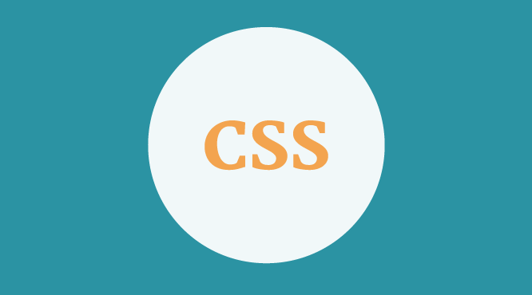

Fig 1.2: CSS

CSS stands for Cascading Style Sheets, it is merely a text file with the name extension is .css. In this style sheet contains CSS commands. Each command of CSS will format a certain section of HTML such as: font of the text, borders, background color, align images etc ..

Previously when no CSS, web designers have to mix the ingredients and contents shown together. But with the advent of CSS, it is possible to completely separate the presentation and content. Help for the code of the website also more compact and more importantly is easy to edit more.

Before you begin to learn more about CSS I want you to know a little about its strength in web design. For example, if you work with HTML and you want the font of the entire site is Arial. You'll have to go to work like this for all the .html file that you have. But if you use CSS, you only need to do once, and all other pages will automatically be changed.

Three ways to format web pages:

There are three ways you can use to format the site are: local, embedded on the page and a link to a separate CSS file. In fact, the last way is to link to a separate file is used most commonly. But you should also know about the remaining two ways because sometimes you have to use it but not much.

1. Local - CSS code is inserted directly into the HTML tag:

Local formatting that you use CSS code directly into HTML tags and only have an impact on that card.

Example:
1 <p style=”font-size:16pt; font-weight:bold; color:blue;”>
2 If you add CSS code on the card it will change the way the browser displays
3 </p>

2. Dip the website:

The second way is that you declare CSS code within the tags <style> </ style> is placed in the <head> </ head> of the document. Basically it is only a local impact on the file you insert this CSS code. It has a larger sphere of influence is the local inserting been said above, but it does not affect other files in the same site.

Example:

1 <head>

2 <title> Embed in website</title>
3 <meta http-equiv=”Content-type” content=”text/html;charset=utf-8″ />
4 <style type=”text/css”>
5 h1 {font-size: 16px;}
6 p {color:blue;}
7 </style>
8 </head>
3. Link to a separate file:
This last fact a new way is the true power of CSS because you only need to create a CSS file and write the code only once. It will affect the entire site, not just affect a single .html file or just a card in the thousands of cards that you have. This way we can be completely separated from the composition and content presentation from each other. If you write the whole CSS code in a file and link it to the rest of the pages, then changing the repair site becomes extremely simple.
To link the CSS file to all your .html file, you just insert the following code between the <head> </ head> of the document:
Example:
- <link href=”style_sheet.css” rel =”stylesheet” type=”text/css” />

And the browser will automatically use style_sheet.css files to the format for your website. Of course you wrote style_sheet.css file and CSS code.

The last thing you need to know about using CSS 3 is kind:
Local> Embedded Page> Link to a separate file

This formula means a Local "beat" from Embedded page and Link to a separate file. Or in other words, the local embedding is the most powerful, then to Embedded pages and eventually link to a separate file.

CHAPTER 2:

PROBLEM DEFINITION:

This project has the following functionalities:

1. The Home Page should be created making use of Frames with a suitable logo.

2. The look and feel of the project must be made user friendly and uniformity in the color combination must be maintained:

3. About us, Contact Us (address and map) must be added. In the Contact Us page the website of all the shops location must be given:

4. All the categories of the products like HAIR, SKIN, MAKE-UP KITS, NAIL PAINTS, NAIL ARTS, JEWELLRY, WEDDING KITS, UPCOMING PRODUCTS & so on. For each product the cost must be mentioned in the list:

5. Feedback page must be added to take the valuable feedback from the users:

6. Contact Us, About Us:

7. Use GeoLocation API to show the address or location of SIMPLON’s Beauty care centre on the maps.

8. Gallery section can be included.

9. Navigation of the project must be made user friendly.

10. Customer must be allowed to place the order by selecting the product.

11. While placing the dummy order, the total cost of the order must be calculated.

CHAPTER 3:

REQUIREMENT ATTRIBUTES:
1. Main Requirements:
The Main Requirements include HTML5, CSS3, Bootstrap, Jquery,AngularJS.

2. Critical Use Case Specification:
USE CASE SPECIFICATION
Use-case No. | UC01 | Use-case Version | 1.0
Use-case Name | Search for a product
Purpose:
A user can search for a product of his choice by entering name of product. Then a select query is used to retrieve data from the database and display the selected information.
Input:
The user will enter name of product in the search box.
Output:
The system will display the movie which matches the search criteria and the user can click to link to its detail page.

2. Use case Diagram:

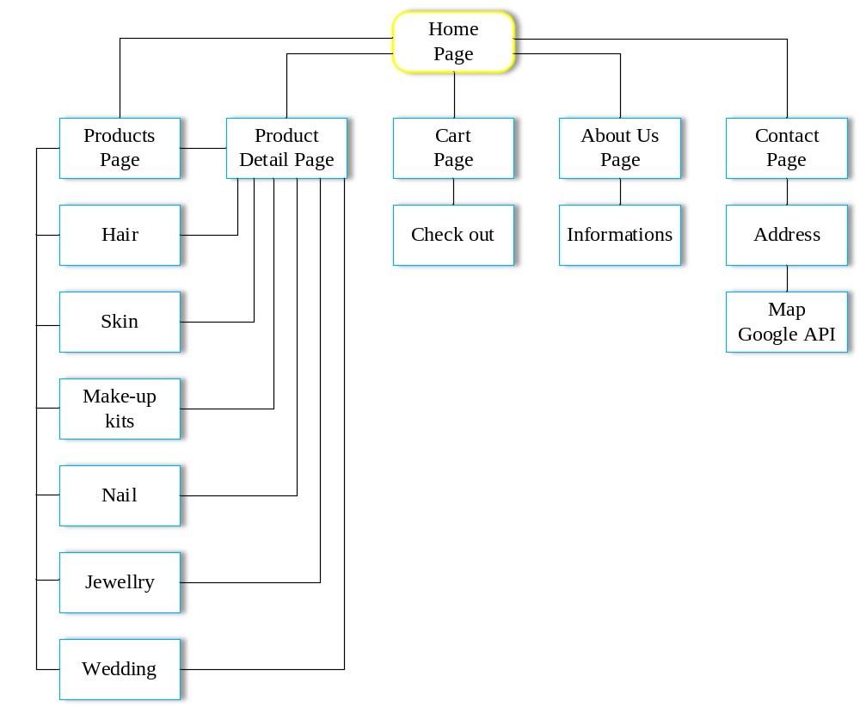

Fig 3.3.1: User use case diagram

CHAPTER 4:

DESIGN PROTOTYPE:

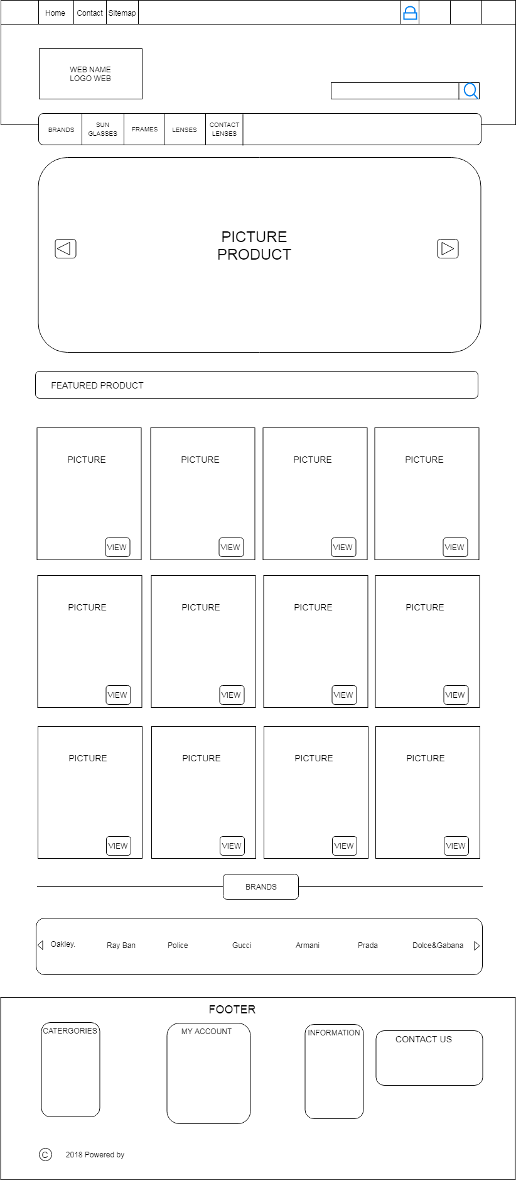

CHAPTER 5:

TECHNICAL:

The technique used to build the Website:
- HTML5 & CSS3.
- Jquery.
- Javascript.
- Bootraps.

CHAPTER 6:

THE PAGES BASIC OF WEBSITE:

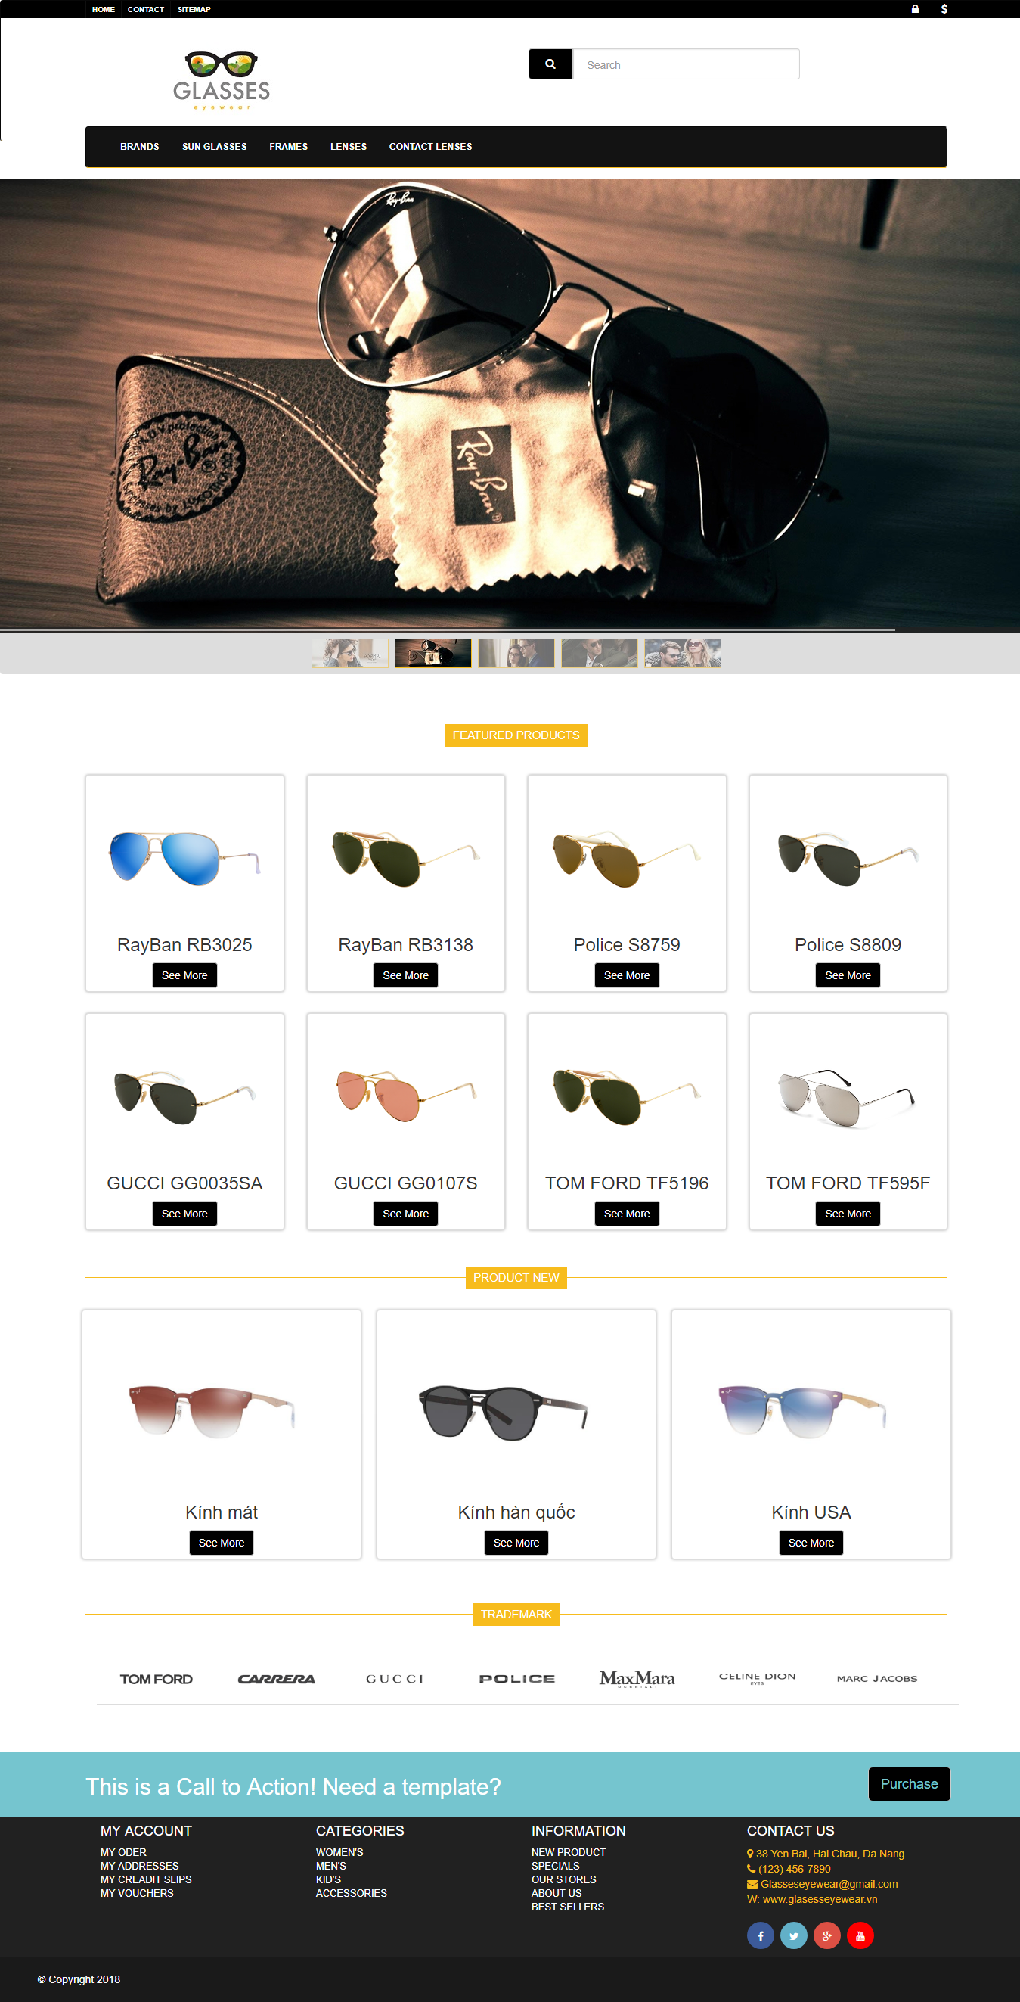

Fig 7.1. Home Page Interface.
Fig 6.2. Contact Us Page.
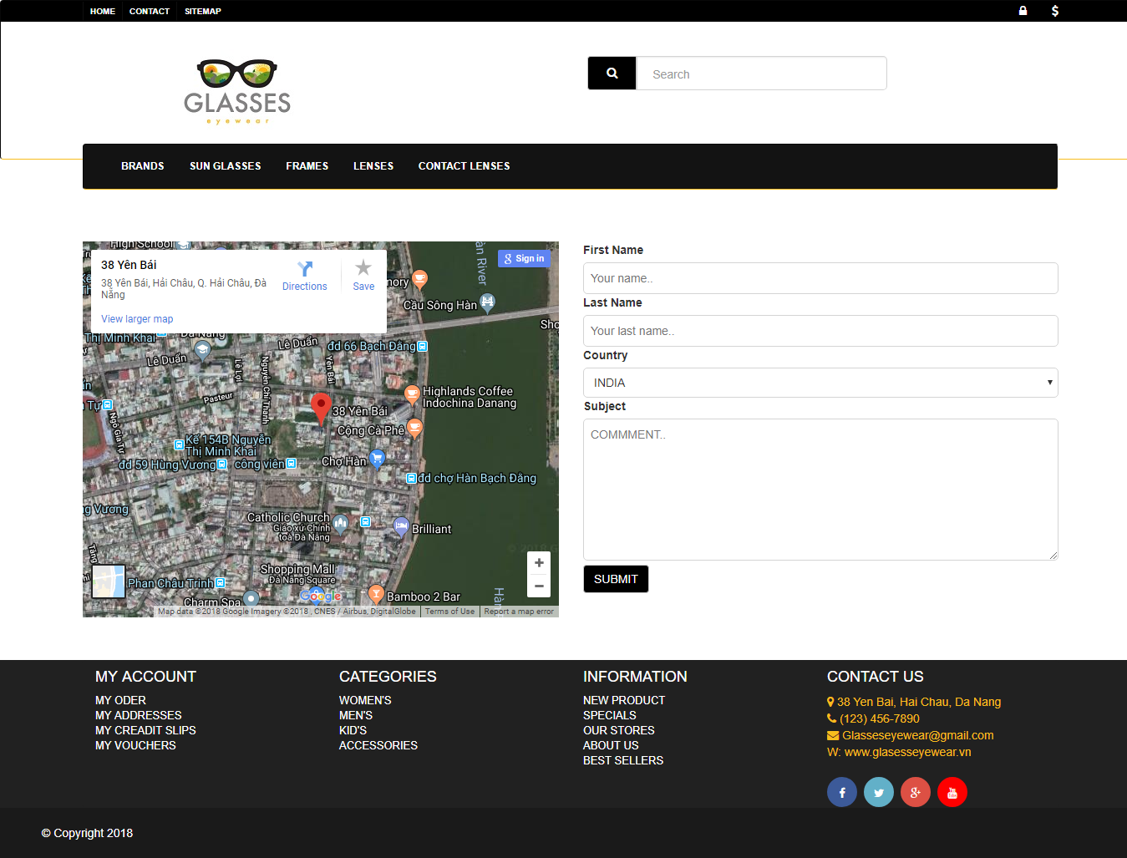

Fig 6.2. Contact Us Page.

