Project Synopsis — Submission Template
HCLTech Career Shaper Programme | III Year Industry Project | 2025-26

Field | Details (Learner to complete)
Project Title | Student Performance Analyzer — Data Science Project Analyzing Education Data
Project No. | [FILL IN]
Domain | Data Science / Python
Difficulty | Advanced
Duration | 4 Weeks
Format | Individual Project
Learner Name | Aniket Sharma
Roll Number | 2300320150013
College / Campus | ABES Engineering College, Ghaziabad (Department of CE/IT)
Mentor Name | [FILL IN]
Submission Date | [FILL IN]

1. Problem Statement
Secondary-school teachers and academic coordinators usually find out that a student is failing mathematics only after mid-term results or report cards are published, when learning gaps have already compounded and tutoring or counselling is far less effective. This project builds an early-warning system that flags students likely to fail (final grade below 10 on the 0–20 scale) at the start of the term, using only pre-outcome information such as past failures, study time, absences, parental education and home context, so that support can reach them in time.

2. Proposed Solution & Approach
I built an end-to-end data-science pipeline in Python: reusable modules clean the UCI Student Performance (Mathematics) data, engineer five pre-outcome features, and scale and encode 35 input features (18 numeric, 17 categorical) with a scikit-learn ColumnTransformer. Six candidate classifiers were compared using 5-fold stratified cross-validation and ranked by recall on the at-risk class; a class-balanced Logistic Regression was selected for its recall and interpretability. Prior-term grades G1 and G2 are deliberately excluded, with an assertion in code guarding against target leakage, so predictions are genuinely available at the start of term. To compensate for the small sample, a Gaussian-copula generator (src/synthetic.py) creates synthetic students from the training rows only, and every model is evaluated on real held-out students only. The trained pipeline is saved with joblib and served through a Streamlit dashboard that offers cohort analytics with filters and an individual risk form returning the predicted class, risk probability and a Low / Moderate / High risk tier.

3. System Architecture
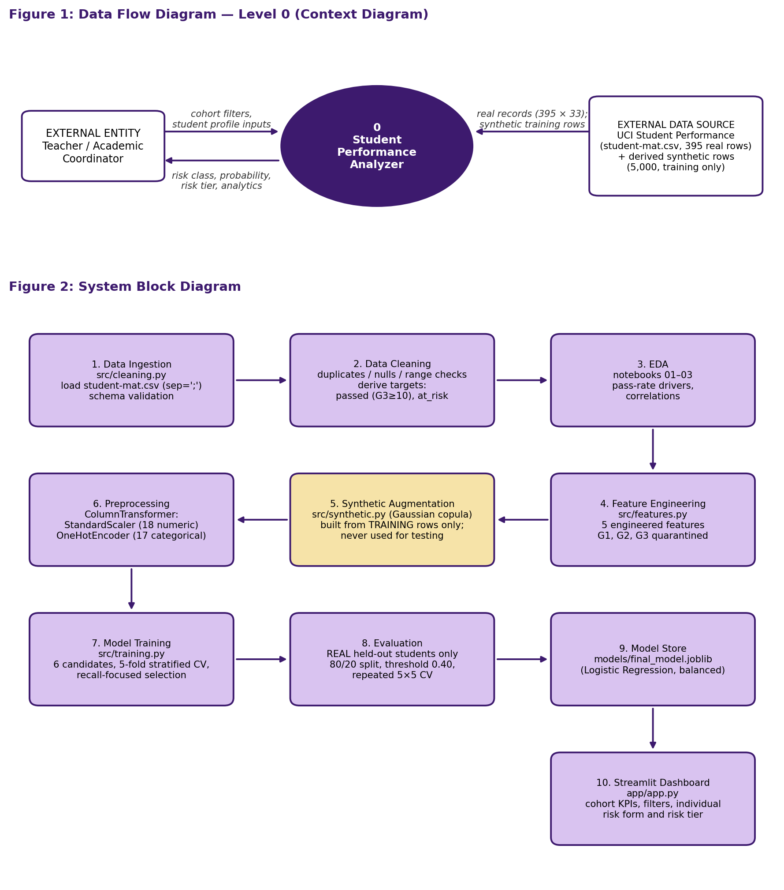

4. Technology Stack
Frontend / UI: Streamlit dashboard (app/app.py)
Backend / Logic: Python 3 — modular scripts src/cleaning.py, src/features.py, src/training.py (pandas, NumPy)
Database: None — flat CSV files (data/raw, data/processed); trained model stored as a joblib file
AI/ML Framework: scikit-learn (Pipeline, ColumnTransformer, Logistic Regression, Random Forest, Decision Tree, Gradient Boosting)
Visualisation: Matplotlib and Seaborn (rendered in Streamlit); Jupyter notebooks for EDA
Hardware: Not applicable — runs on a standard laptop CPU

5. Dataset Used
Dataset file name: student-mat.csv (UCI Student Performance dataset, Mathematics; semicolon-separated); cleaned copy saved as student_clean.csv; synthetic extension student-mat-synthetic-5000.csv
Number of rows: 395 real; 5,000 synthetic (generated from the real rows; used for training augmentation and app demos only, never for evaluation)
Number of columns: 33 (35 after adding the derived targets passed and at_risk); the synthetic file has the same 33 columns
Key columns (list 5): failures, studytime, absences, Medu / Fedu (parental education), internet — the target is derived from G3 (final grade); G1 and G2 are excluded
Any additional data collected: Synthetic data only — 5,000 rows from a Gaussian copula (mean column-distribution difference 1%, mean correlation difference 0.03, no exact copies of real rows); no new real data

6. Key Results & Metrics
Metric 1: Test Accuracy (79-student real holdout set) — 58.2% trained on real data only; 73.4% with 5,000 synthetic training rows added (single split, indicative only)
Metric 2: At-Risk Recall — 42.3% at the default 0.50 cut-off and 61.5% at a 0.40 risk threshold (precision 40.0%, F1 48.5%), real data only. In 5×5 repeated cross-validation on real students, adding synthetic training rows raised recall at the 0.40 threshold from 70.2% to 79.7% (precision 43.3% to 42.2%)
Metric 3: ROC-AUC — 0.602 on the holdout, real data only (0.734 with synthetic rows on the same split). In 5×5 cross-validation, AUC moved from 0.679 to 0.693, a difference that is not statistically significant (Wilcoxon p = 0.22)
Business value achieved: A working pre-outcome early-warning tool that, at the lower threshold, identifies about 3 in 5 students who go on to fail (16 of 26 at-risk students in the holdout set) at the cost of more false alarms, so teachers can prioritise tutoring early. Synthetic augmentation mainly shifts the operating point toward flagging more at-risk students; it adds no new real information, and the single-split gain is far larger than the repeated cross-validation supports. Past failures proved the strongest predictor (r = −0.36; 75.0% pass rate with no past failures versus 37.3% with one or more). The tool supports, and does not replace, teacher judgement.

7. Challenges Faced & How Resolved
Challenge 1: Prior-term grades G1 and G2 correlate strongly with the final grade G3 (r = 0.80 and 0.91), which would inflate accuracy but make the model useless as an early warning → Resolution: G1, G2 and any grade-trend features were excluded from the feature set, and get_feature_target_split() asserts that no leakage column enters the feature matrix.
Challenge 2: Only 395 real students, of whom 32.9% are at-risk, and a standard Logistic Regression missed most at-risk students (cross-validated at-risk recall 35.6%) → Resolution: used class_weight='balanced', selected the model on at-risk recall with stratified 5-fold cross-validation (raising it to 56.8%), lowered the decision threshold to 0.40 on risk probability, and generated 5,000 synthetic students from the training rows only, never from or for the test data. Repeated cross-validation showed the synthetic rows add no reliable ranking gain, so results are reported on real students only.

8. References
1. P. Cortez and A. Silva, “Using Data Mining to Predict Secondary School Student Performance,” in Proc. 5th Future Business Technology Conference (FUBUTEC 2008), Porto, Portugal, 2008, pp. 5–12.
2. UCI Machine Learning Repository, “Student Performance” dataset (ID 320). https://archive.ics.uci.edu/dataset/320/student+performance
3. F. Pedregosa et al., “Scikit-learn: Machine Learning in Python,” Journal of Machine Learning Research, vol. 12, pp. 2825–2830, 2011.
4. Streamlit Documentation. https://docs.streamlit.io
5. N. Patki, R. Wedge and K. Veeramachaneni, “The Synthetic Data Vault,” in Proc. IEEE Int. Conf. on Data Science and Advanced Analytics (DSAA), 2016, pp. 399–410.
6. A. Sklar, “Fonctions de répartition à n dimensions et leurs marges,” Publications de l’Institut de Statistique de l’Université de Paris, vol. 8, pp. 229–231, 1959.

9. Ethical Compliance Declaration
I confirm that:
☐ All dataset usage complies with the source licence.
☐ No personally identifiable information (PII) is stored without consent.
☐ AI tools used for code/writing are disclosed in the Appendix.
☐ This project complies with the DPDP Act 2023 where applicable.
Learner Signature: _________________________ Date: ________________

Submit this file as 'Project_Synopsis_[YourName]_[RollNo].docx' | HCLTech Career Shaper Programme 2025-26

