Quiz 3

Task 8:
Suppose there is a worldpopEqual.txt (attached in folder)file,

China = 1330044605
India = 1147995898
United Kingdom = 60943912
United States = 303824646

Write a JAVA program popMAX.java to
1). handle the equal sign (=) separator
2). generate an output file: worldpopMAX.txt, which has the following content (you need to read in countries and compare their population numbers to get the results):
The country with maximum population is ***, and the number is ***

Please note: In your output file, *** should be replaced with actual content.

Your submission list: 1). popMAX.java and 2). worldpopMAX.txt

Task 9:
Assume we have a file worldpopByLine.txt, (attached in folder) write a JAVA program (ReadingMixOfStringsAndNumbersScannerByLineSum.java) to parse country names as String, and population as Int types. Then you need to count number of countries in the file and calculate the sum of population numbers.

Output the results (right figure below) to a file worldpopByLineOutput.txt.
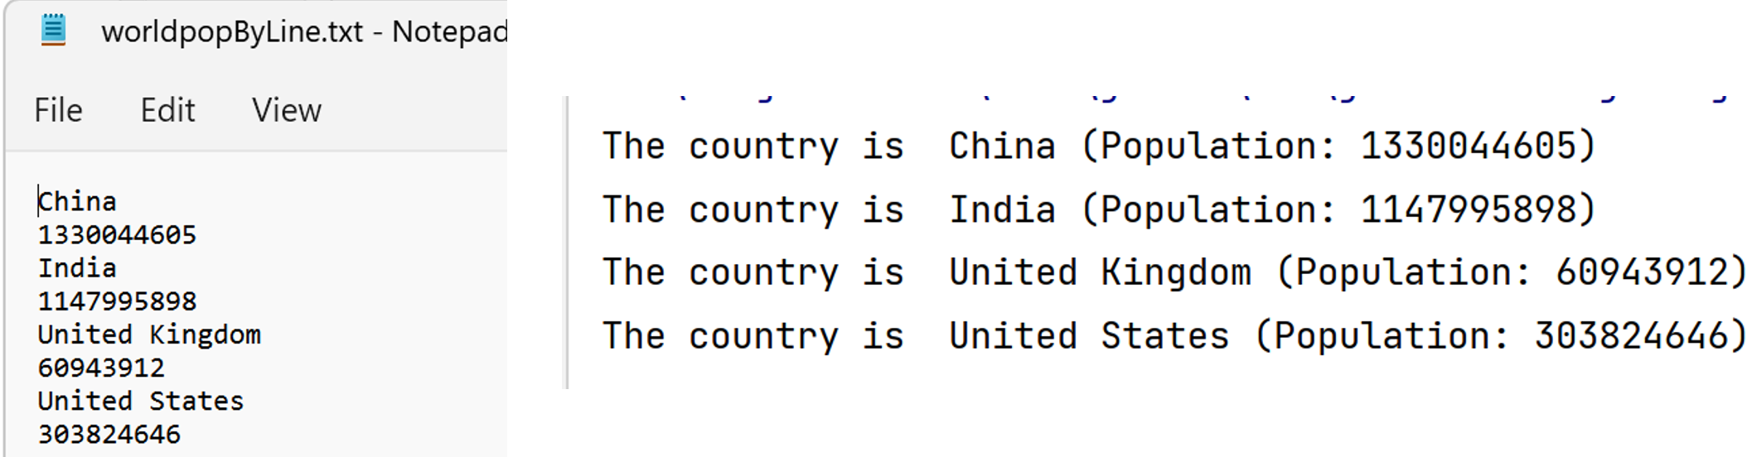

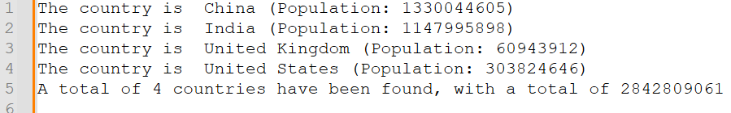

Your submission list: 1). ReadingMixOfStringsAndNumbersScannerByLineSum.java
and
2). worldpopByLineOutput.txt

