CASE STUDY · ADVANCED EXCEL
Building a Fraud Risk Monitoring Dashboard in Excel
Turning a flat 1,488-row transaction feed into a scored, chart-driven dashboard an ops team could actually run from — using COUNTIFS/SUMIFS logic and native Excel charts, not a single manual lookup.
1,488  Transactions scored | 4  Combined risk flags | 13  High-risk transactions | 19,745  Formulas, zero errors

Situation
The SQL project (companion case study) is built for deep, one-off investigation — an analyst runs it when they already suspect an account. But most fraud-ops teams also need something they can open every morning: a live, transaction-level risk score across the whole feed, and a dashboard that shows where the pressure is building before it becomes a case. That's a different tool for a different moment in the workflow, and it's where Excel — not SQL — is actually the better fit.

Approach
I built a four-sheet workbook (Transactions → SQL Findings → Risk Scoring → Account Summary → Dashboard) that combines two kinds of detection logic:
- Real-time, single-transaction rules computed directly in Excel with nested IF/AND and COUNTIFS — a velocity flag (more than 6 transactions from one account in the same hour), a round-amount flag (wire transfers in exact $1,000 multiples), and an off-hours flag (ATM withdrawals over $2,000 between midnight and 5 AM).
- Account-level findings imported from the SQL project — structuring, geographic impossibility, and duplicate charges — brought in with a COUNTIF lookup against a reference list, since those patterns need a multi-row join that a single Excel formula can't see on its own.
The two combine into one RiskScore (0–4) and a RiskLevel of Low / Medium / High per transaction, with conditional formatting so a reviewer can scan the sheet visually instead of reading every cell. An Account Summary tab then rolls this up with SUMIFS and COUNTIFS — total transactions, flagged transactions, high-risk count, and flagged dollar volume per account — and the Dashboard tab turns that into three native Excel charts.

Dashboard
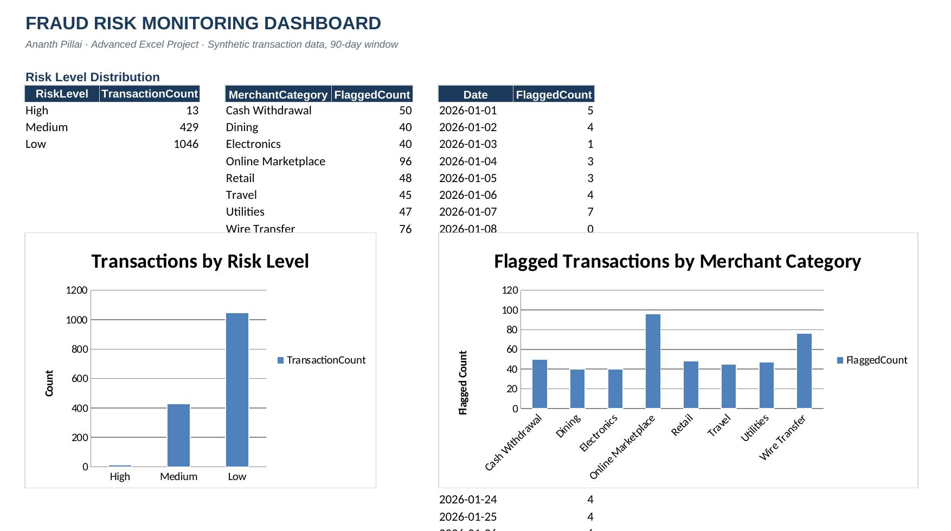
Risk-level distribution and flagged-transaction volume by merchant category — both built from SUMIFS/COUNTIFS aggregation tables feeding native Excel bar charts.
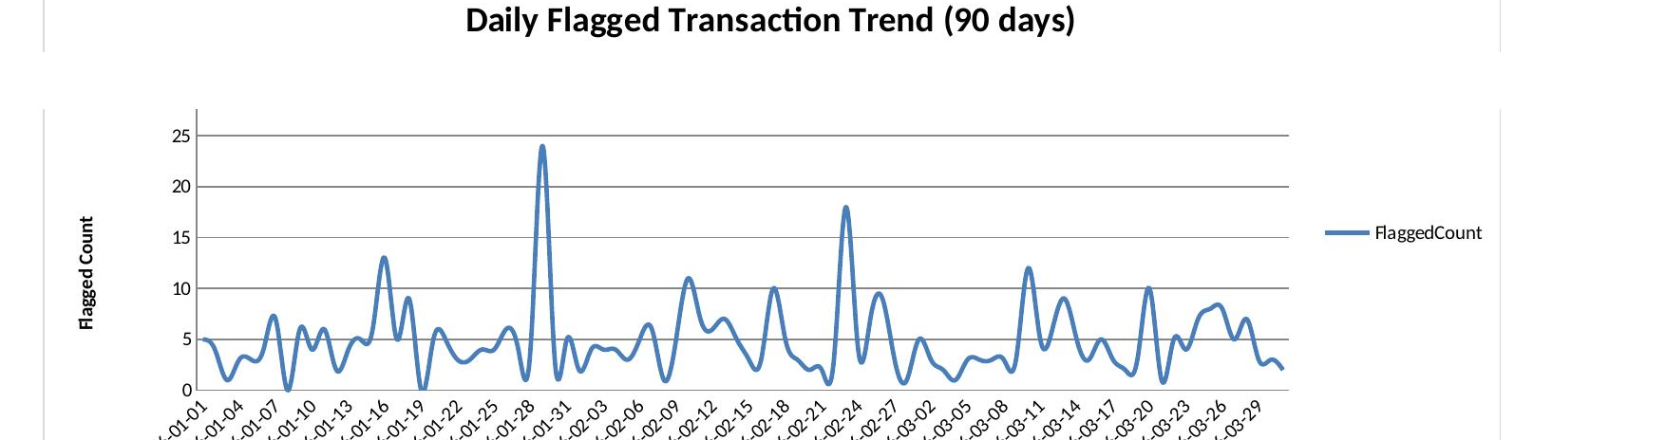
90-day daily flagged-transaction trend. The two visible spikes are exactly where the velocity-spike pattern was concentrated — the kind of signal an ops lead would catch at a glance, not by reading rows.

Findings
Of 1,488 scored transactions, 1,046 came back Low risk, 429 Medium, and 13 High — a distribution that looks right for a healthy account base with a handful of accounts needing attention, rather than an over-tuned model flagging everything.
- Online Marketplace (96 flagged) and Wire Transfer (76 flagged) carry the largest share of flagged volume by merchant category — the two channels where velocity abuse and structuring respectively are easiest to hide.
- The daily trend isolates two clear spike days against a steady baseline of roughly 3–7 flagged transactions per day — exactly the kind of anomaly a morning dashboard check is meant to catch.
- At the account level, ACC1004 surfaces as the clearest priority case: 41 of 41 transactions flagged, 10 of them High risk, $6,527.97 in flagged volume — a account-level view the SQL project alone doesn't produce.
One deliberate design choice worth calling out: once an account is flagged by a SQL cross-transaction rule, every transaction for that account inherits the flag — not just the triggering rows. That's not double-counting; it mirrors standard fraud-ops practice of pulling an account's full activity for review once it trips a pattern, rather than looking at the triggering transaction in isolation.

Tools & Technique
- Advanced Excel — nested IF/AND, COUNTIFS, SUMIFS, COUNTIF cross-sheet lookups, conditional formatting
- Native Excel charting — bar and line charts built directly from formula-driven aggregation tables, not pasted values
- Workbook validated end-to-end: 19,745 formulas recalculated with zero errors before publishing

Why It Matters for the Role
This is the artifact a fraud-ops team actually opens each morning — not a query result, but a live workbook a non-technical reviewer can scan, filter, and trust. Building it required the same judgment a working analyst needs: knowing which checks belong in a formula an analyst can run in real time, and which need the heavier cross-transaction logic SQL is built for — then making the two work together in one place. The full workbook (fraud_risk_audit.xlsx) is available on request.

