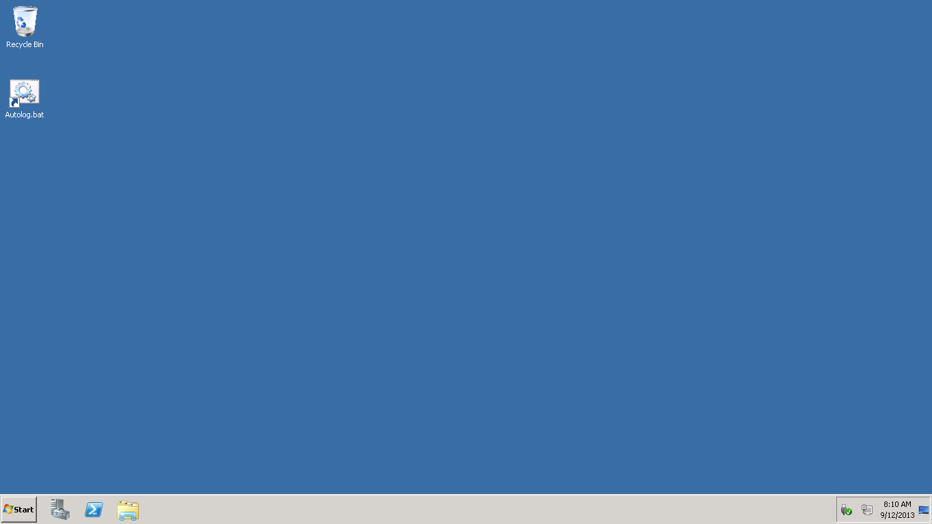

In order to configure IIS server on remote windows machine first connect to remote desktop by using specific username and password.

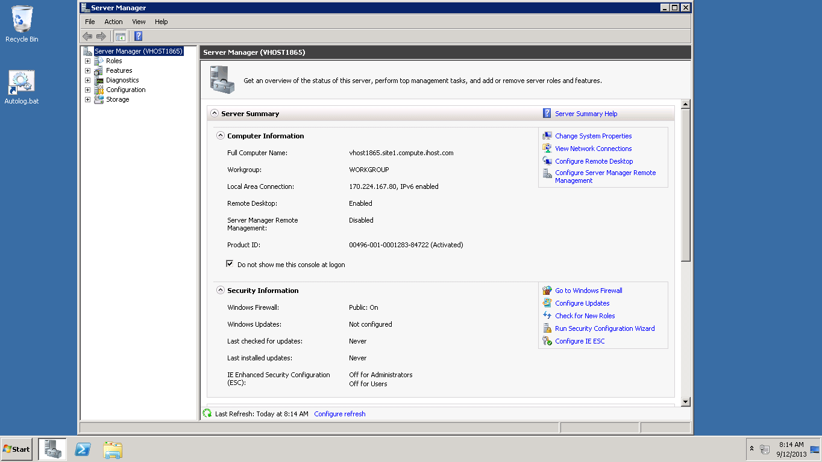

Then open server manage window by right clicking on my computer and then selecting manage option.

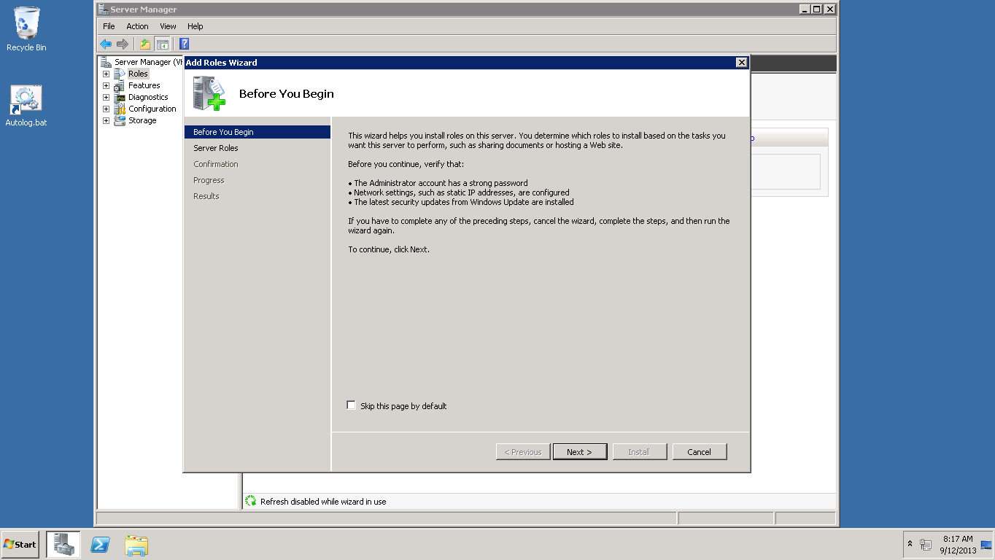

Click on rolls button under server manager and then click an add rolls, then select server rolls.

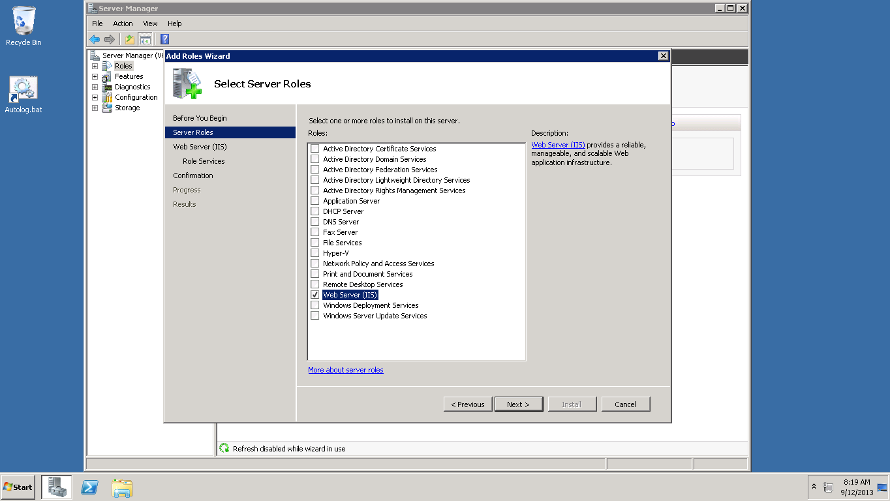

Select web server (IIS) check box then click on next.

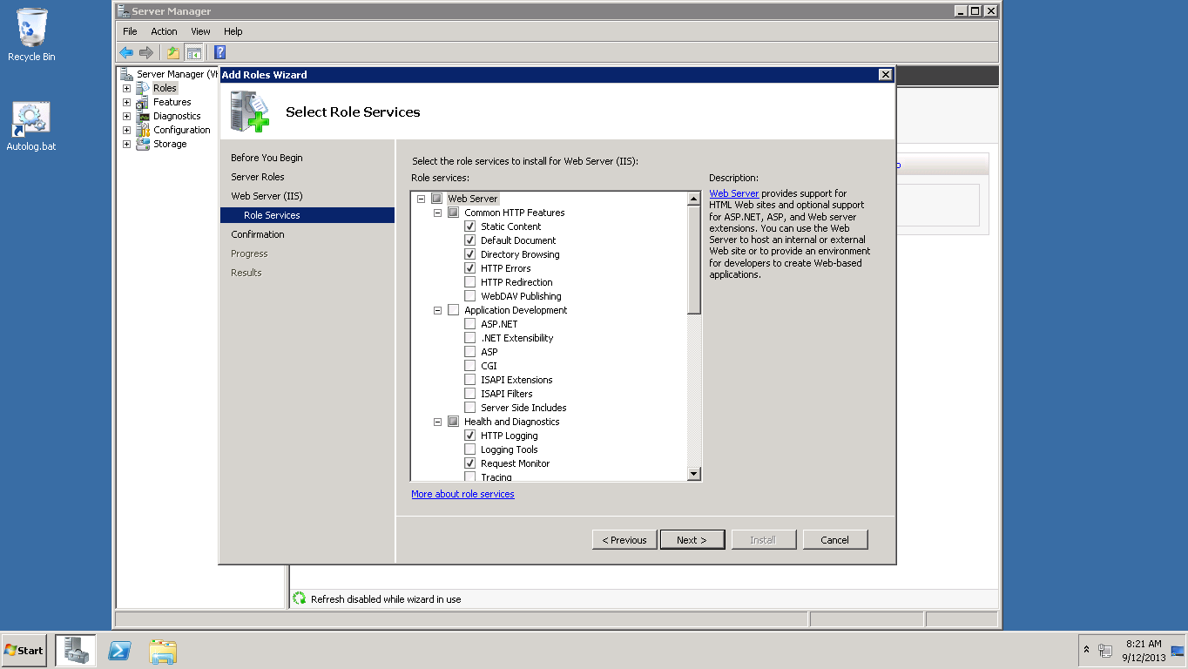

On select roll services window keep default options and click on next.

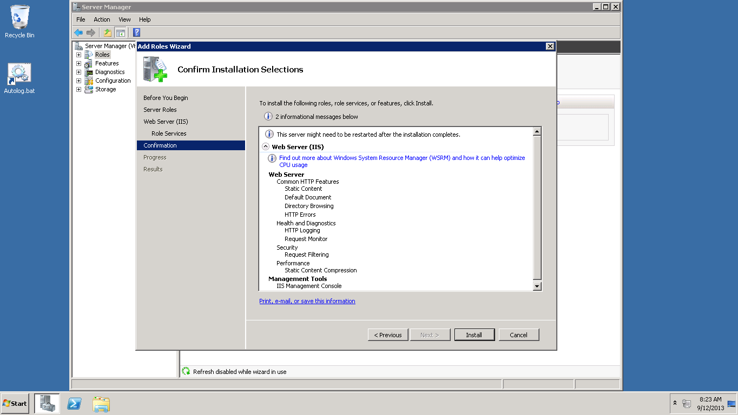

Then click on install button in order to complete installation process.

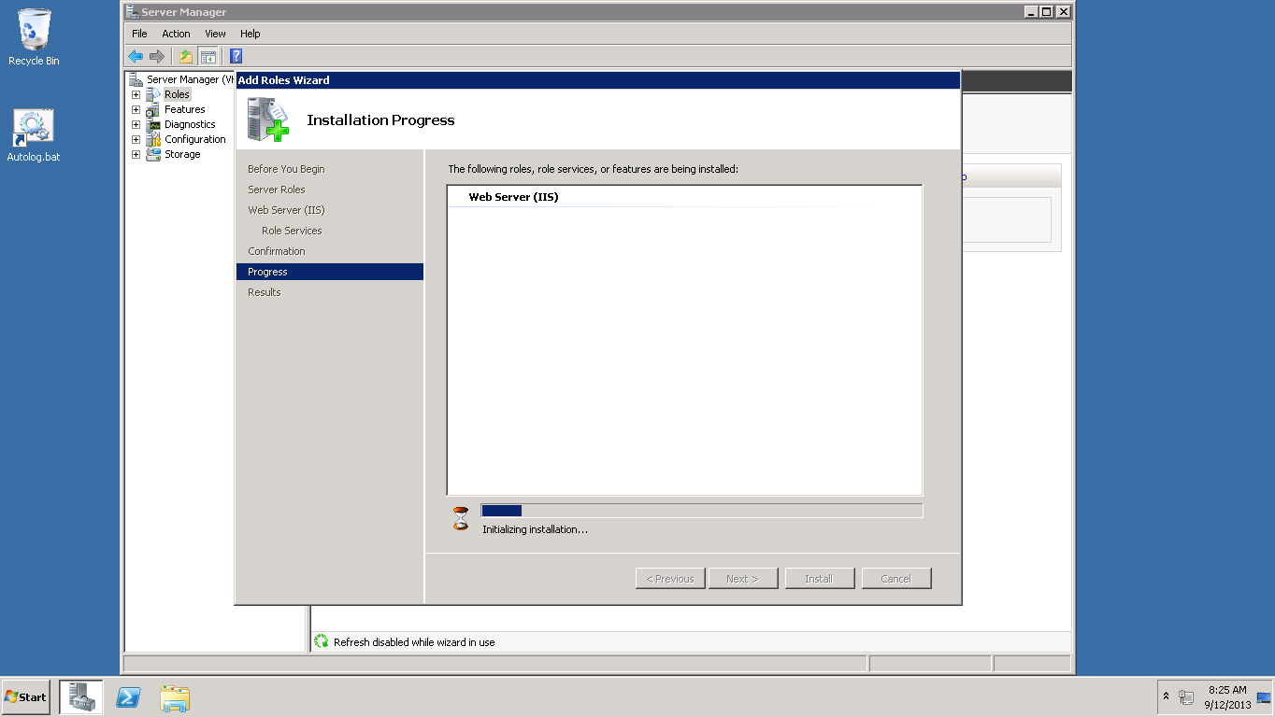

Installation is in progress.

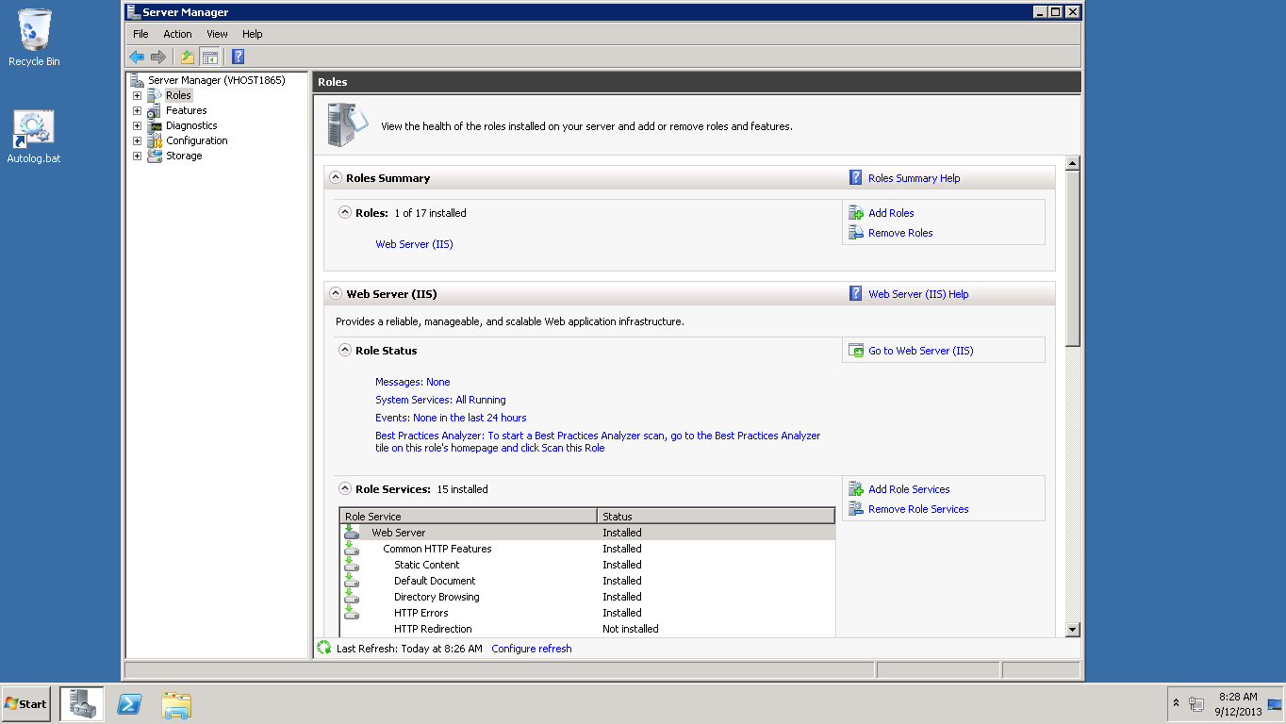

After installation is complete.

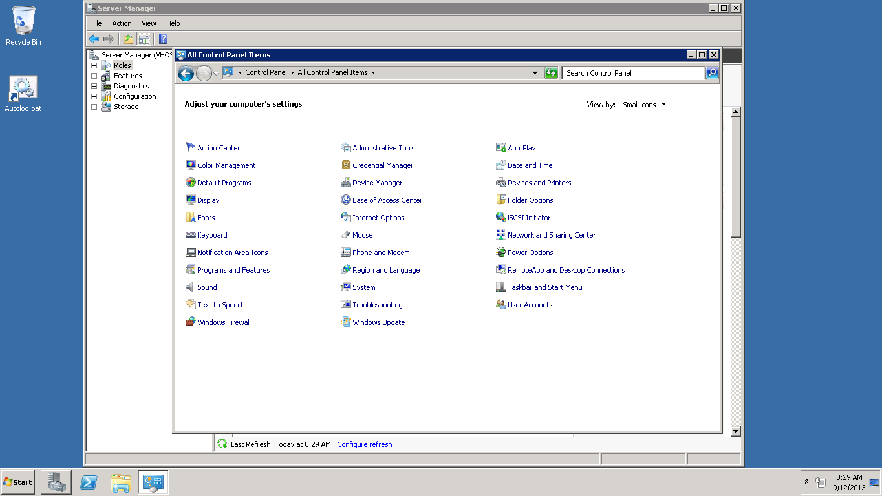

Go to control panel and select small icons and choose windows firewall in order to ensure that firewall is set up correctly

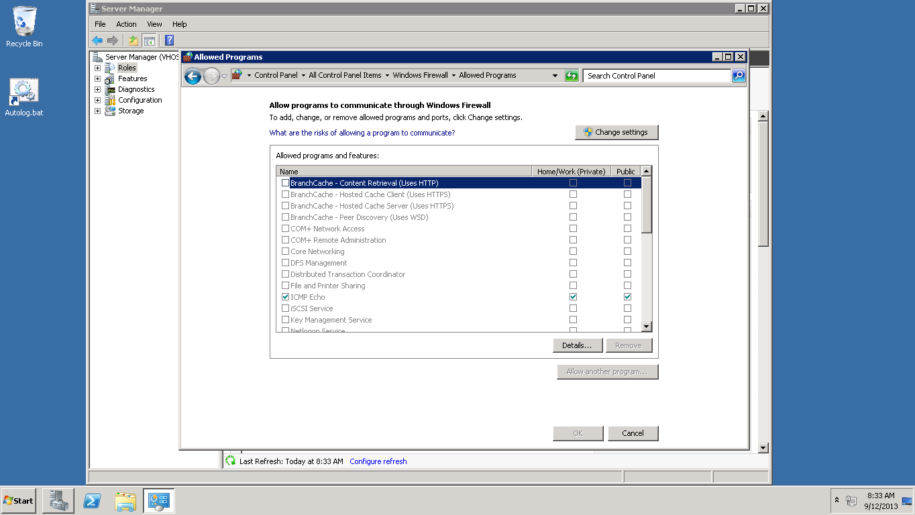

Firewall set to default world wide web services to allow http/port 80 traffic.

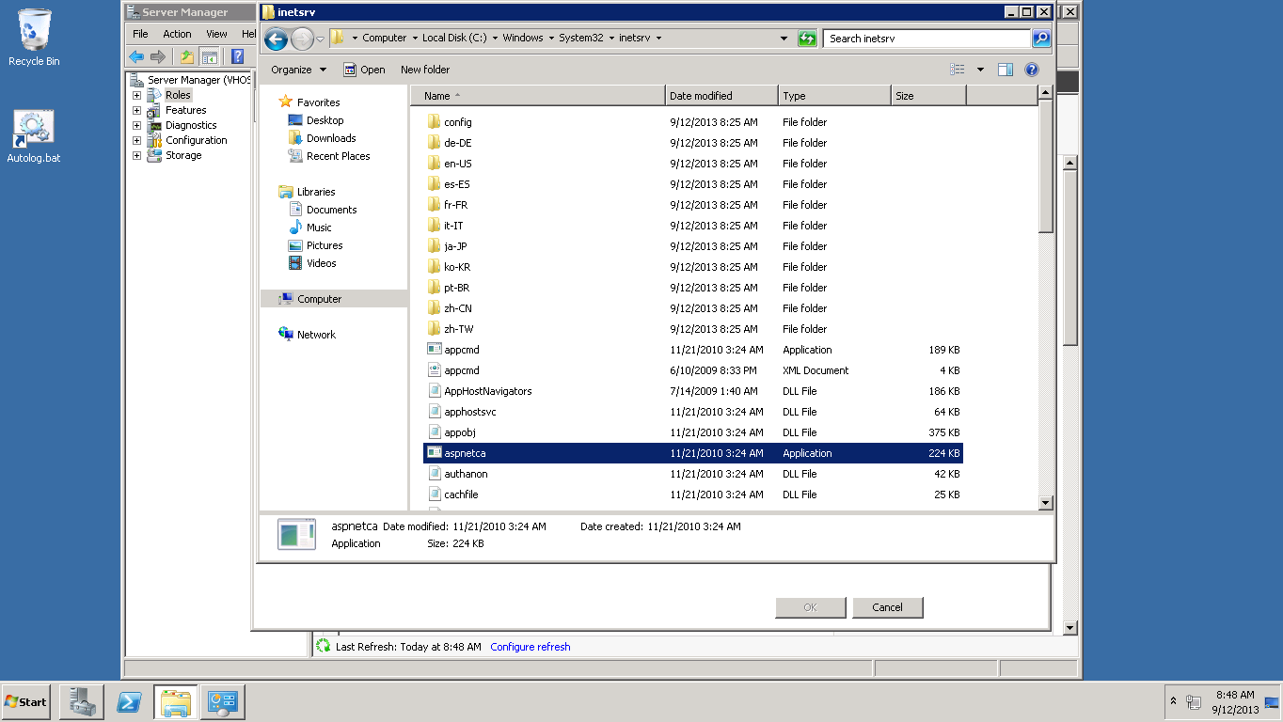

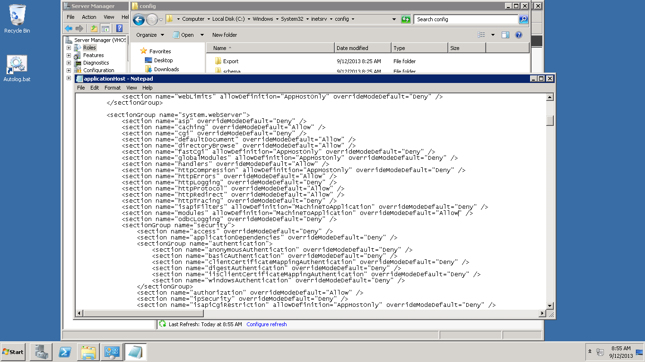

Change the application host.

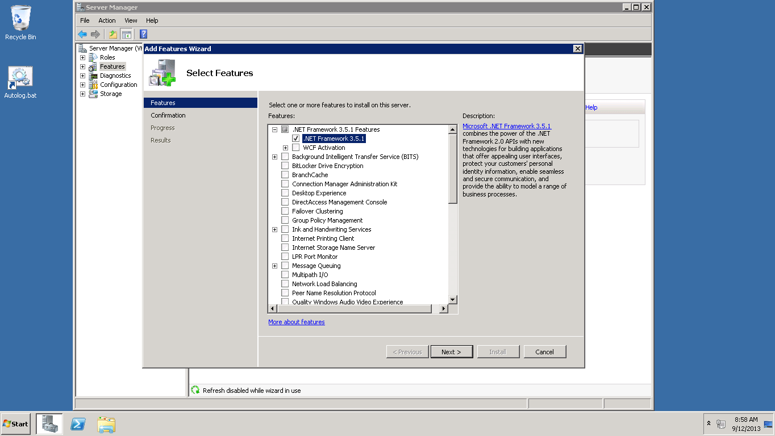

Addition of 3.5.1 frame work.

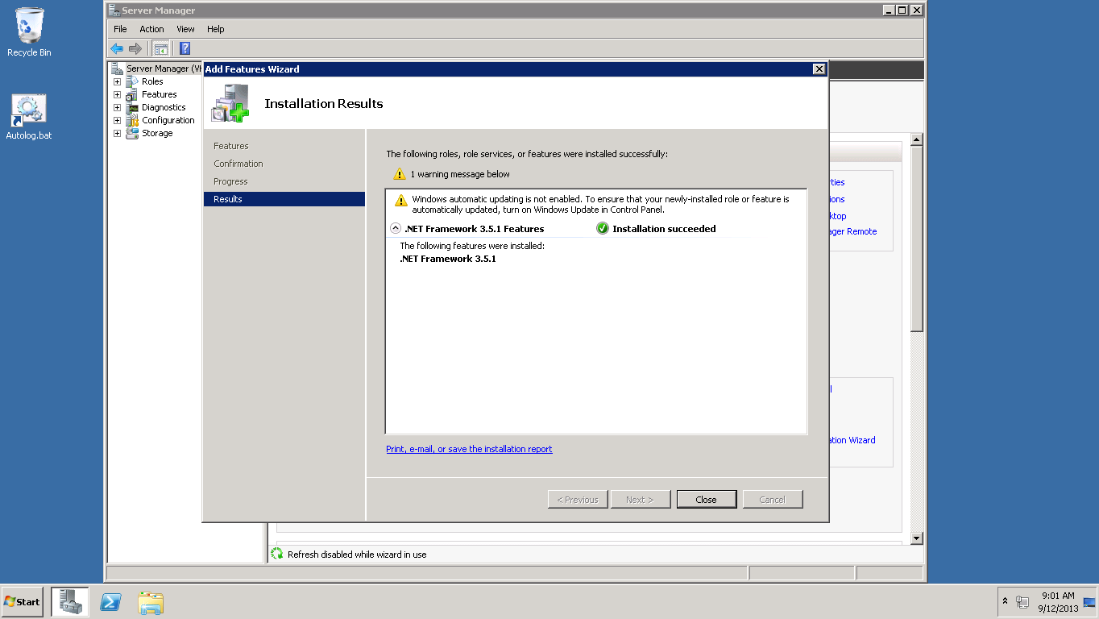

After installation is successful.

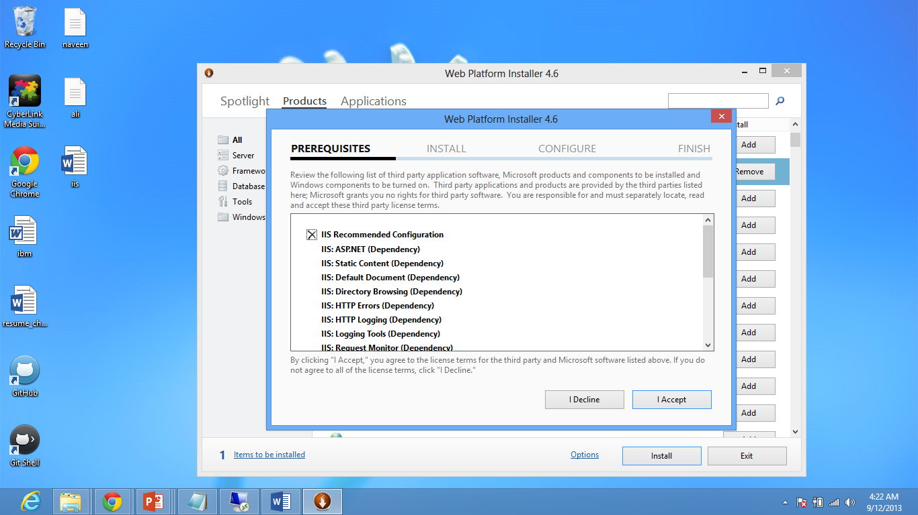

Installing .net framework 4.5