I created a mashup application which uses google maps, twitter and google+ api’s

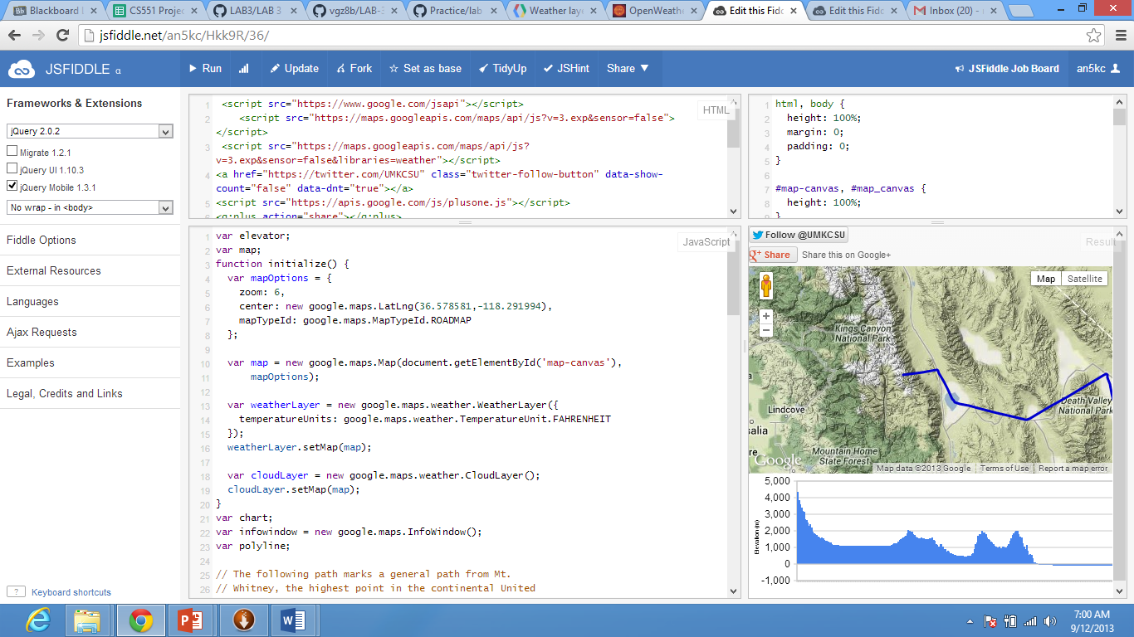

In this application one who use this one can get elevation along a path.

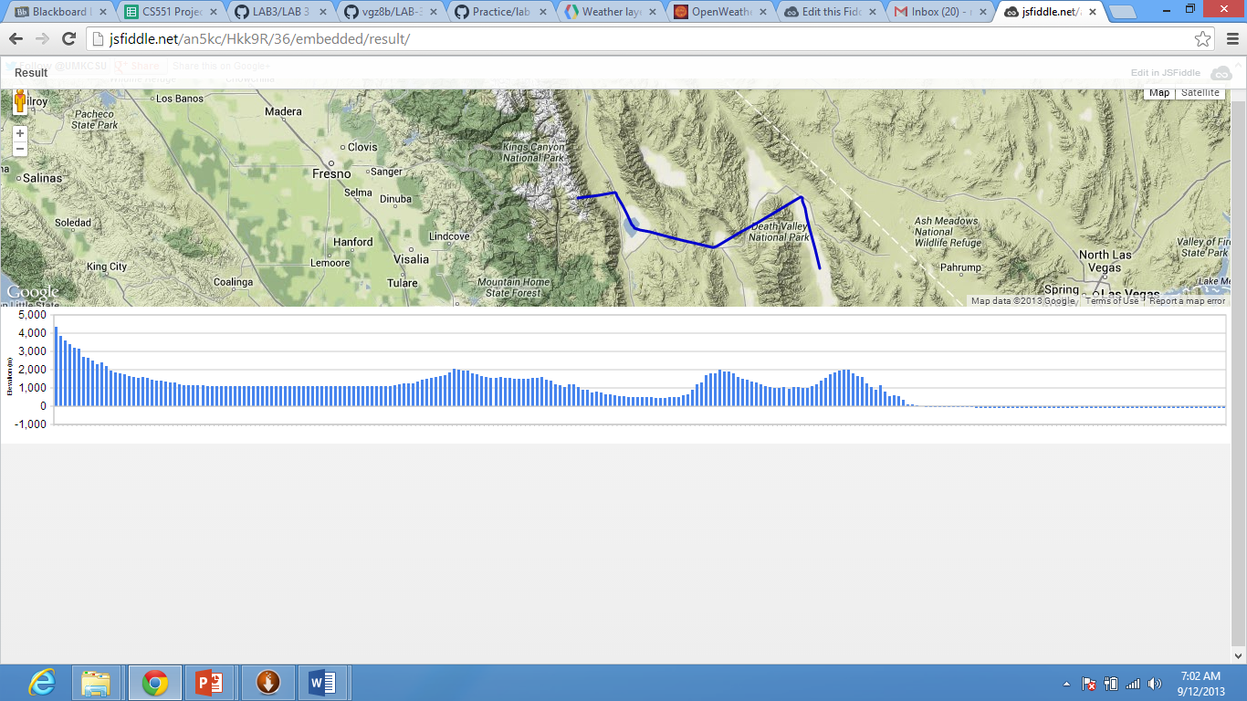

This is the output of the application that represents elevation.

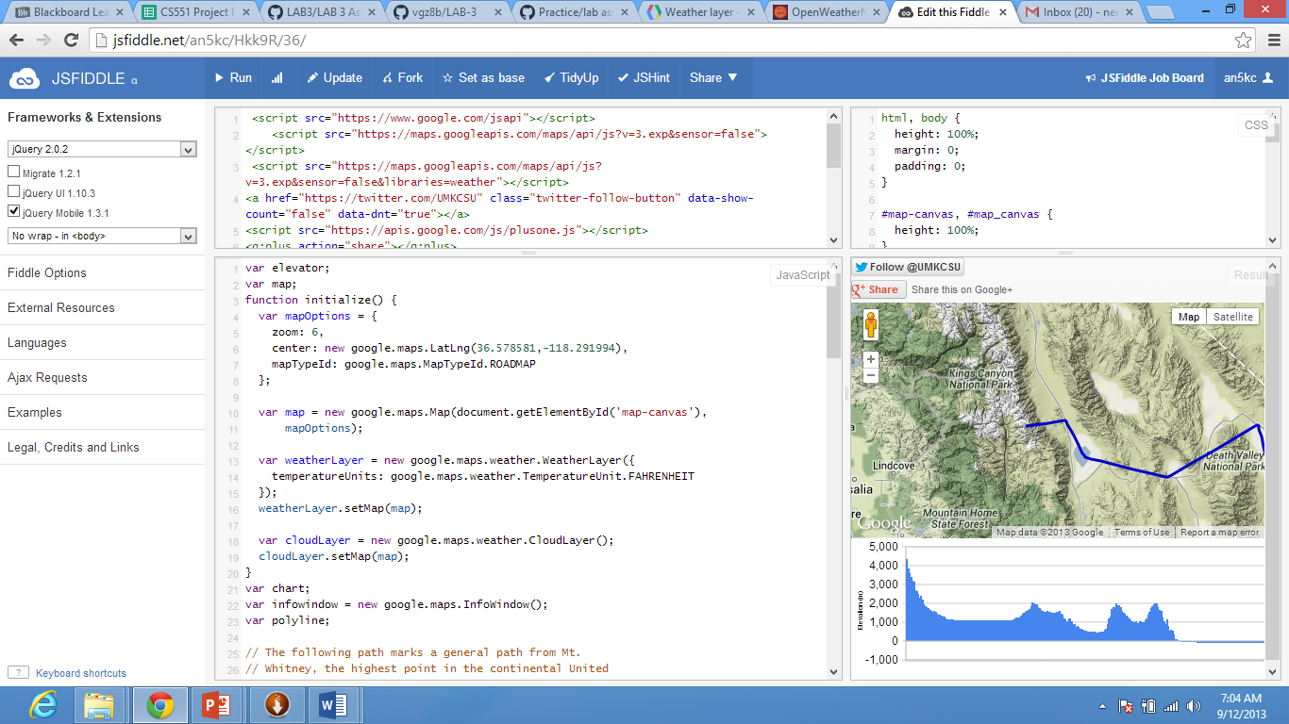

In this application the user can share the result using google+ as well as twitter. Google+ and twitter share options are mentioned at the top of the result. User can share result by providing certain login information.

Jsfiddle link for lab3: <http://jsfiddle.net/an5kc/Hkk9R/36/>