Test Plan for
PROJECT A

 | General information
Customer | SmartStudy – Student Learning Management Platform
Created by (Author) | Anastasia Vonsovych
Preparation date | 17/03/2026
Version | 1.0
Status | Final

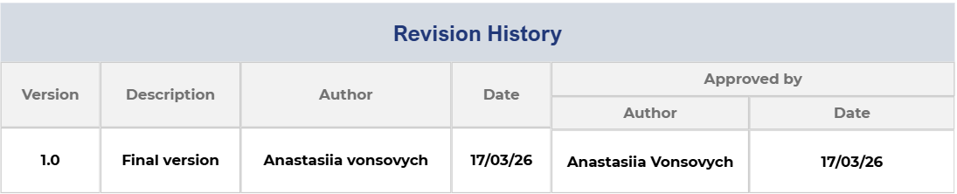
Summary
1. Introduction 4
1.1. General information 4
1.2. Purpose 4
2. Scope of project 4
2.1. Scope of web portal 4
2.2. Scope of mobile application 4
2.3. Scope of Admin part 5
3. Work plan 5
4. Test Plan and Strategy 5
4.1. Functional testing
4.2. Test Procedure 6
4.3. Bug Reports 7
5. Resources 8
5.1. Tools 8
5.2. The list of the browsers 8
5.3. The list of the devices 8
7. Testing Process Risks 9
8. Test Team Expectations 9
9. Responsibilities of Test Team Members 9
10. Deliverables 10

1. 1. Introduction

1.1 General Information
This document provides a comprehensive description of the testing approach, methodologies, and procedures that will be applied during the testing process of the SmartStudy – Student Learning Management Platform.
SmartStudy is a web-based Learning Management System (LMS) designed to simplify and improve the educational process by integrating course management, assignment handling, grading, and communication into one centralized platform.
The system is intended to be used by:
- Students
- Instructors
- Administrators
This Test Plan acts as a guideline for all testing activities and ensures that the system meets functional and non-functional requirements before deployment.

1.2 Purpose
The main purpose of this Test Plan is to define a structured approach to testing and ensure that all aspects of the SmartStudy system are properly validated.
The document aims to:
- Ensure that all system functionalities work as expected
- Identify defects and inconsistencies
- Define testing scope and objectives
- Provide clear testing procedures
- Improve overall system quality
Additionally, the Test Plan helps coordinate communication between developers, testers, and stakeholders.

2. Scope of Project

2.1 Scope of Web Portal
The SmartStudy web platform will be tested as the main system component.
The following modules and functionalities are included in testing:

User Management
- User registration with validation
- Secure login and logout
- Password recovery

Course Management
- Creating courses (Instructor)
- Enrolling students
- Viewing course materials

Assignment Management
- Creating assignments
- Submitting assignments
- Deadline tracking

Grading System
- Assigning grades
- Viewing grades
- Feedback from instructors

Notification System
- Deadline reminders
- System alerts
- Messages

User Profile
- Editing personal data
- Viewing activity

2.3 Scope of Admin Part
The admin panel will be tested for full system control functionality.
Includes:
- Creating and managing users
- Assigning roles
- Monitoring system activity
- Managing courses and data
- Generating reports

3. Work Plan
The testing process will follow a structured workflow:
- Test Planning
Creation of test documentation and strategy
- Test Design
Writing test cases and preparing test data
- Test Execution
Running test scenarios and identifying defects
- Bug Reporting
Documenting and tracking issues
- Regression Testing
Re-testing after bug fixes
- Final Testing Report
Summary of testing results

4. Test Plan and Strategy

4.1 Functional Testing
Functional testing ensures that all features of the system operate according to requirements.
Testing will include:
- Valid input testing
- Invalid input testing
- Boundary value testing
Each function will be tested individually and as part of the whole system.

Entry Criteria
Testing will begin only when:
- The system build is stable
- All required features are implemented
- Test environment is configured
- Test data is prepared

Completion Criteria
Testing will be completed when:
- All test cases are executed
- No critical or blocking defects remain
- All major defects are resolved
- Test results are approved

4.2 Test Procedure
Testing will follow a structured procedure:
- Execute test cases
- Record results
- Identify defects
- Log bugs into tracking system
- Retest fixed issues

Testing Types:
- Functional Testing
- UI Testing
- Usability Testing
- Compatibility Testing
- Regression Testing
- Retesting

4.3 Bug Reports
Bug reporting is a critical part of the testing process.
Each bug report must contain:
- Clear description
- Steps to reproduce
- Expected result
- Actual result
- Severity level
- Attachments (screenshots)

Severity Levels:
- Critical – system failure, cannot continue
- Major – important feature not working
- Minor – small issue, does not block work
- Trivial – UI or text errors

5. Resources

5.1 Tools
Testing will use modern tools:
- Jira – bug tracking
- TestRail – test case management
- Snagit – screenshots

5.2 Browsers
System compatibility will be checked on:
- Google Chrome
- Mozilla Firefox
- Microsoft Edge
Testing ensures consistent behavior across browsers.

5.3 Devices
- Desktop computers
- Laptops
- Optional mobile devices (future scope)

6. Quality Criteria
The system must meet the following quality standards:
- All features must work correctly
- No critical errors allowed
- User interface must be clear and intuitive
- System must be stable and responsive

7. Testing Process Risks
Possible risks include:
- Frequent requirement changes
- Delays in development
- Lack of test data
- Environment instability
- Limited time for testing

8. Test Team Expectations
The QA team expects:
- Clear documentation
- Stable system builds
- Quick bug resolution
- Good communication

9. Responsibilities

Project Manager
- Oversees entire process
- Allocates resources

QA Lead
- Coordinates testing
- Assigns tasks
- Reviews results

QA Engineer
- Executes tests
- Reports bugs
- Verifies fixes

10. Deliverables
The testing process will produce:
- Test Plan document
- Test cases
- Bug reports
- Daily reports
- Final testing report

