Homework Ch 11
Exercises 11.1
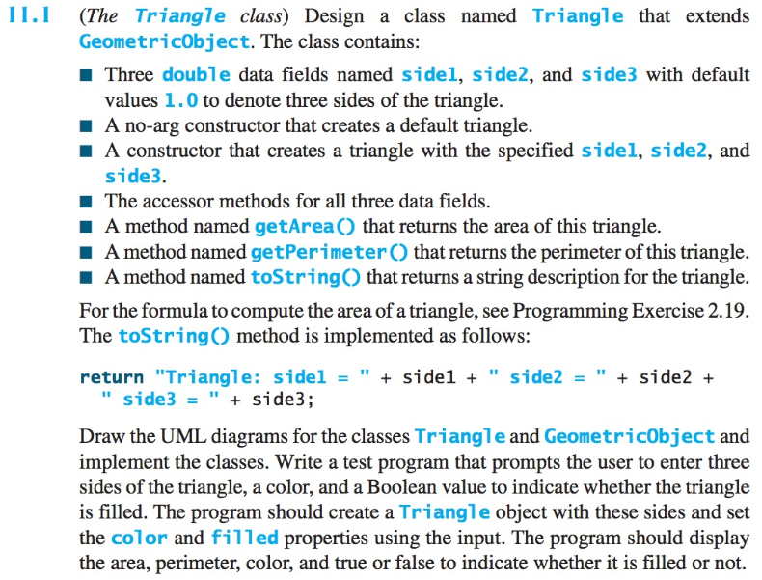
Exercise 11.9
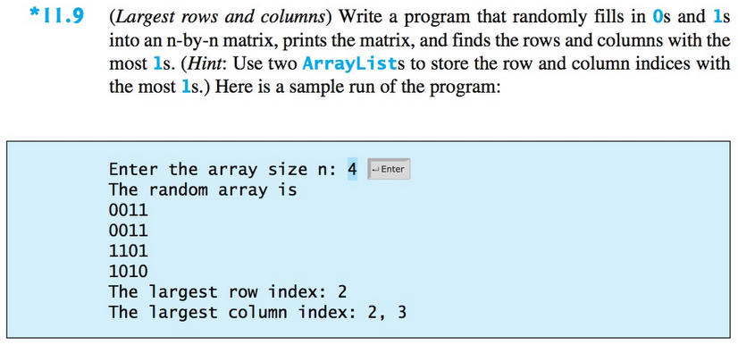

Exercise 11.17 (Bonus, 50 points)
