Homework Ch 12
Exercises 12.1
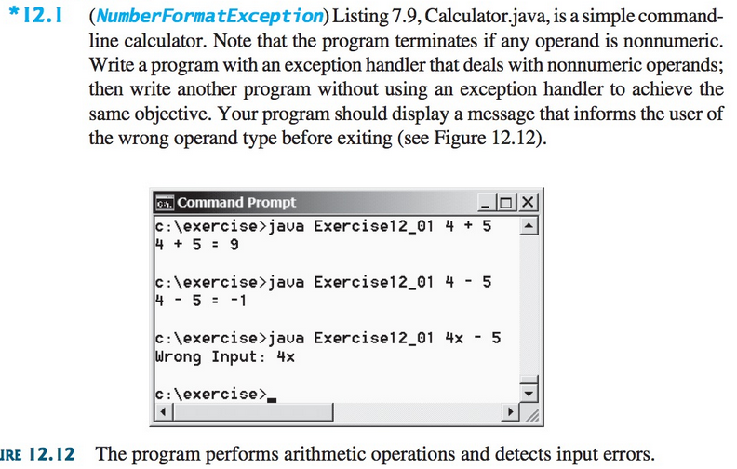

Exercise 12.11
