Homework Ch1
Exercises 1.3
(Display a pattern) Write a program that displays the following pattern:
FFFFFFF U U NN NN
FF U U NNN NN
FFFFFFF U U NN N NN
FF U U NN N NN
FF UUU NN NNN

Exercise 1.7
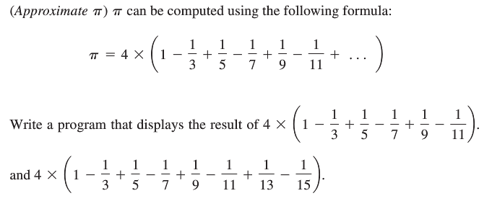
Exercise 1.11
(Population projection) The US Census Bureau projects population based on the following assumptions:
One birth every 7 seconds
One death every 13 seconds
One new immigrant every 45 seconds
Write a program to display the population for each of the next five years. Assume the current population is 312032486 and one year has 365 days. Hint: in Python, you can use integer division operator // to perform division. The result is an integer. For
example, 5 // 4 is 1 (not 1.25) and 10 // 4 is 2 (not 2.5).

Exercise 1.17
(Turtle: draw a line) Write a program that draws a red line connecting two points (-39, 48) and (50, -50) and displays the coordinates of the two points, as shown in Figure 1.19b.
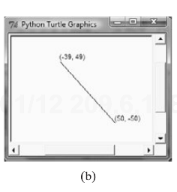
Exercise 1.21
(Turtle: display a clock) Write a program that displays a clock to show the time 9:15:00, as shown in Figure 1.20c.
